If At First You Don’t Succeed ….

Phillip H. Hoffman
alkihistoryproject@gmail.com

Note to the Reader: ‘Alki’ designates a geographic area facing Elliott Bay and Puget Sound located on the northwest corner of the Duwamish Peninsula (location map – Appendix A). A feature of Alki is Alki Point, the western most land projection of the Alki area into Puget Sound. Alki and Alki Point may be used interchangeably. Alki Point herein, means the western most land projection into Puget Sound unless the context clearly indicates otherwise. Duwamish Peninsula refers to that land mass lying between Puget Sound and the Duwamish River north of today’s SW Roxbury Street and its eastward and westward projection to the River, to the east, and Sound to the west.

Why I Wrote This Paper and Why I Hope You Will Read It

This paper has been written because elections matter.

Nominally, this paper concerns bringing municipal and school governance to Alki and its Duwamish Peninsula neighbors. But the deeper story reveals past successful efforts to silence our electoral voice. In the course of creation of local government on the Peninsula, elections were found, in and of themselves, to be harmful to powerful economic interests. Therefore, by judicial decree, elections were cancelled and voting results were discarded. Suspected judicial integrity issues contributed to this outcome.

It is through free and fair elections that we choose our political leaders and resolve our conflicts. In the case at hand, elections concerned extension of and creation of new city jurisdictions for Alki and Duwamish Peninsula governance. Those opposing municipal governance resorted to the courts under questionable circumstances and utilized suspect maneuvers to cancel elections and to summarily dismiss election results. They acted to prevent the will of the voters from being heard so that they would not have to have their view of the issues tested, on their merits, at the ballot box or within the halls of justice. Obstruction of elections was favored over issue resolution.

Acknowledgment and understanding of past manipulation of judicial processes to frustrate governance and public decision making is one of the objectives of this paper. The second objective is to aid in the prevention of this past from becoming our future.

With the assistance of an unknown ‘capable attorney’ hired by the Seattle Chamber of Commerce, Alki and its Peninsula neighbors became part of the City of Seattle and the Seattle School District. This outcome was not a foregone conclusion.

Table of Contents

Page

Why I Wrote This Paper and Why I Hope You Will Read It i
Table of Contents ii
List of Maps v
List of Tables vi
List of Figures vi
Introduction 1
Overview, definition of annexation and incorporation, Cities of West Seattle
and South Park, overview of attempts to create municipal governance
First Attempt at Municipal Governance on the Duwamish Peninsula 4
Southern Suburban Strip Annexation March 1904, annexation fails
Why Municipal Government 5
Alki beginnings, lack of common instrument of control for public infrastructure,
need to support urbanization, opposition to liquor licensing, timber interest
oppose municipal government, elimination of public service ‘free riders’,
utility finance incentives, need for fresh and safe water, education and
libraries, hyper-growth and ‘Greater Seattle’
Where Will My Children Go to School? 10
Establishment of the West Seattle School District, jurisdictional boundaries,
School District decisions influencing future municipal governance actions
Go It Alone, Well Almost 12
Alki Point Beer Garden, one-mile prohibition licensing zone prohibits beer
West Seattle seeks to annex territory to south of existing city and east of
proposed City of Alki Point (August 1904), West Seattle holds annexation
election (September 1904), Puget Mill Company seeks court order preventing
counting of election votes
Some of the Parties Agree to Settle. Popular Sovereignty Is Cast Aside 18
Election results are not reported, unofficially voters approve proposed
annexation, allegations of the Puget Mill Company, West Seattle Reservations
become point of contention, parties agree to never officially count the
elections’ ballots, issues remain outstanding
The West Seattle School District Takes A Hit – Youngstown Wants A
School District All Its Own 22 Youngstown School District is formed from territory of West Seattle School
District, reasons why Youngstown School District is established
Spring Hill Villa Wants A School Too 24
West Seattle School District is enlarged to include Spring Hill Villa
A New Foe Arises 25
New West Seattle annexation area is proposed excluding Puget Mill
Company lands and Youngstown, issues of adjacency to Seattle arise,
street railway issues arise, street railway is a financial burden, annexation
election fails on tie vote (March 1905), new annexation election is scheduled
(April 1905), Jacob Furth seeks to obstruct and frustrate City of West
Seattle annexation, Furth fails to perform under franchise agreements,
Furth franchise agreement is revoked, West Seattle authorizes municipally
owned street railway, proposed West Seattle annexation is approved,
West Seattle is posed to extend street railway

Page
A Second Courthouse Cruise, With an Extended Stay at the State
Supreme Court 31
Estate of Amos Brown seeks to enjoin holding of annexation election, Judge
Yakey grants order prohibiting election, West Seattle officials hold election,
annexation is approved, ten months later election is found ‘null and void’ by
trial court, Washington Supreme Court upholds (June 1906) finding that
election was ‘null and void’, merits of annexation are not addressed,
governance status quo
Judge Griffin’s Logic Wasteland Has A Silver Lining 33
West Seattle School District jurisdiction is extended
Alki Needs a Street Car, and the Bathers, Dancers and Stockade Hotel
Needs a Liquor License 34
Stockade Hotel owner seeks Alki street car franchise, Alki Improvement Club
opposes annexation to West Seattle, Stockade Hotel seeks liquor license,
liquor license application rejected, a new effort to annex Alki to West Seattle
fails (February 1906)
The Saloons Hold Firm, The Puget Mill Company Has Nothing To Fear
And Furth Gets His Way 38
Stockade Hotel apply again for a liquor license, West Seattle City Council
reconsiders street railway matters, Seattle Electric Company applies for street
railway franchise, West Seattle attempts another annexation (October 1906),
consolidation with City of Seattle is contemplated, West Seattle agrees to sell
street railway to Furth interests, Youngstown defeats West Seattle annexation
Go Big! 44
Existing cities consolidate with Seattle, new cities are formed to consolidate
with Seattle, Washington C. Rutter becomes proxy for Puget Mill company
opposing incorporation of the City of Alki-Rainier, Incorporation election is called
(January 1907), Youngstown and Seattle Steel Mill excluded from Alki-Rainier
boundaries, Alki-Rainier is proposed as third-class city, Rutter seeks to enjoin
holding of incorporation, election is enjoined, municipal governance gap is
created
A Little Ol’ Bitty Bill That Don’t Do Nothin’ 53
Cotterill’s bill passes defining municipal contiguousness when separated by
body of water, Seattle Chamber of Commerce hires legal counsel for annexation
area residents to direct movement, Youngstown saloonkeepers opposed to
annexation, Cotterill seeks increase in minimum Youngstown liquor license fee
“I Wish Youngstown Was In Kitsap, and West Seattle in Snohomish. As
To Georgetown, Well Yuma County Arizona, Would Suit Me For
Its Location” 55
Youngstown’s early days, real estate entrepreneurs respond to railroad
speculation, Spokane Street tide flats trestle opens 1902, Seattle Steel Mill
opens, saloons open in Youngstown, incorporation of Youngstown is proposed
to protect saloons, Youngstown saloons found in violation of one-mile
prohibition zone, saloons forced to close, court appeal fails
Getting Close to Municipal Governance for Alki and Its Duwamish
Neighbors 59
West Seattle calls another annexation election (May 1907), corporate interests
fail to oppose annexation, West Seattle City Council commits to calling Seattle
consolidation election if annexation is approved, attempt to enjoin holding of
annexation election fails, annexation is approved, adjacency with Seattle
achieved, pending Youngstown incorporation petition removed from
Commissioners’ calendar
Page
In Quick Order 66
Election to approve consolidation West Seattle-Seattle consolidation held
(June 1907), West Seattle city council advises Seattle City on current needs,
consolidation approved by Seattle City Council, West Seattle passes out of
existence,
One Last Matter 69
West Seattle School District merged into Seattle City School District
Epilogue 70
Rainier-Dunlap annexed to Seattle, Georgetown consolidates with Seattle,
Seattle achieves its Greater Seattle objective, Seattle annexation policy
questioned, Renton Commercial Club seeks Seattle – Renton consolidation,
Alki-Spring Hill Villa submits petition requesting no liquor licenses be issued,
use of name Seattle fades for outlying districts other than for West Seattle
Conclusions 73
Yakey’s Propriety or Absence Thereof 73
Election Cancelled 74
Failure to Defend Principle Cost the City of West Seattle 76
Why Did the Puget Mill Company Relent? 77
The Historical Record 77
The Sliver by the River and Other Unincorporated Areas
Surrounded 80
Why Did the Seattle Annexation and Consolidation Succeed?
Why Did It End? 80
Street Railway – Motivations to Build 82
Acknowledgements 83
Appendix A – Alki Location Within the City of Seattle, Elliott Bay
the North, Puget Sound on the West and South 85
Appendix B – Financial Performance Calendar Year 1906 West Seattle
Municipal Railway 86
Endnotes 87

List of Maps
Page
Map 1 – Proposed Southern Suburban Strip Annexation Area March 1904 4
Map 2 – Alki Point Ownership Pattern as of May, 1893 6
Map 3 – WSSD Boundaries (District #73) – February 15, 1890 11
Map 4 – Survey of Alki Point Indicating One Mile Limit, 1905 13
Map 5 – Proposed City of Alki Point, 1904 15
Map 6 – Proposed City of West Seattle Annexation Area, September 1904 16
Map 7 – Territory Removed from WSSD to Create YSD (District # 151) –
December 28, 1904 22
Map 8 – WSSD Boundaries (District # 73) – December 28, 1904 23
Map 9 – WSSD (District # 73) Jurisdiction and Boundaries December 20, 1905 24
Map 10 – City of West Seattle Annexation Area, March and April 1905 25
Map 11 – WSSD Jurisdiction Late 1905 or Early 1906 33
Map 12 – Alki Point Annexation Area, February 1906 37
Map 13 – Proposed Annexation Area to the City of West Seattle, October and
May 1907 42
Map 14 – Proposed Boundaries of the City of Alki-Rainier, December 1906 47
Map 15 – Southeastern Portion of Proposed City of Alki-Rainier Boundaries 50
Map 16 – Territory Excluded from Annexation and Incorporation, 1907 52
Map 17 – Youngstown Area Plats and Subdivisions – 1888-89 55
Map 18 – Duwamish Peninsula Proposed Railroads – 1890 56
Map 19 – Liquor License Premises, Youngstown Locations – January 1907 57
Map 20 – City of West Seattle Jurisdiction to be Annexed to and Consolidated
with the City of Seattle, July 1907 67
Appendix A – Alki Location Within City of Seattle 85
List of Tables
Page
Table I – Summary of Municipal Governance Proposals, 1904-1907 3
Table II – West Seattle Municipal Railway Financial Performance 27
Table III – 1910 Demographic Data Seattle Pre-Annexation Boundaries
And Areas Annexed 82
Appendix B – Financial Performance Calendar Year 1906 – West Seatte
Municipal Railway 86

List of Figures
Page
Figure One – Alki Point Real Estate Sale Classified Advertisement – 1897 7
Figure Two – Giving Annexation Meaning 9
Figure Three – A West Seattle Homesite Also Buys “Fine Schools” 10
Figure Four – Seattle Daily Times, June 27, 1904 Report on Alki Proposed
Incorporation 12
Figure Five – Stockade Hotel – Alki, Seattle, Washington, circa 1905 14
Figure Six – Opposition to Annexation 28
Figure Seven – Jacob Furth, circa 1907 29
Figure Eight – Judge John B. Yakey, 1908 31
Figure Nine – Alki Improvement Club Organizes to Protest West Seattle
Annexation 35
Figure Ten – Petition to the City of West Seattle for Annexation 36
Figure Eleven – George F. Cotterill, 1912 43
Figure Twelve – Washington C. Rutter, 1891 45
Figure Thirteen – Alki-Rainier to Incorporate and Then Annex to Seattle 46
Figure Fourteen – West Seattle Annexation, Organizing for the Election 63
Figure Fifteen – Seattle Department of Lighting Service Extensions – 1911 69

Introduction

Over the three-year period beginning 1904, there were seven attempts to bring municipal (city) governance to Alki. There were three other attempts to expand municipal government on the Duwamish Peninsula that impacted Alki governance choices. The governance debate featured conflicts over local autonomy, taxation, service levels, private and municipal utility ownership and liquor licensing. In the end, resolution of “demon rum” issues would dictate Alki’s municipal governance.
Particularly significant in the municipal governance saga are two cancelled elections due to judicial intervention. One cancellation took place the day before the polls were to open. The second took place less than forty-eight hours prior to when voting was to commence. Both cancellations were based upon perceived harm to the parties bringing the litigation from an election, per se. In a third case, the state trial court acquiesced to an agreement not to count the ballots cast in a duly called and conducted election.

Decisions made in the 1904-07 period resulted in the City of Seattle and the Seattle School District being the primary local government entities of the Duwamish Peninsula as they are today. The governance decision making road featured repeated returns to the ballot box, corporate interests demanding gerrymandering of prospective government boundaries, and suspected lack of judicial integrity leading to election cancellations. The aid of the Seattle Chamber of Commerce to the “annexationists” of Alki and its Peninsula neighbors was instrumental in bringing the area, as part of the City of Seattle, into the Chamber’s ‘Greater Seattle’ vision.

Seattle was a city of 100,000, as the effort to bring municipal governance to Alki and the Peninsula began. Seattle would double its population within a seven-year period. Seattle’s pioneer era had just passed. The Seattle community’s movers and shakers wished to propel Seattle into the Pacific Northwest’s leading metropolitan center known as Greater Seattle. Alki and its Duwamish Peninsula neighbors, most particularly the City of West Seattle, were an integral element to be added to Seattle to create the Greater Seattle domain. The people of the Peninsula numbered about 2,000 spread over 16 square miles.

Key elements contributing to the success of Alki’s annexation to Greater Seattle were timely legislative enactments sweeping aside potential opposition, the lack of organized opposition within the annexing city Seattle, the perception that a higher level of public services and improvements, at a lower cost, could be offered by Seattle to the newly annexed area than provided by the annexed area itself. The Seattle annexation program came to an end because of central city cost concerns to serve recently accreted territory, the emergence of new issues largely associated with public vice (police corruption, gambling, alcoholic beverages and prostitution) and preparation for Greater Seattle’s Alaska-Yukon-Pacific exhibition.

Municipal governance is customarily extended by the enlargement of the jurisdiction of a city taking over territory not within an existing city. This process is called annexation. Municipal governance can also be accomplished by the creation of a new city whose jurisdiction was previously without an established city or municipal government. This process is called incorporation. Territory within a city is called incorporated and territory without is referred to as unincorporated. The boundaries of a city government are frequently referred to as city limits.

Two or more cities may be merged into one. This process is called consolidation or sometimes annexation and consolidation. In the case of consolidation there is a surviving city within which the consolidated city is merged. The identity of the consolidated city is lost upon consolidation. The path toward municipal governance for Alki and its Peninsula neighbors exhibited annexation, incorporation and consolidation attempts.

A public-school district serving the Duwamish Peninsula was organized in 1890. It was called the West Seattle School District. Given state law of the time, as municipal jurisdictions were established and changed, the boundaries of school districts changed accordingly. School district jurisdictions were required to be at least coterminous with the city that they laid within. A school district could be larger than its host city so long as two or more school districts did not serve the same city.

The West Seattle School District pre-dated by twelve years the City of West Seattle. The City of West Seattle was the Peninsula’s first municipal government. The City was incorporated on April 21, 1902 by the prospective city’s voters on a vote of 97 for and 68 against. West Seattle was located on the Peninsula’s north end directly across Elliott Bay from its near namesake Seattle. Located in the southeast quadrant of the Peninsula, along the Duwamish River banks, the Town of South Park was established December 9, 1902. South Park was the Peninsula’s second municipal government. South Park would not play a significant role in bringing city government to Alki and its neighbors. West Seattle would play a meaningful role.

A summary of the attempts, subsequent to the incorporation of West Seattle and South Park, to bring municipal governance to Alki and its Duwamish Peninsula neighbors is shown in Table I below:

Table I - Summary of Municipal Governance Proposals, 1904-1907
Date | Proposal | Outcome | Map
March, 1904 | Petition to the Seattle City Council for annexation to Seattle of the Southern Suburban Strip | Annexation failed. Majority of voters disapproved in the area to be annexed. | 1
August, 1904 | Petition to the King County Board of Commissioners for incorporation of the Town of Alki Point | Petition was withdrawn. Election to approve or disapprove the incorporation was never held. | 5
September, 1904 | Petition for Annexation to the City of West Seattle of that part of the Duwamish Peninsula north of Roxbury Street SW and west of 16th Avenue SW, excluding Alki and Spring Hill Villa | Annexation election held but settlement of the judicial challenge enjoined the City of West Seattle from ever officially certifying election results. Unofficially, the annexation was approved at the scheduled election. | 6
March, 1905 | Petition for annexation to the City of West Seattle of that part of the Duwamish Peninsula north of Kenyon Street SW and west of 34th Avenue SW, excluding Alki and Spring Hill Villa. Lands owned by Puget Mill Company excluded from annexation area. | Annexation approved within the City of West Seattle. Annexation failed on a tie vote (4-4) in the annexation area. | 10
April, 1905 | Same as March, 1905 annexation proposal | Annexation approved within the City of West Seattle and the proposed annexation area. Upon judicial challenge the Washington Supreme Court declared the annexation election "null and void". | 10
February, 1906 | Petition for annexation of a limited portion of Alki to the City of West Seattle | Annexation failed. Majority of voters in the area to be annexed disapproved. | 12
October, 1906 | Petition for annexation to the City of West Seattle of substantially all the Duwamish Peninsula north of SW Roxbury Street except the Town of South Park | The annexation was defeated. A majority of voters in the proposed annexation area disapproved. | 13
December, 1906 - January, 1907 | Petition to the King County Board of Commissioners to incorporate the City of Alki-Rainier | King County Board of Commissioners were enjoined from holding the election. | 14
May, 1907 | Petition to the City of West Seattle for annexation of the Duwamish Peninsula north of SW Roxbury Street and west of the former Town of South Park. | Annexation approved within the City of West Seattle and the proposed annexation area. | 13
June, 1907 | Petition to the City of Seattle for annexation and consolidation of the City of West Seattle into the City of Seattle | Annexation and consolidation of the City of West Seattle was approved by the voters of the newly enlarged City of West Seattle. Seattle City Council approved the annexation / consolidation. | 20

First Attempt at Municipal Governance on the Duwamish Peninsula

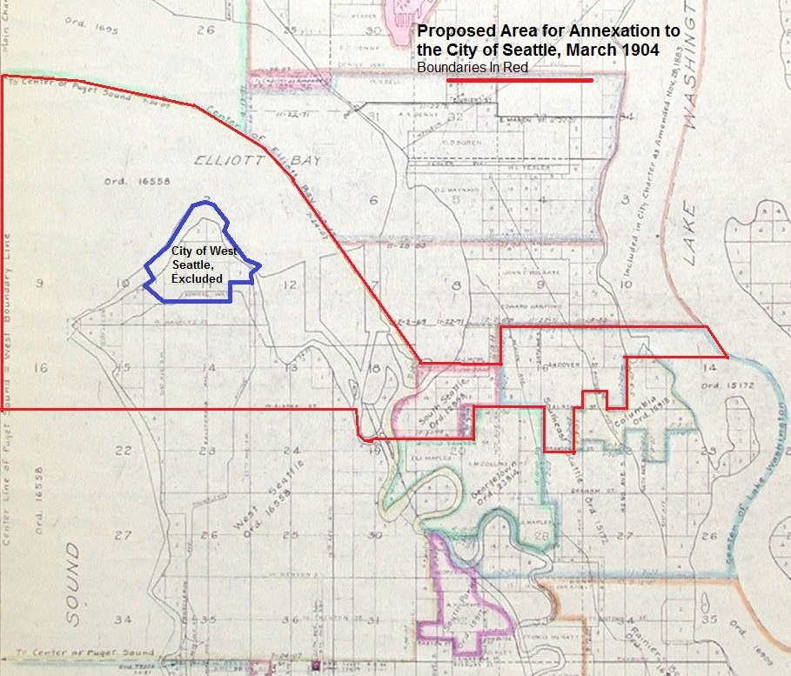
On election night March 8,1904 the open city forces of the City of Seattle were triumphant, with a few exceptions. Annexation by the City of Seattle of Alki, lands on the Duwamish Peninsula east of Alki and north of Alaska Street, and territory south of the then existing City of Seattle on the eastern side of the Duwamish River extending to Lake Washington failed. The proposed annexation area is shown on Map 1 left. Under the then existing state law, a referendum was required to approve the annexation of a territory to an existing and adjacent city. Concurrent majorities of those voting within the existing city and the proposed annexation area were required. The citizens of the City of Seattle voted 12,878 to 2,961 for annexation while those to be annexed vetoed the proposal with 131 for and 176 against. Over the next 39 months there would be numerous attempts to bring Alki and its neighboring communities under municipal governance. Some attempts involved the creation of a new city government. Other attempts sought annexation to an existing municipal authority. Municipal governance proponents were finally successful in June, 1907 when Alki and nearly all the Duwamish Peninsula was annexed to the City of West Seattle. A month later, the newly enlarged West Seattle municipality was consolidated with the City of Seattle.
Map 1
Proposed Southern Suburban Strip Annexation Area
March 1904
Base map from Seattle Municipal Archives, Seattle, WA, Map # 932 found at: http://archives.seattle.gov/digital-collections/index.php/Detail/objects/21288. Annexation area boundaries drawn by author based upon special election notice appearing in the Seattle Star, Seattle, WA, March 4, 1904, page 2 and Seattle Daily Times, Seattle, WA, March 4, 1904, page 18. Note in this map the Duwamish River appears in its natural meandering course prior to its dredging and channelization. Future annexation proposals would define boundaries based upon the River’s meandering course. Also, the City of South Seattle appearing in the annexation area on the eastern shore of the Duwamish River was not incorporated until July, 1905.
Why Municipal Governance?

Alki was a remnant of Seattle’s pioneer legacy. Alki sits six miles across Elliott Bay from the Seattle central business district. Seattle’s founding European – American immigrants took, in November 1851, Alki residence. In search of free land for the taking, these migrants soon relocated across Elliott Bay. Even though free, the territory was perceived as being more promising. They were proven correct. In the process, indigenous people were dispossessed of the land they had long occupied and used for trade, cultural and religious activities and subsistence.
Some of Alki’s first immigrants remained at Alki. Charles Terry and John Low and family remained. John Low and family soon had a change of heart and relocated to Olympia, Washington. Charles Terry continued with his vision of Alki as a grand city originally founded as a namesake of the east coast’s New York City. Terry’s grand vision quickly passed. The struggling community’s name, Town of Alki, or Alki Point, took root. Terrys’ Town of Alki soon failed and, by 1856, was deserted.
After several changes of ownership, in 1868, the Alki estate came into the hands of Hans Martin Hanson, Anna Hanson and Knud Olson. The Hansons, husband and wife, held one half interest while Olson held the remainder. Alki would remain an agricultural backwater until the very beginning of the twentieth century. In 1888 the Hansons and Knud Olson sold the southern end of their holding, consisting of 40 acres, to Nelson Chilberg a Seattle merchant and real estate magnet. This left the Hansons and Olson with a 280-acre estate lying north of today’s SW Spokane Street (then called Smith Avenue) and west of today’s 55th Avenue SW.
Three years after the land sale to Nelson Chilberg, the Hansons and Olson platted (subdivided) their 280-acre estate. Title to individual tracts were divided between the Hansons and Knud Olson. A checkerboard pattern of ownership resulted. (See Map 2 below).

Map 2 – Alki Point Ownership Pattern as of May 1893
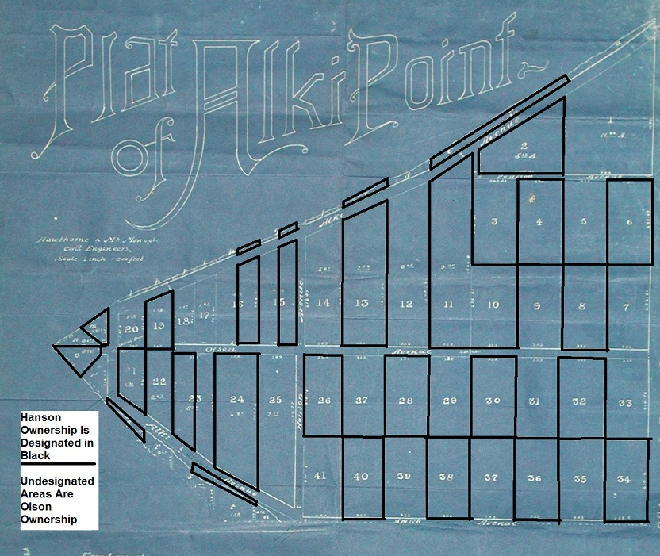
Base map of Plat of Alki Point from Seattle Municipal Archives, Seattle, WA. Ownership information from King County Archives, Seattle, WA, Book of Deeds, Vol 142, p. 14, October 17, 1891, file 86775 and Vol 171, p.154, May 22, 1893, file 114538.
Before their deaths in 1900 and 1901, the Hansons further divided their Alki holding between their five children. Alki would be owned by six individuals who, in turn, sold or held their realty as their desires and income needs required. There was no longer any convenient means of achieving common purpose or control over the former Alki estate. In fact, the Hanson children and their heirs found their interests at odds with one another. The courts would become a forum for their dispute resolution.
Chilberg’s land holding was the beginning, in 1889, of a new residential community giving rise to an increasing demand for urban services and improvements, particularly roads, water and street railways. Chilberg’s community and nearby lands, especially those of his brother Andrew, held in his capacity as president of the Scandinavian-American Bank, would become known as Spring Hill Villa. At times the Chilberg holdings would be referred to as South Alki Point.
Spring Hill Villa and Alki shared the same need to overcome the topographic challenges of steep hillsides, bluffs, grades and limited accessibility to the growing Seattle center. Alki and its neighboring communities would be pulled into Seattle’s urbanization and industrialization orbit. The riches of converting agricultural and timber lands into commercial and housing development parcels would become too good to resist.
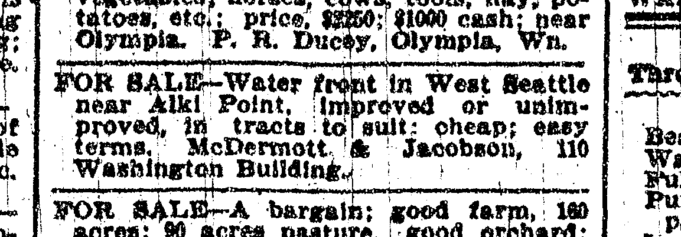
But first, there was a need for public services and improvements--to make a city you need to be a city. A municipal government was required to manage and finance a program of public services and improvements demanded by an urban citizenry and real estate entrepreneurs. This was particularly true in the absence of a common private instrument of control and infrastructure finance. Issues of accessibility had to be addressed. Water and sewer systems, paved roads, street railways, electric power systems, police and fire protection, garbage collection and disposal and schools were on the essentials list to support urbanization and real estate profiteering.
Figure One
Alki Point Real Estate Sale Classified Advertisement - 1897
From: Seattle Daily Times, Seattle, WA, April 7, 1897, page 6, column 4.
Others saw creation of a municipal authority as a method to prevent annexation by an existing city. Inclusion within a city would result in the licensing of alcoholic beverage sales. Conversely, others saw a municipal authority as means to circumvent a quirk in state law which prohibited, at Alki and other Peninsula areas, alcoholic beverage sales.
Opposition to municipal governance was found among timber interests. Frequently, timber remained to be harvested from lands in the urban fringe. Timber interests resisted inclusion within an urban governance jurisdiction and had no current demand for a higher public service level and the concomitate taxation. However, once the timber was harvested, and the growing urban center provided opportunities to profit from land development, these interests reversed their position. Timber interests, whose officers and directors resided as far away as San Francisco, had no vote; they only had the courts.
In the case of an existing city extending its boundaries, advocates sought new areas to share the public costs of support of a central place and public service infrastructure benefiting and serving residents beyond the existing city. These advocates sought to eliminate urban fringe public service “free riders”. This issue was of limited concern in the period in which Alki and its Peninsula neighbors were being eyed for municipal governance. What was important then was the inclusion within a larger municipal body so they would not stand apart from the growing ideal of ‘Greater Seattle’.
Extension of existing municipal service boundaries had the benefit of spreading fixed capital costs over a greater number of public service consumers thereby lowering unit costs. This was particularly significant in the case of the City of Seattle at the turn of the twentieth century. In 1895, the City of Seattle embarked upon a massive (at least for the times) water supply project known as the Cedar River Watershed Project. The project was completed and placed into service in 1901. Auxiliary benefits of the Cedar River Project were the generation of electrical power to supply the city’s electric street lighting infrastructure and enhanced firefighting capacity.
Financing the Project involved an innovative scheme of pledging revenues derived from the sale of water to repay the Project’s construction and periodic interest costs. Heretofore, such a project would have been financed from a pledge of general tax revenue to repay associated costs. In the mid to late 1890’s the City of Seattle had exhausted its ability to borrow and repay from general tax revenues. Financed by traditional means, the City could not legally undertake expansion of the City’s water supply infrastructure of the magnitude of the Cedar River Project.
Pledging revenues from the sale of water to finance the Project was a godsend but it came at a cost. The financing scheme created an enterprise that was compelled, by economic forces of self-sufficiency, to act as if it was a business. The water price charged would have to pay operating, maintenance and past capital costs. Also, price would have to provide a margin to pay “upfront” costs of future system extension and replacement of utility plant as needed. The system needed to promote product consumption and to continually lower its unit costs and price, as any business need do. The sale of water to newly serviced areas was a quick and easy method to promote consumption and system sales. When the Seattle electric generation and distribution business, beginning as an appendage to the Cedar River project, adopted the same financing method as the water system, they too became a public enterprise motivated by private self-sufficiency economics -- promote consumption, spread fixed costs over greater units of consumption enabling lower prices which, in turn, would promote more consumption. A young engineering assistant, George Cotterill, was chief architect of the new Seattle utility finance method.
In the urban fringe, water provision often meant a water supply that could be and was easily contaminated by human and animal wastes. As urbanization of the urban fringe progressed, the probability of waste contamination and the demand for sanitary sewerage disposal and service increased. From a consumer perspective, annexation could mean a reliable water service delivering a clean water supply and enhanced firefighting capabilities.
Utility services were not the exclusive focus of extension of services to the urban fringe. One early annexation advocate cited beneficial use of Seattle’s public library and its ability “to bring the opportunity (good reading) within the (economic) reach of all who care to take advantage”.

When addressing municipal governance, questions of public school attendance and jurisdiction are often overlooked. In the case of Alki and its Duwamish neighbors the questions of municipal governance and public school jurisdiction were inseparable. Annexation, at the turn of the twentieth century, often meant inclusion, for the first time, within a public school district. Annexation advocates, as a benefit of city living, readily pointed to tuition free school attendance and free textbooks.

Residents of areas proposed to be included within a municipal government also had reservations. These persons had taken to their current residence choosing a mix of taxation, politics, public services and land ownership significantly different from that of a municipally governed and urbanized community. Annexation or incorporation would alter their past choice on the premise of a better and, perhaps, unwanted future circumstance. Inclusion within a larger, and possibly more diverse and socially differentiated city, may have meant unwanted social and political association, public regulation and conflict that was avoided by their earlier residential choice. The past lifestyle and political choice of residents made through residential location could be perceived as being upended by a change in municipal governance.

Since 1890, the population of the City of Seattle was doubling every ten years. In 1910 the population reached 188,058 for the boundaries as existing in 1900. The official population count for the city as then constituted was 237,194. Seattle was a hyper-growth region for its time. The surrounding or suburban area was growing as well. The City of Ballard, between 1890 and 1900, grew from 1,173 to 4,568. From a place unworthy of separate population reporting, the Peninsula reported 1,686 persons, in 1900, living at the Peninsula’s north end. The area’s population explosion meant increasing public service and improvement demands.

This hyper-growth gave Seattle’s boosters confidence and a perceived necessity to project itself upon the nation’s stage and consciousness. Following the 1897 Klondike Gold Rush there emerged, early in the first decade of the 1900s, the ideal of ‘Greater Seattle’. Greater Seattle was a localized combination of ‘manifest destiny’, ‘divine right’, and ‘can do attitude’. The Greater Seattle notion had an external face to the nation well demonstrated in the August 11, 1905 forty plus page edition of the Seattle Republican entitled Greater Seattle. This edition was widely distributed and intended for a national audience, at the Portland, Oregon Lewis and Clark Exposition. Given prominence in the issue where the “Greater Seattle Makers” (all men) and their accomplishments. The city’s great opportunities and natural and man-made advantages were placed center stage.
Figure Two
Giving Annexation Meaning

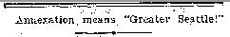
Locally, the Greater Seattle ideal became a rallying cry. Earlier in the year 1905 the Seattle Republican editorialized, “When the suburbs can get the advantages of cheap taxes, cheap light, cheap transportation, cheap heat and cheap power, they will want to be let into the corporation of Seattle (i.e. the City of Seattle). The owning of the public utilities by the city, as stated, is the key to making a greater Seattle out of Seattle, its suburbs and contiguous territory.” The Seattle Star, a competing daily newspaper, characterized the proposed Ballard City annexation and consolidation as being “admitted as part of Greater Seattle”.
From: Seattle Sunday Times, Seattle, WA, July 30, 1905, page 6.

The Greater Seattle ideal was to fuel economic growth and expansion and its success was to be measured by increased population and size ranking among American cities. Increasing Seattle’s standing in the size hierarchy of American cities was the imperative. Annexation was a pathway toward greater national recognition.

Where Will My Children Go to School?

A successful real estate venture requires a scheme of public education needs to be put into place. As every real estate entrepreneur knows, parents ask; ‘where will my children attend school?’.
Figure Three
A West Seattle Homesite Also Buys "Fine Schools"

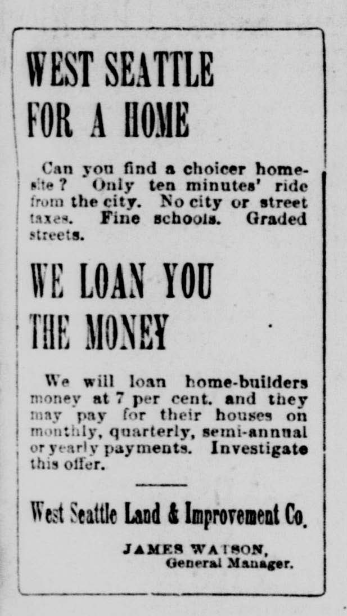
In late 1889, initial plans were laid for establishing a West Seattle school. At an early organizational meeting, $400 was subscribed to build a school house. To this end, Thomas Ewing, president of the West Seattle Land and Improvement Company, pledged “a liberal amount”. It is unknown if the pledge was ever collected.

Early the next year, the Alki, Humphrey (later to take the name Youngstown) and West Seattle communities organized a public school district. West Seattle lay at the far north end of the Duwamish Peninsula. Alki and Youngstown lay on the Peninsula shores to the west and east. Heretofore, children in these communities were not formally educated (at the time, there being no compulsory school attendance requirements), or were taught by their parents or private tutors. If children from these communities attended school, they did so on a tuition paying basis.
The King County Board of Commissioners on February 15, 1890 established School District # 73. The petition to create the District was originally submitted to and heard by V. A. Pusey, King County School Superintendent on November 13, 1889. Superintendent Pusey characterized the territory of the new district as “embracing what is commonly known as West Seattle”. Pusey granted the petition, forwarded it onto the County Commissioners for final action and found that the “territory (of the new district) is entirely outside of any organized school District and the children residing therein are consequently deprived of school privileges”. The West Seattle School District (as formerly known, District # 73) would open the following fall with an enrollment of 73 students. It is not known if the District welcomed the enrollment of indigenous and Asian children. With the organization of the West Seattle School District (hereinafter ‘WSSD’), the Duwamish Peninsula real estate entrepreneurs had eliminated a significant impediment to their enrichment.
From: Seattle Post-Intelligencer, Seattle, WA, April 30, 1893.
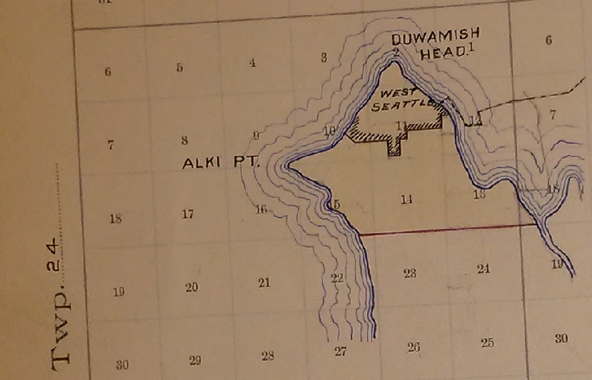
The petition submitted to Superintendent Pusey has likely been lost to history. Under state law existing at the time, the petition to create the WSSD was to be signed by “at least five heads of families residing within the boundaries of the proposed new district……and give the names of all children of school age residing within the boundaries of such proposed new district……”. Pusey’s grant of the petition and the King County Commissioners’ order establishing the WSSD does not state any exception to petitioners’ proposed boundaries. The WSSD’s boundaries were set as “north of the south line of lot Six in Section 18 Township 24N, Range 4E. and north of the south line of sections 13, 14, and 15 in Township 24N, Range 3E”. The boundary map, maintained by the King County School Superintendent, is shown in Map 3 left. The WSSD shared the same southern boundary as the Southern Suburban Strip annexation area west of the Duwamish River (see Map 1 earlier).
Map 3
WSSD Boundaries (District # 73) – February 15, 1890
In today’s landmarks, the WSSD was bounded by Alaska Street SW on the south, the Duwamish River (prior to its dredging and channelization) on the east, and Elliott Bay and Puget Sound on the north and west.
From: School District Boundary Record, King County, Vol. 2, District # 73, Puget Sound Regional Branch, Washington State Archives, Bellevue, WA, Educational Service District 121, Superintendent of Schools King County, PS821-11A-0-310
Though the record does not indicate the source of the name ‘West Seattle’, the name was most likely taken from the subdivision plats and land development activities of the West Seattle Land and Improvement Company and its predecessor. The City of West Seattle would not be founded until twelve years after WSSD’s establishment.
The initial members of the WSSD Board of Directors were A. T. Kasson, T. F. Robertson and C. N. (Charles) Cooper. All were appointed by King County School Superintendent Pusey. The Board held its inaugural meeting Monday, February 17, 1890.
Two future actions of the WSSD would be important in advocacy for municipal governance. The first was the initiation of a high school program. The District began its high school ‘department’ for the 1902 fall school term. The District, with the high school program creation, sponsored a ten-year instructional curriculum. A twelve-year instructional program would not come into being for many years thereafter. For the 1905 fall term, the District began supplying “all textbooks free of cost to all children attending” District schools.
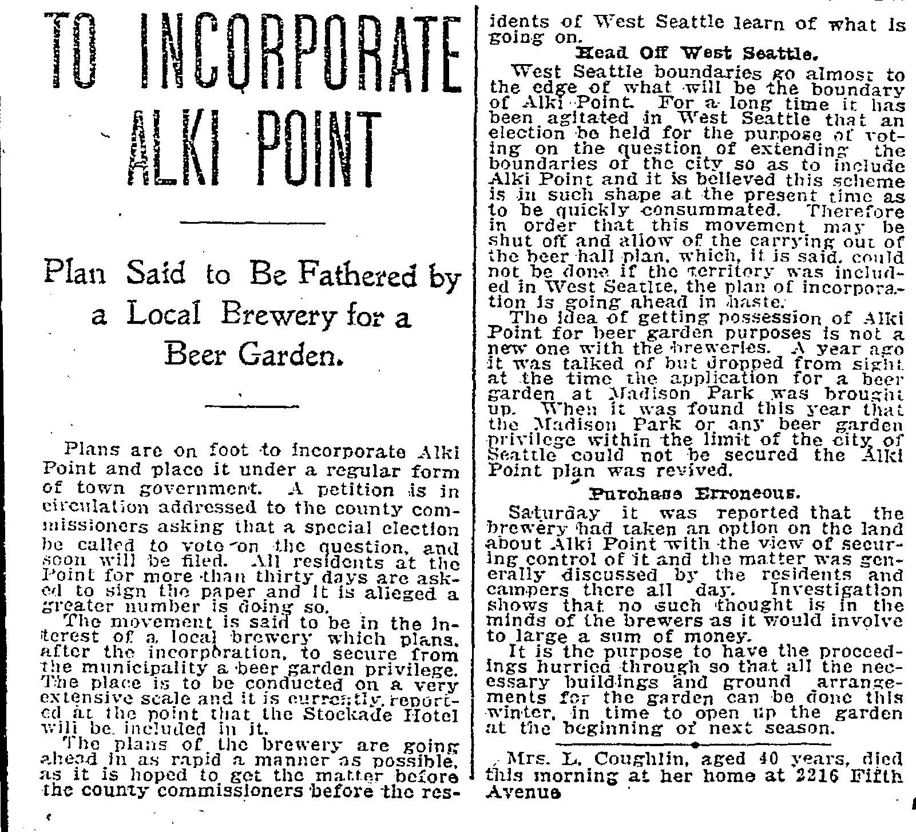
Jurisdictional changes (1890-1908) of the WSSD were to become inseparable from actions to create municipal governance. In the end, the WSSD was eliminated because of the 1907 consolidation of the cities of West Seattle and Seattle. If the 1904 Southern Suburban Strip annexation had been successful, under the state law of the time, the WSSD would have then been consolidated into the Seattle School District.
Figure Four
Seattle Daily Times, June 27, 1904 Report on Alki Proposed Incorporation

Go It Alone, Well Almost

In the early summer of 1904, issues of local governance of Alki, Spring Hill Villa and the Duwamish Peninsula were renewed. Appearing in the Monday afternoon newspaper of June 27th was a report that a local brewery was seeking to establish an Alki Point Beer Garden at or near the Stockade Hotel. This would not be Alki’s first alcoholic beverage vendor. Fifty years previous, Alki hosted two grog shops which closed with Alki’s 1855 desertion.
From: Seattle Daily Times, Seattle, WA, June 27, 1904, Page 3, Column 1.

Nevertheless, this news report set off alarm bells and a call to action by Alki and Spring Hill Villa residents. Licensing of the proposed beer garden could have been provided by a newly created city or by the City of West Seattle if West Seattle annexed the territory of the proposed beer garden location.

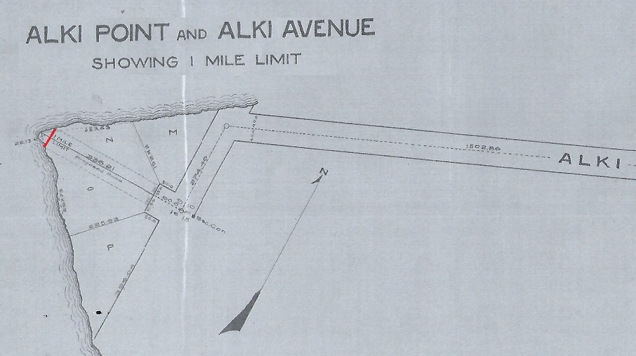
The governance status quo would not have permitted license issuance. A license issued for a location outside a city, under state law, would have to be issued by the Board of County Commissioners. However, the Board of County Commissioners was prohibited from issuing a license within one-mile of the city limits of a city or town. All of Alki, except for the most western 28 feet at the Point itself, was within one mile of the corporate limits of the City of West Seattle. (see Map 4 below.) Those favoring the sale of alcoholic beverages would have to change the status quo. Those opposing beverage sales could not, with assurance, depend upon status quo maintenance.
From: Journal of the County Commissioners, King County Archives, Seattle, WA. Vol 15, page 48, Record Group 011, Liquor License Files, Series 113, Box 2, Item 1310. Survey by F. H. Whitworth, filed with King County Board of Commissioners March 31, 1905 in protest of potential application for a liquor license by the Alki Transportation Company or others. Emphasis added by author.
Map 4
Survey of Alki Point Indicating One Mile Limit, 1905

Records of the King County Commissioners indicate that no application was made during the summer of 1904 for a liquor license at the Stockade Hotel or any other Alki location. The forces opposing licensing however were organized and submitted a petition to the County Commissioners, dated November 22, 1904, opposing a Stockade Hotel liquor license. Petitioners knew their strong hand informing the Commission; “You are aware that the hotel comes within the miles limit, and if a license is granted, proceedings will be instituted at once to have it revoked…..”. Among these petitioners were Percy G. Copp, W. J Blackburn and Al Bender. Soon these three would play an important role in attempting to bring to Alki municipal governance. Other notables signing the petition were Knud Olson, head of one of Alki’s two founding families, J. L Teig, Olson’s son-in-law, Ferdinand Schmitz, Seattle hotel keeper and restaurateur, B. W. Baker, Rose Lodge operator, Max Wardall, prohibitionist and future Seattle City Councilmember, and J Haglund, Alki real estate developer and father of Seattle’s future notorious restauranteur Ivar Haglund.
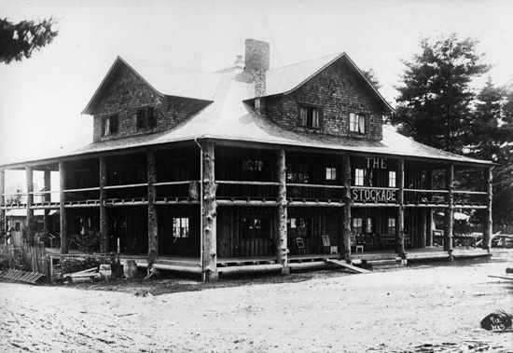
But the status quo did not fully favor Alki’s southern neighbor Spring Hill Villa. The southern reach (generally anything south of today’s SW Oregon and Alaska Streets and a projected line thereof to Puget Sound) of Spring Hill Villa was outside the one mile zone of the then existing West Seattle city limits. Based upon West Seattle annexation plans, then being contemplated, the jurisdiction of the City of West Seattle would have been sufficiently enlarged such that the entire Spring Hill Villa would have been brought into the one mile liquor license prohibition zone. With a sufficiently enlarged West Seattle no license for sale of alcoholic beverages could be issued by the King County Board of Commissioners at any Alki or Spring Hill Villa location, save for Alki’s most western 28 feet.
Figure Five
Stockade Hotel - Alki, Seattle, Washington, circa 1905

Those supporting and opposing alcoholic beverage sales faced a predicament. If the City of West Seattle was successful in annexing sufficient territory, all Alki and Spring Hill Villa would be within the prohibited licensing zone. The brewery and kindred firms would be locked out. This was equally as true for an indoor swimming pool and dance pavilion located on the northern Alki shore neighboring the Point and the 28-foot strip (see Map 4 above). The pool and pavilion were a license hopeful.
From: Log House Museum/Southwest Seattle Historical Society, Accession: 1992.002.0074

To the pro-licensing forces, the only sensible act appeared to be to create a new city. Officials of the new city would be empowered to license alcoholic beverage sales without regard to the one-mile limit. Because anti-licensing forces could not control West Seattle’s annexation outcome, the creation of a new city would seem to be as equally attractive so long as they could control the new city’s licensing policy. Neither “wet” nor “dry” forces could control or depend upon West Seattle’s annexation outcome. For both sides the status quo would have to give way.

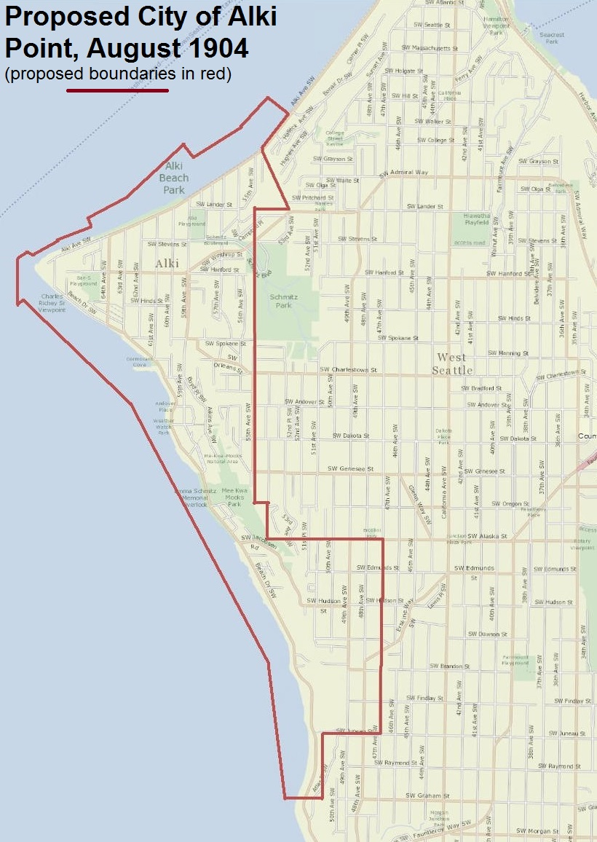
Matters came to a head in the summer of 1904 with petitions to the King County Board of Commissioners to incorporate the City of Alki Point. Concurrently, residents beyond Alki and Spring Hill filed a petition with the City of West Seattle to annex territory east and south of Alki and Spring Hill Villa.
Map 5
Proposed City of Alki Point, August 1904

If the West Seattle annexation succeeded, all Alki (except the most western 28 feet) and Spring Hill Villa would have been within the prohibited one-mile prohibition zone and the “drys” would prevail. But Alki and Spring Hill would have to forego the benefits of municipal governance and local autonomy to prevent liquor licensing with certainty.

If the City of Alki Point was created foregoing the protection of the one-mile prohibition zone, the licensing issue would become a political contest of wills between pro and anti-licensing proponents. If “demon rum” was to be held at bay, the “drys” had to carry the burden of their issue as well as arguing in favor of the necessity of municipal taxation and services. Similarly, the “wets” had to defend the necessity of municipal taxation and services, as well as the rationale for licensing alcoholic beverage service, if they were ever to be able to be granted a liquor license.
From: King County iMap base map is a contemporary mapping of the Alki Point area showing contemporary street network. Boundaries drawn by author from proposed incorporation legal notice meets and bounds description using public land survey system landmarks and then current plats found at Washington State Secretary of State digital archives:
https://www.digitalarchives.wa.gov/Collections/TitleInfo/2067

Anti-licensing forces filed their petition for incorporation of the City of Alki Point on June 30, 1904. As required by state law, the petition was filed with the King County Board of Commissioners. Map 5, above, shows the proposed City of Alki Point jurisdiction. That same day the Board set down the petition for a hearing on July 21, 1904. Final approval by the Board and the holding of a referendum to approve the Alki Point incorporation was to follow in August and September 1904.

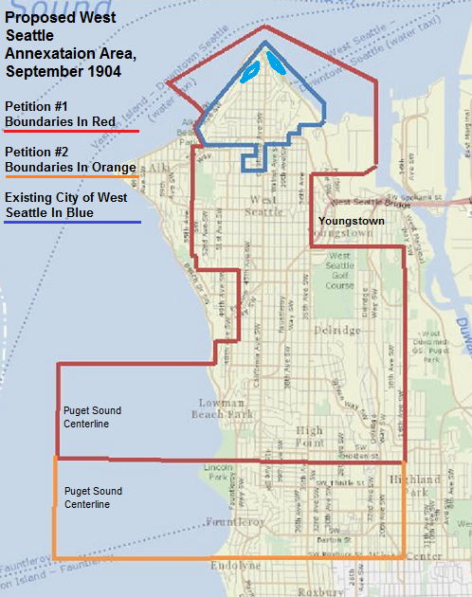
The lead incorporation petitioners were the aforementioned Percy G. Copp, W. J. Blackburn and Albert Bender.
Map 6
Proposed City of West Seattle Annexation Area, September 1904

Meanwhile West Seattle annexation proponents were marshalling their forces and filed, on August 9th, with the City of West Seattle, a petition of Alfred Gould and 39 others to annex the territory east and south of Alki and Spring Hill Villa, north of today’s Kenyon Street and west of 16th Avenue SW except for the Youngstown community in and around the Seattle Steel Mill. The proposed West Seattle annexation territory is shown on Map 6 left .

A second petition was filed August 16th with the City of West Seattle seeking annexation of the same area as that of the earlier petition with the exception that the requested annexation area was extended in a more southerly direction to today’s SW Roxbury Street. This greater proposed annexation area is also shown on Map 6, above. This second petition was signed by G. R. Cooley and 44 others.
From: King County iMap base map is a contemporary mapping of the Alki Point area showing contemporary street network. Boundaries drawn by author from proposed annexation area boundaries recorded in the notice of special election using public land survey system landmarks and then current plats found at Washington State Secretary of State digital archives accessed at: https://www.digitalarchives.wa.gov/Collections/TitleInfo/2067

If the West Seattle annexation initiative passed, the Alki “drys” would have no need for the City of Alki Point for all Alki (substantively) and Spring Hill would have been in the prohibited liquor licensing zone.

The City Council of the City of West Seattle considered the annexation petitions before them, taking no notice that the western boundary of the proposed annexation area was identical to that of the proposed eastern boundary of the City of Alki Point; a matter no doubt intended and evidence of coordination with Alki Point incorporation petitioners. The West Seattle City Council promptly granted the second petition at the same meeting that the petition was presented. The Council called a September 28, 1904 special election to approve or disapprove the proposed annexation.

A majority vote within the existing City as well as the area to be annexed was required. However, the inclusion of territory on the eastern edge of the annexation area, south of Youngstown, between today’s 34th and 16th Avenues SW, and belonging to the Puget Mill Company, would result in a denial of petitioner’s aspirations.

The exclusion of the Youngstown community, located in the Peninsula’s northeast quadrant, was a deliberate act to eliminate annexation opposition.

As future events would show, West Seattle annexation boundaries were often gerrymandered to exclude properties and residents known to oppose inclusion within the city. In the case of the Youngstown area (see Map 6 above) there were two economic interests excluded; the Youngstown saloon keepers and the Seattle Steel Mill and lands owned by its founder William Piggott. The Youngstown saloon keepers feared increased liquor license fees or outright license denial. The Seattle Steel Mill and its founder feared municipal taxation.

But matters were not going well for the City of Alki Point incorporation petitioners. Records of the hearings held by the Board and news reports are unavailable. Of the 82 incorporation petitioners only the three lead petitioners are known. The presumed anti-liquor license stance is taken from the appearance in the November 1904 liquor protest petition of the lead petitioners. No record of the hearing to be held July 21st exists and the Journal of the Board indicates that the incorporation petition was filed a second time on August 4, 1904 and set for a hearing on August 11th. On August 11th the Board took the incorporation matter under advisement once again. According to the Commissioners’ Journal of Proceedings the incorporation petition was refiled, yet again, on September 1st. A hearing was scheduled for September 22nd and was later continued to the day after the West Seattle annexation special election scheduled for September 28th. At the request of the incorporation petitioners, the hearing was continued until October 6th, a week after West Seattle’s special election results were to be known. The October 6th hearing was then continued until the 27th. On October 27, the Alki Point incorporation matter, at the petitioners’ request, was indefinitely postponed. When the October 27th hearing was postponed results of the West Seattle annexation election, held a month earlier, were still officially unknown.

Why the incorporation petitioners sought continuing delay of the Board’s consideration of their petition probably lies in the “officially” unknown September 28th West Seattle annexation election results. The election ballots had yet to be canvassed and official voting results announced. The Puget Mill Company sought the involvement of the King County Superior Court on the Saturday after the Wednesday election to prevent canvassing and reporting of votes cast in the annexation referendum. This left Alki incorporation petitioners hanging on the hooks of West Seattle annexation uncertainty.

Some of The Parties Agree to Settle. Popular Sovereignty Is Cast Aside.

On October 1st, Judge W. R. Bell granted the Puget Mill Company’s request to prohibit the West Seattle annexation election vote canvass and reporting scheduled for Monday morning October 3, 1904. The consequence of Bell’s order was that the September 28th election results would never be officially known. In granting the order halting the official reporting of election results, the court relied upon the Company’s complaint and supporting affidavits. There is no record of any opportunity for the defendants to object, to offer opposing arguments or to rebut the Company’s allegations.

Unofficially, the required concurrent majorities approved, at the voting polls, the proposed annexation. So long as election results were unofficial, the Puget Mill Company could prevent enlargement of the West Seattle city boundaries and inclusion of their lands within the West Seattle municipality.

In King County Superior Court, the Puget Mill Company alleged that:

- The company owned lands included in the annexation area were “wild, unimproved and unsettled” and “distant from the City of West Seattle”,
- It was highly impractical for the city to “open streets, extend electric lights, street railways, water, sewer pipes” and for the annexation area “to receive police and fire protection” due to remoteness of the annexation area from the pre-existing city and the topographic challenges of steep ridges, slopes and hillsides characterizing the annexation area,
- The census taken to support promotion of the City of West Seattle from the fourth class to the third class was faulty in that it included temporary residents residing on the shore and beach front and therefore the City of West Seattle failed the minimum population size test for a city of the third class (the required population was 1,500 persons, the census enumerated 1,549),
- The City of West Seattle did not permit inspection of papers and records pertaining to the local census of population and there were procedural irregularities in holding the referendum to approve the promotion of the city from the fourth to the third class,
- The annexation petition submitted to the West Seattle City Council was deficient in the required number of signers,
- The annexation area was gerrymandered to exclude settled land to the west (Alki Point and Spring Hill Villa) and to include “wild, broken, unimproved lands, sparsely covered with timber and almost wholly destitute of any population”,
- The notice of the special election was insufficient and was not properly published in a newspaper of local publication and distribution,
- The Company would be subject to unlawful, unequal and unjust taxation and that such taxation would be “without receiving any benefit whatever”,
- The inclusion of Company owned lands in the annexation area would create “a cloud on the title” to the Company owned lands, and
- The annexation and the underlying statue authorizing the annexation process was unconstitutional under the constitution of the State of Washington.

The Puget Mill Company, in their court action, asserted that the City of West Seattle had improperly promoted itself from a city of the fourth class to that of the third class. This was a significant allegation in that a city of the fourth class was prohibited from having a jurisdiction greater than one square mile in area and that the jurisdiction of a city of the fourth class could not contain more than 20 acres of un-platted (subdivided) lands belonging to any single person without that person’s consent. At the time of the September 1904 annexation election the City of West Seattle was bumping up against the maximum size restriction and the Puget Mill Company’s land holdings were un-platted and greatly exceeded 20 acres. The Puget Mill Company had not consented to inclusion of its land holdings into any municipal authority. If the City of West Seattle was found to be a city of the fourth class, upon procedural errors, then the annexation proposal and all future similar measures would fail as a matter of law. The City would have to repeat, with uncertain outcome, procedures to promote the city from the fourth to third class. This was the dagger repeatedly pointed, in recurring judicial contests, at the heart of the City’s annexation policy.

At the time that the Company’s requested order prohibiting the City of West Seattle from canvassing the vote cast was granted, a further hearing was scheduled for Thursday October 6, 1904.

At the October 6th hearing the West Seattle Land and Improvement Company (hereinafter ‘WSL&ICo’) joined the litigation, parroting and reciting the Puget Sound Company’s original complaint. The WSL&ICo was a significant Peninsula land owner and operator of the West Seattle-Seattle ferry. Seemingly the Company would have no objection to enlarging the boundaries of the City of West Seattle given that the Company was a long time West Seattle real estate promoter and entrepreneur. The City of West Seattle’s public improvements program facilitated real estate sales.

Easily overlooked was a provision in the annexation boundary specification that would have annexed three unincorporated enclaves within the City of West Seattle. These enclaves resulted from previous litigation and court orders surrounding the original 1902 West Seattle incorporation. The enclaves were located on the bluffs and steep hillsides above the Duwamish Head (the most northern point of the Duwamish Peninsula), had existed since the original 1902 West Seattle incorporation and were referred to as the West Seattle Reservations. These enclaves would have been annexed to the City by defining all that territory within the annexation boundaries shown on Map 6 above (in red and orange), except the then existing City of West Seattle as subject to the annexation referendum. Since the enclaves were within the annexation area, outside the existing City of West Seattle and contiguous to the City of West Seattle they were subject to the proposed annexation. This disturbed the previous truce between WSL&ICo and the City of West Seattle dating from West Seattle’s original incorporation. WSL&ICo would have none of that.

At the October 6th hearing and in ensuing months the presiding judge W. R. Bell (Bell’s term of office would expire prior to the conclusion of the case) was unmoved to permit the City of West Seattle to officially canvas and count the September 28th vote. The annexation proposal was held in suspension. It was as though the annexation special election had never been held. So long as the West Seattle annexation election results were officially unknown, the governance status quo of Alki and Spring Hill Villa held.

In the absence of any licensing threat to the southern reaches of Spring Hill Villa there was no incentive to move forward with the City of Alki Point incorporation and beg the question of the prudence of municipal taxation and pubic services. But the “wets” needed to upset the status quo if there was ever to be any hope of licensing Alki alcoholic beverage sales. Those advocating for improved public services shared the necessity of the “wets” to upset the governance status quo.

Rather than having potential judicial constraints placed on action by the City of West Seattle, the City Council agreed to settle the Puget Mill Company matter. Settlement was announced Thursday, February 9, 1905 with an agreement that the votes of the September 1904 election would never be counted and canvassed. With Judge A. W. Frater’s assent, no one would ever know ‘officially’ if the proposed annexation was approved or disapproved. In other words, the election’s ballot box containing the requisite concurrent majorities was to be ignored. The settlement maintained the prerogative of the West Seattle City Council and those they represented to move forward with the city’s annexation program. For annexation area residents, other than the malcontent Puget Mill Company, their popular sovereignty would have to await another day. No one represented annexation area residents. No one demanded that every vote be counted. But the City of West Seattle was prepared to give them a quick ‘do over’. West Seattle would come to regret the decision not to stand with the annexation area voters and defend the ballot box victory.

All other matters raised by the Puget Mill Company were forgotten except by plaintiffs in future judicial challenges to extension of municipal governance to Alki and the Duwamish Peninsula.

One unresolved claim stands out and reaches into the heart of municipal governance -- at what moment is it appropriate for a municipal government to incorporate the urban fringe? State law of the time did not specify any criteria or standard governing the definition and eligibility of an area for inclusion within a municipal boundary other than territorial adjacency and contiguousness. Guidance on the degree of the required urbanization, if any, then or in a defined time horizon, for incorporation of wild, unimproved and unsettled lands into a municipal governance structure was not provided. In state law, questions of the practicality and efficacy of municipal governance, service provision and improvements were not addressed. Similarly, no standard was set on the viability and appropriateness of a new city creation.

Subjecting annexation and incorporation to approval by the voters, in an election, would suggest that the Legislature deemed the questions of municipal appropriateness best answered by affected residents voting. The Puget Mill Company thought otherwise, arguing in favor of a judge’s discretion and judgment over that of the voters. Litigation over annexation and incorporation on the Duwamish Peninsula would never be decided based on annexation or incorporation merits. Procedural issues would prevail. In the end the merits of municipal governance would be a voters’ determination. But Judge John B. Yakey, in future litigation, would see ‘irreparable’ harm to those opposing annexation and incorporation. He supported their position by effectively cancelling duly called and scheduled elections. Annexation and incorporation proponents never had the opportunity to present to Yakey a contrary view.

The West Seattle School District Takes A Hit – Youngstown Wants A School All Its Own
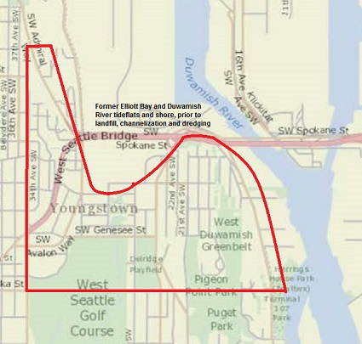
On December 28, 1904 the King County School Superintendent entered into the School District Boundary Record, “Following territory transferred from School District # 73 to form new District #151: Lot 1 of Section 12-24-3 and all of fractional Sec. 13 Twp 24 R3, also lots 6 and 7 in Sec 18 Twp 24 R4”. The effect of this boundary change was to create School District #151, commonly known as the Youngstown School District (hereinafter ‘YSD’).The territory in question was the eastern territory of the WSSD adjoining the Duwamish River and Elliott Bay tide flats. This area was known as Humphrey (later known as Youngstown or Pigeon Point) and was home to the recently established Seattle Steel Mill (also called Seattle Steel Company). The construction and opening of the Seattle Steel Mill prompted significant housing development in the mill’s environs.
Map 7
Territory Removed from WSSD to Create YSD (District # 151) - December 28, 1904
It should be noted that YSD’s boundaries reflect Elliott Bay and Duwamish River shorelines prior to the Elliott Bay tide flats being filled-in and the Duwamish River channelized and dredged. Map 7, left shows the area removed, in the context of a contemporary map, from the WSSD in creation of the new YSD.
In contemporary landmarks, the area transferred from the WSSD to YSD was bounded by 34th Avenue SW on the west, Alaska Street SW on the south, an eastern projection of Stevens Street SW on the north and a meandering line along the Elliott Bay and Duwamish River, as it then existed, to an eastern projection of Alaska Street SW terminating on the Duwamish shoreline at Herrings House Park.
Map drawn by author based upon School District Boundary Record, King County, Vol. 2, District # 73, Puget Sound Regional Branch, Washington State Archives, Bellevue, WA, Educational Service District 121, Superintendent of Schools King County, PS821-11A-0-310. Base map from King County iMap.

Map 8, below, shows the boundaries of the WSSD after YSD creation.
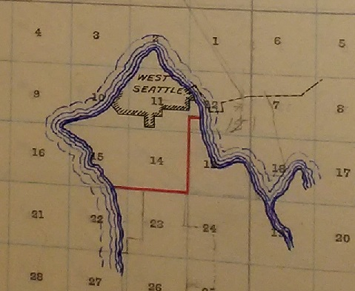
The motivations for YSD creation are not entirely clear. They probably lie in an effort by the Seattle Steel Mill to minimize taxation of its physical assets. The City of West Seattle policy of annexation, in the period 1904-1906, excluded the Seattle Steel Mill and properties owned by its founder William Pigott. The Seattle Steel Mill feared higher municipal taxation. From the Steel Mill’s perspective municipal governance and its taxation was optional, but a school district serving the surrounding residential community was necessary. The early business plan of the Mill; “proposed to secure a large acreage for a townsite, which will necessarily grow up around an institution of this kind, which will certainly bring in its train many other manufacturing industries…”. One or more schools serving this new town would contribute to the town’s success. The Seattle Steel Mill, as a charitable endeavor, was instrumental in construction of YSD’s first school house. Management of the educational taxation burden was the Mill’s probable objective. Creation of a ‘captive’ school district would facilitate this objective. With a captive school district, the Mill could influence school costs drivers such as the number of grades offered and length of the school term. Being outside an incorporated city or town permitted a minimum three-month school term. Location within a city, such as West Seattle, required a term of “at least six months each year.”
From: School District Boundary Record, King County, Vol. 2, District # 73, Puget Sound Regional Branch, Washington State Archives, Bellevue, WA, Educational Service District 121, Superintendent of Schools King County, PS821-11A-0-310
Map 8
WSSD Boundaries (District # 73) – December 28, 1904
From a resident’s perspective, a school district providing a nearby school implied greater convenience in transporting students to and from school. At the time there were no direct roads from the Youngstown neighborhood to the West Seattle school on the hilltop overlooking the community. Travel to the West Seattle school occurred via a roundabout trip along the Duwamish shoreline to the ferry dock and street car transit to the school house, or a long walk up a steep slope and hillside. A Youngstown school implied shorter travel time, less parental supervision for the school commute, and/or avoidance of a round trip street car fare.

Another matter that should not be overlooked is the role of potential social class differences between the Youngstown and West Seattle student bodies. Youngstown would be a town largely populated by mill hand and laborer families. West Seattle was a commuting suburb populated by families headed by white collar and mercantile workers of an urban center. Social class differences may well have driven the two communities apart.

Spring Hill Villa Wants A School Too

A year after YSD creation, growth on the Duwamish Peninsula south of Alki in the Spring Hill Villa area gave rise to enlargement of WSSD’s jurisdiction. On December 20, 1905 the King County School Superintendent prescribed an area to be added to the WSSD jurisdiction. In contemporary landmarks this area was bounded by SW Alaska Street and a projection of Alaska Street west to Puget Sound on the north, 47th Avenue SW on the east, SW Juneau Street on the south and Puget Sound on the west, plus a panhandle on the south along Beach Drive SW north of SW Graham Street. This area was substantively the same as that area joined to Alki for various annexation proposals and/or municipal incorporation attempts taking place in 1904-1907 (see Map 5 above for example).
Map 9
WSSD (District #73) Jurisdiction and Boundaries December 20, 1905
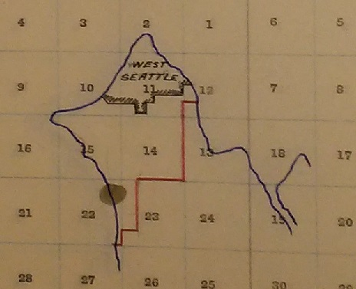
A map of the newly enlarged WSSD is shown in Map 9 left. The enlargement of the District’s boundaries would have taken place under the then existing state law, requiring a petition of a majority of heads of families residing in the area to be added. This petition also appears to be lost to history. Simultaneous with the inclusion of the Spring Hill Villa community into the WSSD there were various attempts, to incorporate or annex to a pre-existing city the Spring Hill community for municipal governance purposes. These efforts would extend over the next two years. But for the moment, and for the first time, public education opportunities were extended to Spring Hill Villa.
From: School District Boundary Record, King County, Vol. 2, District # 73, Puget Sound Regional Branch, Washington State Archives, Bellevue, WA, Educational Service District 121, Superintendent of Schools King County, PS821-11A-0-310.
A New Foe Arises

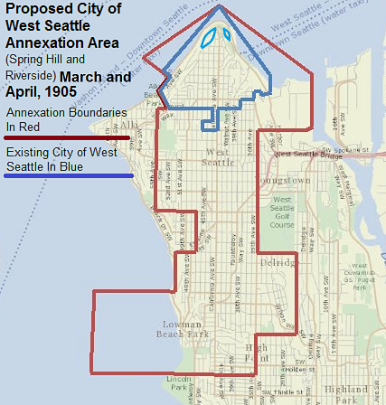
On the Monday following the Puget Mill Company settlement (February 13, 1905), an annexation petition by U. R. Niesz and 100 others was filed and granted by the West Seattle City Council. That petition sought annexation of an area identical to that subject to the earlier September 28th referendum, except the land holdings of the Puget Mill Company and the area between today’s Kenyon Street SW and Roxbury Street SW were excluded (see Map 10 left, as compared to Map 6 above). The City of West Seattle and its annexation allies had agreed to exclude rather than fight the Company. The Puget Mill Company was probably aware of this possible annexation area at the time of the earlier litigation settlement. Court records do not indicate any annexation area understanding. The West Seattle Reservation enclaves were also excluded from the territory proposed to be annexed. The proposed annexation area continued the earlier practice of exclusion of the Youngstown community and the Seattle Steel Mill property.
Map 10
City of West Seattle Annexation Area, March and April 1905
Base Map from King County iMap GIS, boundaries drawn by author as set forth in City of West Seattle Minutes, February 13 and March 22, 1905, Seattle Municipal Archives, Seattle, WA

The City of West Seattle had, once again, excluded hostile corporate interests to minimize opposition to its annexation program. This would not be the last time that the City of West Seattle conformed itself to corporate interests to resolve opposition to its annexation program. This annexation referendum was scheduled for March 18, 1905.

As will be noted later in greater detail, in the year following the initial 1902 West Seattle incorporation, public debate over a scheme to merge West Seattle into the City of Seattle arose. This was driven by envy of a higher level of public service and improvements existing in Seattle and the potential for a prevailing lower West Seattle tax burden. Merging West Seattle into the City of Seattle was predicated upon achieving adjacency and contiguousness between the two cities. The annexation that voters were asked to approve at the March 1905 election would have created a new West Seattle city jurisdiction that lacked any adjacency to the City of Seattle. The earlier September 1904 annexation attempt shared this characteristic. By continuing to eliminate Youngstown and now the Puget Mill Company properties, the City of West Seattle was even further removed from potential annexation to and consolidation with Seattle.

Failure to achieve territorial adjacency to Seattle may or may not have been a factor contributing to annexation success at this time, but it would later prove key. At this time, street railway issues were paramount.

The City of West Seattle was reputed to be the first to build and operate a municipally owned street railway. A week after the annexation petition was granted and the required election was scheduled, the West Seattle City Council passed a resolution setting forth an intended program of street railway expansion to serve the proposed annexation area. The street railway was to be extended southerly with a terminus at Lincoln Beach (now named Lowman Beach Park). This extension would have provided hourly service for nearly the length of the Duwamish Peninsula and coordinated arrivals and departures with the West Seattle – Seattle ferry.

West Seattle was anxious to get the street railway extension underway. The railway had been placed in service on December 28, 1904 and proved to be a significant financial drain. In the course of the earlier Puget Mill Company litigation, the West Seattle attorney informed the court, by a January 24, 1905 affidavit, that;

“….. at the present time said railway system is not taking in sufficient revenues from fares and freight to offset the cost of operation; but that said system is daily running behind from $7 to $10. That all such deficit in the operation of said system must be made up out of the Current Expense fund of said city……(and) that the corporate limits of said city would be enlarged and additional territory included therein, and that thereafter said street car system extended in order to open up and tap an extensive territory to the south of said city, thereby increasing the revenues of said system and putting the same on a sound financial basis.”

During the first months of operation of the street railway, the financial performance of the system was even worse than that stated by the West Seattle attorney as shown in Table II below:
Table II - West Seattle Municipal Railway Financial Performance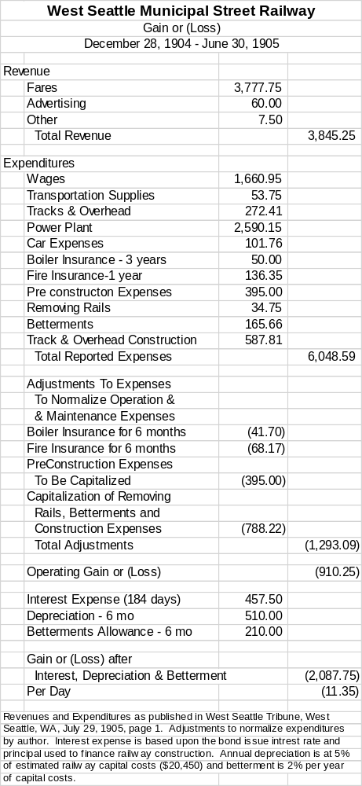

In future months and years matters would not materially improve. The citizens of West Seattle would be compelled to address the street car’s cost and benefit. The railway’s financial burden would be seen by a Seattle citizen as an aid to elimination of detested ‘municipal ownership’. Preventing extension of the West Seattle street railway would not only arrest the spread of the municipal ownership disease but would also accentuate the railway’s financial burden.

Meanwhile, Alki stood aside of this annexation attempt. But the issue of street railways would soon compel reexamination of Alki’s municipal governance.

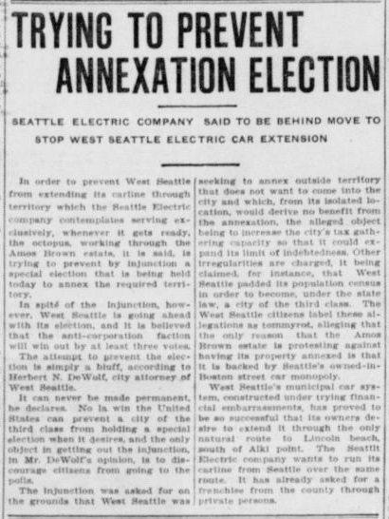
Proving that there is no substitute for turning out the vote, the March 1905 referendum election failed on a 4-4 tie vote.
Figure Six
Opposition to Annexation

At the meeting of the West Seattle City Council, immediately following the election failing to approve the annexation on a tie vote, a new petition was presented seeking annexation of the same area to the city. The vote was scheduled for Saturday, April 22nd. But during the run-up to the referendum, the opposition of the Seattle Electric Company (‘SECo’) to annexation enabling extension of the West Seattle municipally owned street railway was heard. The SECo president was Seattle citizen Jacob Furth.

The root of the SECo opposition lies in the first ever meeting of the West Seattle council held May 6, 1902 just days after the city’s incorporation. At that meeting, West Seattle received applications for both street railway and electric lighting franchises. These franchises would have permitted applicants to construct, maintain, and operate over the city’s streets and other rights of way, street railway and electrical generation, transmission and distribution systems. Such franchises were particularly valuable in an era before mass automobile ownership and at the dawn of the transition from animal and steam power to electrical power. Though Jacob Furth did not apply at that initial council meeting, he did apply, in his name, in February 1903. He was granted a street railway franchise on March 3, 1903. While other franchise applicants came and went, languished or were denied, Furth’s application was promptly approved by a unanimous city council vote.
From: Seattle Star, Seattle, WA. April 22, 1905, page 7.

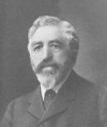
But Furth dragged his feet in fulfilling his obligations to construct and operate a street railway system along California Avenue connecting the West Seattle ferry dock and the West Seattle community on the highlands and ridgeline above the Duwamish Head. Railway extension to the east across Elliott Bay to connect with the Seattle street railway system was promised. The granted franchise secured a commitment to a single nickel fare for travel within West Seattle and to Seattle. Furth contracted to place into service his street railway within a year. As the year was coming to an end, Furth sought a time extension. Councilmembers Cunningham, Ayton, and Davis said no, while their colleagues deNeuf and Coles supported the extension. Upon denial of the time extension, the city passed a resolution to revoke Furth’s street railway franchise for failure to perform and declared his $2000 security deposit forfeited. Councilmembers aligned themselves on the motion to revoke the franchise as they did to deny a time extension.
From: Clarence Bagley, History of Seattle from the Earliest Settlement to the Present Time, Volume 2, 1916.
Figure Seven - Jacob Furth, circa 1910

Furth’s representative (SECo General Manager Grant) in the month following the original franchise award suggested that construction would get underway when permission from the War Department was secured to cross the Duwamish River and Elliott Bay tide flats. Surviving records of the War Department’s Army Corp of Engineers do not indicate that SECo or its principals ever made application for permission to cross the River and Bay, nor do they indicate permission approval or denial. Moreover, the records of King County, Washington, fail to indicate a necessary SECo franchise application, in this period, for crossing over unincorporated territory between Seattle and West Seattle. Furth and SECo were marching in place.

Revoking the Furth franchise brought West Seattle no closer to meeting the needs and conveniences that a street railway would offer. Overcoming the steep slopes, hillsides and grades separating the ferry dock and the highlands 375 feet above was a near necessity for residents and real estate developers alike in a pre-automobile era. The City took matters in its own hands when it acted upon a request of the West Seattle Improvement Club to engage an engineer to prepare plans and estimates for “building (a) street railway up the hill”. Street railway passengers would forgo direct service to Seattle, in favor of a Seattle-West Seattle Ferry transfer.

At the Council’s first meeting in April 1904, the Council received a report on plans and costs for a street railway and proceeded to call a special election to authorized incurring debt to finance street railway construction. The railway was to be city “owned and controlled”. The special election required 60% of those voting to approve the financing. Also, the special election sought voter approval of the street railway plans and specifications. At the May 3, 1904 special election, 61% of voters approved incurring the necessary railway construction debt while 58% approved railway plans and specifications. The City of West Seattle was in the street railway business. As the new year turned the West Seattle railway was placed into service.

The reasons Furth failed to perform, in accordance with his franchise grant, probably lies with his Seattle street railway activities which he saw as more pressing and important. Furth was the Seattle agent of the nationwide public utility holding company Stone & Webster. Furth exercised his agency as president of Stone & Webster’s Seattle Electric Company (‘SECo’). As Stone & Webster’s agent, he began to assemble under one ownership Seattle’s twenty-two street railways. The Seattle street railways were a hodge-podge of individual operations driven more by real estate development and speculation objectives than public convenience and service. Furth placed the Seattle street railways under single private ownership. The railway consolidation effort began in 1900 and lasted through 1903. At this point, significant investment was made in rebuilding the railways so that they could operate as a unified system. Then Furth turned his attention to ‘employee relation’ matters.

Furth was known as an anti-labor employer who broke the street railway carmen’s union in favor of a docile company dominated union. Furth, under the cover of an organization called Citizens Alliance, turned to his fellow Seattle capitalists to break unions across the city. Furth and SECo earned the unending enmity of Seattle’s labor community. But SECo’s critics, outside of labor, fearing the excesses of monopoly, high rates and poor service began to be heard. As 1905 ended, labor and SECo’s critics merged into a ‘Committee of 100’ advocating municipal ownership of the Seattle street railways. In the end, Furth retained his Seattle railway franchise and achieved labor peace on his terms. Many years later, SECo’s street railways would become a publicly owned enterprise.

In agreeing to a one-year term for completion of the West Seattle street railway, Furth probably had no intention of complying with such a requirement. The absence of documentation permitting the crossing of Elliott Bay and Duwamish River demonstrates Furth’s intent. Seattle matters had greater priority.

But Furth’s ire was raised by the upstart West Seattleites sponsoring a scheme of municipal ownership, a matter he was battling and would prove victorious over in his Seattle hometown just a few miles across Elliott Bay. The West Seattle operation had originally been his until taken away by municipal ownership advocates. Furth seized an opportunity to recover his West Seattle street railway and, as an extra bonus, an electric lighting franchise. Annexation was an opportunity to obstruct and frustrate West Seattleites until he got his street railway back.

At the April 1905 election the annexation area voters approved annexation, 13-10. West Seattle city voters, as anticipated, approved 48-6. As matters then stood it appeared that extension of the West Seattle street railway, notwithstanding Jacob Furth, was now a mere formality and Alki (save the last 28 feet at the tip of the Point) and Spring Hill Villa would be included within the one-mile liquor license prohibition zone. But at the King County courthouse, in downtown Seattle, others saw matters differently.

A Second Courthouse Cruise, With an Extended Stay at The State Supreme Court

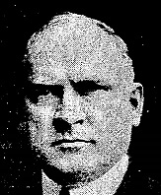
On the Friday before the Saturday annexation vote, some four weeks after the City Council voted to hold the annexation referendum and four weeks of public notice, the Estate of Amos Brown sought judicial intervention into the election process. Less than 24 hours prior to the opening of the voting polls, the Amos Brown Estate sought to halt the annexation election. Visiting Kitsap County Superior Court Judge John B. Yakey, sitting at the King County Superior Court, issued an order in favor of the Estate prohibiting the West Seattle City Council from holding the next day’s election. This would not be the last time Judge Yakey would frustrate those seeking to extend municipal governance.
Figure Eight - Judge John B. Yakey, 1905

The Estate’s complaint before the court was nearly identical to that of the earlier Puget Mill Company pleading. Nothing substantively new was offered. Once again, the dagger pointed at the heart of the City of West Seattle’s annexation policy was the procedures followed in promotion of the city to a city of the third class and an alleged failure to pass a test of the efficacy and appropriateness of municipal governance in the newly annexed territory. This time there would be no settlement nor resolution of the question of the efficacy and appropriateness of the West Seattle’s annexation policy.
From: Seattle Daily Times, Seattle, WA, March 5, 1905

The West Seattle City Council went forward with the April 22nd election. The Council would later assert that they had had no notice nor service of the Estate’s complaint or knowledge of the April 21st order restraining the Council from holding the scheduled election. There is no indication, in the case record, that the City of West Seattle was afforded, at this time, an opportunity to defend itself and rebut arguments put forward by the Estate in support of its requested order effectively cancelling the April 22nd election.

The City Council and its members were later accused and found guilty of contempt of court.

Voting results of the contested election were canvassed and certified on April 24, 1905. The City received on May 22, 1905 a certificate dated April 24,1905 from the Washington Secretary of State giving official notice of the annexation and the City of West Seattle enlarged its boundaries consistent with the annexation proposal. After the vote canvas, judicial pugilism between the City and the Amos Brown Estate ensued.

On February 15, 1906, nearly ten months after election day, the King County trial court found that the annexation election was “null and void” and that the City of West Seattle was properly promoted to a city of the third class. Merits of the contested annexation were not addressed. Presiding Judge Arthur Griffin enjoined West Seattle officials “from taking any step to levy or collect any special or general taxes for any purposes whatsoever from, off, or upon the lands of the plaintiff described ….. or the other lands described in the notice calling said special election ….”.

Everyone was left in something of a logic wasteland – if the election was null and void how could the city levy a tax on property in the annexation area? By singling out only the authority to tax, did Judge Griffin mean to imply that the City could do all things, including extending the municipal street railway, that a city could do, except tax? Also, Judge Griffin failed to notice, or it was not called to his attention, that the City had held a general election the proceeding December in which a member of the City Council residing in the contested annexation area was elected and that residents of the contested annexation area voted.

Eventually, upon appeal, the Washington Supreme Court made its voice heard and addressed two questions:

- Was the legal notice of the April 22, 1905 special election sufficient, and
- Holding aside the “propriety or legality” of Judge Yakey’s restraining “order made so short a time before the election”, did the making and issuance of the restraining order “have a tendency to prevent a full, free and fair expression of the voters and was the result probably affected by these matters”?

The Washington Supreme Court determined that legal notice of the election was sufficient. On the latter question, the Court agreed with the trial court that, considering the potential public confusion over election processes created by the holding of the annexation election when officials had been restrained from doing so, that the election was “null and void”. Washington’s highest court did not address questions of the annexation’s merits. As future events would show, the court’s implied rebuke of Yakey, in suggesting a question of propriety or legality, went unheeded.

The Duwamish Peninsula had returned, on June 29, 1906, by decree of the Washington Supreme Court, to the municipal governance status quo.

Judge Griffin’s Logic Wasteland Has A Silver Lining

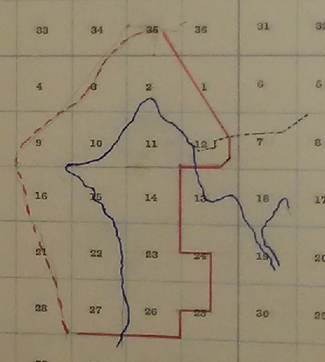
The apparent success of the April, 1905 West Seattle annexation election required the King County School Superintendent to adjust school district boundaries accordingly. By operation of state law, the boundaries of the WSSD were required to be extended to be at least coterminous with that of the newly enlarged City of West Seattle.
Map 11
WSSD Jurisdiction
Late 1905 or Early 1906
The WSSD’s boundaries could be and were larger than those of the City of West Seattle. Hence, Alki and Spring Hill Villa areas could remain within the WSSD but outside the City of West Seattle. The resulting new WSSD jurisdiction, subsequent to the April 1905 annexation election, is shown in Map 11 left. The exact date that the King County School Superintendent recorded this boundary change is unclear but would have been no earlier than the Spring Hill Villa addition to the District on December 20, 1905. The Superintendent stated that the change was “made by extension of limits of West Seattle”.
From: School District Boundary Record, King County, Vol. 2, District # 73, Puget Sound Regional Branch, Washington State Archives, Bellevue, WA, Educational Service District 121, Superintendent of Schools King County, PS821-11A-0-310. WSSD boundaries in red.
The hesitation of the Superintendent to record the changes in District boundaries, by operation of law lies, no doubt, in the litigation surrounding the April, 1905 annexation. Immediately after the 1905 election results were certified and the City of West Seattle extended its municipal boundaries, the Amos Brown Estate litigation continued. Final resolution of the Brown litigation did not take place until June 29, 1906.
In the interim, sometime after December 20, 1905 and before final judicial resolution of the annexation matter, the Superintendent recorded the WSSD’s jurisdictional enlargement. It should be noted that the King County Superintendent and WSSD were not parties to the Brown Estate litigation. They acted as if the annexation was in effect or, at a minimum, the only thing restrained by Judge Griffin’s order was the levy and collection of West Seattle municipal taxation. School taxation was another matter.
After the Washington Supreme Court’s June 1906 ruling, with the City of West Seattle losing the annexation challenge, the records of the County School Superintendent do not reflect any reversionary adjustment to the WSSD boundaries. The effect of the annexation election was to enlarge the WSSD jurisdiction but not that of the City of West Seattle. The WSSD jurisdictional enlargement went unquestioned. In contemporary landmarks the area added to the School District lies north of Kenyon Street SW and SW Myrtle Street, south of SW Alaska Street, east of the Spring Hill Villa area and west of 24th and 36th Avenue SW. It should be recalled, that the boundaries on the east and south, resulting from annexation, were an intentional gerrymandering to exclude timberlands and properties, east of the district boundary and west of the Duwamish River owned by the Puget Mill Company and the Youngstown community and steel mill.
Like the addition of the Spring Hill Villa community, enlargement of the WSSD to encompass the annexation area south and east of the City of West Seattle (see Map10 above), brought a system of common schools and educational opportunities, for the first time, to the affected areas.
But WSSD jurisdictional matters would not rest there.

Alki Needs a Street Car, and the Bathers, Dancers and Stockade Hotel Needs a Liquor License

A.A. Smith and J. H. Allen, in February, 1905 made application to the West Seattle City Council for a street railway franchise. The proposed railway would run from the West Seattle Ferry towards Alki. A. A. Smith was the son-in-law of the now deceased Hansons, former owners of half of the Alki estate. At the turn of the century, Smith and his wife Lorena, developed the Stockade Hotel. Charles O’Bryan leased and operated the Hotel and made substantial physical improvements. Street car service from the Ferry dock to Alki proper would greatly improve Hotel access from the Seattle center, via the West Seattle Ferry. Similarly, Alki residents would greatly benefit. But Alki remained outside of the jurisdiction of the City of West Seattle. As such the City could not extend service to or grant a franchise to serve the Alki community. If Alki were annexed to West Seattle, under the City’s banner, street car service could be extended to the residential-beachside community.

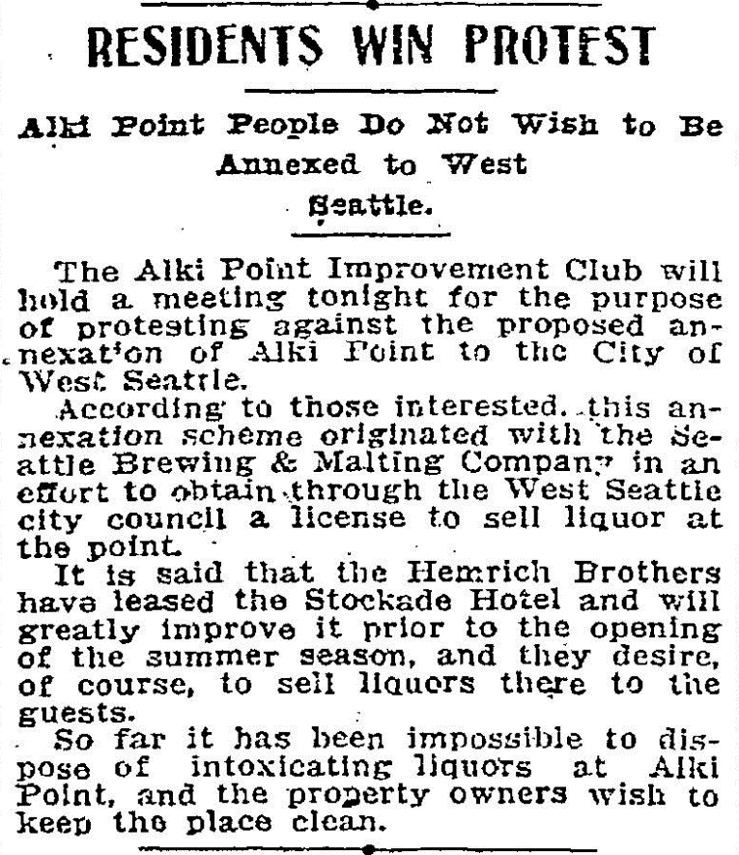
Early that same month, under the leadership of the Alki Point Improvement Club, Alki residents began organizing to protest Alki annexation to West Seattle. Residents were responding to news that an annexation scheme “originated with the Seattle Brewing & Malting Company” and that liquor licensing at the Stockade Hotel was soon to follow. At the far end of Alki Point, the Alki Point Transportation Company began making plans to open a bath house and dancing pavilion. Summer 1905 would be the bath house and pavilion’s inaugural season. The Alki residents feared that the Transportation Company would apply and be granted a liquor license for the 28-foot strip outside the one-mile exclusionary zone neighboring the bath house. (See Map 4 earlier). The community organized and, in protest, petitioned the King County Board of Commissioners. A summer 1905 liquor license application for the 28-foot strip failed to materialize. But there would be licensing trouble ahead.
Figure Nine
Alki Improvement Club Organizes to Protest West Seattle Annexation

In the meantime, the City of West Seattle held its March and April 1905 annexation elections that excluded Alki and its immediate environs. Pending disposition of the Amos Brown Estate litigation, the people of Alki, once again considered their fate and public service needs. It appeared that Alki could not have its street car and remain “dry”. No action was ever taken on the Smith-Allen railway franchise application.
From: Seattle Daily Times, Seattle, WA, February 9, 1905, page 4.

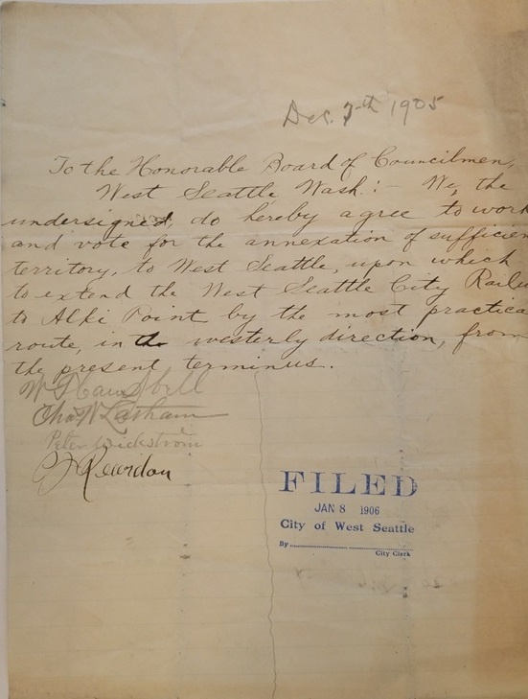
On June 19, 1905 the Seattle Times brought unwelcome news to Alki’s liquor opponents; O’Bryan was retiring and sold his Stockade Hotel interest to beer baron Louis Hemrich. O’Bryan operated the Stockade until the summer of 1905. As the 1905 summer began to end, the Alki Point Improvement Company, the new operators of the Stockade Hotel, located in the heart of Alki at today’s 63th Avenue SW and Alki Avenue SW, made a liquor license application. The application was by Alvin Hemrich, president of the Seattle Brewing and Malting Company and brother of Louis Hemrich. The application was promptly rejected three days later August 8, 1905.
Figure Ten - Petition to the City of West Seattle for Annexation

December 1905 brought renewed effort to settle Alki’s municipal governance question. On the 7th of that month, W. T. Campbell, Charles W. Latham, Peter Wickstrom and C J Reardon petitioned the West Seattle Council stating that they “agree to work and vote for the annexation of sufficient territory to West Seattle, upon which to extend the West Seattle City Railway to Alki Point…..”.

On January 22, 1906, the West Seattle City Council received a petition seeking annexation of Alki.
From: Seattle Municipal Archives, City of Seattle, City of West Seattle City Clerk’s Files, Box 3 Container 27 Petitions, Alterations of City Boundaries.
The proposed annexation area is shown in Map 12 below. A special election was scheduled for February 24, 1906.
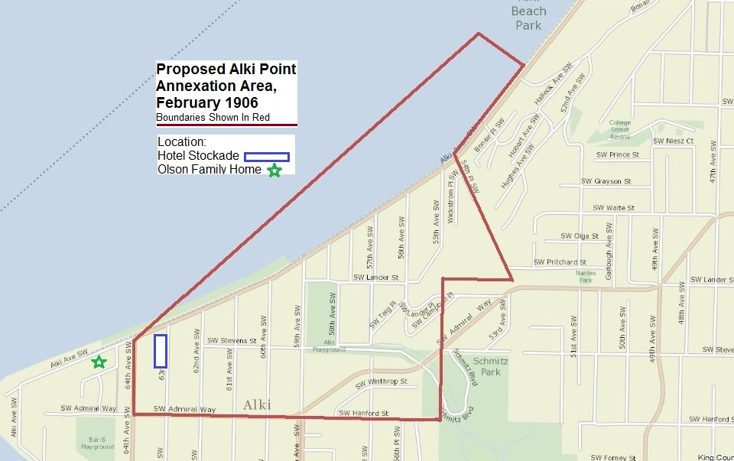
Map 12 Alki Point Annexation Area, February 1906

Base Map from King County iMap GIS, boundaries drawn by author as set forth in City of West Seattle Minutes, January 22, 1906, Seattle Municipal Archives, Seattle, WA.

Unlike the earlier City of Alki Point incorporation attempt, the defined Alki annexation area was much truncated (compare Map 12 above to Map 5 earlier). This newly defined area was west of the then existing City of West Seattle, east of today’s 64th Avenue SW and north of Admiral Way. The rejiggered boundaries included the Stockade Hotel but excluded the Point and the home of Knud Olson, head of one of the two Alki estate families.

If this annexation were to be approved all Alki, except that part annexed to West Seattle, would have been brought into the one-mile liquor license prohibition zone and the southern reaches of the Spring Hill Villa community would remain outside the license prohibition zone. But the City of West Seattle could issue licenses within the newly annexed area. The Stockade Hotel would become eligible to receive a liquor license but the bath house and dance hall located at the extreme end of Alki would remain ineligible. To the “drys” the 28-foot irritant would be no longer. With annexation as contemplated by the City of West Seattle, extension of the municipally owned street railway providing service to the Alki community was possible. But the possibility of liquor licensing at the Stockade would have to be accepted. It appeared that the Alki community could not have street car convenience without some potential liquor licensing. The Stockade Hotel stood to profit from a positive resolution of both issues.

Alki’s voters rejected the annexation on a vote of 2 – 20. West Seattle voters approved 54-2. The municipal governance status quo remained, awaiting resolution of the Amos Brown Estate litigation.

Within days, annexation opponents initiated an incorporation scheme like the earlier City of Alki Point proposal, to end the “trouble experienced by certain hostelry proprietors in securing licenses for the sale of liquor.” Nothing more was heard of this scheme. Attention would turn, after the late June 1906 final adjudication of the Amos Brown Estate litigation, to municipal governance of the entire Duwamish Peninsula, including the Alki and Spring Hill Villa communities. There would be one last effort to license the Stockade Hotel.

The Saloons Hold Firm, The Puget Mill Company Has Nothing to Fear and Furth Gets His Way

For the forthcoming 1906 summer season, Louis Hemrich made an application for a Stockade Hotel liquor license. The County Commissioners, well-educated in the opposition of Alki residents to liquor licensing, denied the March 14, 1906 application. The Commissioners noted; “Less than ¾ of mile from West Seattle Limits”. The Alki “drys” were feeling confident. This application was the last heard of alcoholic beverage service at Alki until prohibition repeal. But Alki’s municipal governance fate was now in the hands of the “wets” and Jacob Furth.

Two weeks after the Stockade Hotel was denied its liquor license, members of the West Seattle City Council were feeling the economic pinch of the municipal street railway. A resolution was introduced at the March 26, 1906 council meeting resolving:

“that, after a full investigation of the operation and maintenance of said street railway and electric light works ……. (the City Council) has ascertained that the said street railway line and electric light works cannot be operated by such City of West Seattle so as to repay the cost and expense of operation and interest on the capital invested therein and the necessary and continuous depreciation thereof and the same is and threatens to become a burdensome charge upon the tax payers of the said City of West Seattle.”

The proposed resolution then laid out a program of sale of the street railway assets, subject to approval of the city’s voters, and a measure for an interim operating lease. Clay Allen was the prospective purchaser and lessee. Ordinances granting necessary franchises to authorize the street railway sale and lease were also introduced. Neither the resolution nor ordinances were enacted. At the same council meeting a package of ordinances granting street railway and electric plant franchises, directing sale of the city street railway, and leasing the West Seattle Ferry slip at Louisiana Street to A.B.C. Denniston were introduced. The Denniston ordinance package was never enacted and the underlying franchise applications were withdrawn in late August. Jacob Furth and the SECo would be more successful than Allen and Denniston.

SECo made application for a West Seattle street railway franchise a month later April 23rd. On May 14th the application was referred to Council committee. Six weeks later, on June 29, 1906 the Washington Supreme Court issued its Amos Brown Estate decision upholding Yakey’s effective cancellation of the annexation election held the previous year. West Seattle was returned to being a jurisdiction of a little less than one square mile located at the north end of the Duwamish Peninsula, but a city of the third class free to undertake its annexation program. Jacob Furth won the first round designed to frustrate and obstruct West Seattle’s annexation program. Furth’s franchise application set in motion events leading to a mutual accommodation.

What Furth wanted was street railway and electric utility franchises and the elimination of municipal ownership. What West Seattle wanted was elimination of opposition to the annexation program, operation of a railway “up the hill” and relief from the continuing railway operating deficit. Both were about to get what they wanted.

SECo and Furth were granted, by the West Seattle burg, on July 23rd, a street railway franchise. Three weeks later SECo accepted the offered franchise. Meanwhile, the West Seattle municipal street railway continued in operation from the West Seattle ferry dock to the hill top above, nearly one mile away. The fare box failed to cover costs at the rate of $12 per day (see: Appendix B).

The August 27, 1906 West Seattle City Council meeting was an eventful one:

- Mayor Emil deNeuf resigned,
- Ordinance # 152 was enacted calling a special election to approve or disapprove annexation by the City of West Seattle of the area shown on Map 13 following, and
- Ordinance # 153 was enacted authorizing sale of the West Seattle municipal street railway to SECo for $30,000 subject to an election approving the railway’s sale.

Both elections were set for October 6th. The annexation election would require concurrent majorities of West Seattle voters and annexation area voters. The election approving the railway’s sale would require a majority of West Seattle voters. The set of elections represented substantial policy changes. Some saw the two items as companions. Others saw the policy changes as severable from one another.

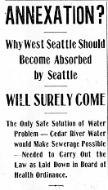
Just over a year after the initial incorporation (April, 1902) of the City of West Seattle, as described earlier, a public debate over the advisability of annexing West Seattle to its Seattle neighbor across the Bay emerged. The debate was led by John Bushell, Sr in the columns of the local newspaper, the West Seattle News. The paper’s editor was John Bushell, Jr. Over a five-week period, Bushell outlined the advantages of annexation to Seattle including Cedar River water, a rapid advance in real estate values, improved drainage, sewerage and fire protection, free use of the Seattle public library, tuition free attendance at the Seattle High School, free textbooks (the West Seattle Schools had not yet adopted a free textbook program), parks development, and spreading the future costs of West Seattle improvements over a larger Seattle tax base. To the credit of the News editor, annexation opponents were given access, but not comparable, to the paper’s pages as well. The opponents emphasized loss of local autonomy and control and cast doubts upon the practicality of Seattle, from afar, meeting West Seattle needs. News reports of the activities of the West Seattle Improvement Club in support of annexation to the City of Seattle were given prominent coverage. News coverage of the annexation movement of West Seattle to Seattle appears to have concluded with the following June 19, 1903 report:
From: West Seattle News, West Seattle, WA Page 1, May 15, 1903, accession # 2003.20.28.

“A committee of five, consisting of Mr. Geo. B. Nicoll, John Bushell, Sr., A. L. Kasson, A. D. Andrews and Herbert N. DeWolfe, was appointed to interview the Seattle Council and obtain their views upon the question of annexing our town to Seattle. The committee is to call another meeting of citizens when ready to report.”

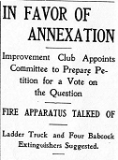
Documentation of the Seattle Council interview has not survived. But it would have been remiss if it had not noted that state law required in any annexation by one city of another, or consolidation, that cities must be adjacent and contiguous to one another. West Seattle and Seattle failed that test. If West Seattle was to surrender itself to Seattle it would first be necessary to enlarge one or both cities such that they shared a common border. At this point, based upon future events, annexation to Seattle, as an immediate objective, was deferred.
From: West Seattle News, West Seattle, WA Page 1, May 15, 1903, accession # 2003.20.28

While awaiting the outcome of the Southern Suburban Strip annexation proposal, West Seattle embarked upon a modest annexation (March, 1904) to increase the city’s population, in preparation for a potential promotion of the city from the fourth class to the third class. If the Southern Suburban Strip annexation had succeeded, West Seattle would have achieved boundary adjacency with the City of Seattle and met the requirements for annexation and consolidation with Seattle (see Map 1). This annexation and consolidation would have been subject to West Seattle voter approval. The Strip proposal failed and any consolidation discussion with Seattle was moot. At this point, West Seattle undertook its modest effort to enlarge its boundaries and population in keeping with fourth-class city requirements. With the completion of this effort, the city was ready to take the next step to promote West Seattle to a city of the third class. With this promotion, the city would be free of the limitation upon its jurisdiction size of not more than one square mile. Unless freed of this size limitation it would not be possible to achieve Seattle adjacency and contiguousness.

Up to this point no West Seattle annexation proposal achieved Seattle adjacency and contiguousness. The proposal to be voted upon October 6, 1906 would be the first. This proposal indicates a shift in West Seattle annexation objectives and an embrace of the 1903 Bushell position.

As shown in Map 13 below, the proposed annexation area included the Duwamish Peninsula north of today’s SW Roxbury Street and west of the Town of South Park and Duwamish River. Annexation success would mean that West Seattle’s jurisdiction would be enlarged to include Alki, Spring Hill Villa and Youngstown.

Map 13
Proposed Annexation Area to The City of West Seattle,
October 1906 and May 1907 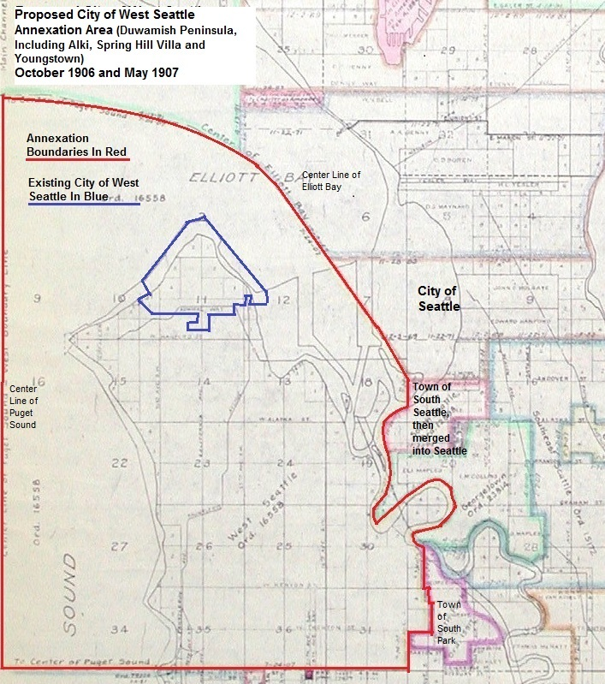
Basemap from City of Seattle, Seattle Municipal Archives, Map # 932. Boundaries drawn by author based upon Proposed Annexation by the City of West Seattle, Notice of Special Election, The West Seattle Tribune, West Seattle, WA, September 6, 1906, page 1. The Town of South Park was merged into the City of Seattle May 1907 prior to the May 1907 West Seattle annexation election.

The proposed annexation area stretched northward to the waters and tide flats of the Elliott Bay centerline. The Bay centerline was the Seattle City boundary. Adjacency and contiguousness were achieved along the Duwamish River at the western boarder of the former City of South Seattle. South Seattle was consolidated, in January 1905, with Seattle. The West Seattle Reservations, Puget Mill Company and Youngstown community, including the Seattle Steel Mill were included in the territory to be annexed. The October 1906 proposal represented the first time that Youngstown was proposed to be annexed to West Seattle. Its inclusion was an integral part of achieving Seattle adjacency and contiguousness.

The grant to SECo of a street railway franchise was only half of Furth’s desire. He also sought to eliminate municipal ownership and its potential competition. At the October 6th election, the West Seattle citizenry was to determine the fate of their railway. Would it be possible that the city could have the convenience of transit “up the hill” at no further public cost? Under municipal ownership, railway extensions south and west of the city had been requested and planned, but never executed. The Alki street car was only a dream. Since West Seattle did not have the financial wherewithal and legal authority, perhaps privatization could deliver improved street car service. Voters were being asked to overlook Furth’s earlier failure to perform.
Figure Eleven - George F. Cotterill - 1912
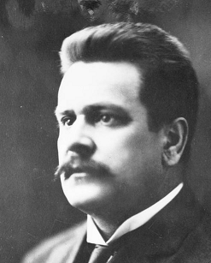
In the week before the annexation election, Seattle officials, Mayor Moore and City Engineer R. H Thompson fanned out over the Peninsula, making appearances in favor of annexation and joining Greater Seattle. Issues of provision of Cedar River water were a major topic. On the day before election day, George Cotterill, City Engineer Thompson and Seattle Times editor A. J. Blethen appeared before a West Seattle audience. Cotterill at that time was a private citizen and a long-standing member of the Seattle Chamber of Commerce Special Committee on Annexation. Blethen and Thompson urged the West Seattleites onward toward annexation with Blethen suggesting the many “blessings ….” to those coming in “under the protection of the Greater Seattle”. Cotterill suggested the same but differed from both Blethen and Thompson. Cotterill urged the audience to vote ‘no’ on the sale of the street railway. Thompson was silent and Blethen suggested that Cotterill’s municipal ownership theories be repudiated as they had been in the past. Cotterill was not to have his way the next day on any issue.
From: Seattle Municipal Archives, Seattle, WA

West Seattle voters approved the railway sale to SECo, 115-62.

In keeping with past outcomes, the citizens of West Seattle proper also approved the proposed annexation, 163-13. The annexation area’s Spring Hill precinct voted 22-2 to approve with Alki passing the measure, 52-36. Fears of “demon rum” were set aside, or at least, tempered in favor of municipal governance benefits and advantages. The potential for West Seattle franchised street railway service or the implied promise of admission to Greater Seattle played a significant role. But Youngstown was another story. The Youngstown vote of 44 in favor to 134 against, when added to that of Spring Hill and Alki resulted in an overall annexation area disapproval vote. The vote total was 118-172. The overwhelming Youngstown ‘no’ vote represented 46% of the total annexation area vote and 78% of the total ‘no’ vote. Youngstown clearly saw things differently from its neighbors.

The October 6th election was the first time that Youngstown voter sentiment was tested. Future events would demonstrate that the Youngstown saloon interests were blamed for the annexation’s defeat. The next test of voter sentiment, seven months hence, would take place under significantly different circumstances. In the interim, paperwork to conclude the sale of the street railway to the Furth interests moved forward. On February 1st of the next year, King County awarded SECo the necessary franchises to cross unincorporated jurisdictions necessary to transit Elliott Bay to Seattle, south toward Lincoln Beach and west along the Peninsula to Alki. Furth had good reason to show progress toward street railway development pending final purchase of the municipal railway – he wanted a West Seattle electric utility franchise.

Go Big!

The failed October 1906 West Seattle annexation election resulted in continuation of the governance status quo. The question of municipal governance of Alki and the Duwamish Peninsula, outside the City of West Seattle, seemed no closer to resolution than it had been two years earlier. But there were growing voices from existing incorporated areas south and north of Seattle to consolidate with the City of Seattle. This movement was so strong that new incorporated places were formed for the purpose of consolidating with Seattle.

North of Seattle, the City of Ballard, incorporated 1890, petitioned to have their city annexed and consolidated into the City of Seattle. The first attempt of the Ballard annexationists / consolidationists failed but the issue returned to the table in late 1906. The new Town of Ravenna, incorporated October 11, 1906, petitioned the Seattle City Council for annexation and consolidation. Ravenna’s brief existence would end, becoming part of the City of Seattle, on January 15, 1907, 96 days after its incorporation.

South of Seattle, in the area known as the Southern Suburban Strip, which had been subject to the failed March 1904 annexation referendum, two cities were incorporated. The first was the City of South Seattle which came into being July 13, 1905 and then promptly petitioned for annexation / consolidation with the City of Seattle. Effective October 20, 1905 South Seattle was merged into Seattle. South Seattle had a short existence of three months. The City of Southeast Seattle began its public service mission July 2, 1906 and six months later, on January 7, 1907, passed its assets and liabilities onto its successor Seattle.

Two somewhat older municipal governments, the Town of South Park and City of Columbia, began the process of annexation and consolidation in late 1906 and completed their mergers with Seattle on May 3, 1907.

All these consolidation efforts were facilitated by a 1903 change in state law. Authored by state senator Ritchey M. Kinnear. This amendment to state law authorized any city of the third or fourth class, subject to approval of a majority of the city’s voters, to petition for annexation / consolidation by and with a city of the first class (i.e. Seattle) if both cities were adjacent and contiguous to one another. The annexation / consolidation could be made effective by a vote of the city council of the first-class city eliminating the necessity of voter approval of the annexation / consolidation in the larger acquiring city.
Figure Twelve - Washington C. Rutter, 1891
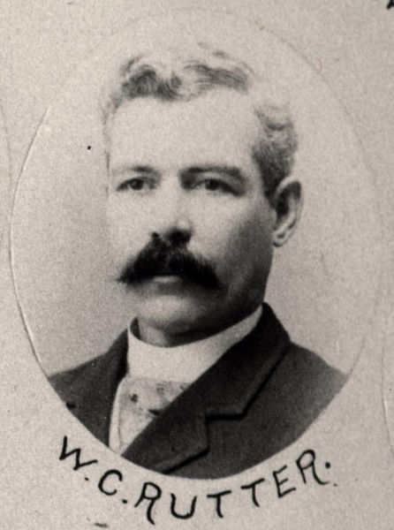
Observing the successful efforts of first incorporating a new city and then consolidating with the City of Seattle, those favoring Alki and Duwamish Peninsula municipal governance would try a new tactic; they would go big. But first they would have to overcome the opposition of Washington C. Rutter who served as a proxy for West Seattle’s annexation nemesis the Puget Mill Company.

Rutter lived on twenty acres just west of the Town of South Park. Originally from Kittaning, Pennsylvania he made his way west while in his teens. He was employed as President of the Kittanning Copper Mining Company of Index, Washington. He operated, in downtown Seattle, a general insurance agency. Michael S. (M.S.) Drew conducted a real estate sales business out of the offices of Rutter’s agency. M. S. Drew would correspond with Cyrus Walker of the Puget Mill Company utilizing Rutter Insurance Agency letterhead. In the 1890s, Rutter employed Fred Drew. Fred Drew handled, on behalf of the Rutter Agency, the insurance business of the brothers William and Cyrus Walker; Puget Mill Company managers and proprietors. Fred Drew, originally from Port Gamble, Washington, home of the Puget Mill Company, was the son of M. S. Drew. M.S. Drew was the Puget Mill Company’s Port Gamble lumber mill manager. M.S. Drew, representing Kitsap County, and Rutter, representing King County, served together as members of the Washington State Legislature in 1889-90. After leaving the Rutter Insurance Agency, Fred Drew was appointed the Puget Mill Company’s Land and Logging Agent. He also headed the Fred Drew Investment Company. The scale of investment into the Fred Drew Investment Company by the Puget Mill Company is unknown but the Investment Company was managed in the offices of the Puget Mill Company. Correspondence of the Drew Company was written on the letterhead of the Puget Mill Company. The Drew Company had a significant land holding on the Duwamish Peninsula but not nearly as large as that of the Puget Mill Company. Given the associations, it was most likely Fred Drew who, prevailed upon Rutter to assist the Mill Company in bringing its next judicial challenge to Alki and Duwamish Peninsula municipal governance. The legal action was in Rutter’s name but was intended to serve Puget Mill Company interests. Rutter would attempt to cancel the upcoming incorporation election.
From: State of Washington, Senate, 1891 / Rogers / State Senate Group Photos, 1881-1993, Washington State Archives, Digital Archives, accessed at: https://commons.wikimedia.org/wiki/File:WCRutter.jpg
Figure Thirteen
Alki-Rainier to Incorporate and Then Annex to Seattle
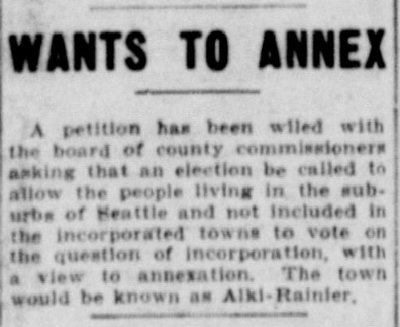
Appearing in the October 9, 1906 edition of the Seattle Star was a brief news report stating a “petition has been filed (with the King County Board of Commissioners) to vote on the question of incorporation with a view to annexation. The town would be known as Alki-Rainier”. This report appeared the same day the Town of Ravenna voted to incorporate. The Alki-Rainier petition had been filed the day before. The petitioners appeared to be emulating the Ravenna process.

The County Commissioners held hearings on the proposed Alki-Rainier incorporation November 8th and November 30th. At the December 13th meeting of the Board, the Board granted the incorporation petition and called an election for January 5, 1907 to approve or disapprove the proposed new City of Alki-Rainier. The election’s eligible voters would be those residing within the proposed city’s jurisdiction. A majority of those voting would be required to give Alki-Rainier its municipal life. Four days later, the Board changed the date of the scheduled election to Saturday, January 19, 1907 to comply, apparently, with the required minimum legal notice and advertising period. The proposed jurisdiction of the City of Alki-Rainier is shown in Map 14 below.
From: Seattle Star, Seattle, WA. October 9, 1906, page 1.
Map 14 - Proposed Boundaries of the City of Alki-Rainier, December, 1906
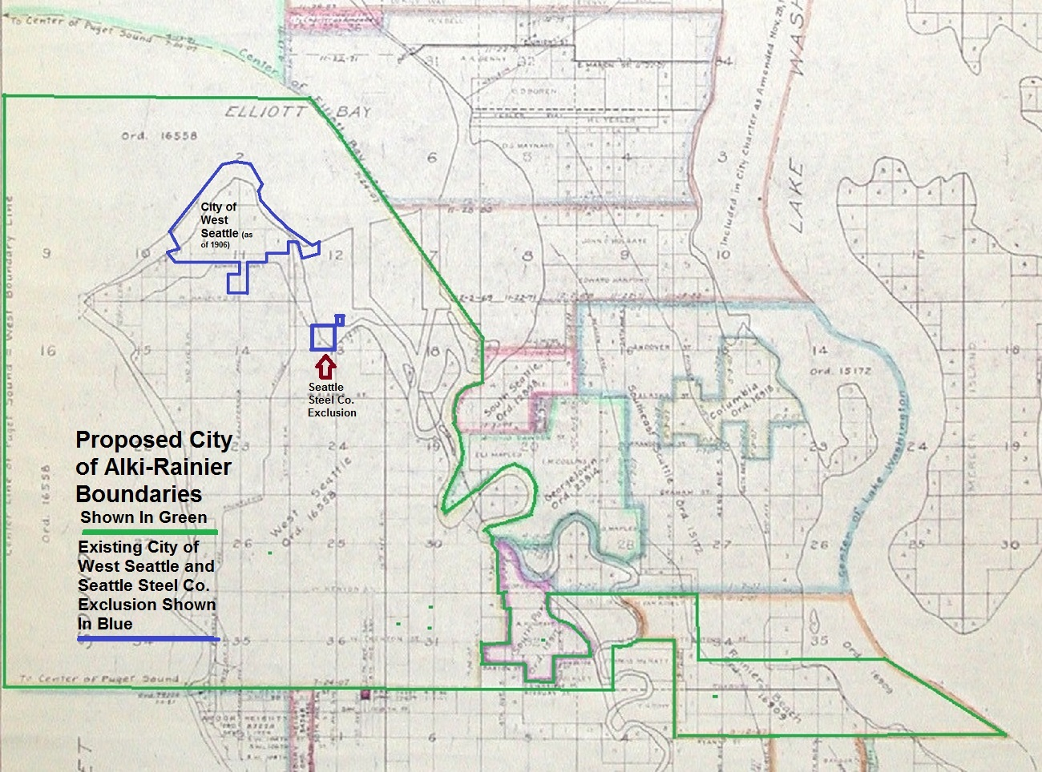
Basemap from City of Seattle, Seattle Municipal Archives, Map # 932. Boundaries drawn by author based upon Proposed Incorporation of the City of Alki-Rainier, Notice of Election, West Seattle Tribune, West Seattle, WA, January 5, 1906 (sic corrected date of publication is January 5, 1907), pages 3 and 6.

The Alki-Rainier boundaries encompassed Alki and all the Duwamish Peninsula, north of today’s SW Roxbury Street and west of the free flowing and meandering Duwamish River excepting the existing cities of West Seattle and South Park. In addition, a strip of land east of the Duwamish River stretching to the Lake Washington centerline was included within the proposed new city. This strip, shaped somewhat like a ‘shoe’, was known and is known today as Rainier Beach and Beacon Hill. To the north and west, on the Peninsula, the new city’s boundaries were defined as the centerlines of Puget Sound and Elliott Bay. These boundaries were carefully crafted to achieve adjacency to the City of Seattle whose jurisdiction ended at the Elliott Bay centerline and along the Duwamish River eastern shore which was previously the western limit of the old City of South Seattle. South Seattle had previously (January 1905) been merged into the City of Seattle. Like the October 1906 West Seattle annexation effort, this adjacency was essential if the plan to consolidate with Seattle was to succeed. Rainier Beach and Beacon Hill, at the time of the incorporation petition, afforded no Seattle adjacency.

Like the October 1906 annexation effort, Youngstown was included within the new city’s boundaries, but Youngtown’s Seattle Steel Mill properties were explicitly excluded. The Steel Mill’s properties would have become an enclave within the future Alki-Rainier city.

The enclaves known as the West Seattle Reservations were also excluded from the new city incorporation because they were not adjacent to or contiguous to the new city’s boundaries. The Reservations were surrounded by the City of West Seattle. Therefore, the Reservations’ owner, WSL&ICo, was held at bay. The unincorporated area known as Dunlap north of Rainier Beach was intentionally excluded from the proposed city as it had developed a reputation as a center of annexation opposition.

Given the proposed jurisdiction, it was necessary to be a city of the third class. The area of the proposed city lying west of the Duwamish River and outside the City of West Seattle had fewer than 1,500 persons. The minimum required population for a city of the third class was 1,500. Taken together Alki and Rainier met the population requirement. This enabled Alki-Rainier to escape the fourth-class city constraint of no more than twenty (20) acres of un-platted (not subdivided) territory, in a single person’s ownership, and a jurisdiction not to exceed one square mile.

Alki-Rainier was an expediency. Incorporation opponents readily pointed out, with merit, that the proposal was to join three disjointed and unconnected unincorporated villages (Alki, Youngstown and Rainier Beach) sharing no defined line of travel nor community of interest. The sole purpose of combining these disparate places was to meet the minimum population requirement while escaping fourth-class city constraints. Predominate travel was north-south from Seattle toward Renton, the Green River Valley, Tacoma and along the Duwamish River. Similarly, for West Seattle, Alki and Youngstown the travel focus was to the Seattle center. East-west travel arterials and routes were as nominal then as they are today.

On the south, as the proposed city boundaries skirted the Town of South Park, the Alki-Rainier jurisdiction narrowed to as little as 495 feet wide. Map 15 below, shows the southeastern Alki-Rainier ‘shoe’ on a contemporary map. The narrow connecting strip, often referred to as a ‘shoestring’ adds to the Alki-Rainier proposal as an expediency. In contemporary times, this ‘shoestring’ would be suspect, at least in an annexation context.

Map 15 Southeastern Portion of Proposed City of Alki-Rainier Boundaries
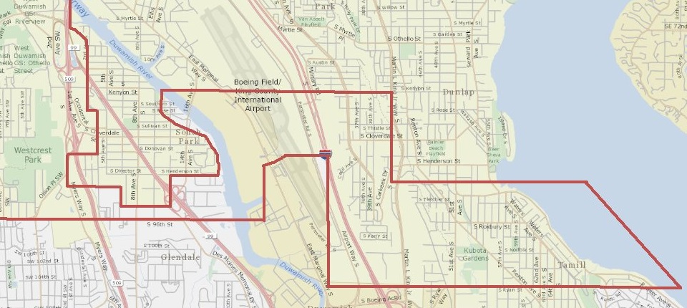
Base map from King County iMap GIS. Boundaries by author, based upon Notice of Election, See Map 14 above. Boundaries are as prescribed in 1906 and are superimposed upon a contemporary map reflecting Duwamish River dredging and road networks.

Rutter’s legal team filed, on Saturday January 12, 1907, seven days before the scheduled election, their complaint and request to enjoin the King County Board of Commissioners from holding the Alki-Rainier incorporation election. The complaint, according to Rutter had been perfected two days earlier.

Having learned some lessons from the Amos Brown Estate litigation, plaintiffs extended, somewhat, the events timeline to give a reduced appearance of attempt to ‘jam’ the defendants and forestall judicial appeal and review.

Judge A. W. Frater scheduled for 9:30am on Tuesday the 15th, a hearing on plaintiff’s request for an order restraining the King County Commissioners from holding the election planned for the 19th. All parties appeared at the appointed time and place. They found Visiting Superior Court Judge John B. Yakey sitting on the bench. Awaiting until Thursday, the 17th, Judge Yakey issued an order enjoining the Commissioners from holding the Alki-Rainier incorporation election. In this case, plaintiff’s actions were only slightly less egregious in forestalling judicial review and appeal. Yakey’s absence of propriety cancelled another election.

Defendants were effectively given two-days’ notice of plaintiff’s action resulting in something less than a forty-eight-hour period for potential judicial review and appeal. In the Amos Brown Estate case, the potential review and appeal period, prior to election day, was on the order of less than twenty-four hours.

The County Commissioners, upon orders of Judge Yakey and having learned from the contempt of court proceeding taking place in the Amos Brown Estate litigation, failed to hold the scheduled January 19th election. On January 22nd, attorneys for the King County Commissioners made an appearance requesting judgment in favor of the Commissioners and that the injunction preventing the January 19th election be dissolved. The case record indicates that no action, on the motion, was taken. The idea of Alki-Rainier was forgotten except by former Judge W. R. Bell and his future clients, George and Julia Hill and Youngstown saloon keeper James F. Wilson.

Whatever logic existed behind the City of Alki-Rainier was swept away by the January 1907 consolidation of the Cities of Seattle and Southeast Seattle and May 1907 consolidation of the Town of South Park into the City of Seattle. With these consolidations Rainier Beach had adjacency to the City of Seattle as would the Peninsula if it could extend the boundaries of West Seattle to the Duwamish River and the former Town of South Park.

Failure to complete the Alki-Rainier incorporation did result in a long-standing Peninsula municipal governance ‘gap’ that persists to this day. The ‘shoestring’ and its connecting lands south of the Town of South Park and the area lying between the South Park eastern boundary and the Duwamish River would be excluded from future incorporation and annexation proposals. The excluded territory is shown in Map 16 below. The area between South Park and the Duwamish is frequently called the ‘Sliver by the River’.

Map 16 - Territory Excluded from Annexation and Incorporation, 1907

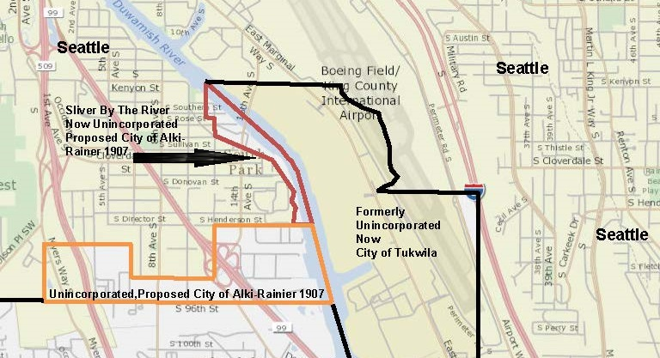
Base map from King County iMap GIS. Boundaries drawn by author. The area in red remains unincorporated at this writing. A small portion of the area in orange was incorporated in the mid 1950's. The balance of the area remains unincorporated. The area shown as part of the City of Tukwila would have been part of the City of Alki-Rainier and subsequently, annexed to and consolidated with the City of Seattle if the City of Alki-Rainier proposal has been successful.
If the Alki-Rainier advocates had prevailed in Judge Yakey’s courtroom and the scheduled election had approved the incorporation, the planned next step was consolidation of the City of Alki-Rainier and Seattle. Today’s ‘Sliver by the River’ and the unincorporated strip south of South Park would have become a part of the City of Seattle.

After the consolidation of Alki-Rainier and Seattle, a consolidation of the West Seattle City enclave into Seattle may have ensued. The fate of the unincorporated Seattle Steel Mill and West Seattle Reservations properties are uncertain. In time, by legislative act or petition of the property owners, these enclaves may have been annexed into Seattle as occurred with similar other areas years later and the story of bringing municipal governance to Alki and its neighbors would have concluded. Matters took another course.

A Little Ol’ Bitty Bill That Don’t Do Nothin’

In a possible post October 1906 West Seattle annexation election and Alki-Rainier incorporation failure review, someone may have questioned if two cities separated by a body of water were truly adjacent and contiguous. This was a question confronting West Seattle and the Town of South Park. In the case of South Park, it sat on the opposite side of the Duwamish River from the former City of Southeast Seattle, now merged into Seattle. Seattle, in the case of West Seattle annexations was potentially joined at the centerline of Elliott Bay, the Bay tide flats and opposite shores of the Duwamish River.

Into this suspected ambiguity stepped State Senator George F. Cotterill. He had a ‘little ol’ bitty bill’. Cotterill, since mid-1903, had been a member of the Seattle Chamber of Commerce’s Special Committee on Annexation of Territory to the City of Seattle. The Special Committee had followed Seattle annexation matters for some time, had supported Senator Kinnear’s bill, and pledged the Chamber “to obtain reasonable public improvements” for suburbs becoming part of Seattle. On October 7, 1903 the Chamber Committee outlined a proposed annexation area substantially equal to that of the Southern Suburban Strip. The Committee reported that the “district has been determined upon as the most suitable, south of the city, for annexation…..”. The Committee also suggested that annexation north of the city should take place but provided no specifics.

Cotterill first took his senatorial seat at the 1907 legislative session. He represented the same senatorial district as Ritchey Kinnear, now retired from legislative politics. Cotterill was a Democrat elected in a Republican dominated community, was a progressive, and an advocate of municipal ownership, public improvements and elimination of public vice. His contested election plurality was two votes out of nearly 2,100 cast. Parenting Seattle’s innovative utility finance scheme, as an assistant to city engineer R. H. Thompson, he would return after his legislative service to municipal politics as city councilmember and Mayor.

On March 18th, Cotterill’s ‘little ol’ bitty bill’ became law. This new legislative act provided;

“That where municipalities are separated by water or by tide or shore lands …. such municipality shall be deemed to be contiguous for all purposes …. And may be consolidated …. and upon such consolidation any such intervening water, tide or shore land shall become part of the consolidated city.”

Cotterill’s bill was grounded in the notion that to answer a question, a legislative bill is more certain and cheaper than a lawyer’s litigation bill. Nevertheless, the Seattle Chamber of Commerce was about to incur a significant lawyer’s bill.

Five weeks after Cotterill’s bill was enacted, B. W. Baker, Alki resident, owner of the Rose Lodge, City of Alki-Rainier advocate and Seattle insurance agent, wrote the Chamber asking for the Chamber’s assistance. He wrote on behalf of a committee of residents of West Seattle and environs seeking annexation. Baker, at this point, did not identify a specific annexation proposal or the nature of assistance requested.

The Chamber Committee considered Baker’s request and recommended to its Chamber members that “some aid be given to the people in the unincorporated territory south of West Seattle, in the form of legal advice and the direction of the movement by capable attorney.” The Committee recommendation was adopted and the Committee “was authorized to employ counsel.” For the first time, residents of an annexation area had legal representation and advocacy in support of municipal governance. Courthouse confrontations like those brought by the malcontents Puget Mill Company, Brown Estate and Rutter held the promise of being met by an opponent of a strong will, abundant resources, unquestioning advocacy and having as deep connections as the plaintiffs.

A second matter in the probable post October 1906 election and Alki-Rainier failure review was an assessment of how to overcome the opposition of the Youngstown liquor purveyors and saloon patrons. The saloon keepers feared higher license fees, at best, and the elimination of their licenses at worse. The Youngstown crowd also gave thought to their position and seized upon the notion of incorporation of their own town which would preserve their licensing eligibility. A new town would prevent annexation by another municipal entity. It could also issue licenses at the lowest possible fee allowed. Depending upon boundaries a new town may have stood in the way of West Seattle and Seattle adjacency.

At Alki, those seeking a liquor license were held at bay by state law that prevented the County Commissioners from issuance of a liquor license within one-mile of an incorporated city. The purpose, presumably, behind the one-mile limit was to prevent congregation of saloons just beyond the city limits of an incorporated place. An unintended side effect was to create protected markets within incorporated communities. In the case of Alki, the nearest licensed alcoholic beverage premises were in the West Seattle saloon district neighboring the ferry dock and street railway bayside terminus. The West Seattle saloon district establishments had a vested interest in faithful compliance with the license prohibition zone requirement.

In late winter 1907, public questioning of the location of the Youngstown saloons relative to the West Seattle boundaries emerged. If the Youngstown saloons were found to be within one mile of the West Seattle city jurisdiction, the annexationists would have a point of leverage. In the absence of annexation by West Seattle, licensees would risk having the County issued liquor licenses revoked. To preserve their leverage, the West Seattle annexationists would need to prevent Youngstown’s incorporation. Leaving the Youngstown saloons hanging in a one-mile license prohibition zone was essential.

But first, George ‘Landslide’ Cotterill had another ‘little ol’ bitty bill that don’t do nothin’. Senate Bill 56 was introduced at the 1907 legislative session on January 22nd, the same day attorneys for King County sought to dissolved Judge Yakey’s order restraining the County Commissioners from holding the Alki-Rainier incorporation election. The bill specified that the minimum liquor license fee for any establishment within five (5) miles of a city of the first class (Seattle) would be $1,000 per year. Heretofore, state law specified that license fees were to be set by the licensing authority. Fees were required to be not less than $300 and not more than $1,000 per year. At the time, the county license fee applicable to Youngstown licensees was $300. Cotterill’s little ol’ bill meant an immediate $700 license fee increase. Youngstown lay well within the proposed five-mile limit. The bill was ‘a shot across the bow’ clearly aimed at the Youngstown saloon magnates. The other notorious saloon district located outside Seattle, Georgetown, was not an object of Cotterill’s aim for the licensees of Georgetown were located within and subject to the City of Georgetown authority.

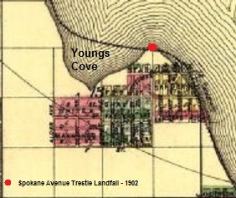
Cotterill, demonstrating his lack of legislative acumen, brought his bill up for a vote on February 18th. The bill was defeated on a vote of 8-24. Nevertheless, a message had been sent to the Youngstown saloon district that the days of a $300 license fee were numbered and another message was sent to the King County Board of Commissioners that their days of easy revenue from Youngstown were over as well.
Map 17 - Youngstown Area Plats and Subdivisions - 1888-89
(Proposed Seattle & Southern Railroad Along Shoreline)

“I Wish Youngstown Was In Kitsap, and West Seattle in Snohomish. As to Georgetown, Well Yuma County Arizona, Would Suit Me For Its Location.”
King County Commissioner Beckingham, Seattle Star, April 30, 1907, page 1

Youngstown’s (formerly known as Humphrey) early days began in 1888-89. A land development boom started south and southeast of Young’s Cove as an outcome of rumored construction of the Seattle and Southern Railway (see Map 17 left). The Seattle and Southern was to run along the western shore of the Duwamish River and up the Duwamish Peninsula to a junction with the Portland and Puget Sound Railroad. The Seattle and Southern was intended to be the Southern Pacific Railroad’s entry into the Seattle market from points south including San Francisco. The Portland and Puget Sound Railroad (an appendage of the Union Pacific Railroad) was to run north from Portland to Seattle along the Puget Sound’s eastern shoreline to Alki and then along the Alki shore and around the Duwamish Head. At the junction of the two railroads, on the Duwamish Peninsula, near the West Seattle ferry dock, the railroads were to cross Elliott Bay and tide flats to the Seattle business district. Both railroads were failures and were never completed (see Map 18 below).
Extracted from O. P. Anderson's Map of Seattle, July, 1890, accessed: Library of Congress. For plats see endnote 133. Annotations by author.

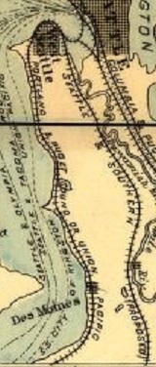
In response to the rumored and anticipated railroad construction, real estate entrepreneurs undertook Youngstown land platting and real estate subdivision. Given, actions to found the West Seattle School District, some of the Youngstown platted and subdivided real estate, apparently, found its way into housing development. Like its Duwamish Peninsula neighbors, upon the railroads’ 1890 failure, the Youngstown residents found themselves isolated and lacking access to the Seattle center, except by the remote West Seattle – Seattle ferry. At this point, the shore of Youngs Cove represented one of history’s many railroads induced real estate failures. The failure was not to last long.
Map 18
Duwamish Peninsula Proposed Railroads - 1890
(Along Puget Sound on the West and Duwamish River on the East)

The only access the communities of the Duwamish Peninsula had to the Seattle center was waterborne. Travel up the Sound, around the Duwamish Head or along the Duwamish River was via watercraft. There were no bridges crossing the Duwamish River until the 1890 completion of the Seattle Terminal Railroad linking West Seattle and Seattle. The Peninsula’s near isolation ended in September, 1902 and Youngstown was a major beneficiary. The King County Board of Commissioners commissioned in late 1901 the construction of a wooden plank trestle over the Elliott Bay tide flats. The trestle, opening in September 1902 began on the east at the tidelines of Seattle at Spokane Street and extended across the Elliott Bay tide flats following the Spokane Street line. The trestle’s western landfall was at Youngstown (see Map 17 above). This landfall made Youngstown the first point of the Peninsula’s new connection to Seattle and gave Youngstown a land development competitive advantage over all other Peninsula communities. Proposals for new roads radiating south and west from Youngstown were soon made to the King County Commissioners.
Extracted From: O. P. Anderson Map of Seattle, July, 1890

Youngstown was to share in more than a public infrastructure good fortune. Seattle’s desire to become a manufacturing center would grace the former Humphrey with a steel plant. Seattle saw itself as a natural resource extraction and commercial center. Seattle was not a manufacturing center. The opportunity to become a center of steel production would be created by local entrepreneur, William Piggott, and a combine of fellow Seattle capitalists. Youngstown, Washington, now taking the name of Youngstown, Ohio, would soon hold itself out to be the Pittsburg of the west. Hundreds seeking work would settle in and around the steel plant located on the Youngs Cove western shores. Operations of the Seattle Steel Company began May, 1905. The real estate entrepreneurs of 1888-89 would finally get their due. The operations of the commercial oyster beds sharing the same shore as the steel plant, presumably, ceased operation at the same time.

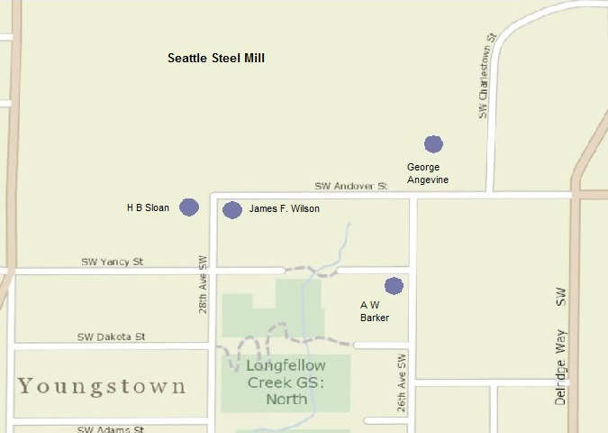
As Spring 1905 began, 103 Youngstown residents petitioned the King County Board of Commissioners, “to not grant any more Saloon Licenses here as there is already 2 saloons here and we think that is sufficient. We ask your honorable body to grant this favor.” One additional petition signer, Mrs. E. M. Wilson, in protest to the position of the other signers, noted next to her signature, “would prefer more” (presumably saloons). Mrs. Wilson was the wife of James F. Wilson, Youngstown liquor license holder. Mrs. Wilson prevailed for there were soon to be four licensed Youngstown saloons. A map of the locations of Youngstown’s licensed premises is shown in Map 19 left.
Map 19 - Liquor License Premises, Youngstown Locations – January 1907

Just after the first of the year 1907, apparently, the taverns of Youngstown began feeling more intense political heat, over and above Cotterill’s licensing fee bill. In early February, word began circulating that a petition was being prepared seeking Youngstown’s incorporation. A second petition was reported as being circulated among residents seeking refusal to renew previously issued liquor licenses held by the Youngstown establishments. The petition seeking license non-renewal asserted the regulated beverage establishments were within the one-mile license prohibition zone.
Base map from King County iMap. Location data from Application and Bond for a Retail Liquor License of the indicated licensees. RG 011, Series 113, King County Commissioners, Liquor License Files, March 19, 1904 - January 15, 1908, Boxes 2 and 3.

The petition seeking license non-renewal was submitted May 11th. But judicial authority had spoken to the validity of Youngstown’s liquor licenses two days earlier. The “wet” versus “dry” conflict was clearly delineated as the issue at hand, not incorporation. The “wets” wanted municipal governance to preserve the saloon licenses. The “drys” would have none of it. Keeping Youngstown unincorporated meant removal of demon rum from the community. Outside Youngstown, the West Seattle annexationists were using the “drys” to get their form of municipal governance.

The King County Board of Commissioners, as the Youngstown licensing authority and incorporation referee, was squarely caught in the middle: pleasing one side would result in displeasing all others. No wonder Commissioner Beckingham expressed angst. The threatened incorporation petition, according to its proponent’s legal advisor, W. R. Bell, former judge, was to be filed “in a few days”. A week later, Bell made a similar public statement. It would be nearly two months before the petition seeking incorporation of the Town of Youngstown would be filed. The County Commission, on April 30th, received the petition. Bell’s earlier public statements appear to be nothing more than bluster to influence county commissioners to await incorporation results before taking up questions concerning the validity of outstanding liquor licenses.

Upon receipt of the incorporation petition, the Board set the matter down for a hearing on May 28,1907. Events would transpire rendering the hearing unwarranted.

Bell’s strategy failed. On the same day that the incorporation petition was filed, the City Attorney for the City of West Seattle, publicly questioned the location of the Youngstown licensed premises. T. B. MacMahon, city attorney, demanded that the licenses be revoked, by the County Commission, on the basis that the saloons in question were within one-mile of the West Seattle city limits. This must have come as something of a shock to all concerned much like the discovery of gambling at the Casablanca Rick’s Café Americaine. Several of the establishments had been in business since, at least, June 10, 1904 and others as recently as November 1, 1905. All $300 license fees were paid up in full.

The County Surveyor, A. L. Valentine was dispatched to begin a survey of the distance between the West Seattle boundary and the four Youngstown saloons. Valentine reported back to the Commission that “all the barrooms are within one-mile limit…..” The Commission on April 30th revoked the licenses of the Youngstown saloons. The most distant licensed premise was 5,062 feet from the West Seattle city limits. The closest was 4,780. There are 5,280 feet in a mile.

To recover their licenses the saloon keepers sought the comfort of the courts. James F. Wilson on his own behalf and that of his fellow license holders appeared the next day before Judge Robert Albertson pleading for an order enjoining the Commissioners from enforcing the license revocation. The attorney for the licensees, former judge Bell, secured temporary relief for his clients pending a final hearing on the matter. On May 9th Judge Albertson concluded that “When the County Commissioners find that they have made a mistake …., it seems to me they have the perfect right to correct that mistake.” Albertson permitted the license revocation to go forward. Records of the proceeding do not indicate any appeal of Albertson’s order.

The saloon opposition to West Seattle annexation had been dealt a substantial blow. But the petition for Youngstown incorporation was still pending. Wilson and his associates needed to find a way to hasten Youngstown’s incorporation. A newly incorporated city could issue anew the recently revoked liquor licenses.

Getting Close to Municipal Governance for Alki and Its Duwamish Neighbors

With Yakey’s effective cancellation of the Alki-Rainier incorporation election and the Board of Commissioner’s decision not to press the matter, the people of Alki, Youngstown, Spring Hill and West Seattle reconsidered their position. Annexation of the entire Peninsula outside the former Town of South Park would be attempted. The question was still begged: did everyone want such governance and would the courts permit the ballot box to speak?

On April 22nd, five years and one day after the original incorporation of West Seattle, the City Council met. At this meeting, they were about to initiate a new series of events that would bring the West Seattle municipality to an end. They received the petition of U. R. Niesz and 263 others pleading for an election to enlarge the boundaries of the City of West Seattle. The petition, unsurprisingly, was granted. The annexation election was scheduled for May 25th. The annexation election would proceed the Youngstown incorporation hearing by three days. An incorporation election would follow the hearing four weeks later. James Wilson and his associated saloon keepers needed to find a way to reverse the order of the proceedings so that incorporation was considered and approved before annexation.

The proposed new West Seattle boundaries are shown in Map 13 earlier. The annexation territory subject to the May 1907 election was identical to that proposed for annexation at the October 1906 election.

Alki, Youngstown, Spring Hill Villa and the entire Duwamish Peninsula north of today’s SW Roxbury Street and west of the Duwamish River and west of the former Town of South Park (now merged into Seattle) were to become West Seattle. Adjacency and contiguousness to Seattle was to be achieved at the former western boundary of South Seattle, Southeast Seattle, South Park and along the Elliott Bay and Bay tide flats centerline. This time, like the October 1906 election, there would be no gerrymandering and enclaves appeasing corporate interests. The Seattle Steel Mill, Puget Mill Company timberlands, and the West Seattle Reservations were all included in the annexation area. This was a return to the position, for these properties, as it existed for the October 1906 annexation election.

As noted earlier the Steel Company was opposed to and feared higher municipal taxation. Singling out the Steel Mill for special treatment weakened the annexationists arguments. It was hard to justify a gerrymandered tax exemption for one without extending it to others.

William Pigott, along with his associate William Hofius, is frequently credited with being the entrepreneur behind the Seattle Steel Company. But the ‘skin in the game’ went well beyond Pigott and Hofius. A well-heeled group of Seattle capitalist backed the enterprise.

Meeting late in December 1902, in the offices of the Seattle Chamber of Commerce, this group laid plans to “form a syndicate of Seattle businessmen for the purpose of raising …. (capital) and to enter into the manufacturing of iron and steel upon a considerable scale …. this plan contemplates the location of the steel and iron plant in the vicinity of Seattle and to make it a Seattle institution.” The organizers of the syndicate laid out a complex capitalization plan requiring a $125,000 syndicate equity investment leveraging a $1 million debt offering. The capital raised was to be used to acquire existing iron ore mine assets and construct blast furnaces and an open-hearth steel plant and rolling mill. The plan then called for a subsequent $6 million stock offering. Of this stock offering, $1 million was to be paid, as a bonus, to the members of the original investment syndicate. In other words, for each dollar invested, the Seattle capitalists were to be rewarded with a near immediate return of eight dollars, plus whatever dividend and interest payments were made in the interim.

On January 14, 1903 the syndication agreement was fully subscribed. Syndicate members and their investment were:

Subscriber Identity
$5,000 Subscribers
Jacob Furth Seattle Electric Company President, Banker and Investor
J W Clise President, Seattle Chamber of Commerce
C D Stimson Stimson Mill Company
T S Lippy Manufacturer, Seattle Mattress & Upholstery Co
J A Moore Real Estate Investor, Developer
Maurice McMicken Lawyer and Banker (First National Bank)
M F Backus Banker (National Bank of Commerce)
John Leary Former Seattle Mayor, Lawyer and Coal Mine Operator
William Pigott Industrialist
Charles L Denny Denny-Renton Clay & Coal Company, Manager of A A Denny
Estate, Investor Denny-Blain Land Company
James B Hoge Jr Banker (Union Savings & Trust Company)
R Onffrey
Sherwood Gillespy
W D Hofius Industrialist and Partner of William Pigott
J D Lowman Printer, Stationer and Henry Yesler Estate Executor and Assets
Manager
R E Cosgrove
The Times Investment
Company by
A J Blethen Newspaper Publisher
J M Frink Washington Iron Works, Early Electric Utility Investor
R R Spencer Banker (Seattle Bank of Commerce)
Seattle Brewing &
Malting Company Georgetown Beer Brewery, Hemrich Brothers
Henry C Pigott
E E Caine Alaska-Pacific Steamship Company

$2,500 Subscribers
A S Kerry Banker (Dexter Horton National Bank)
M Thompson Former Head Counsel, Great Northern Railroad
A L Brown President Amos Brown Estate, Inc.

$1,000 Subscriber
Samuel Rosenberg Hotelier, Real Estate Investor
Cooper & Levy
Frederick & Nelson Dry Goods Merchants and Retailer
William Trimble Real Estate Investor, Lawyer
M A Gottstein Furniture Retailer
John Davis Real Estate, Mortgage Loans and Insurance

From a defensive position the Seattle Steel investment offered too good of a return to let the Company become entwined with a local political issue that involved a relatively minor cost. More importantly, the group of Seattle capitalists, closely tied to the Seattle Chamber of Commerce, could not be seen opposing a long-standing chamber backed policy for which they were paying a capable attorney to direct. For Furth and A. J. Blethen it would have been particularly embarrassing to be seen backing one public policy while privately they were attempting to ‘opt out’ of the same policy. Hypocrisy or inconsistency of position would not serve the annexation campaign well. The company’s financial backers, most likely interceded with management. In the end, the company’s properties were included in the annexation area subject to the May 1907 election.

The Seattle Steel Company was not the only annexation back-peddler with a short memory. A. L. Brown, president and executor of the Amos Brown Estate as well as Seattle Steel Company investor, at the height of the Youngstown saloon license revocation fight, was quoted;

“The impression of some people that I am opposed to annexation is ill-founded. I want to see West Seattle annexed to this city (Seattle), because we control a large amount of property in both places. I contributed toward the fund raised to promote the Alki-Rainier movement.”

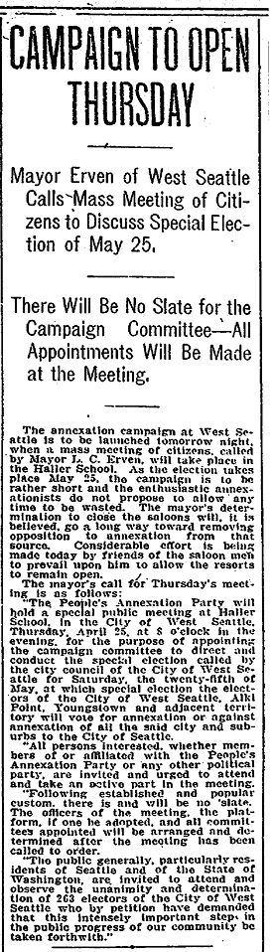
In the short space of eleven months, Brown had forgotten all that he had done to foil the West Seattle annexation program. It would be more important for Brown to be aligned with his fellow Chamber of Commerce capitalists (including Jacob Furth) than to be consistent.
Figure Fourteen
West Seattle Annexation, Organizing for the Election

In the ordinance calling the May 25th election, the West Seattle Council inserted the following provision;

“It is the intention of the City of West Seattle, in event of the result of said special election being favorable ‘For Annexation’, to call another special election ….. (to) effect the immediate and permanent annexation of the City of West Seattle to the City of SEATTLE.”

With this statement the Council ensured that this annexation election would not be about becoming part of West Seattle, but would be about becoming part of Seattle.

As annexation advocates prepared the campaign to marshal support for the extension of municipal governance, litigation experts were doing the same in opposition. W. R. Bell, the former judge, was retained once again. Bell was representing the Youngstown barmen and had represented the Brown Estate, Washington C. Rutter and various others in actions seeking to obstruct and frustrate proponents of enlargement of West Seattle jurisdiction. He had been the presiding judge in the initial stages of the Puget Mill Company action of 1904. Bell would deploy the same strategy that had succeeded in cancelling an election in the Amos Brown and Alki-Rainier cases.

This time Bell was met, before the presiding judge, Robert B. Albertson, with a declaration that the strategy behind the plaintiff’s case was one where “the whole question of the right to hold said election will be decided not on its merits, but on a motion for an injunction”.

Bell represented George A. and Julia D. Hill, residents on fifty-five acres west of the former Town of South Park, now Seattle. Washington C. Rutter was their neighbor. Rutter may have introduced Bell to his clients but the defendant, the City of West Seattle, suggested to the court that plaintiffs have “simply permitted using their names” and that the “real parties in interest are James Wilson and his associate saloon keepers”. Wilson and his associates, ten days before in Albertson’s courtroom, had become defrocked barkeeps. Whether, raising the specter of the liquor issue was a ploy or not to taint public perception of annexation opponents, the involvement of Wilson and his associates clearly communicated Youngstown incorporation as an alternative to West Seattle annexation.
From: Seattle Daily Times, Seattle, WA, April 24, 1907, p 7.

George Hill was a sixty-four-year-old native Tennessean and lawyer by occupation. Julia Hill took George as her husband thirty-seven years previously. She was 59 and born in Oregon Territory.

Bell in one form or another resurrected many of the arguments previously heard in the Puget Mill, Amos Brown Estate and Alki-Rainier cases. Questions pertaining to the validity of the promotion of the City of West Seattle to a city of the third class were rehashed, a matter determined nearly three years earlier. Issues of the appropriateness, value and efficacy of municipal governance for the annexation area were voiced once again and as before it was alleged that it was impossible to bring municipal advantages, improvements and utilities to the territory being annexed. In the end, Bell described the harm that his clients would suffer as “the lands of the plaintiff ….. will be forever subjected to the burden of taxation for the purpose of carrying on the government of the City of West Seattle and extending its public improvements without any resulting benefit (to the Hills) whatsoever.” With the May 21st complaint filing, Bell requested an order enjoining the officials of West Seattle from holding the Saturday, May 25th election.

Judge Albertson scheduled a hearing for Thursday, May 23rd at 1:30pm. By all appearance, history was about to repeat itself and an injunction would be issued in a timeframe and manner designed to forestall judicial review and appeal. Fearing contempt of court, West Seattle officials would then fail to open the appointed polling places. In that event plaintiffs would have prevailed, once again, on the strength of an election cancelled.

On Friday, May 24th, Judge Albertson, in a reversal of Yakey precedent, denied plaintiff’s requested order. Election officials would open the polls at 9:00am on Saturday the 25th, as scheduled. The ballot box would now speak. Did the interests of the Seattle Chamber of Commerce and its members unduly influence Judge Albertson? Was Albertson or Yakey correct in the perception of irreparable harm to plaintiffs of an election in and of itself?

To approve the enlargement of the City of West Seattle jurisdiction concurrent majorities were required. The issue received the requisite majorities. There were five votes against annexation and 180 favorable ballots cast within the City of West Seattle. In the annexation area, the proposition was approved 254-200. The Alki precinct, indicating continuing community division, voted 66 yes and 77 no. Youngstown was torn as well, 87-123. But Spring Hill Villa had no reservations or uncertainty, voting 101-0. The May 25th vote was officially canvassed and counted on May 27th.

Voting turnout dramatically increased in Alki and Spring Hill Villa over that of the October 1906 election. The Youngstown turnout also increased but not nearly as large as Alki’s and Spring Hill’s. The Youngstown opposition vote fell from 75% disapproval to 53%. But it was Spring Hill’s unanimous approval vote and turnout increase of 321% that carried the day.

The Youngstown incorporation petition came before the King County Board the day after the annexation vote was canvassed and officially counted. The incorporation petition was removed from the Board’s calendar. The incorporation matter was concluded. Youngstown had been annexed to West Seattle.

Alki annexation by West Seattle, resolved the 28-foot, bathhouse and dancing pavilion, and Stockade Hotel licensing irritant. Both the Hotel and Bathhouse were now eligible to be licensed. From an Alki ‘dry’ perspective, the community was no longer protected by the one-mile liquor licensing prohibition zone but had municipal governance benefits and responsibility. The only question now was what would be the governing and licensing entity – West Seattle or the City of Seattle.

With West Seattle and Seattle adjacency achieved, the West Seattle Council turned its attention to fulfilling its commitment to annexation by and consolidation with the City of Seattle. The Hills and the Youngstown saloon keepers remained silent and turned their attention to other unknown matters. On June 26, 1907, the defendant City of West Seattle moved to have the Hill litigation dismissed. Based upon case records, no action was taken on the motion. In a little less than a month it would not matter.

The identity of the ‘capable attorney’ employed by the Seattle Chamber of Commerce to direct the annexation campaign is unknown.

Following in the wake of the successful 1907 West Seattle annexation election, the King County School Superintendent made two entries in the School Districts’ Boundary Record. The first marked the end of the Youngstown School District (‘YSD’), simply dated 1907, “This district (# 151) ceased to exist by being annexed” to West Seattle. The Superintendent labeled YSD “defunct”. The existence of the YSD came to an end and was returned from where it came two years earlier. The probable date of this entry is sometime after the May 1907 election day and the end of the school year on June 30, 1907. The Superintendent may have awaited making his entry until the dust settled in the judicial contest over the annexation matter and it became apparent that the plaintiffs were going to let the matter lie.

In Quick Order

As promised, the West Seattle City Council moved to initiate procedures to annex West Seattle to Seattle and consolidate the two cities. An election was called for Saturday June 29th to approve or disapprove the annexation and consolidation. The newly enlarged West Seattle, including Puget Mill Company lands, Seattle Steel Mill properties and the West Seattle Reservations along with territory north of today’s SW Roxbury Street and west of the Duwamish River and the former Town of South Park were to be joined to Seattle (see Map 20 below). Only a single majority of the voters of the newly enlarged West Seattle were needed to approve the annexation and consolidation.

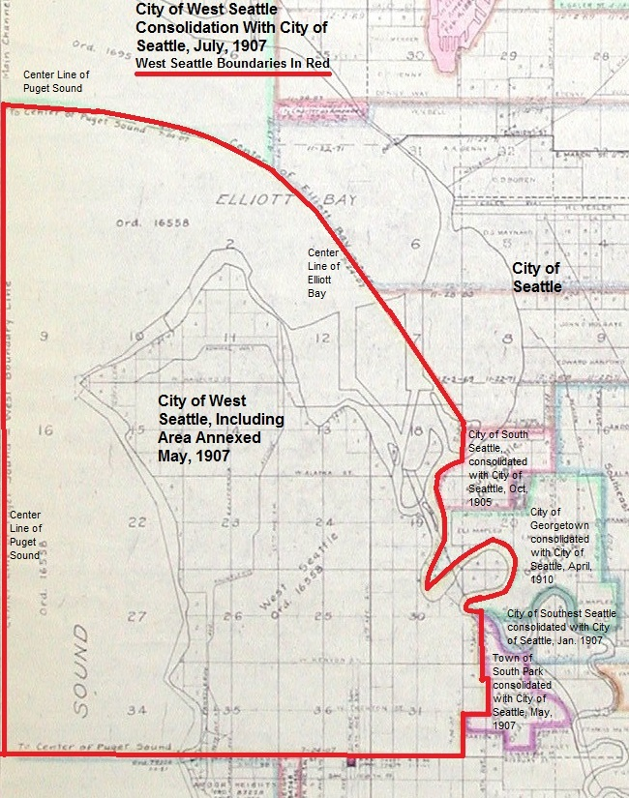
Map 20
City of West Seattle Jurisdiction to be Annexed to and Consolidated with the City of Seattle, July 1907
Base map from City of Seattle, Seattle Municipal Archives, Map # 932. Boundaries drawn by author based upon provisions of Ordinances 172 and 178 of the City of West Seattle, Seattle Municipal Archives, Seattle, WA
The West Seattle vote in favor of approval was 325 to 8. Of those disapproving, one each resided in the Alki and Spring Hill precincts, six within the former West Seattle city jurisdiction and none in Youngstown. Whatever division of opinion existed over the prudence of municipal governance faded when it became a fait accompli and the choice was between Greater Seattle and West Seattle. There was no judicial challenge of the West Seattle – Seattle consolidation election or election outcome. There was no attempt to have the election cancelled.

Once approved at the voting polls the petition to be annexed to and consolidated with the Seattle City was referred to the Seattle City Council for final approval. With Council approval, the consolidation would be in effect. By ordinance enacted July 24, 1907, the City of West Seattle was merged into the Seattle City. The City of West Seattle ceased to exist. All assets, liabilities, records and functions were passed to the City of Seattle.

At the final West Seattle City Council meeting, the Council by resolution stated:

“Council refer the following matters to the City Council of the City of Seattle ……..

7. The City (West Seattle) is in need of electric light and the field has been held open for municipal lighting …..”

The West Seattle governing body had had the last word at Jacob Furth’s and Stone & Webster’s expense. Jacob Furth had made application, in August, 1906 to the City of West Seattle for an electric utility franchise. The Council had delayed consideration of the franchise. Presumably, the Council had more pressing matters to attend to relative to the sale of the municipal railway. In late February 1907, as the railway sale was being finalized, Furth raised the matter again and requested action. A new ordinance, granting Furth the electric utility franchise was introduced in late March and a majority report was given in late April recommending Furth’s grant of the electric utility franchise. At the same meeting that the franchise grant to Furth was recommended, the City Council called the annexation election that would lead to enlargement of the city’s jurisdiction and eventual Seattle consolidation. No action was ever taken on Furth’s electric utility franchise.

The delay in granting Furth his electric utility franchise seems to have been purposeful and perhaps insightful. The future lay with universal electric service not street railways. Seattle quickly extended its municipal electric utility to Alki and the Peninsula.

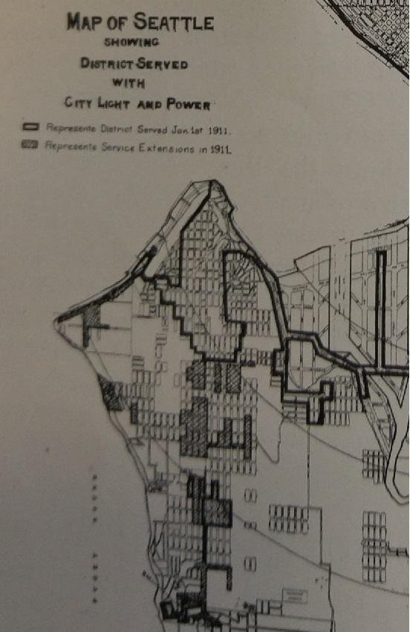
The West Seattle council had given municipal ownership advocates a starting line advantage over the Furth and Stone & Webster combine. Vestiges of the Stone & Webster electricity empire, within Seattle, would slowly fade.
Figure Fifteen
Seattle Department of Lighting Service Extensions – 1911

The City of West Seattle had served the public, built significant improvements, and initiated local general-purpose government services throughout the Duwamish Peninsula. Public schools preceded and followed the spread of general-purpose government. The City of West Seattle lived 63 months and three days. During its time West Seattle led Alki, Youngstown, Spring Hill Villa and the Peninsula’s sparsely populated southern region into Greater Seattle. What remains unclear is the intent and aspiration of West Seattle’s original incorporation – to be the prime Peninsula governing instrumentality or the means to become a part of Greater Seattle.
.

From: 1911 Annual Report, City of Seattle Department of Street Lighting. Seattle Municipal Archives. City of Seattle, Seattle, WA

One Last Matter

In the King County School Superintendent’s boundary book there is no entry recording a change in WSSD jurisdiction because of the June 1907 annexation election. Matters were moving very quickly and no doubt, given experience, officials were awaiting the next judicial challenge. The Superintendent paused and waited the outcome of the soon to follow election to approve or disapprove the West Seattle-Seattle consolidation. The Superintendent, simply recorded that District # 73, “Annexed to Dist No. 1. July 26, 1907.” (Dist No. 1 being the Seattle School District.) The Superintendent had overlooked a recent change in state law requiring that school district boundary changes, in Seattle’s case, be effective the next succeeding June 30th. The WSSD corrected that error.

Appearing in the records of the WSSD was the following June 30, 1908 entry:

“Upon motion properly made & carried the clerk was instructed to turn all books, accounts & documents over to the secretary of Dist # 1 and District # 73 was declared out of existence, all future business to be transacted by the Directors of the Seattle Schools. Meeting adjourned sine die.”

The WSSD, initially serving the Alki, West Seattle and Youngstown communities, preceded into existence the City of West Seattle by twelve years. It survived the City of West Seattle by eleven months. State law, requiring that a school district was to be at least coterminous with the boundaries of the city it lay within, compelled WSSD to be merged into the Seattle School District. When the WSSD passed out of existence, it employed 18 teachers, enrolled 1,145 students and provided 109,825 days of instruction over a ten-month school term.

With the earlier extension of the jurisdiction of the Seattle School District, as a consequence of the consolidation of the Town of South Park and City of Seattle, the Seattle School District’s jurisdiction encompassed the entire Duwamish Peninsula north of today’s SW Roxbury Street and its projection eastward to the Duwamish River and westward to Puget Sound. All children of the Peninsula now had ‘school privileges’.

Epilogue

With the merger of the newly enlarged City of West Seattle into the City of Seattle, Seattle would soon take its final geographic form for the next forty-five years. Following the West Seattle annexation, the unincorporated area of Rainier-Dunlap, in September 1907, joined Seattle. This area was essentially the ‘shoe’ of the proposed City of Alki-Rainier (see Maps 14 and 15 above). This annexation was facilitated by a 1907 enactment of the State Legislature that permitted annexation to a city of the first class (i.e. Seattle) by a majority of voters of the annexation area and an ordinance of the annexing city’s governing authority. This bill placed annexation of unincorporated areas on the same procedural plane as city consolidation. The necessity of concurrent majorities for an unincorporated area annexation election was abandoned.

Because of West Seattle’s incorporation into Seattle, the City of Georgetown became a Seattle enclave (surrounded by the old cities of South Park, West Seattle, South Seattle and Southeastern Seattle). Georgetown was annexed and consolidated. Its merger into Seattle took place April, 1910 two months prior to Greater Seattle’s eagerly awaited 1910 Decennial Census. (See Map 20 above).
Shortly before Georgetown’s required consolidation vote, George Cotterill reported upon his estimated current Seattle population. He opined, in the Seattle Daily Times;

“our population hovers …. probably over the 300,000 mark. The annexation of Georgetown, officially adding about 7,000 population …. would assure …. the placing of Seattle above the 300,000 mark …. The official addition of Georgetown, which is really part of Seattle, may make Seattle nineteenth among American cities instead of twenty-fifth. Seattle belongs in America’s twenty greatest cities. Georgetown voters can put there in 1910.”

Cotterill’s population estimate was wide of the mark. Nevertheless, the population gain was significant. The 1910 Decennial Census found Seattle’s population to be 237,194 of which 49,126 persons resided in the areas annexed or consolidated into the city between 1905-1910. The Seattle annexationists achieved their goal of propelling Seattle up the population hierarchy of American cities. Seattle ranked, in 1910, 21st among the nation’s largest cities up from 48th ten years previous. More importantly, Seattle outranked and leapfrogged its rival Portland, Oregon at 28th largest up from 42nd largest in 1900. Seattle became the west coast’s third largest city ranking behind San Francisco and Los Angeles. Without the benefit of the newly annexed areas and communities, Seattle would have been a city of 188,058, ranking 29th among American cities, one rung below rival Portland at 207,214 persons.

Questioning of the Seattle annexation policy and program began to emerge with the Rainier-Dunlap annexation. Tensions were beginning to build over use of scare resources in the newly annexed territory to make improvements promised and alternative use of those resources in the older city to lower tax burdens or invest in capital facilities and improved services. It was beginning to dawn on municipal officials that the newly annexed areas were not on a pay-their-own-way basis, but that the older city would have a substantial liability in aid to the newly annexed territory. While the Rainier-Dunlap annexation question was before the Seattle Council’s Committee on Elections and Boundaries, its chair, Hiram Gill, and future Mayor, said;

“If this practice of annexation is allowed to go on the city will be bankrupt. Seattle will not be able to give this new territory anything in the way of improvements and when this is realized by residents of that section the claim will be made that the people there have been deceived.”

Gill’s sentiments were echoed by his fellow committee member, Frank Mullen. The other committee members gave lukewarm and tepid support to a continuing annexation program. In the end a majority of the five committee members agreed with the proposed annexation. The full Council approved, in September 1907, the Rainier-Dunlap annexation. But doubts regarding the annexation program were sown.

Lying three miles south of Seattle, after the 1907 Rainier-Dunlap annexation was the City of Renton. In 1910, Renton was a city 2,700 persons growing to 3,300 ten years later. It was a coal mining, timber and fishing center. On August 2, 1919 the Renton Commercial Club wrote Seattle’s Mayor Ole Hanson, inquiring of Seattle’s willingness to discuss legal issues of annexation of the City of Renton and the unincorporated area lying between the two cities. The Club’s president then stated, “We take it for granted that the city of Seattle wants us to come in (be annexed) …..”

Mayor Hanson referred the communication to the City Council. On August 14th, the Council adopted the report of its Judiciary and Department Efficiency Committee; “petitioner (be) advised that it is impossible for the City of Seattle to consider the matter of annexation at this time.” The southern Seattle boundary would be fixed, except for some minor annexations, until the mid-1950s. The City of Renton continues to this day.

In the case of Alki and Spring Hill Villa, within five days after the effective date of the City of West Seattle’s consolidation with Seattle, the residents of the Alki-Spring Hill Villa annexed territory submitted a petition to the Seattle City Council requesting that no liquor license be issued in the newly annexed territory. The petition was signed by 728 Alki-Spring Hill residents. From that point forward, until Washington State’s liquor prohibition effective January 1, 1916, there were no liquor licenses issued at Alki and Spring Hill Villa. At Youngstown, the four saloonkeepers never recovered their licenses. There is no record of any license thereafter issued by the City of Seattle prior to the January 1, 1916 dawn of statewide prohibition. The “drys” prevailed and County Commissioner Beckingham could rest easy.

The original naming of West Seattle by the Niesz-Whittksey Company and WSL&ICo was most likely a marketing ploy motivated to indicate a location near Seattle and to attach the new community to a vibrant commercial center. The earlier West Seattle names of Milton, Fremont and indigenous people’s naming constructs gave way to West Seattle. The naming of the place ‘West Seattle’ persisted from its first days in the mid 1880’s, through its consolidation with the City of Seattle and beyond to contemporary times. Today, West Seattle commonly refers to the entire Duwamish Peninsula.

This naming convention differs from other communities taking for similar reasons and, in part, their name as Seattle. In the case of the cities of South Seattle and Southeast Seattle, their place names passed into infrequent use and have disappeared in favor of Mount Baker, Holly Park, Rainier Valley and Beacon Hill among others. Mercer Island’s northwest quarter was first known and platted in 1888 as East Seattle. East Seattle was a contemporary of West Seattle and similar to Alki featured a lakeside recreation and resort hotel. The East Seattle name gave way to Mercer Island. The City of Mercer Island was incorporated in 1960 completing the name change transition. In perhaps the most ironic of name changes, one of Alki’s first immigrants, David Denny, and his father, in 1869, platted and named North Seattle. The area of the Plan of North Seattle, as the Dennys named it, lay west of today’s Seattle Center and east of Elliott Bay between Denny Way and Mercer Street. Today we would call Dennys’ North Seattle Lower Queen Anne. West Seattle endures.

Conclusions

Yakey’s Propriety or Absence Thereof

An 1884 graduate of the University of Missouri at Columbia law school, John B. Yakey, made his way west and began his Seattle legal career managing a land abstract and title office. Several years later he relocated to Sidney (later renamed Port Orchard), Kitsap County, Washington. He became active in local politics and was elected Kitsap County Prosecuting Attorney in 1894. He served as such until February 28, 1905 when he accepted appointment as Kitsap County Judicial Circuit’s first Superior Court Judge.

As a jurist, he would become known for an ongoing dispute with the County’s State Senator W. J. Bryan. This dispute became unsavory with Bryan accusing Yakey of padding his expense accounts and renting to saloons. Yakey sought disbarment proceedings against Bryan. The Yakey-Bryan dispute resulted in accusations by the Senator that his clients were unable to secure a fair hearing in Yakey’s courtroom. Probably at Senator Bryan’s urging, the State Legislature, in 1911, stepped into the dispute by enacting legislation permitting a change in case venue or judge on the basis of prejudice shown by simple affidavit of any party or attorney asserting that such party or attorney believes that they cannot have a fair and impartial trial before the judge in question.

Eight months after Yakey began his judicial career he denied a divorce decree in a case involving domestic violence and failure to support the wife and children. In explaining the basis of the denial, Yakey stated, “If divorces were granted under such conditions as the evidence shows in this case, three-fourths of the families of the state would be divorced. Such conditions are common and this court does not deem them sufficient grounds for divorce” (emphasis added by author). Yakey’s reported statement, while reflecting the time’s construct of patriarchal domination and inherent acceptance of violence against women to maintain that domination, illustrates his predisposition to reach well beyond his courtroom to justify his bias. Resorting to wild exaggerations as the pretext for denial of the divorce decree, although exposing his character and beliefs, was unnecessary in the conduct of his courtroom. Its necessity was his need to express support for those in position of power regardless of their deeds. This would not be the only time Yakey reflexively expressed unending support for the powerful.

On two occasions, within the bounds of his authority, Judge Yakey found irreparable harm to those contesting the holding of an election. At issue, in his courtroom, were the existence of elections. There were no issues asserted or presented pertaining to election processes, election mechanics, voter eligibility, polling places, election judges or election fairness. The elections per se were found, by Yakey, as a source of harm.

Issues raised by those asserting harm could have awaited an examination of the issues on their merits after the voters had spoken. In both cases, based upon the complaints filed, Yakey found irreparable harm. Defendants were restrained from holding the election scheduled for the following day or two. Hence, the Washington Supreme Court’s wonderment at so short of notice. Yakey was compliant not once, but twice, with the position of the influential and powerful economic interest appearing in his courtroom. One can only guess what other considerations weighted upon him.

One must seriously question plaintiff’s good faith in both matters, and Yakey’s role, in bringing their legal actions. Plaintiffs, in Yakey’s courtroom, conducted themselves in a manner designed to frustrate and obstruct orderly processes of governance and to secure action in a manner designed to preclude timely review and appeal (at least in that era’s available transportation and communications technology). Plaintiffs brought their legal actions at an optimal time to forestall appellant review so long as they had a cooperating judge. The temporary restraining orders sought were a tactic to obstruct, not a means to prevent immediate danger to rights, life or property. Notice to the plaintiffs, and all others, of the elections at issue took place over the four preceding weeks. Yakey never questioned plaintiff’s timing. At best, Yakey allowed himself to be used. At worse, he was a willing collaborator. Plaintiff’s sole aim, as expressed by the defendant in the Hill action, was to use judicial processes to evade ballot box decision making.

In Judge Albertson’s courtroom matters were different. Albertson would not be used, but then powerful and influential interests were on the side of an orderly conducted election.

After the Amos Brown Estate and City of Alki-Rainier matters were concluded Judge Yakey found himself in good fortune. He became one of four founding shareholders in his hometown Kitsap County Bank. His fellow shareholders were Jacob Furth, Peter Nordby and George Miller. In 1913 Yakey stepped down from the bench and later that year relocated to Los Angles, California and resumed private law practice.

Election Cancelled

“Article I. Section 19. Freedom of Elections.
All Elections shall be free and equal, and no power, civil or military, shall at any time interfere to prevent the free exercise of the right of suffrage.”
Constitution of the State of Washington, adopted 1889.

The story of bringing municipal governance to Alki and the Duwamish Peninsula is a demonstration of democracy’s fragile nature. On three occasions, the will of the voters was frustrated, once by summarily tossing aside the ballot box and twice by cancelling a duly called and scheduled election. One could suggest that it matters little what happened on the Peninsula well over a hundred years ago. After all, the issues were minor to all except the handful of people impacted. Those who would say that such things could not happen today, assume a high degree of judicial integrity and a healthy respect for the other branches of government and governing processes. In the end, it is these norms upon which democracy’s preservation rests. Lessons learned from Judge Bell’s actions, Judge Frater’s acquiesce in the Puget Mill case and Yakey’s questionable decision making has, perhaps, fortified democracy’s persistence. The compelling question is what would happen if the lessons were ignored or forgotten. Judges Bell and Yakey, in affirmative spirit and action, interfered to prevent the free exercise of the right of suffrage. Judge Frater passively did the same.

The Alki municipal governance story amply demonstrates how, by intemperate or compromised judicial conduct, the ballot box can be silenced. The right of suffrage is only as strong as the judiciary’s respect for that right. Across the nation, in contemporary times, the judiciary is being called upon to respect that right. In the 1960s, there was a wave of judicial decisions that mandated equality of votes and remediated the denial of the right to vote. Today those cases, in the context of gerrymandering and production of voter identification are being tested once again. In the case of municipal governance of Alki and its neighbors, the silencing of an election was, on the surface, over a single issue. It could just as well have been an election for the highest office of the land or a justice of the peace. An election not held in one key precinct, in one key county, or in one key state can determine an election’s outcome. If an election, per se, is cancelled, as was done on the Duwamish Peninsula, democracy’s voice is not heard.

The judicial challenges to municipal governance decision making and the way challenges were addressed raises issues of public confidence in the judiciary’s fairness and impartiality. The same facts, substantively, were presented on four occasions. Judge Frater’s passive acceptance of the parties’ settlement was a failure to rise to the defense of an election’s voters and their sovereign decision making. He heard from no one in opposition to the settlement. The annexation area voters were unrepresented and it was their votes that were being tossed aside. It fell to Judge Frater to demand that their votes and acts of suffrage be safeguarded and he did not. He could have demanded that the merits of the case be heard and in the course of having the annexation question stand or fall on its own merits that “the exercise of the right of suffrage” be defended. Bell’s actions, on the other hand, were no better than Frater’s. Bell could have respected the ballot box and its result by enjoining, after the vote canvass, the City of West Seattle from taking administrative acts to finalize the annexation while awaiting a determination, on the merits, of plaintiff’s case.

In the four municipal governance cases brought before the Washington courts no one ever asserted a constitutional protection of “the free exercise of the right of suffrage”. No one gave the matter, in public debate or judicial argumentation, the status of a ‘kitchen sink’.

On the heels of judicial intervention into the Peninsula governance electoral process the stakes were raised. At the 1907 Washington State legislative session, the legislature enacted the long sought ‘direct primary’. This legislative provision required major political parties to nominate candidates for office by a vote of the electorate. Nominating petitions and conventions were no longer permitted. Reformers sought to break the backs of political machines and party cabals. Popular sovereignty now reached into the fundamental political party purpose and task.

Four years later Washington State amended its constitution to provide for petitioning to the Legislature of proposed laws. If the Legislature failed to approve the proposal an election to approve or disapproved the proposed law was required. This process was called ‘initiative’. The constitutional amendment also provided, upon petition, that most all legislative enactments were subject to voter approval or rejection at an ensuing election. This process was called ‘referendum’.

The direct primary, initiative and referendum broadened the potential involvement of the voting public into great and small policy matters. Governance processes were evolving from an exclusive representative democracy to a representative democracy having substantive issue resolution involvement by the voter. The role of representation was giving way to a direct voice. Clearly, judges Yakey, Bell and Frater were out of step with the emergent voter participation changes in public policy decision making. Yakey, Bell and Frater had little regard for the electorate’s role. Under Yakey, Bell and Frater’s logic, primary, initiative and referendum elections could be enjoined and effectively cancel, on the presumption that these elections, in an of themselves, brought harm.

Failure to Defend Principle Cost the City of West Seattle

The September 1904 annexation election was a victory by the City of West Seattle. They handed their victory back to the Puget Mill Company by failing to defend the right to vote and have every vote counted. For the next three years West Seattle and its Peninsula neighbors struggled with issues of municipal governance. At each turn annexation or incorporation advocates gerrymandered boundaries to appease corporate interests and to eliminate potential judicial challenges. All was unnecessary if the right of suffrage had been first defended.

If the right of suffrage had been defended, it is likely that the path toward municipal governance would have unfolded differently than the eventual outcome. New cities, such as a City of Alki Point or Town of Youngstown may have been founded along with a much-enlarged West Seattle. These cities may have maintained their local autonomy or consolidated with Seattle in the same manner as many other cities of the era did. Was the sacrifice of the ballot box worth the pathway toward ‘Greater Seattle’ as then taken?

The one issue of great concern to West Seattle, at the time, was its third-class city standing. The crux of the matter was the census undertaken and its validity in finding a resident population meeting minimum third-class city requirements. The City of West Seattle was willing to abandon annexation area voters in favor of their own procedural irregularities, if any. If the census was truly faulty, with time, there would have been enough growth to fully comply with third-class city requirements. Questions of enlargement of the City of West Seattle and/or consolidation with the City of Seattle could have then moved forward. West Seattle officials chose to defend their third-class city standing over a defense of suffrage.

Why Did the Puget Mill Company Relent?

The Puget Mill Company did not assert a judicial challenge to the City of West Seattle’s successful May 1907 annexation effort. On the surface the matter was left to James Wilson and the Hills. The reasons for this change of heart can only be surmised.

The position of the Seattle Chamber of Commerce was likely to have had an influence upon the Puget Mill Company. The Chamber’s 1904-1907 annexation/consolidation position was always favorable. But it moved from passive approval of legislative enactments (Senator Kinnear’s 1903 bill permitting Seattle to effect annexation by a vote of its City Council) facilitating the spread of municipal governance to active involvement in the hiring and payment to legal counsel for annexation area advocates. Seattle Chamber peers likely pressed their views upon the Puget Mill Company principals.

After Jacob Furth secured his second West Seattle street railway franchise and operation, he no longer needed to oppose enlargement of West Seattle’s territorial jurisdiction. In fact, he wished to curry the good favor of the West Seattle Council to secure his electric utility franchise. The Puget Mill Company lost a supporting fellow traveler leaving them in isolation except for the Youngstown saloon keepers and Seattle Steel Mill. The Seattle Steel Mill was soon to reverse its position under pressure from its Chamber of Commerce member shareholders.

The Historical Record

The historical record of the political involvement of the Walker Brothers and Edwin Ames of the Puget Mill Company and Jacob Furth is lacking. There are no known “smoking guns” left lying in the files and archives. Much of what has been written herein is based upon inferences drawn from known events, facts and limited documentation.

In the case of Jacob Furth, what is well known is that he fought labor and the municipal ownership movement. There is no direct evidence that Furth extended his anti-municipal ownership position to West Seattle circumstances. It is an inference drawn from his position and actions taken across the Bay. It is reasonable to assume consistency in his position. His presumed West Seattle opposition comes from news reports of the day which are given credibility based upon consistency of position. Given the reaction taken by his anti-municipal ownership ally of the day, Seattle Times publisher A. J. Blethen, to continued ownership by the City of West Seattle of the street railway, it is reasonably certain that Furth’s opposition to West Seattle annexation was well grounded in the municipal ownership fight.

It is surprising that the surviving papers of the Puget Mill Company and the Walkers are devoid of documentation addressing the period’s political strategy and tactics. What survives are a few innocuous papers supporting Republican Party politics and some not so innocuous papers from their attorney dealing with the Seattle harbor lines and waterfront property ownership dispute. When reviewing these papers, one is left with the impression that, except for the harbor lines dispute, the Company and its agents were disinterested in the issues of the day and their outcomes. This conflicts with the economic power and industry leader status that the Company held.

Documentation of the formation of municipal governance from the 1904-07 era is incomplete, particularly that associated with Cities of Alki Point and Alki-Rainier incorporation. Several of the West Seattle early annexation petitions do exist in the Seattle Municipal Archives. Many petitions are missing. What survives are the legal notices of the petitions or entries in governing body proceeding minutes. Other than lead petition signers, the great body of petitioners are unknown resulting in difficulty understanding the motivations of petitioners. Similarly, petitions dealing with the formation and extension of school district jurisdictions are missing.

Based upon the names of the lead petitioners on the City of Alki Point incorporation legal notice that also appear on a nearly cotemporaneous anti-liquor license petition an inference has been drawn about the prohibitionist stance and motivations for Alki Point incorporation. At the time of resolution of Alki and its neighbors municipal governance issues, prohibitionist sentiment ranged from total banishment of the manufacture, sale and consumption of alcoholic beverages to a local determination if beverages were to be sold while private consumption continued.

The prohibitionist stance of petitioners should not be assumed to be alcoholic beverage banishment. In fact, several petition signers noted that they were opposed to a saloon license and supportive of a Hotel license with meal service. One anti-license petitioner was Ferdinand Schmitz. Schmitz was a Spring Hill Villa resident, hotelier, restauranteur, Hamrich Brothers landlord and home brewer. His motivation in signing the anti-licensing petition was most likely prevention of perceived or potential neighborhood nuisances, not an aversion to “demon rum”. To Schmitz and potentially many others, it was a land use not a product consumption issue. Schmitz would serve as the first Seattle City Councilmember representing the 14th Ward largely composed of the Duwamish Peninsula area annexed to Seattle.

Liquor license petitions, both pro and con, filed with the King County Commissioners have been retained and remain a part of the public record.

Campaign memorabilia, pamphlets, and literature from the period are also lacking. The surviving newspapers of West Seattle and neighboring communities have frequent gaps. There are only two weekly editions from 1907 available and none from 1904. Preservation of the available newspapers are due to the efforts of the staff and volunteers of the Southwest Seattle Historical Society. During the early days of the movement to establish Alki and Peninsula municipal government the Seattle newspapers infrequently reported upon events. As judicial conflicts intensified and A. J. Blethen, Seattle Times publisher, and the Seattle Chamber of Commerce took a more active interest in the issue, the Seattle paper’s coverage expanded. As additional research is undertaken, the discovery of campaign material and additional local newspaper editions could better illuminate events.

One interesting question is the remarkable voting results from the Spring Hill Villa precinct for the June 1907 West Seattle annexation election. Not only was the vote unanimous but the voting turnout was three times greater than the previous annexation election held. One wonders if the organization for the Alki-Rainier incorporation election was as ready as it was for the June 1907 election and who was responsible. Ferdinand Schmitz is suspected as being responsible. Schmitz was a Spring Hill Villa resident and proponent of Seattle consolidation. He was the prospective Treasurer of the City of Alki-Rainier and would be involved in public affairs for many years after the West Seattle–Seattle consolidation. Currently the historical record is insufficient to be able to award organization credit for the June 1907 Spring Hill Villa election result.

Lacking are records from the West Seattle Improvement Club as well as diaries, letters and papers of elected officials and citizen ‘activists’ of the time. An example of the importance of these items is the Richard Saxbe letter. It would have been impossible to reconstruct the West Seattle December 1905 general election to determine the voters in that election and identify the residence of candidates relative to the old and new city jurisdiction. Insight into the scope of Judge Griffin’s order of the following February would be missing in the absence of the Saxbe letter. Much more will become known about the events surrounding the organization of municipal government, particularly motivations, as these kinds of records are discovered and made known.

The ‘Sliver by the River’ and Other Unincorporated Areas Surrounded

SW Roxbury Street is an arbitrary line. Repeatedly it was selected as an annexation or incorporation southern boundary. Roxbury does not represent any geographical feature or readily recognized landmark. Roxbury follows a line drawn in the Public Land Survey System, representing a boundary six miles distant from a similar boundary north or south. Its virtue was that it was easily mapped and frequently surveyed. The Roxbury line is invisible otherwise. On the Peninsula it simply demarcated two townships to the north and two to the south, each township composed of 36 sections one-mile square in area within a square grid. It framed potential land ownership descriptions. The various annexation and incorporation proposals could have just as easily selected a southern boundary a mile farther south or north.

With the completion of the annexation and incorporation actions of 1907 on the Duwamish Peninsula there remained a few patches of unincorporated territory south and east of the former Town of South Park, and lands south of what became SW Roxbury Street that remain outside municipal governance today (see Map 15 earlier). If the Alki-Rainier proposal had succeeded much of this territory would now be part of the City of Seattle and contemporary issues of responsibility for the costs of upgrading substandard sewer and drainage infrastructure would not exist.

But then the marinas located on the Sliver’s Duwamish shore may be playing the same role as the Puget Mill Company, West Seattle Reservations and the Settle Steel Company played 110 years earlier.

Why Did the Seattle Annexation and Consolidation Program Succeed? Why Did It End?

The proposed annexation of the Southern Suburban Strip in March 1904 failed the requirement of a concurrent majority in the annexing city and proposed annexation territory. Within the annexing city the issue passed muster with the electorate 4.35 to 1. Such a high plurality would seem to indicate a high degree of voter consensus for extension and enlargement of Seattle’s municipal jurisdiction. After March 1904 this consensus was never tested, at the voting polls, again.

State law was revised in 1903 to permit annexation and consolidation of smaller cities of the third and fourth class (classification of cities was based on population) with a city of the first class upon approval by the voters of the smaller city and a vote of the city council of the larger city. In 1907 this scheme for approval was extended to annexation of an area lying outside a first-class city. Sponsors of these legislative changes were Seattle centric, heavily invested in real estate and urged on by the Seattle Chamber of Commerce. The opportunity for electoral division to arise, within Seattle, over annexation policy was eliminated.

Wherever indicated, state law was continually revised to bring certainty to statues governing annexation and to reduce the probability of litigation success and to lower the annexation procedural bar. Would the question of annexation policy ever become a flashpoint of conflict within the Seattle electorate? It might have in the context of the municipal ownership and Furth’s anti-labor campaign. It is surprising that it did not. A contributing factor may be the relationship of George Cotterill, ardent annexation proponent, and his brother Frank. Frank was the business agent for the Seattle Central Labor Council. The two working together may have kept issues of annexation from becoming conflated with those of labor and municipal ownership.

Seattle, after 1907, turned its attention to preparations for the Alaska-Yukon-Pacific Exhibition and the projection of ‘Greater Seattle’ upon the world stage. After the 1909 Exhibition new issues presented themselves. Seattle was still on its hyper-growth trajectory. Public vice and corruption shared this growth trend. With this growth it became increasing difficult to restrict such activities to permitted districts and zones. The arrival of women at the polls in 1911 created a new political landscape and Seattle turned inward to manage its public morals, vice and corruption conflicts.

Public economics probably played a central role in pausing the continuing enlargement of Seattle’s jurisdiction. Means and methods of extending utility services without extending the city’s jurisdiction were found. This permitted fixed costs to be spread over ever greater units of consumption; an essential need of the public utility bureaucracy. The bureaucracy’s need for “Greater Seattle” was eliminated. Hiram Gill and his allies would have no need to fear that “Seattle will not be able to give this new territory anything in the way of improvements…..”.

In the 1960’s it was postulated that the degree of social class differentiation between a metropolitan area’s central city and its suburbs was a key element in the probability of annexation success. It was found that an “important sociological variable appeared to be the differential in status (or social distance) between city and its surrounding suburbs ….. distance favoring (higher status) the suburbs appeared as a distinct barrier to annexation” …. (and) where city and suburbs are socially undifferentiated the barrier” to annexation is missing.

The richness of social, economic and demographic data of the first decade of the twentieth century is lacking relative to what existed at midcentury when the work cited above was first completed. At mid-century the researcher had available income, occupation, educational attainment, housing adequacy, family relationship, and prior residency data, at small aerial levels, all missing at the time of the Seattle annexation wave. However, some data exists that provides an indication of the social distance between the annexed areas and the Seattle central city as well as who possessed the higher status. Table III below presents, that data from the 1910 census:

Table III
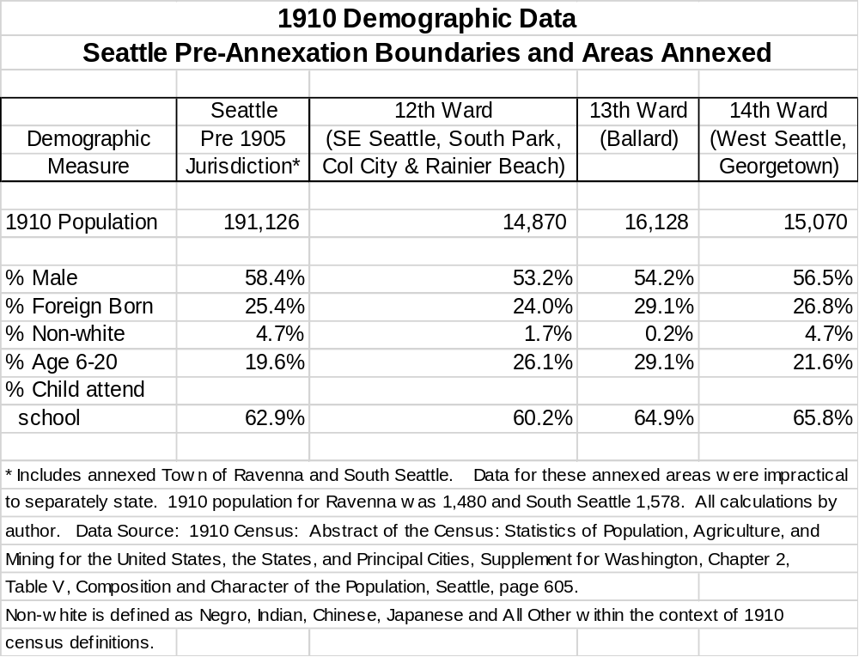

From the above it does not appear that there was any significant social distance between Seattle, on its whole, and its annexed areas. The absence of such differentiation would have aided annexation advocates and detracted from the arguments of opponents. However, key family income and occupational data is unavailable. This missing data detracts from a clear statement that social differentiation between Seattle and annexed areas was absent.

Street Railway – Motivations to Build

The motivations of the West Seattle contingency and their city representatives should be seen as civic improvement. There is no evidence that the West Seattle political leadership was motivated by any public ownership dogma or doctrine. The evidence points to a desire to serve the community and real estate development interests. If the City’s citizenry wanted to transport themselves to Seattle or to the West Seattle waterfront to satisfy social and commercial needs, it was necessary to transverse, by foot, wagon, horse or otherwise, a steep hillside with a change in elevation of nearly 400 feet in under a half mile distance. They faced a challenging chore. A street car would immeasurably improve quality of life. The West Seattle Improvement Club was the prime organizer of support for the construction and operation of the city’s street car. The Club consistently worked to develop West Seattle parks, improved sewerage facilities, public health measures, sidewalks, and beautification programs. The municipal street car was just one of many tasks undertaken.

This is not to deny that the West Seattle street railway served other needs and purposes most particularly real estate speculation and development. Previously, the area was served by a cable car. The cable car ceased operations in 1897. The original 1902 West Seattle city incorporation was premised upon securing a street railway operator. The WSL&ICo real estate sales were enhanced by a street railway. Ira Bronson, WSL&ICo attorney and corporate Vice President, for good reason, pledged to the West Seattle City Council, cooperation in the street railway endeavor. The City and Company came to agreement upon a joint street car–ferry fare, division of revenue and coordinated scheduling. A successful West Seattle street railway implied prevention of competition with WSL&I Co’s owned ferry by a street car crossing the Elliott Bay tide flats and serving the same route(s) as the municipal street car system. Cooperation was to their mutual benefit.

Acknowledgments

The assembly of the material used in this paper was made possible by the efforts of the staff of the King County Archives, Seattle Municipal Archives, the Washington Secretary of State’s Puget Sound Branch Regional Archives and the Seattle School District Archives. Records preserved and catalogued by these heroes of history contributed mightily to the telling of the story herein. Without the aid of the staff of the Seattle Room of the Seattle Public Library and the University of Washington Library, Special Collections, important details would be lacking. Similarly, the volunteers and staff of the Southwest Seattle Historical Society provided critical source materials. Their encouragement to press on was essential.

Several individuals aided over and above the call to duty. I would like to recognize Greg Lange of the King County Archives whose encyclopedic knowledge of archived records, turn of the century land development and mapping records and contextual material suggestions were indispensable. Jordan Hecker, Southwest Seattle Historical Society Advisory Council member provided insight that was critical to understanding the legal environment and maneuvering underlying establishment of the Peninsula’s municipal governance. John Sweetland’s efforts to catalogue and make accessible the West Seattle newspapers of the era under study opened an important research vista. Clay Eals insistence to address the question of ‘why is this important’ gave focus to the project.

The editorial and editing skills of Patricia Ahonen much improved this paper. Her support in the research and writing of this paper is much appreciated. She understood and accepted when the author’s attention was drawn to this paper when it should have been placed elsewhere. Her special ‘shout out’ is well deserved.

The origins of this paper lie in a review of the turn of the twentieth century King County, Washington liquor license files applicable to Alki and West Seattle. The research question revolved around early land use regulation to mitigate nuisances. As is so often the case, something unexpected presented itself. In this case it was an entry in the unpublished index to the Proceedings of the King County Commissioners reading ‘Alki Point, City of’ quickly followed by ‘Alki-Rainier, City of’. A new line of inquiry instantly opened. As the inquiry progressed it became clear that these two index entries were intimately connected to the right to vote and to have every vote counted. Hopefully, this paper contributes to the preservation of democratic ideals and self-governance.

Return To Text

Appendix A
Alki Location Within the City of Seattle, Elliott Bay on the North, Puget Sound on the West and South
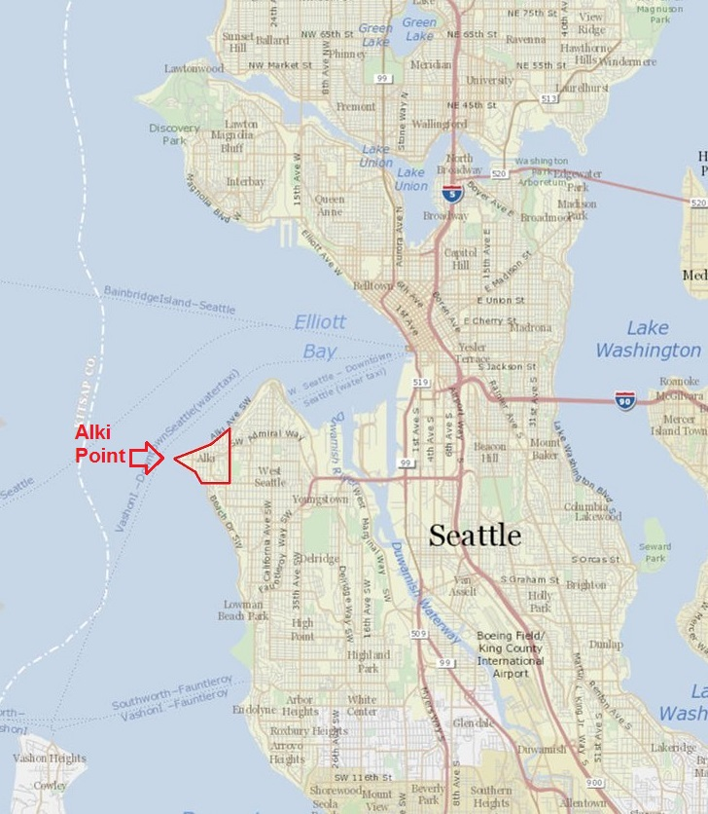
From: King County, WA GIS iMap, Seattle, WA accessed: HYPERLINK "http://www.kingcounty.gov/services/gis/Maps/imap.aspx" http://www.kingcounty.gov/services/gis/Maps/imap.aspx
on June 22,2017. Annotation by author.
Return To Text
Appendix B

Financial Performance Calendar Year 1906 - West Seattle Municipal Railway

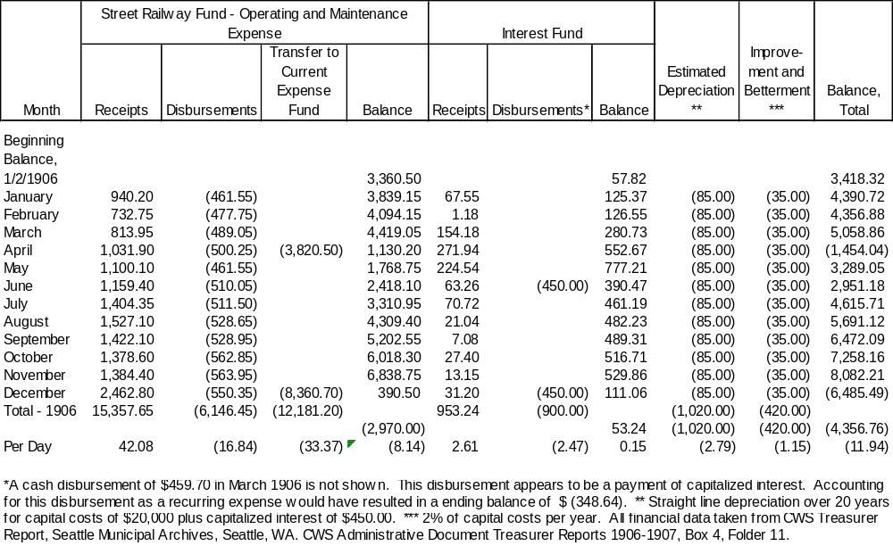

Endnotes

Proponents of legal and extra-legal gambling, vice, prostitution and alcoholic beverages.
Alki Point and Alki are used interchangeably. Both refer to the area, within the City of Seattle defined by SW Spokane Street on the south, 55th Avenue SW on the east and Elliott Bay and Puget Sound on the north and west. Alki Point can also refer to the geographic feature of the most westerly land projection into Puget Sound of the Alki area. Unless the context clearly indicates otherwise, Alki Point, herein, refers to the area define above within the City of Seattle. See Appendix A above.
Notice of Special Election, Seattle Star, Seattle, WA March 4, 1904, page 2.
Session Laws of the State of Washington, Session of 1889-90, Chapter VII – Cities, page 229.
Ballinger Won, Seattle Star, Seattle, WA, March 9, 1904, page 3.
The Town of South Park, in the south of the Peninsula, was annexed to and consolidated with the City of Seattle on May 3, 1907. See City of Seattle ordinance 15917, Seattle Municipal Archives, Seattle, WA.
Phillip Hoffman, Navigate to the Town of Alki, Alki History Project at https://alkihistoryproject.com/manuscripts-presentations-and-research-articles/navigate-to-the-town-of-alki/ , October 1, 2017. The Town of Alki was a place designation. It was not a governance entity.
Knud Olson was the brother in law of Hans Martin Hanson. His wife, Martha, died in child birth some years prior to their Alki arrival. Martha and Anna Hanson were sisters. Their brother, Amud Amuds, would play a significant role in the urbanization of Alki and lands due south as an early land owner and then officer of the Scandinavian-American Bank and subordinate of Andrew Chilberg bank president and brother of Nelson Chilberg. Formerly, Knud Olson, purchased the Alki estate and years later the shared ownership of the estate between Olson and the Hanson was formalized. Prior to the Olson and Hanson ownership tenure, the Alki property was owned by early Seattle resident David S. (Doc) and Catherine Maynard who, in turn, sold Alki and then foreclosed upon Noah S. Kellogg. See: Phillip Hoffman, Alki’s First Housing Finance Crisis Alki History Project.com at: https://alkihistoryproject.com/manuscripts-presentations-and-research-articles/alkis-first-housing-finance-crisis/ February 27, 2017.
King County Book of Deeds, Olson to Chilberg, Vol 61, Page 521 King County Archives, Seattle, WA
Daisy M. Haglund v T. A. Jensen, et al, King County Superior Court, case # 51673, June 15, 1906, Seattle, WA.
See Chilberg’s Addition to West Seattle plat at: https://www.digitalarchives.wa.gov/Record/View/8E0CD211851A81E28560F67B9A2B303D Washington Secretary of State, Digital Archives accessed May 13, 2018.
Andrew Chilberg, Nelson’s brother, assembled the Spring Hill Villa estate in the name of and as president of the Scandinavian-American Bank. See Spring Hill Villa plat at: https://www.digitalarchives.wa.gov/Record/View/548221A49BE3454AE0E6372CF0B64A19 accessed May 13, 2018. Contributing to the estate was fellow Scandinavian – American Bank officer Amud Amunds (a/k/a Amud Amundson), the brother of Anna Hanson and Martha Olson, the wife of Knud Olson. Martha died in childbirth prior to the Alki arrival of the Hansons and Olson. In addition to the Chilbergs and Amuds, lands south of Alki and north of or part of Spring Hill Villa were owned and developed by Samuel Crawford, owner and publisher of the Seattle Post-Intelligencer, and W. F. Boyd, Seattle businessman and photographer. See: Plat of Arabella Amunds Road, 1897, and 1900, King County Road Vault, at: http://info.kingcounty.gov/transportation/kcdot/roads/mapandrecordscenter/mapvault/Default.aspx?DocId=Fa6LL2M52-I1 accessed May 13, 2018. Arabella Amunds Road is now known as Beach Drive SW.
In 1890, Seattlites numbered 42,000 persons. By 1900 their numbers rose to 80,700 and 237,200 ten years later. By any measure, Seattle was a hypergrowth urban region at the turn of the 20th century. Population counts from United States Census of Population for the indicated year.
William H. Wilson, Shaper of Seattle, Reginald Heber Thomson’s Pacific Northwest, Pullman, WA: Washington State University Press, 2009), 67-89.
Ibid, 77.
In the first full year (1902) of operation of the Cedar River Project, water sale receipts were $299,247. Project interest and debt repayment equaled $100,025 or one-third of sale receipts. By 1913, Project interest and debt repayment of $101,285 equaled 11.6% of water sale receipts. Project interest and debt repayments fell relative to water sales by two-thirds. Years later, George Cotterill, chief architect of the Cedar River financing scheme noted “rates (were) reduced far below the Spring Hill rates (the water supply system predating the Cedar River Project) and with increase in business (sale) estimates were exceedingly low. The Klondike rush was on and when bonds were issued there was no trouble selling them, and the money came in so fast that the bonds were going to be paid outright in about 12 years”. Cedar River Project bonds were initially projected to be repaid in a 20 year time horizon at 5% interest per annum. See: Accession No. 0038-001, George F. Cotterill Papers, 1890-1956, Box 27, Folder 15, University of Washington Library, Special Collections, Seattle, WA, page 12-13, Annual Report of the City Comptroller of the City of Seattle for the Year Ending December 31, 1902, Seattle Municipal Archives, Seattle, WA, p. 10, 18, and 23 and For the Year Ending December 31, 1913, p. 6, 10 and 30. The initial Cedar River Project estimated costs and cost financed was $1.25 million. City of Seattle Ordinance 3990, enacted October 269, 1895, City of Seattle, Seattle Municipal Archives, Seattle, WA. In 1897, the Washington Territorial Legislature authorized municipalities to pledge enterprise revenues from water, sewer, cable and street railway, gas, electricity and power sales and retroactively authorized municipalities to proceed with similar acts taken earlier under the provisions of the newly enacted statue. The retroactive provision had the effect of removing any cloud over the previous City of Seattle Cedar River Project financing actions. Session Laws of the Territory of Washington, Session 1897, Chapter CXII, Washington Territorial Legislature.
See, for example: Board of Health Organized, West Seattle Observer, West Seattle, WA, April 16, 1903, page 1 and A Very Busy Session and Ordinance No. 59, West Seattle Observer, West Seattle, WA, May 7, 1903, pages 1 and 3. Southwest Seattle Historical Society, Seattle, WA accession # 2003.20.21 and 2003.20.22.
More About Annexation, John Bushell, West Seattle News, West Seattle, WA, May 22, 1903, page 1. Southwest Seattle Historical Society, Seattle, WA accession # 2003.20.29
Greater Seattle Edition for the Lewis and Clark Exposition, The Seattle Republican, Seattle, WA, August 11, 1905.
Bryanism and Populism. The Seattle Republican, Seattle, WA, May 12, 1905, page 5.
Ballard Council Votes to Annex Immediately, The Seattle Star, Seattle, WA, May 1, 1905, page 1.
West Seattle School, Seattle Post-Intelligencer, Seattle, WA, September 17, 1889, page 4.
Journal of the Proceedings of the County Commissioners, King County, Wash. February 15, 1890, page 94, King County Archives, Seattle, WA.
Superintendent’s Daily Record, King County, Vol. 1, page 163, Puget Sound Regional Branch, Washington State Archives, Bellevue, WA, Educational Service District 121, Superintendent of Schools King County, PS821-11A-0-52B
Ibid.
Ibid, page 188-189.
This is a point worthy of additional research. What is known is that, some years later, the West Seattle School District (District # 73) adopted, September 24, 1907, a rule reading; “that no Japanese or other applicants, not citizens of this country, be admitted to this school (the West Seattle school) unless they are less than 21 years of age …..”. Minutes of School District #73, Vol. 1907-1908, page 9, Seattle School District Archives, Seattle, WA. This rule, as unartfully drawn as it is, is open to several interpretations. One strong interpretation is that any Japanese, regardless of age or citizenship status, was excluded school admission. Another, is that all Native American children were excluded based on citizenship. Native Americans, born within the United States, were not considered citizens until adoption of the Indian Citizenship Act of 1924. Duwamish tribe villages had long been located along the Duwamish River. At least one of these villages was in existence, just north of today’s Alaska Street, at the West Seattle School District’s formation. Washington State Law, since at least 1897, did specify that “Every common school, not otherwise provided for by law, shall be open to admission of all children between the ages of six and twenty-one years residing in that school district.” (Session Laws of the State of Washington, Session 1897, Tittle III – The Common School System, Chapter 1, District Schools, Section 64, page 384).
Session Laws, 1889-90, Chapter XII – Education, Section 19.
Superintendent’s Daily Record, Vol. 1, page 163 and Journal of the Proceedings, page 94.
The West Seattle Land and Improvement Company began its activities in 1888. See: https://en.wikipedia.org/wiki/West_Seattle_Land_and_Improvement_Company The Niesz-Whittksey and Company began its platting and development activities under the name West Seattle Five Acre Tracts as early as 1885. See plat dated September, 1885 at: https://www.digitalarchives.wa.gov/DigitalObject/Download/8BC31134-D41A-452D-955A-BDA0125A87F7 and plat dated January, 1890 at: http://cdm16118.contentdm.oclc.org/cdm/ref/collection/p16118coll2/id/61
The Teachers Who Receive Certificates – The West Seattle District, Seattle Post-Intelligencer, Seattle, WA, February 16, 1890, page 8 and West Seattle District, February 20, 1890, page 8.
Local, The West Seattle Observer, West Seattle, WA, October 9, 1902, page 2 and Free Text Books, West Seattle Tribune, West Seattle, WA, August 5, 1905, page 1, Southwest Seattle Historical Society, Seattle, WA Accession# 2003.20.15 and 2003.20,35.
Session Laws of the State of Washington, 1899 Session, Chapter XIV – Formation and Alteration of School Districts, page 21.
Fifty years previously, Alki was home to two grog shops. See: Charlotte Coffin Gardner, Journal Kept by Charlotte Coffin Gardner While Onboard Ship Sarah Parker, 1852-1855, San Francisco Maritime National Historic Park, Maritime Research Center, San Francisco, CA. Typescript of Journal, April 7, 1853 page 10.
General Laws of the Territory of Washington, Chapter LXXII – An Act to Regulate, Restrain, License, or Prohibit the Sale of Intoxicating Liquors, Section 1, February 2, 1888, page 124.
King County Board of Commissioners, Vol 15, page 48, Record Group 011, Liquor License Files, Series 113, Box 2, Item 1310, King County Archives, Seattle, WA. When Hans Martin and Anna Hanson distributed their land holdings to their children the most western 28 feet at Alki’s Point came into the possession of their only son Edmund Hanson.
Journal of the Proceedings of the County Commissioners, Vol 14, page 577, and Record Group 011, Liquor License Files, Series 113, Box 2, Item 1247, King County Archives, Seattle, WA.
Measurements by author.
Journal of the Proceedings of the County Commissioners, Vol. 14, page 511. King County Archives, Seattle, WA.
Petition for the Incorporation of the City of Alki Point, Seattle Star, Night Edition, Seattle, WA, September 28, 1904, page 6.
Ibid. Perry C. Copp (sic, Percy G. Copp) was a boat builder who resided in the Alki community at 4102 Alki Avenue (now Beach Drive). Years later he would move to West Seattle’s Admiral Junction District. Albert Bender passed away in 1909. His wife, Theresa, and family continued to reside in the South Alki (Spring Hill Villa) community at 4148 Chilberg Avenue for many years thereafter. Nothing is known of W. J. Blackburn. He may have left town and his contemporaries were unable (or unwilling) to locate him. He may have been a party to mortgage fraud (George W. Moore, respondent v W. J. Blackburn, et al. Appellants, Washington Reports of the Supreme Court of Washington, Vol. 67, February 2, 1912, page 117.)
City of West Seattle Council Minutes Book, Volume One, pages 243 - 249, August 9, 1904 and pages 251 - 255, August 16, 1904, Seattle Municipal Archives, Seattle, WA
Ibid. Boundaries of the proposed annexation area are described in the special election resolution.
For an inventory of Puget Mill Company land holdings see: University of Washington, Special Collections, Edwin Gardner Ames Papers, Accession # 3820-001, Box 113, Folders 10 and 12, Seattle, WA. See also: O P Anderson Map Company, Map of West Seattle 1907, reprinted in West Side Story (Robinson Newspapers, Seattle, WA, 1987), page 46.
The original petition filed with the Board of Commissioners has been purged from County records. No copy of the petition is known to exist. The three known petitioners were cited in the required legal notice of the petition and special election published in the Seattle Star, Seattle, WA, August 18, 1904, page 8.
Journal of the Proceedings of the County Commissioners, Vol. 14, pages 522, 525, 531, 539, and 543, August 1904-October 1904, King County Archives, Seattle, WA.
The Puget Mill Company was a leading timber and lumber mill company in the Pacific Northwest. It was a subsidiary of Pope and Talbot Company located in San Francisco, CA. The Company was managed by the brothers William and Cyrus Walker and Edwin Ames. The Company had numerous interests but its most important mills were located at Port Gamble and Port Ludlow. The Company had significant land holdings in and around Seattle, including what would become the Washington Park Arboretum and a large portion of the eastern side of the Duwamish Peninsula. See endnote 44 above.
Contemporaneous news reports indicate that the concurrent majorities approved the annexation 17 to 12 in the area to be annexed and 71-19 in the City of West Seattle. See: Annexed, The Seattle Star, Seattle, WA, September 29, 1904, page 7, column 4. Technically, the Puget Mill Company sought to prohibit the canvassing of votes cast. Canvassing is the act of counting and verifying various precinct vote totals and determination of total election district results. Canvassing results are an ‘official’ vote count. Both sides knew the unofficial vote result. The Puget Mill Company would have had no incentive to have pursued the matter if the votes to be canvassed had disapproved the proposed annexation. Similarly, the City of West Seattle would have had no incentive to defend the right to canvas the vote if the preliminary vote totals indicated disapproval of the proposed annexation.
Puget Mill Company v City of West Seattle, King County, Washington Superior Court, Case # 44569. Washington Secretary of State, Puget Sound Regional Archives, Bellevue WA and King County Superior Court Clerk, Seattle, WA.
See endnote 48 above.
Session Laws of the State of Washington, Session 1889-90, An Act Providing for the organization, classification, incorporation and government of municipal corporations, and declaring an emergency, Section 15, page 141.
City of Seattle, Seattle City Clerk’s Office Comptroller File # 35742, Seattle Municipal Archives, Seattle, WA
Events taking place in 1907 would have these enclaves annexed into the City of West Seattle. Today we know these enclaves as the Marshall Reserve and Hamilton Viewpoint Park. The second and most western reserve remains undeveloped due to topographical issues, has no current designation and is largely, but not exclusively in the ownership of the City of Seattle Department of Parks and Recreation. See: First Plat of West Seattle By The West Seattle Land and Improvement Company, Washington State Digital Archives, at: https://www.digitalarchives.wa.gov/DigitalObject/Download/8a9c196b-883f-47fb-ab8f-9a2950a28d19 , Sherwood Park History Files, Seattle Municipal Archives, Seattle, WA, Hamilton View Point at: http://clerk.seattle.gov/~F_archives/sherwood/HamiltonVP.pdf and City of Seattle Comptroller File # 35742, Seattle Municipal Archives, Seattle, WA.
Seattle City Comptroller File #35742, Proceedings of Incorporation As A City of the Fourth Class, Proviso to Boundaries Description, Seattle Municipal Archives, Seattle, WA, and First Plat of West Seattle by the West Seattle Land and Improvement Company, accessed at: https://www.digitalarchives.wa.gov/Record/View/B3AF113E2ACCAE8184CA51D3F61AD153
See endnote 48 above
Session Laws of the State of Washington, Session 1889-90, An Act Providing for the organization, classification, incorporation and government of municipal corporations, and declaring an emergency, Section 9, page 136.
School District Boundary Record, King County, Vol. 2, District # 73, Puget Sound Regional Branch, Washington State Archives, Bellevue, WA, Educational Service District 121, Superintendent of Schools King County, PS821-11A-0-310.
In addition to the territory severed from the West Seattle District, the territory of the new District # 151 also included the Elliot Bay and Duwamish tide flats and waterways to the centerline of Elliott Bay. See: School District Boundary Record, King County, Vol. 3, District # 151, Puget Sound Regional Branch, Washington State Archives, Bellevue, WA, Educational Service District 121, Superintendent of Schools King County, PS821-11A-0-310.
Record of the Minutes of the Meetings of Seattle Chamber of Commerce, 1907-1909, May 15, 1907, page 53, Seattle Room, Seattle Public Library, Seattle, WA.
Record of the Transactions In Connection With The Pacific Steel Company Matter, Seattle, WA, December 30, 1902, pages 3-4, contained, as a separate document in the Record of the Minutes of the Meetings of Seattle Chamber of Commerce, July 2, 1902-June 2, 1903, Seattle Room, Seattle Public Library, Seattle, WA.
See: “Seattle Public Schools, 1862-2000: Frank B. Cooper Elementary School”, HistoryLink.org Essay 10489 at http://www.historylink.org/File/10489
Session Laws of the State of Washington, Session 1897, Chapter CXVIII – Code of Public Instruction, Section 70, page 385.
Census data at the necessary geographic level to definitively judge the social class differences between these two communities is unavailable. The role played by social, economic and ethnic differences is a topic that should be pursed further. It is known that these class differences during the 1920s and 1930s played a role in the divergent development paths of the West Seattle community on the ridge above the Youngstown area. See: http://www.loghousemuseum.org/history/delridge-history/
Session Laws of the State of Washington, Session 1903, Chapter 104 – Amending the Code of Public Instruction, Section 1, page 157.
West Seattle Minutes Book, Vol 2, page 8, Seattle Municipal Archives, Seattle, WA.
Also excluded were small holdings in the lower southeast quadrant of the former annexation area, owned by the WSL&I Co and the Drew Investment Company. The Drew Investment Company was managed by Fred Drew, Puget Mill Company Log and Land Agent. Drew’s ownership and/or partnership with the Puget Mill Company is unclear but the Investment Company was managed out of the offices of the Puget Mill Company by Fred Drew. See: University of Washington Library, Special Collections, Edwin Gardner Ames Papers, Accession # 3820-001, Box 130, Folders 1-20, Seattle, WA. See: O P Anderson Map Company, Map of West Seattle 1907, reprinted in West Side Story (Robinson Newspapers, Seattle, WA, 1987), page 46.
Adella M. Parker, The First Municipal Street Railway in America, “The Independent”, S. W. Bennett Publisher, New York, NY, Vol. 60, May 17, 1906, p. 1153 (see: Hathi Trust Digital Library), and West Seattle Minutes Book, Vol. 2, page 16-17, Seattle Municipal Archives, Seattle, WA. During West Seattle’s street railway ownership and operation there would be several proposals for railway extension. All these extensions were to be financed on a subscription basis. For an example see: Letter from J. W. Hainsworth of Elliott Bay Realty Company to W. G. Dickinson, West Seattle City Clerk, and attachment, April 4, 1906, City of West Seattle Correspondence 1903-1907, Box 2, Folder 20, Seattle Municipal Archives, Seattle, WA. Lincoln Beach is not to be confused with Lincoln Park. See: Don Sherwood Park History Files, Seattle Municipal Archives, Seattle, WA at: http://clerk.seattle.gov/~F_archives/sherwood/LowmanBeach.pdf
Affidavit of Herbert N. DeWolfe, January 24, 1906, Puget Mill Company v City of West Seattle, King County Superior Court, Case # 44569. Washington Secretary of State, Puget Sound Regional Archives. Bellevue, WA.
West Seattle Minutes Book, Vol. 1, pages 96 and 101 and City of West Seattle Ordinance #56. Seattle Municipal Archives, Seattle, WA.
City of West Seattle Ordinance #56, Seattle Municipal Archives, Seattle, WA.
Formal revocation of the Furth franchise took place by ordinance adopted on April 19, 1904 (City of West Seattle Ordinance # 86, Seattle Municipal Archives, Seattle, WA).
West Seattle Minutes Book, Vol. 1, pages 173 and 178, Seattle Municipal Archives, Seattle, WA.
Waiting to Hear From the War Department, West Seattle News, West Seattle, WA, April 11, 1903, p. 1. Southwest Seattle Historical Society, Seattle, WA, accession # 2003.20.25. The permission to be sought was use of navigable waterways under the Rivers and Harbors Act of 1899.
Records Group 77, Records of the Office of the Chief of Engineers, Seattle District, Operations & Maintenance Subject Files, Bridges and Obstructions, (1902-1903), National Archives and Records Administration, Seattle District Office, Seattle, WA. Permission was ultimately granted under application dated September 10, 1906 based upon a second franchise granted and accepted from the City of West Seattle as of August 13, 1906. See: Records Group 77, Records of the Office of the Chief of Engineers, Seattle District, Operations & Maintenance Subject Files, Bridges and Obstructions, (1902-1903) Box #5, National Archives and Records Administration, Seattle District Office, Seattle, WA.
Index to the Journal of the Proceedings of the Board of County Commissioners 1902-1907, King County, Washington and Index to franchises, permits, easements and agreements, 1889-1918, RG 011, Series 342, King County Archives, Seattle, WA. A franchise was ultimately granted by King County, Washington, August 30, 1906. See: Journal of the Proceedings of the Board of County Commissioners, Vol. 15, page 256 and Index to franchises, permits, easements and agreements, 1889-1918, RG 011, Series 342, Box 1, Folder 11-342, page 39, King County Archives, Seattle, WA
West Seattle Minutes Book, Vol. 1, page 176, Seattle Municipal Archives, Seattle, WA.
West Seattle Minutes Book, Vol. 1, page 184, Seattle Municipal Archives, Seattle, WA.
West Seattle Minutes Book, Vol. 1, page 194, Seattle Municipal Archives, Seattle, WA.
Public utility holding companies became particularly notorious for stock manipulation, undercapitalization of their operating companies, intercompany charges designed to inflate the basis for rate setting even when in a rate regulated environment, evasion of state public service and rate regulation, disregard for the convenience of the consuming public and other anti-competitive acts. The utility holding companies were finally brought to ‘heel’ by the Great Depression and Franklin Roosevelt’s Public Utility Holding Company Act of 1935. Under the nation’s reorganization of the holding companies (most were technically bankrupt) pursuant to the 1935 Act, Stone & Webster evolved into a utility engineering and service company.
Leslie Blanchard, The Street Railway Era In Seattle, A Chronicle of Six Decades (Forty Fort, PA: H.E. Cox, 1968), page 50-56.
John Putman, Class and Gender Politics In Progressive-Era Seattle (Reno, NV: University of Nevada Press, 2008), pages 40 -49.
Ibid.
The Estate of Amos Brown was managed by Brown’s son, A. L. Brown. Amos Brown had been an early Seattle real estate investor. His initial fortune was made in the timber industry. Ironically, Amos Brown had served as a member of the Seattle City Council. See: http://www.historylink.org/File/3755
Yakey was appointed to the Kitsap County Superior Court bench on February 28, 1905. Seattle Times, Seattle, WA, March 5, 1905, page 14.
West Seattle Minutes Book, Vol 2. page 33, Seattle Municipal Archives, Seattle, WA and Gets Annexation Certificate, Seattle Times, Seattle, WA, May 23, 1905, page 4.
Findings of Fact and Conclusions of Law, February 15, 1906 by Judge Arthur Griffin, Estate of Amos Brown, Inc v City of West Seattle, King County Superior Court, Case # 46912, Washington Secretary of State, Puget Sound Regional Archives, Bellevue, WA and Letter of Richard Saxbe Jones, legal counsel to the City of West Seattle, to Major Emil deNeuf, February 7, 1906, Seattle Municipal Archives, City of West Seattle Correspondence, Box 2, Folder 22.
Amos Brown’s Estate, Inc. v. City of West Seattle et. al. Washington Supreme Court, June 29, 1906, 85 Pacific Reporter 854. The trial court did find that the City of West Seattle had been properly promoted to a city of the 3rd class; hence the City of West Seattle could be enlarged to a territory greater than one square mile and contain, without the owner’s permission, more than 20 acres of un-platted territory. The question of the City of West Seattle’s correct classification was not appealed. The question of annexation merits was also not heard by the trial court.
Ibid.
Session Laws of the State of Washington, Session 1899, Chapter XIV – Formation and Alteration of School Districts, Section 2, page 21. This provision of State Law would later result in the merger of the WSSD and District # 151 with the annexation by the City of West Seattle of the entire Duwamish Peninsula north of Roxbury Street to the centerline of Elliott Bay, Puget Sound and the western shore of the Duwamish River. This merger would be effective June 30, 1907.
The boundaries reflect the new City of West Seattle limits, plus the Alki and Spring Hill Villa areas previously part of the WSSD.
The City of West Seattle held a municipal general election in December, 1905 at which voters residing in the contested annexation area voted. A candidate residing in the contested area was elected a city council member.
Robert E. Bowman, “Hansen/Gundvaldsen Genealogy”, Bulletin Seattle Genealogical Society, Seattle, WA, Vol. 59 No. 1 (Autumn/Winter 2009-2010), page 17 and Attractions At Alki Point, Seattle Sunday Times, Seattle, WA, June 18, 1905, page 52.
Journal of the Proceedings of the County Commissioners, Vol. 14, page 610 and Vol. 15, page 48 and King County Commissioners, Record Group 011 Liquor License Files, Series 1/3, Items 1310 and 1312, Deed (unexecuted), and Plat Relative to Saloon at Alki and Petition Against Granting a Liquor License, King County Archives, Seattle, WA.
Retires from the Stockade Hotel, Seattle Times, Seattle, WA June 19, 1905, page 7.
Journal of the Proceedings of the County Commissioners, Vol. 15, Page 50, Record Group 011 Liquor License Files, Series 1/3, Liquor License Application, Item 1312, King County Archives, Seattle, WA.
The City of West Seattle entertained several initiatives to extend the street railway line in addition to that subject to the March and April 1905 annexation proposals. The initiatives were grounded in a scheme for residents and property owners to finance the extension on a subscription basis.
Alki Point to Incorporate, Seattle Times, Seattle, WA, February 26, 1906, page 3.
Journal of the Proceedings of the County Commissioners, Vol. 15, Page 186, Record Group 011 Liquor License Files, Series 1/3, Liquor License Application, Item 1372, King County Archives, Seattle, WA.
Washington State prohibition would begin January 1, 1916. National prohibition ended in December, 1933 with Washington State beginning to regulate alcoholic beverages in January, 1934.
West Seattle Minutes Book, Vol Two, page 77-78, Seattle Municipal Archives, Seattle, WA
Denniston was operator of the Alki – Seattle Ferry and had many other business interests.
West Seattle News, West Seattle, WA. various issues beginning with May 15, 1903 and ending June 19, 1903, Southwest Seattle Historical Society, Seattle, WA accessions # 2003.20.28 – 2003.20.32. Quotation is from the June 19, 1903 issue. George Nicoll was a West Seattle Councilmember and Mayor. Kasson was president of the Improvement Club, served as School District Board member and an electrical contractor. DeWolfe served as city attorney until mid-1905 and was also a real estate sales entrepreneur. Andrews’ was an early West Seattle City Council member.
M.O.P. Attempts To Hoodwink People, Seattle Daily Times, Seattle, WA, October 5, 1906, page 2.
West Seattle Minutes Book, Vol. 2, page 109. Seattle Municipal Archives, City of Seattle, Seattle, WA.
Ibid.
Sale of the railway took place mid-March 1907. Originally the sale was expected to take place by January 14, 1907. But, as was becoming common in West Seattle matters, the authority of the City to make the sale was challenged. In response, the City Council requested its state representative, Samuel Coles, to sponsor a bill (H.B. 133, 1907 Session) effectively granting retroactive authority to the City of West Seattle to “sell and convey any line or lines of street railway”. The bill became law March 8, 1907 (Session Laws of the State of Washington, Session 1907, Chapter 86, p 166).
Index to Franchises, King County Archives, Seattle, WA, RG 011, Series 342, Box 1, pages 39-40 and Journal of the Proceedings of the County Commissioners, King County Archives, Seattle, WA, Vol. 15 page 256 and 295
Session Laws of the State of Washington, Session 1903, Chapter 145 – Amending An Act Providing for the Organization and Government of Municipal Corporations, page 279. This act provided that when cities of the third- or fourth-class desired annexation to a city of the first class that no election was required in the city of the first class.
See: Annexation Tool, Seattle Municipal Archives, Seattle, WA accessed at: http://clerk.ci.seattle.wa.us/~F_archives/annexations/annexations.htm and http://clerk.ci.seattle.wa.us/~public/annexed.htm
Session Laws of the State of Washington, Session 1903, Chapter 145, p. 279. Senator Kinnear was the brother-in-law of A. L. Brown, president of the Amos Brown Estate. At the time of the 1903 enactment Brown and Kinnear were business partners. See: Bagley, History of Seattle p. 805.
Former Senator Dies After Suicidal Act, Seattle Daily Times, Seattle, WA, May 15, 1912, page 7. Letters from M. S. Drew to Cyrus Walker, University of Washington Libraries, Special Collections, Edwin Ames Papers, 1856-1931, Accession 3820-001,Box 55, Folder 5. Washington C. Rutter, Polk’s Seattle City Directory, 1890, page 614 and 1894-95, page 707. The Kittanning Copper Mining Company Stock Certificate, July 5, 1900 accessed May 14, 2018 at: http://www.oldwesthistorystore.com/_wizardimages/shopkittanninglarge.jpg Washington C. Rutter, Polk’s Seattle City Directory 1900, page 896 and 1901, page 1016. Geology and Ore Deposits of the Index Mining District, Washington Geological Survey, State Geologist, Olympia, WA, 1912 accessed June 2, 2018 at: http://www.dnr.wa.gov/publications/ger_b7_geol_ore_dep_indexdistrict.pdf
"United States Census, 1880," database with images, FamilySearch (https://familysearch.org/ark:/61903/1:1:MXT6-2YM : 15 July 2017), M S Drew, Port Gamble, Kitsap, Washington, United States; citing enumeration district ED 34, sheet 301D, NARA microfilm publication T9 (Washington D.C.: National Archives and Records Administration, n.d.), roll 1397; FHL microfilm 1,255,397.
State of Washington Members of the Legislature, 1889-2011, Legislative Information Center, Olympia, WA accessed May 1, 2018 at http://leg.wa.gov/History/Legislative/Documents/MembersOfLeg2011.pdf In 1889 Rutter and Drew were members of the Legislature’s House of Representative.
Ames Papers, Accession 3820-001, University of Washington Library, Special Collections, Box 130, Folder 3. See also endnote 66.
O.P. Anderson Map Company, Map of West Seattle 1907, reprinted in West Side Story (Robinson Newspapers, Seattle, WA, 1987), page 46.
King County Archives, Seattle, WA, Journal of the Proceedings of the County Commissioners, King County, Washington, October 8, 1906, Vol. 15, page 305.
King County Archives, Seattle, WA, Journal of the Proceedings of the County Commissioners, King County, Washington, December 13 and 17, 1906, Vol. 15, pages 360 and 362.
This changed with the annexation and consolidation of the City of Southeast Seattle in January and the Town of South Park in May of 1907.
Affidavit of B. W. Baker and George A. Smith, January 15, 1907, page 3, King County Superior Court, Rutter v. King County Board of Commissioners, Case # 54370.
State of Washington ex rel, W. C. Rutter and Emma B. Rutter v P. C. Smith, Dan Abrams and Charles Beckingham as County Commissioners of King County, Washington, King County Superior Court, Case # 54370, January 12, 1907, Seattle, WA, Complaint, paragraph V and Suburban Tons Ought To Join Seattle, Seattle Daily Times, Seattle, WA, December 11, 1906, page 14.
In later years, such an incorporation or annexation boundary would become known as a ‘shoestring’ boundary and would be held suspect, except in unusual circumstances, by judicial and administrative officials. See: Annexation by Washington Cities and Towns, Municipal Research and Services Center, Seattle, WA, 2014, page 105-106.
State of Washington ex rel, v P. C. Smith, et al as County Commissioners of King County, Washington, King County Superior Court, Case # 54370, January 12, 1907, Seattle, WA.
Ibid. Temporary Injunction, January 17, 1907.
Suburban Towns Ought To Join Seattle, Seattle Daily Times, Seattle, WA, December 11, 1906, page 14 and Alki-Rainier Incorporation May Fail, Seattle Sunday Times, Seattle, WA, November 25, 1906, page 29.
See: http://clerk.ci.seattle.wa.us/~F_archives/annexations/, Seattle Municipal Archives, Seattle, WA
Records of the Minutes of the Meetings of Seattle Chamber of Commerce, July, 1902-June, 1903, page 117, 216-217, and 220. Records of the Minutes of the Meetings of Seattle Chamber of Commerce, July, 1903 – December 4, 1904, page 3-4, 6, 36-38, 113. Seattle Public Library, Seattle Room, Seattle, WA. Special Committee members, in addition to Cotterill were Thomas W. Prosch, George W. Sinclair, Fred E. Sander, E. S. Shorrock and two others, one of whom was likely to have been James W. Clise. Surviving records do not indicate with certainty the identity of the unidentified members.
Senate Journal of the Tenth Legislature of the State of Washington, Adjourned Sine Die, March 14, 1907, page 5 – 10.
Record of the Minutes of the Meetings of Seattle Chamber of Commerce, 1907-1909, April 24, 1907, Seattle Public Library, Seattle Room, Seattle, WA.
Record of the Minutes of the Meetings of Seattle Chamber of Commerce, 1907-1909, May 15, 1907, page 51, Seattle Public Library, Seattle Room, Seattle, WA.
General Laws of the Territory of Washington, Chapter LXXII, page 124 and Record Group 011, Liquor License Files, Series 113, Items 1410, 1426, and 1454, Box 1, 2 and 3.
Senate Journal of the Tenth Legislature of the State of Washington, 1907, p. 460.
The Southern Pacific, West Seattle Gazette, August 16, 1890, page 4, West Seattle, WA Southwest Seattle Historical Society, Seattle, WA accession # 2003.20.11
See the following 1888-89 plats and surveys: Whites and Manning, at: https://www.digitalarchives.wa.gov/Record/View/214655551AE62BEDAB80160FA557EDDD Faegres 1st and 2nd Addition, at: https://www.digitalarchives.wa.gov/Record/View/68C2AC22755239E04369B3D811C41B4D and https://www.digitalarchives.wa.gov/Record/View/F113C2D4E02D694936BEE3562DD592F2 South Haven Addition, at: https://www.digitalarchives.wa.gov/DigitalObject/Download/3a7a1e84-37fa-47b6-9f7b-bd08476727be Southern Pacific Addition, at: https://www.digitalarchives.wa.gov/Record/View/F114FEA721471EA1E92017A10BECB586 Sander’s 1st and 2nd Addition at: https://www.digitalarchives.wa.gov/DigitalObject/Download/A2897AB1-82B8-45E3-A188-7BAE4C64CC6E https://www.digitalarchives.wa.gov/DigitalObject/Download/0DD43822-016F-42AE-8898-508CF0014689 Star Addition at: https://www.digitalarchives.wa.gov/DigitalObject/Download/c3bbc43f-0ba4-48e9-98c8-218462505cc0
The New Elevator, West Seattle Gazette, August 16, 1890, page 1, West Seattle, WA Southwest Seattle Historical Society, Seattle, WA accession # 2003.20.11
Journal of the Proceedings of the King County Commissioners, Vol. 14, page 219, King County Archives, Seattle, WA.
King County Road Services Map Vault, Bellevue, WA access at: https://info.kingcounty.gov/transportation/kcdot/roads/mapandrecordscenter/mapvault/ In particular see, for Section 13, Township 24N, R 3E, EMMA SCHMITZ RD COUNTY ROAD 675, road established August 15,1903 (now known by various names connecting Spokane Avenue and California Avenue to the south and west) and D MCKINNON RD COUNTY ROAD NO 642, road established April 21, 1904 (now known as Delridge Way).
Richard C. Berner, Seattle 1900-1920, (Seattle, WA: Charles Press, 1991), pages 21-29.
Record of the Transactions in Connection with The Pacific Steel Company Matter, December 30, 1902 as recorded by James B. Merkley, Secretary of the Seattle Chamber of Commerce, pages 1-6 found stored in the Record of the Minutes of the Meetings of Seattle Chamber of Commerce, July 2, 1902-June 20, 1903, Seattle Room, Seattle Public Library, Seattle, WA.
William Pigott (1860-1929), David Wilma, HistoryLink.org, Essay 3177, April 8, 2001, accessed at: http://historylink.org/file/3177
Plat of Oyster Claims Belonging to A. H. Manning and Others As Shown on Annexed Plat, accessed https://www.digitalarchives.wa.gov/Record/View/144E4D665BD77AF005B4C5AF9EAB8E56
Remonstrance to The Board of County Commissioners, March 14, 1905, Journal of the Proceedings of the County Commissioners, Vol 15, page 186, RG 011, Series 113, Item 1371, King County Commissioners, Liquor License Files, March 19, 1904 - January 15, 1908, Boxes 2 and 3, King County Archives, Seattle, WA
Remonstrance Against Saloon Licenses at Youngstown, Journal of the Proceedings of the County Commissioners, Vol 15, page 483, RG 011, Series 113, Item 1495, King County Commissioners, Liquor License Files, March 19, 1904-January 15, 1908, Boxes 2 and 3, King County Archives, Seattle, WA
To File Petition for Annexing Youngstown, Seattle Daily Times, Seattle, WA, February 21, 1907, page 4, and Ready to Ask for Election, Seattle Daily Times, Seattle, WA, March 6, 1907, page 4.
Journal of the Proceedings of the County Commissioners, April 30, 1907, Vol 15, page 471, King County Archives, Seattle, WA
Will Close Up Youngstown, Seattle Star, Seattle, WA, April 20, 1907, page 1.
King County Board of Commissioners Files, Record Group 0111, Section 113, Items 1410, 1417, 1426 and 1454, King County Archives, Seattle, WA
Ascertains Distance From the City Line, Seattle Daily Times, Seattle, WA, April 22, 1907, page 8.
To Arrest Saloon Keepers At Youngstown, Seattle Daily Times, Seattle, WA, April 30, 1907, page 1 and King County Superior Court Case # 55813, Wilson v King County Board of County Commissioners, King County Superior Court Clerk, Seattle, WA
Ordinance # 172 of the City of West Seattle, Seattle Municipal Archives, Seattle, WA.
Ibid
Record of the Transactions in Connection with The Pacific Steel Company Matter, December 30, 1902 as recorded by James B. Merkley, Secretary of the Seattle Chamber of Commerce, pages 1-6 found stored in the Record of the Minutes of the Meetings of Seattle Chamber of Commerce, July 2, 1902-June 20, 1903, Seattle Room, Seattle Public Library, Seattle, WA.
Record of the Transactions in Connection with the Pacific Steel Company Matter, January 14, 1903, pages 7-8. The townsite, surrounding the planned plant apparently did not prove feasible given the pre-existing land ownership pattern around the plant site or was discarded due to financial constraints.
Attempt to Block Annexation, Seattle Daily Times, Seattle, WA, April 24, 1907, page 4.
Ordinance # 172 of the City of West Seattle, Seattle Municipal Archives, Seattle, WA.
G. A. Hill and Julia D. Hill v The City of West Seattle, King County Superior Court, Case # 56072, Seattle, WA. Defendants’ Return, paragraph XI. Washington Secretary of State, Puget Sound Regional Archives, Bellevue, WA.
Journal, In the Superior Court of the State of Washington, for the County of King, Department # 4, Friday March 24, 1907, Book 264, page 255.
West Seattle Minutes Book, Vol 2. Page 156, Seattle Municipal Archives, Seattle, WA.
Journal of the Proceedings of the County Commissioners, May 28, 1907, Vol 15, page 493, King County Archives, Seattle, WA and Says Antis Have No Chance, The Seattle Daily Times, Seattle, WA, May 28, 1907, page 13. In the course of an early May 1907 proceeding, the attorney for the Youngstown incorporation petitioners, W. R. Bell, removed from the files of the Commission the incorporation petition and failed to return it. Bell and the Commission were advised that Bell’s taking was tantamount to withdrawal of the petition. Bell’s failure to return the petition was, presumably, to prevent inspection of the petition for false signatures. The Commission’s final action in the matter, in light of the missing petition, was to direct that the Youngstown incorporation be “stricken from the calendar”. See: Petition Must Be Refiled, Seattle Daily Times, Seattle, WA, May 8, 1907, page 9.
James F. Wilson was to die October 27, 1907 as a result of injuries suffered in an early September 1907 automobile accident. His death (at age 37 according to his Probate Case file) ended his career as a former deputy sheriff, King County Auditor employee, Republican Party activist, private detective, saloon keeper and horse racing enthusiast. Members of the State Legislature were riding in Wilson’s ill-fated vehicle, one of whom also died as a result of injuries suffered in the same accident as Wilson. From whatever assets Wilson left behind, his wife had to pay, to a San Francisco merchant, an outstanding fifty-dollar cigar bill. There is at least one news report, of the time, suggesting that Wilson was president of the Seattle Steel Company. This report is suspect. Wilson failed to show any background which would demonstrate an interest in or capability to hold such a position. An incorporator of the Steel Company was E. M. Wilson. A neighboring property owner was an E. M. Wilson. E. M. Wilson and Etta M Wilson, James Wilson’s wife, are not believed to be one and the same.
School District Boundary Record, Vol. 3, District 151, page 1, Puget Sound Regional Branch, Washington State Archives, Bellevue, WA, Educational Service District 121, Superintendent of Schools, King County, PS821-11A-0-310.
West Seattle Minutes Book, Vol. 2, page 171, Seattle Municipal Archives, Seattle, WA
City of Seattle Ordinance # 16558, enacted July 24, 1907, Seattle Municipal Archives, Seattle, WA.
West Seattle Minutes Book, Vol. 2, page 178, Seattle Municipal Archives, Seattle, WA
West Seattle Minutes Book, Vol. 2, page 100, Seattle Municipal Archives, Seattle, WA
West Seattle Minutes Book, Vol. 2, pages 137, 142 and 149, Seattle Municipal Archives, Seattle, WA
School District Boundary Record, King County, Vol. 2, District # 73, Puget Sound Regional Branch, Washington State Archives, Bellevue, WA, Educational Service District 121, Superintendent of Schools King County, PS821-11A-0-310
Session Laws of the State of Washington, 1907 Session, Chapter 240 - Amending Act Relating to the Public School System, Section 17, pages 621-622.
Minutes of District 73 (West Seattle School District) Board of Directors, 1907-1908, June 30, 1908, page 29, Seattle School District Archives, Seattle, WA.
The Washington State Legislature, at its 1907 Session, provided that the effective date of school district jurisdictional changes would be June 30th following the date of annexation. Annexation of the City of West Seattle to the City of Seattle was effective July 24, 1907, thereby making June 30, 1908 the effective date of merger of the WSSD into the Seattle School District. See: Session Laws of the State of Washington, Session 1907, Chapter 640, Amending Act Relating to the Public School System, Section 17, page 621-622.
Financial and Statistical Report of the Common Schools of King County, For the School Year Ending June 30, 1908, Washington Secretary of State, Puget Sound Regional Branch Archives, Bellevue, WA, Educational Service District 121, Superintendent of Schools, King County, PS821-11A-0-52B, Superintendent’s Daily Records, Vol 3.
Except for a few minor annexations, there would be no major enlargement of Seattle’s jurisdiction until the 1950’s.
Session Laws of the State of Washington, Session 1907, Chapter 245, p. 676. The bill was enacted March 19, 1907 and was authored by Representative Samuel Coles and managed in the State Senate by George F. Cotterill. See House Journal of Tenth Washington State Legislative Session, p. 285 and Senate Journal of Tenth Washington State Legislative Session, p. 893-894.
Seattle Population Letter to the Editor by George Cotterill, Seattle Daily Times, Seattle, WA, March 12, 1910, page 5.
Thirteenth Census of the United States, 1910, Population by Counties and Minor Civil Divisions 1910, 1900, and 1890, Government Printing Office, Washington, D. C. and census enumeration sheets for Enumeration District 182, Precinct 8 and 9, 10th Ward, Seattle, King County, WA. Calculations by author.
U. S. Bureau of the Census, Table 13. Population of the 100 Largest Urban Places: 1900 at: https://www.census.gov/population/www/documentation/twps0027/tab13.txt and U. S. Bureau of the Census, Table 14. Population of the 100 Largest Urban Places: 1910 at: https://www.census.gov/population/www/documentation/twps0027/tab14.txt accessed September 3, 2018.
Annexation Has Opposition In Council, Seattle Daily Times, Seattle, WA, August 19, 1907, page 6.
Ibid.
Petition of the City of Renton for annexation to the City of Seattle, City of Seattle Comptroller File # 74259, Seattle Municipal Archives, Seattle, WA.
Petition That License Permit for Sale of Liquor Not Extended to 14th Ward, City of Seattle Comptroller File # 32587, August 26, 1907, Seattle Municipal Archives, Seattle, WA
Search by author of City of Seattle Ordinances Granting Liquor Sale Licenses, Seattle Municipal Archives, Seattle, WA
See: Senator J W Bryan Fined for Contempt, Seattle Star, Seattle, WA, January 17, 1910, page 1, Perjury Charge Lodged Against State Senator, Seattle Daily Times, Seattle, WA, March 4, 1910,page 31, May Impeach Judge Yakey, Seattle Star, Seattle, WA, March 11, 1910, page 3, Change of Venue Asked By Bryan, Seattle Daily Times, Seattle, WA, June 5, 1910, page 22, Fight Is Over, Seattle Star, Seattle, WA, March 27, 1911, page 3, and Bryan Gets Worst of Court Rulings, Seattle Daily Times, Seattle, WA, April 26, 1911, page 9.
State of Washington Session Laws, Session 1911, State of Washington, Chapter 121 - Relating to Disqualification of Judges of Superior Courts, page 617. Interestingly the underlying bill (S. B. 230) was not introduced by any one member of the Senate, but, as the Journal of the Washington State Senate reports, by the Senate Judiciary Committee. Bryan would offer a floor amendment to the bill that was adopted and vote for its final passage. Several days after the bill was enacted, the Seattle Star reported “Bryan expects to take advantage of this affidavit every time he has to appear before Judge Yakey, he does not expect any more trouble.” See: Seattle Star, Seattle, WA, March 27, 1911, page 3, column 3. Judge Yakey would remove himself from Kitsap County in 1913 to Los Angeles, CA where he resumed his private law practice.
Hubby Has A Right to Kick In The Kitchen Door Says Judge, Seattle Star, Seattle, WA, October 25, 1905, page 1.
Vivian C. Fox, “Historical Perspectives on Violence Against Women”, Journal of International Women’s Studies, Vol. 4 No. 1 (2002), pages15-34. The author does not mean to imply the absence, in Yakey’s time, of other societal constructs of male-female relationships, particularly those of equality expressed by Harriet Taylor and John Stuart Mill.
A technical issue of advertising of the election was raised in the Brown Estate litigation.
Kitsap County Historical Society, Port Orchard (Mount Pleasant, SC: Arcadia Publishing, 2012), pages 24-25.
Findings of Fact and Conclusions of Law, February 15, 1906 by Judge Arthur Griffin, Estate of Amos Brown, Inc v City of West Seattle, King County Superior Court, Case # 46912, Washington Secretary of State, Puget Sound Regional Archives, Bellevue, WA and Letter of Richard Saxbe Jones, legal counsel to the City of West Seattle, to Major Emil deNeuf, February 7, 1906, Seattle Municipal Archives, City of West Seattle Correspondence, Box 2, Folder 22.
Interview by author of Vicky Schmitz, March 27, 2018. Ledger in possession of Vicky Schmitz.
Proposed Incorporation of the City of Alki-Rainier, Notice of Election, West Seattle Tribune, West Seattle, WA, January 5, 1906 (sic corrected date of publication is January 5, 1907), pages 3 and 6, Southwest Seattle Historical Society, Seattle, WA accession # 2003.20.38.
Annexations, Brian Goodnight, City of Seattle, Seattle City Council Central Staff, Seattle, WA, page 5, accessed at: https://www.seattle.gov/Documents/Departments/Council/Committees/CentralStaff/TopicPapers/3a.-Annexations.pdf
Seattle would add as many people to the city between 1910-1920 as there lived in the city in 1900.
Thomas R. Dye, Urban Political Integration: Conditions Associated with Annexation in American Cities, “Midwest Journal of Political Science”, Vol. 8, No. 4 (Nov. 1964), p 445-446.
Within Seattle social distance was greater than between Seattle and its newly annexed areas. For example, compare the above data for Ward 1 to that of all other Wards of the City existing in 1905.

