Navigate to the Town of Alki

Phillip H. Hoffman
alkihistoryproject@gmail.com

(Note to the Reader: Alki designates a geographic area facing Elliott Bay and Puget Sound located on the northwest corner of the Duwamish Peninsula (location map – Appendix A). The Town of Alki was located somewhere within the Alki area. A feature of Alki is Alki Point, the western most land projection of the Alki area into Puget Sound.)

Abstract

Today, the Town of Alki no longer exists. In its place rests remnants of summer beach cottages, 1950’s and 60’s styled houses and, increasingly, a collection of waterfront multi-million dollar homes, condominiums and penthouses. The 1850’s Town of Alki promoters, John N. Low, and the brothers Charles C. and Leander Terry failed in their efforts to build a trade and commercial center along the shores of Puget Sound largely because they failed to recognize the natural and physical limitations to trade and exchange of their town site. Their efforts might have met with more success if they had better observed the settlement and trip patterns of the Native Americans who first occupied Alki and Elliott Bay (then called Duwamish Bay) environs. The story of the Town of Alki is generally seen as an aside to the story of Seattle’s founding. As an aside, the story ignores the significant contributions of persons other than the Denny brothers, fails to adequately explore the motivation and character of the pioneer European-American immigrants and dismisses the role played by environmental characteristics, particularly the lack of accessible fresh water supplies and topographical challenges. The Town of Alki was destined to be deserted.

Introduction

The Alki settlement story is incomplete. The story, as generally told, culminates in the founding of Seattle. In the settlement story, the circumstances and reasons why Alki, failed as an urban place are ignored. Alki’s promoters, John Low and the brothers Charles C. and Leander Terry, did not understand the urbanization process and did not recognize that Alki’s location possessed significant physical and geographical development constraints. These constraints limited Alki’s potential development from its very first days.

The “classic” Alki story, as first related by Arthur Denny in his Pioneer Days on Puget Sound, describes matters unfolding along the following lines:

- Arthur and David Denny along with other family members crossed over the American western frontier in the spring and summer of 1851 and completed their journey in Portland, Oregon intending to settle in Oregon’s Willamette Valley,

- An advance party of David Denny and John Low was dispatched from Portland to Puget Sound for exploration of potential land claims sites as an alternative to settling in the Willamette Valley,

- Low and Denny were joined enroute, at Olympia, Oregon Territory by Lee Terry and Robert C. Fay, a Puget Sound fishing entrepreneur, who assisted, Denny and Terry in making their way to Duwamish Bay (renamed Elliott Bay) where Terry and Low made their Alki land claim,

- Low hired Denny to remain with Lee Terry on the Terry-Low joint land claim and the two began building a cabin while Low returned to Portland for his family,

- In Portland, a determination to settle on Puget Sound was made and Arthur Denny and his family, along with the John Bell, John Low and Carson Boren families, booked passage on the Schooner Exact for Alki along with Charles C. Terry,

- The immigrants departed Portland on November 5th arrived Alki November 13, 1851 in the midst of a rainstorm, completed construction of housing to shelter the group of 12 adults and 12 children, and contracted with an itinerate shipping vessel to provide the vessel with a timber cargo,

- The immigrant group co-existed with over 1,000 Indians who joined the immigrants that winter in living at Alki, afforded these Indians protection from attacks from other Indians and mediated differences between the Indians residing on Alki,

- John Low and Lee Terry laid off a town in the following spring (1852), first called New York then renamed to Alki,

- In the late winter and spring 1852 Arthur Denny, Carson Boren and William Bell began scouting for a site removed from Alki to locate land claims and settled upon a site on the eastern shore of Elliott Bay (today’s Seattle commercial core and waterfront),

- In April 1852 the Denny, Bell and Boren families relocated to the Elliott Bay eastern shore, along with a recent arrival, David S. (Doc) Maynard to found the European-American Seattle community, and,

- Charles Terry and his brother Lee along with John Low and his family remained at Alki and undertook significant steps to establish and build a new Town of Alki.

This paper accepts the broad outline of the “classic” Alki settlement story. The objective herein is to extend the historical record, not to create a substitute record for the old. Depending upon who is retelling the “classic” Alki settlement story, unsubstantiated dramatic elements are frequently added. In this paper, some of these elements are noted but not treated extensively. The greater effort is intended to address the causes and circumstances that foretold and dictated Alki’s failure as an urban place and to examine a more expansive set of events than generally recognized. These events reveal additional insight into pioneer motivations, values, judgments, character and self-interest. The research undertaken has been completed in the spirit of advancing the historical record and to encourage contributions by others.

The Alki settlement story, as an European-American venture, begins with the British naval expedition led by George Vancouver sailing into Puget Sound in 1792; three hundred years after Columbus’ first New World sailing and 10,000 years after the Duwamish Native Americans first held domain over Alki and its environs.

First European-American Contact

The first European-American to visit Alki is unknown, but may well have been a member of George Vancouver’s 1791-1795 exploration expedition. Vancouver was directed by the British crown to “repair to the northwest coast of America, for the purpose of acquiring a more complete knowledge of it”. He and his crew departed the British Isles in 1791 and crossed, from west to east, the Pacific Ocean arriving on the North American northwest coast in the spring of 1792. The Vancouver expedition was the first recorded European-American group to enter what we know today as Puget Sound.,

On May 25, 1792 Vancouver anchored in Puget Sound at a bay he named Restoration Point. Restoration Point lies in Puget Sound nearly due west of Alki. As was common practice for the expedition, crew members would take to small launches and crafts to explore Puget Sound and to map its inlets, coves and shorelines. It is entirely possible for one of these sorties to have landed upon the Alki shores three miles distant from the expedition’s Restoration Point anchorage. Vancouver would map, but not name, Alki (See Maps 1 and 2 below).

Map 1- Vancouver’s Northwest Coast, 1792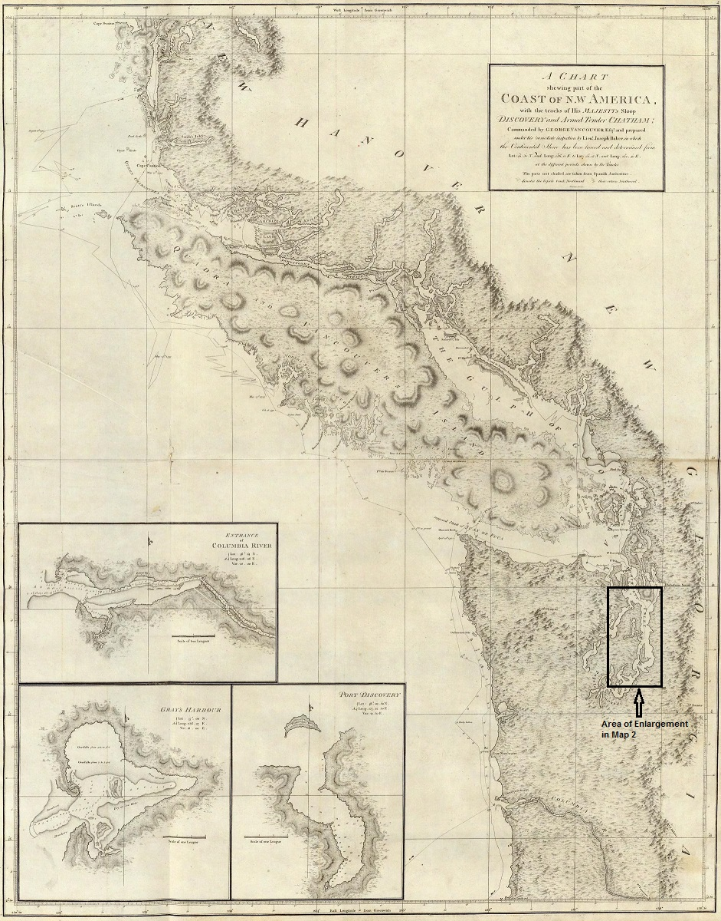
From: David Rumsey Historical Map Collection, www.davidrumsey.com. 1792. Annotations by author.

Map 2 - Restoration Point and Alki - 1792
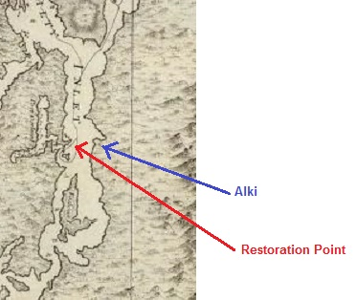
Enlargement from Map 1 proceeding.
Annotations by author.

Vancouver’s northwest coast map extends from Kings Island, British Columbia on the north to Cape Lookout, Oregon on the south, a 560 mile coastline. It is somewhat remarkable that Vancouver’s map captures, with a significant degree of accuracy, the central Puget Sound shoreline that enables ready recognition of Alki and Restoration Points and surrounding land and water features.

Upon Vancouver’s return to Great Britain he would report his Puget Sound observations as;

“To describe the beauties of this region, will, on some future occasion, be a very grateful talk, to the pen of a skillful panegyrist. The serenity of the climate, the innumerable pleasing landscapes, and the abundant fertility that unassisted nature puts forth, require only to be enriched by the industry of man with villages, mansions, cottages, and other buildings, to render it the most lovely country that can be imagined; whilst the labour of the inhabitants would be amply rewarded, in the bounties which nature seems ready to bestow on cultivation.”

It would be words such as these that would begin to form European-American perceptions and expectations for the Puget Sound region and serve as an invitation to settlement and exploitation. Such words to the Native Americans, if they were then aware, would be a warning that their long held land and source of subsistence, would be seen in a vastly different light by an invading people.

In the fifty years following Vancouver’s voyage, largely through the efforts of the British sponsored Hudson Bay Company, small groups of European-American settlers migrated to Puget Sound, established trading and family relationships with Native Americans and initiated agricultural enterprises. William Tolmie, a medical doctor, agriculturalist and trader, in service to the Hudson Bay Company, would visit Alki on July 9, 1833. The purpose of his visit was to assess the area’s suitability as a Hudson Bay Company fort and trading center. Tolmie found Alki lacking. “An unproductive soil & the inconvenience of going at least ½ mile for a supply of water” outweighed, in his view, a “Fort well garrisoned would answer well as a trading post on the prairie where we stood – it would have the advantage of a fine prospect down the Sound, & of proximity to the Indians”. The water supply issue would seal Alki’s fate twenty years hence.
Following Vancouver’s Puget Sound survey, competing British and American northwest territorial claims arose. These competing claims were prompted by the American Lewis and Clark overland expedition to the Pacific at the mouth of the Columbia River. In reaction, the United States Congress authorized a naval expedition that was instructed, under the command of Lieutenant Charles Wilkes, to make surveys and scientific investigations of the Pacific Rim including;
“direct your course to the Northwest Coast of America, making such surveys and examinations, first of the territory of the United States on the seaboard, and of the Columbia river, and afterwards along the coast of California, with special reference to the Bay of St. Francisco …..”
The Wilkes expedition departed Norfolk, Virginia August 18, 1838, rounded South America, undertook its mission of discovery across the Pacific Ocean and entered Puget Sound on May 8, 1841. On May 10th the expedition sailed from the Sound’s Port Madison to just off Vashon Island passing Restoration Point to the west and Alki to the east. Unlike Vancouver’s expedition, Wilkes explicitly named and mapped Alki (see Maps 3 and 4). Alki was first to become known to the European-Americans as Point Roberts.
Map 3 - Charles Wilkes Expedition - Puget Sound 1841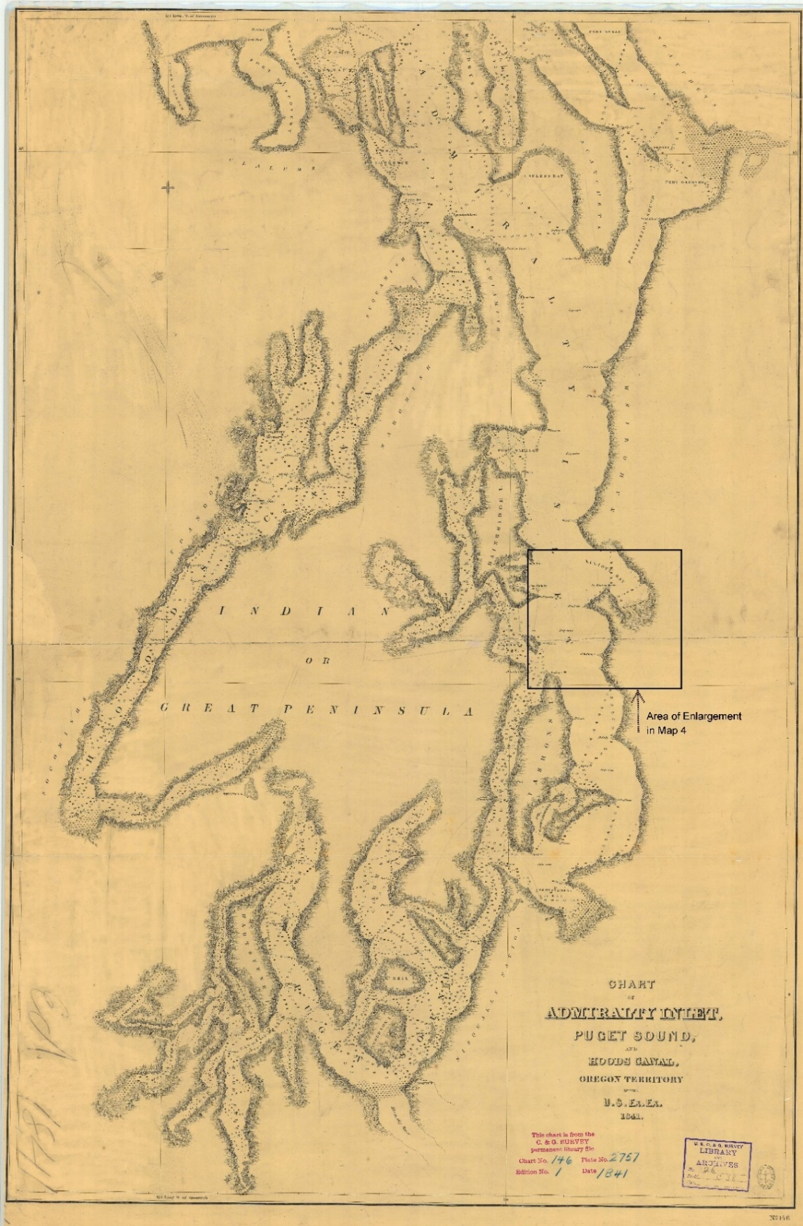
From: Historical Charts and Maps Collection, NOAA accessed
https://historicalcharts.noaa.gov/historicals/preview/image/ExEx146-00-1841 April 25, 2017 (annotation by author)

Map 4 – Point Roberts - 1841
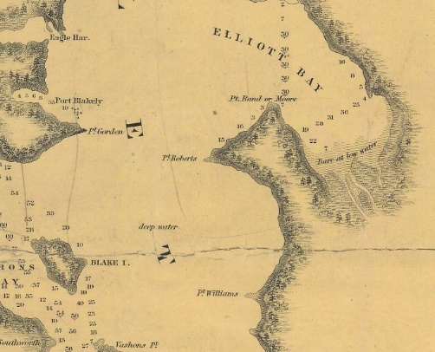
Note: Pt. Roberts, later to become known as Alki Point or Alki, is at map center. Alki Point has also been referred to as Battery Point. Enlargement from Map 3 proceeding.

Wilkes, at this point, compared the area to New York’s Hudson River Valley;
“The scenery …… resembles strongly parts of the Hudson river, particularly those about Poughkeepsie and above that place. The distant highlands, though much more lofty, reminded us of the Kaatskills (sic). There were but few lodges of Indians seen on our way up; and the whole line of shore has the appearance of never having been disturbed by man.”
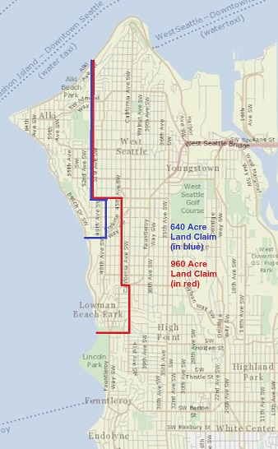
Alki’s first long-term European-American settler was a former New Yorker hailing from mid-New York’s Madison County. It is unknown if he ever read Wilkes words or shared Wilkes’ sentiments. But upon his Alki arrival, Charles C. Terry was bound and determined to change Alki’s appearance to anything other than ‘never having been disturbed by man’. At various times, Charles C. Terry would identify himself as C. C. Terry, Charles Terry, Charles C. Terry, Chas Terry or Charles Carroll Terry. Charles C. Terry and twenty-one others, including twelve children, landed on the Alki shores on November 13, 1851. They joined an advance party of two. The advance party members, David Denny and Leander (Lee) Terry, had been on the Alki shores since late September. Lee Terry, the elder brother of Charles Terry, and his fellow immigrants came to Alki with the intent of founding a great city. They named their burg New York. Lee Terry and his recent friend John N. Low collaborated in the selection of Alki as the site of a great city. Once selected, Low led the main immigrant group to the site of the new city. Low and Lee Terry claimed Alki and its environs as their own. Charles Terry would later assume the claim interests of his brother Lee and John Low.
Map 5 - Potential Low - Terry Land Claim Boundary (west and north of the indicated boundary)
Just What Were Low and Terry Claiming?

The boundaries of the Low and Terry Alki land claim are amorphous and have never been documented. Lee’s brother, Charles, would formalize a land claim boundary in May, 1853. The intent, in fall 1851, is unknown. Lee Terry and John Low would have been eligible for a land claim grant from the United States Government of 320 acres each, or a square mile in total between them, assuming that Lee Terry entered Oregon territory after December 1, 1850. If Lee Terry entered Oregon Territory before December 1st he would have been entitled to a land claim of 640 acres resulting in a combined 960 acre estate. Starting with Alki Point as the central reference point, a 960 acre estate might have been bounded as shown in Map 5 above. A smaller 640 acre estate is also shown. This smaller estate assumes that both Lee Terry and John Low entered Oregon Territory after December 1, 1850.
From: King County iMap GIS accessed
http://www.kingcounty.gov/services/gis/Maps/imap.aspx
on June 20, 2017. Claim boundaries are superimposed upon a contemporary map of the Duwamish Peninsula. Annotations by Author.

The suggested land claim boundaries would have been made with the following objectives in mind: maximization of north and south shorelines for access to maritime commerce, full domain over prairie and grazing lands to the south, avoidance of steep slopes and hillsides, and capturing fresh water supplies found east and south of Alki Point. Low and Terry would have had to come to an understanding for division of the land claim estate between the two.

The land claim’s setting was unrivaled for its natural beauty. From the north shore, the 10,800 foot Mount Baker, to the northeast across Elliott Bay, dominated the skyline. Directly east the towering forests and steep bluffs of the Duwamish Peninsula blocked the view of the Cascades. On the south and west shores, Mount Rainer of 14,400 feet majestically presided, while the view west was framed by the Olympic Mountains. The shoreline was a feeding paradise for waterfowl. In the spring, sea lions reigned and Orcas and other whales visited on their migrating journey north. The small brooks and streams flowing off the Duwamish bluffs and hillsides toward the sea provided spawning salmon habitat. The Point itself provided a clear unobstructed view north through Admiralty Inlet and to the south Puget Sound’s far reaches.

The surrounding forest was composed of fir, cedar, and hemlock with undergrowth often composed of willow, alder, vine maple and hazel. As one moved closer to Alki Point, cherry trees increased in number. The fir trees often reached up to 50 inches in diameter. One fir tree, used as a survey marker was reported as being over six feet in diameter. Surveyors reported steep hills having an elevation gain of 200 feet in as little as 400 feet distance. More generally, these grades would be an elevation gain of 300 feet in 1,200 to 2,000 feet distance. The ridge line above Alki varied between 400 and 500 feet elevation. (See Map 6 below).
Map 6 - Alki Topography
(20 foot contour lines, the closer the contour lines are together the steeper the slope)
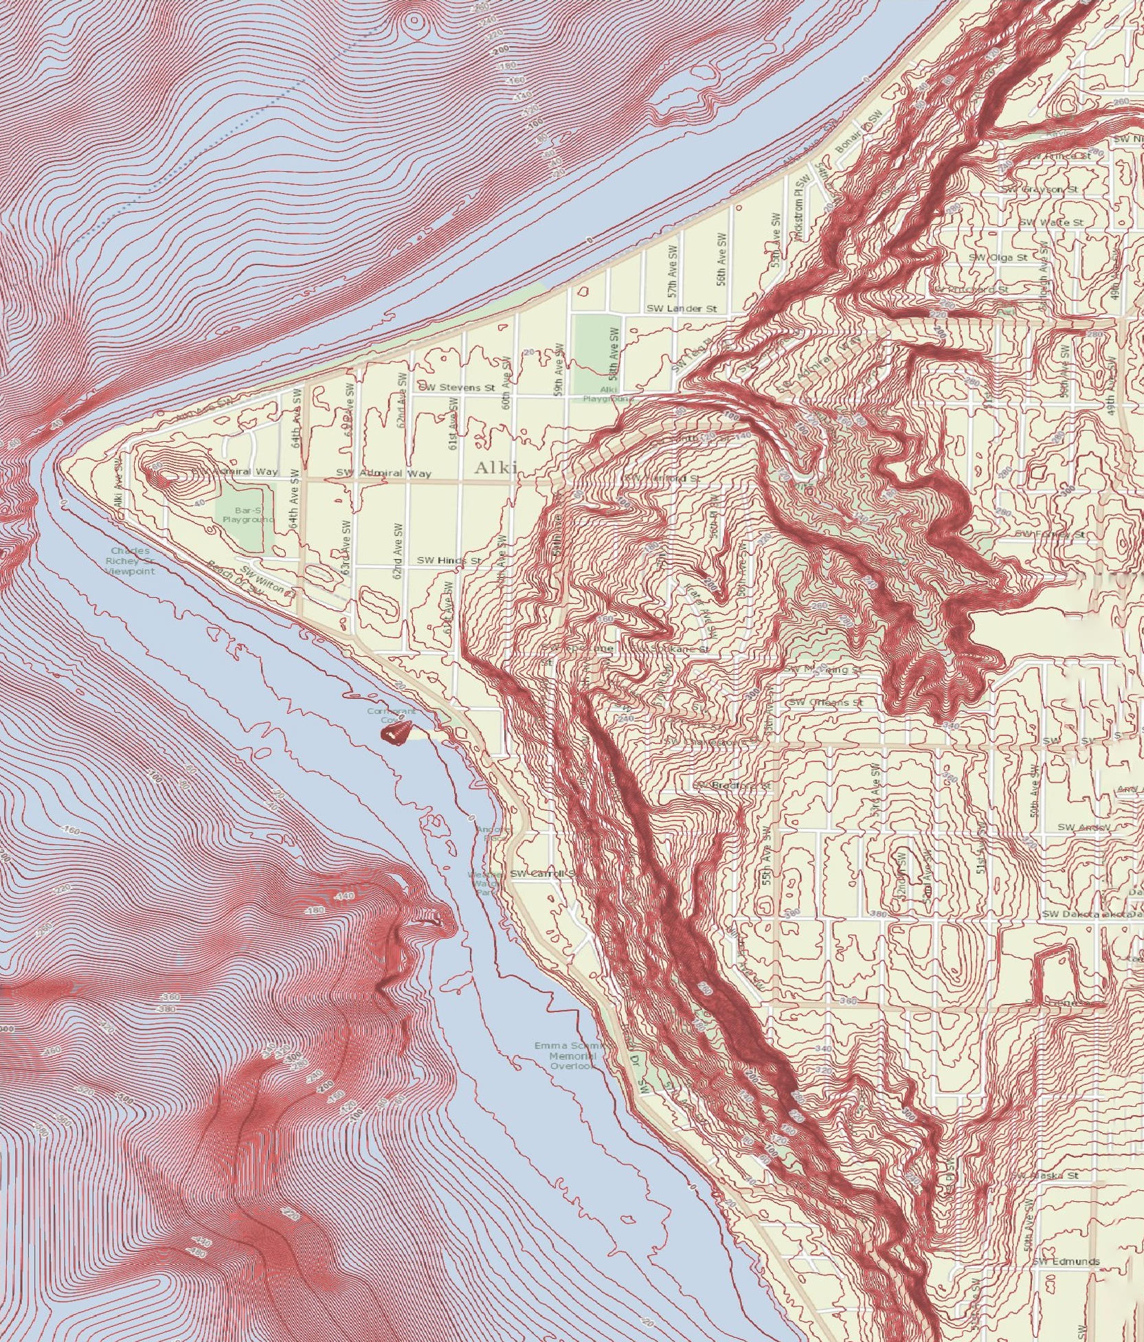
From: King County, Washington iMap GIS accessed http://www.kingcounty.gov/services/gis/Maps/imap.aspx
June 20, 2017. Note this topographical map is a contemporary view. The shoreline plain, as a result of fill and bulwarks, is 20 to 30 feet wider than it was in 1850-1860. This is particularly true in the northeast when the shore was filled in (circa 1905) to accommodate a street railway water trestle and plank road. Also in the northeast there are two significant cuts and grade changes made for road constructions purposes in the 1910s.

The soil was reported as being “2nd rate” and occasionally “3rd rate” for farming, with better land located upon the brooks and adjacent small valleys. In a radius of one to one and half miles from Alki Point the land was flat and gently sloping toward the beaches and tide flats. In the years to come the land would support potato farming and orchards.

The United States Coast Survey described the Alki beach “as smooth and very regular, being composed of sand and gravel”. Just east of the Point, there was a “curiously sloped mound rising behind it”. It was 75 feet in elevation, oblong shaped about 300 feet wide and 900 feet long. This mound may well have been the source of an earlier naming of Alki Point as Battery Point by early United States Coast Surveys, indicating potential naval gun placement. The mound, in future years, would become the object of speculation about its creation and Native American use.

If a climate report had been available, from that era, it would state that winter winds were generally from the south and southwest bearing heavy moisture. Moderate rainfall or drizzle was frequent with temperatures occasionally dropping below freezing but generally falling within a range of 35 to 45 degrees F during the winter. Extreme winter storms of strong winds and heavy rainfall could be expected each season. Summer temperatures were in the range of 55 to 80 degrees F with infrequent extreme highs. Summer winds were out of the north with little rainfall. Tides rose and fell within a range of 20 feet. Cloudy skies prevailed two-thirds of the year.

Southeast of the Point there was a clearing or prairie of about 25-30 acres. This clearing was first reported in the 1862 General Land Office Survey. The clearing may have been the product of the 1851 immigrant group, efforts of Native Americans prior to or after arrival of the immigrant group, or naturally occurring. Whatever its creation source it would play a critical role in the pasturing of John Low’s cattle that were soon to join the Alki immigrant group.

Map 7 - Alki Environmental Conditions Circa 1850
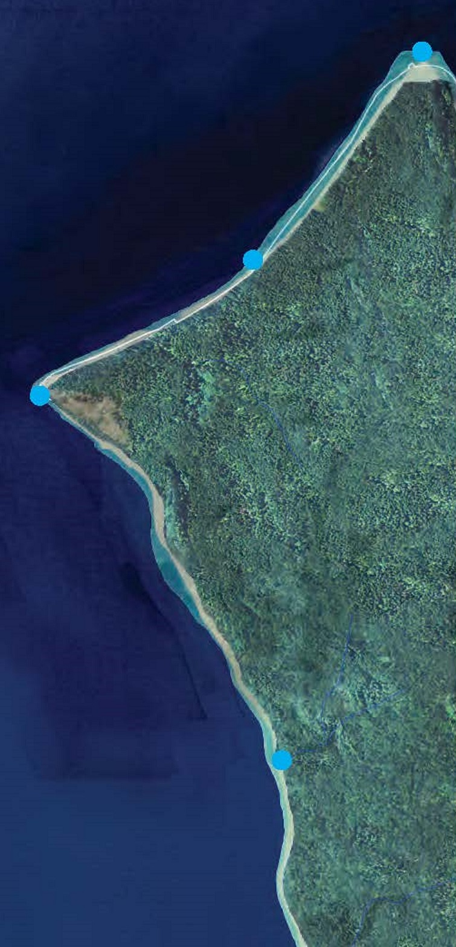
This clearing appears in Map 7 just south and east of Alki Point. Map 7 displays the environmental conditions of Alki and its environs at the time of the first European-American arrival. The mapping is produced by reverse engineering environmental changes over the last 175 years. As can be seen at the time of the Low-Terry land claim, Alki was a dense forest. Free flowing fresh water appears as thin blue lines in the forest flowing toward the shore. The white line running along the shore represents the shoreline as it appears today. The area between the contemporary shoreline and the shore of 1850 is the result of fill, road construction, shore barricades, bulwarks and elimination of marshes and other natural drainage and flood control landforms. The blue dots designate Native American places of interest, but not necessarily settlement.

Laying Claim To Alki

Serving as an advance party, on September 28, 1851, Lee Terry, John N. Low and David T. Denny located the Alki settlement site. Low returned to Portland, Oregon shortly thereafter where the main immigrant party was temporarily housed and led them to the soon to be named New York. The waterborne journey, to Alki, down the Columbia River along the Washington coast, through the Straits of San Juan de Fuca, and into Puget Sound lasted eight days. They sailed on the Schooner Exact, commanded by Captain Isaiah Folger. They departed Portland on November 5th and arrived Alki on November 13th. The Schooner continued onto Olympia arriving November 15th. From Olympia the Schooner reversed its course, exited Puget Sound and sailed onward to the Queen Charlotte Islands on the far north coast of British Columbia.
From: Waterline Map Burke Museum, based upon analysis by Puget Sound Nearshore Ecological Systems Restoration Project See footnote 24 below.

Low, before returning to Portland, hired David Denny to stay with Lee Terry and assist in the building of Alki’s initial pioneer housing. David Denny therefore became Alki’s first employee. It is unknown if Denny worked for wages or in trade for food, clothing and shelter. Low and Lee Terry assumed a property interest in the land and housing being constructed. David Denny’s status as an employee excluded him from whatever Alki property interest Low and Terry asserted.
Low and his family began their trek to Alki from Illinois. Before departing, Low gathered a herd of “45 cows and heifers”. He took pride in assembling this herd composed of the finest available in his Illinois homeland. The Low family and their prized cattle joined David Denny and his father and brothers, including David’s older brother Arthur Denny, at The Dalles, Oregon. They traveled together to Portland, Oregon. The group grew in numbers when they were joined, at Portland, by William N. Bell and family. Bell and family also originated their journey west from Illinois.
John Low and David Denny, as the initial advance party members, departed Portland, Oregon Territory, on September 10, 1851 for the purpose of finding winter pasture for Low’s cattle and making an exploration of the Puget Sound region. They walked to Ford’s Prairie where the cattle were left for winter pasture and then proceeded to Olympia, located on Puget Sound’s southern reaches. It is unknown if Denny and Low intended Olympia as their final destination or if Olympia was to be a jumping off point for Sound exploration. Olympia, at the time, was home to a few hundred persons and was the Sound’s leading settlement.
At Olympia, Low and Denny had two consequential encounters. The first was with Lee Terry and the second with Captain Robert C. Fay.
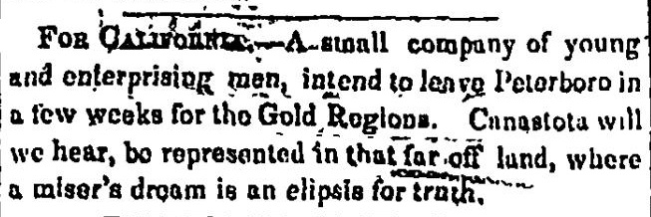
Lee Terry was a New Yorker who made his way to Olympia via the Shasta California gold rush fields. He was 37 years old and had left behind his wife, Mariah, and two children in Madison County, New York when he began his gold quest. Lee was the fourth oldest of eleven siblings. On August 19, 1850 Lee was enumerated in the 1850 census as having his usual abode in Madison County, as of June 1st. Like thousands of others he probably joined with one or more close relatives, in this case his younger brother Charles, the ninth oldest of eleven siblings, dropped his farming endeavor and booked passage to San Francisco via New York City. Charles is reported to have taken passage via South America’s Cape Horn. The Terrys may well have joined a larger group who were from the same community and who joined together to charter or purchase a sailing vessel and financed, as a group effort, their journey and necessary supplies.
From: Madison County Whig, Cazenovia, N.Y. January 17, 1849, Page 3 accessed http://nyshistoricnewspapers.org/
Figure I - California Gold Rush
Madison County Whig
In the alternative, Charles may have made his way, with Lee following, to California in the company of an overland wagon train along the California-Oregon Trails. It is reported by a member of one such train that, on August 3, 1849, he “met a Mr. C. C. Terry, an old friend of my brother James, and had a long talk with him and we parted……” This encounter was reported, some fifty-five years after the fact, based upon a contemporaneous diary entry and was to have taken place near today’s Almo, Idaho (Oregon Territory at the time). The report was silent on the whereabouts of Lee Terry.
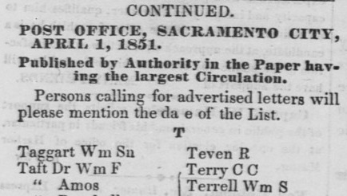
The exact arrangements made by Lee and Charles Terry for their California journey are unknown as well as their intended destination. An unknown party believed that they or, at least, C. C. Terry was destined for the gold fields in and around Sacramento. A letter intended for him went undelivered as of April, 1851 (see Figure II left). Given that the post office held letters for three months before advertising their availability, it was expected that the Terrys would have been in the gold fields by the first of January, 1851. This would date the time of, at least, Charles’ New York departure no later than late winter or spring 1850. If Lee and Charles traveled together this would conflict with the 1850 census enumeration, unless the census enumerator was not clear on the meaning of “usual abode” or Mariah, more likely, was unwilling to accept Lee’s absence as anything other than short term and temporary.
From: Sacramento Transcript, April 11, 1851 page 1, column 1 accessed https://cdnc.ucr.edu/cgi-bin/cdnc
Figure II - Sacramento Transcript, List of Letters, April 11, 1851
Both Terrys eventually found their way to the Shasta gold fields astride the Siskiyou Trail, just south of the Oregon Territory. The Siskiyou Trail was blazed by early traders involved with the Hudson Bay Company. The Trail extended to Portland, Oregon and Fort Vancouver (today’s Vancouver, Washington) on the north and, on the south, the San Francisco Bay area. Travel was by foot, horse or mule. With the California gold rush, the trail gave way to pack trains, wagons and then stages.
The events or conditions that persuaded the Terrys to abandon the quest for California gold are unknown. But Lee and Charles separated and Lee proceeded north arriving Olympia sometime before early September, 1851. Charles remained behind, perhaps to conclude commercial matters. Charles made his way north, crossing into Oregon Territory on November 10, 1850, as he would later claim. Over the next year he would make his way to Portland, Oregon where, on November 5, 1851, he boarded the Schooner Exact. His destination was Olympia.
Charles’ activities in the year between his Oregon arrival and departure are unknown. His asserted Oregon arrival before December 1, 1850, would give him preferential standing in the size of a government Donation Land Claim grant that he could make. He had an obvious incentive to mislead as to his arrival date.
At Portland, Charles presumably learned (by postal letter or letters left at various general stores in Portland or along the Siskiyou Trail) that his brother was in Olympia. Alternatively, the two brothers had made arrangements to meet in Olympia prior to their Shasta departures. When Charles Terry joined John Low, William Bell and the Denny families is a matter of conjecture. The Schooner Exact was always destined for Olympia and Chares may well have booked passage to join his brother, in Olympia, having no knowledge that Lee was out and about exploring the Sound. Or, while on board the Exact, in discussions with John Low or others that Low had informed, he discovered, that his brother was at Alki making arrangements to found the new Town of New York, Oregon Territory. The fortunate encounter with Low prior to boarding or onboard the Schooner Exact would be fateful. Charles Terry would disembark at Alki to join his brother rather than continuing on to Olympia.
At Olympia, in mid-September 1851, David Denny, John Low and Lee Terry joined forces to explore the Sound. Low and Terry resolved to locate a suitable site to make land claims. Why so fast and trusting a friendship arose between Lee Terry and Low is a mystery. David Denny was ineligible to make a land claim due to his youth.
Robert C. Fay owned an open boat and agreed to ferry the three intrepid immigrants sixty miles north to the Dewamps Bay and River (known today as Elliott Bay and Duwamish River) as an activity adjunct to Fay’s endeavor to harvest and barrel salmon for sale in the San Francisco market.
Fay had been the master of the Brig Orbit, owned by Michael T. Simmons. Captain Fay had commanded the Orbit in coastal trade into and out of San Francisco and Portland serving Puget Sound. He first took command of the brig on July 3, 1850 in San Francisco and set course for Puget Sound on July 4th. In the 1850 United States Census he would declare his occupation as seaman while being enumerated as residing in Clark County, Oregon Territory on October 30th. Though the census did not record detailed residential locations an inference can be made, from those persons enumerated, just before and after him that he was at the Hudson Bay Company’s Fort Nisqually at the time of his enumeration.
Figure III
Michael T. Simmons’ Promotion of Olympia As Gold Rush Jumping Off Point
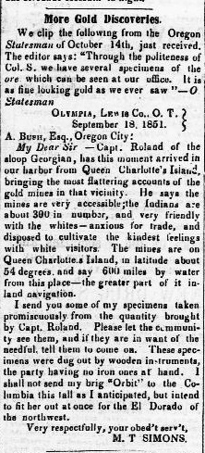
Fay had had a seafaring career out of Nantucket, Massachusetts before his service on board the Brig Orbit. He had sailed on whaling ships. When the California gold rush appropriated America’s shipping resources he, more than likely, made his way west in 1849-50 as a crew member onboard one of many ships abandoning the whaling trade in favor of servicing the California gold rush. In fact, his former whaling ship, the Brig Harvest, arrived San Francisco on May 29, 1850, just a month before Fay took command, in San Francisco, of the Brig Orbit. It is unknown if he was aboard the Harvest upon its San Francisco arrival.
Fay would become a regular fixture on the Sound. The immigrants’ advance party probably heard a great deal, both fact and fiction, from Fay and others, particularly Michael Simmons, in Olympia, about the Native Americans living on the Sound and the advantages and disadvantages of various Sound locations, unsettled and emergent. Michael Simmons had made himself something of a Puget Sound booster and an active investor in many enterprises, including the Sound’s pioneering sawmill at Tumwater, Oregon Territory, and owner and operator of the Brig Orbit (see Figure III left and Appendix B).
Upon arrival at what is known today as Duwamish Head at the mouth of the Duwamish River, Low, Terry and Denny hired two Native Americans and a canoe to reconnoiter the river and bay. Fay continued his fishing mission. Three days later, after parting company with the Native Americans, the intrepid advance party landed on what was to become known as Alki Point and determined that this point, at the southwestern entrance to Dewamps Bay (named Elliott Bay today), was to be Terry’s and Low’s land claim site. Fay rejoined the advance party and agreed to transport Low and Fay’s fishing catch, to Olympia where Low could arrange for his return to his family in Portland.
From: Portage Sentinel, Ravenna, Ohio December 15, 1851 accessed http://chroniclingamerica.loc.gov/
Low and Fay departed Alki shortly after September 28, 1851, the date David Denny and Lee Terry began construction of the initial Alki housing. In the day or two it took to return to Olympia, Fay and Low most likely shared their impressions of the Sound and Fay learned of Low and Terry’s intentions. For Fay, this was an opportunity for income and to earn a ‘good neighbor’ reputation. Fay probably prevailed upon Low to abandon an overland return journey from Portland to Puget Sound and Alki. This would avoid the uncertainty of the winter weather closing in. Also, there was no known and blazed overland route from Olympia to Alki increasing the hazard of an overland journey. A waterborne trip would be quicker and more sure..

Fay’s knowledge of the Sound was much greater than Low’s. Low could have hardly been expected to know the location of Alki relative to all other navigation landmarks. Low had paddled around a small area of the Sound for less than a week and had no knowledge of Admiralty Inlet to the north nor the western Puget Sound shore. He may had seen Wilkes’ 1841 Puget Sound chart. But a chart would have been nearly worthless unless Fay had told him the Low-Terry settlement site was located at Point Roberts as Wilkes had named Alki.

Given Fay’s Puget Sound navigation experience with the Brig Orbit, he certainly had access to locally produced maps and charts as well as firsthand knowledge of the location of the Low-Terry site relative to all other navigation landmarks. Fay’s knowledge was vastly superior, and his aid in returning to Alki would be invaluable. The sailing of the Exact and its captain into Puget Sound in November 1851 would be its first. The aid of Fay, as pilot, would be indispensable in avoiding navigational hazards and guiding the ship to Alki and Olympia, the Exact’s ultimate Puget Sound destination. Fay almost certainly served as pilot assisting Captain Folger of the Schooner Exact to navigate to Point Roberts, as Alki was then known from Wilkes earlier mapping.

At Portland, Fay’s maritime experience would also be of valued assistance to Low in making arrangements for the immigrant group’s journey to Alki. From his captaincy of the Brig Orbit, Fay was familiar with transportation costs and pricing. Fay’s experience also enabled him to offer his services as pilot, to a ship’s captain, reducing risk to a ship in a sailing into Puget Sound and locating the immigrant group’s destination. A commission for brokering the transportation of the immigrants to Alki and a professional fee for his piloting services would be Fay’s reward.

Captain Folger of the Schooner Exact, prior to the ship’s west coast arrival, had served as supercargo. A supercargo was the ship’s officer responsible for the ship’s commercial activities. Upon his assent to Captain, in San Francisco, Folger continued his supercargo responsibilities. Though Folger was 20 years Fay’s senior, it would have been natural for Fay and Folger to negotiate a commercial relationship given their shared seafaring, commercial and Nantucket home port backgrounds.

The Low Party Arrives at Alki

Together Fay and Low, by foot or horseback, returned to Portland. A stopover, in route, at Ford’s Prairie to evaluate the condition of Low’s cattle herd was probable. Low had already made the decision to bring his family to Alki. Arthur Denny heard Low’s Puget Sound and Alki settlement report. At this point, Denny considered all he had heard and read about Puget Sound before and since his arrival in Portland and matters described by Low. At this point, Denny determined that he and his family would part company with his father and brothers (except David who was at Alki), forego a Willamette Valley land claim, and head north to Puget Sound along with the Low family. The Bell and Boren families concurred. All accepted the Fay-Low recommendation of a waterborne journey north. Livestock teams, that brought them west, were to be left in Portland until the following spring. For the Alki journey the immigrant group booked passage on the Schooner Exact.

Fay successfully piloted the Exact to Alki. Passengers destined for Alki and their effects, were unloaded at low tide in the early afternoon of November 13th. Charles Terry, having learned of Lee’s location, from John Low, or others while onboard the Exact, also disembarked.

The Exact then sailed onward to Olympia at that evening’s high tide. Fay and Low were onboard the Exact when it arrived Olympia November 15th. Low’s mission was to begin his journey to bring his cattle from Ford’s Prairie to Alki and Fay was returning to his Olympia home. Both disembarked. Low may have made arrangements for use of a horse or mule and proceeded, to Ford’s Prairie, on the Chehalis River, where his cattle were pastured. In all likelihood Low was paying rent to Judge Ford for use of the pasture land. Bringing the cattle to Alki would avoid continuing rent payment. The trip to Ford’s Prairie from Olympia, on horseback, a distance of 30 miles, would have taken a day or two. The 1858 Annual Report of the Coast Survey (based upon observations made in 1854) described the same journey but northward to Olympia;

“……. then by horse or mules to Olympia, over a tolerably level country, and by a road moderately good in summer but bad in winter. The distance can be made in one day with a good horse.”

The return trip with the cattle would have taken somewhat longer than a man on horseback but certainly something under a handful of days. This would place Low and his cattle in Olympia by November 19-21. It is at this point that Captain Fay delivered his final service in aid to John Low and the Alki immigrant group.
In February, 1851 Robert Fay while in command of the Brig Orbit sailed from Nisqually on Puget Sound just north of Olympia to Fort Victoria (now Victoria, British Columbia) with a cargo of horses and cattle. From this sailing Fay (and maybe others) learned a great deal about shipping cattle via water and its logistics. The trip from Nisqually to Victoria was easily three times the distance as the trip from Olympia to Alki.
The Steamer Beaver called at Olympia on November 19th. The Beaver was a Hudson Bay Company vessel that had long sailed the Sound transporting goods, supplies, passengers and livestock. It is probable that the Steamer Beaver assisted Low in ferrying his cattle to Alki. Given Fay’s experience, at a minimum, he advised Low on the logistics of shipping his cattle to Alki and may have made the shipping arrangements on Low’s behalf. Somewhere along the line, Fay would have been rewarded, once again, with a maritime commission for his efforts.
A sailing from Olympia would have taken well under two days barring adverse weather conditions. Low and his cattle would have returned, most probably, to Alki by the end of November, 1851. The presence of Low’s cattle at Alki would facilitate, in the forthcoming month, the immigrants’ first income earning opportunity as well as providing a source of milk and other dairy products during the difficult winter months ahead.
The Immigrant Group Settles In
Once assembled at Alki the immigrant group faced five critical tasks: building adequate weather resistant shelter for 12 adults and 12 children, fresh water provision, self-governance, generation of income to pay for replenishment of tools, housewares, food and supplies and maintenance of relations with Alki’s sovereign Native American nation, the Duwamish.
First-hand recollections and early accounts of the time are silent on the question of self-governance and group decision making. Somehow the immigrant group made and enforced decisions effecting the welfare of each and all. The question of self-governance however, was addressed as they moved forward, but the process of self-governance has to be inferred from group actions taken and the records describing relationships between group members.
Meeting the Need for Housing

The first house begun by David Denny and Lee Terry was incomplete upon the main party’s arrival. It was intended for John Low and wife, but all took shelter within. While Low continued onward to Olympia to retrieve his cattle, the housing unit was completed. The group then built a housing unit for use by Arthur Denny and wife but the entire party took shelter and shared the Low and Arthur Denny housing units.
Houses for the Bell and Boren families were built next. The decision process and basis for determination of housing unit assignment, sharing and order of construction is unknown. Given that the houses were all completed in about three weeks, the entire party must have, collectively, shared the site preparation and construction burden as well as the shelter created. But the ownership or assignment of the cabins probably sowed the seeds of division among the settlers or accentuated existing divisions, particularly since Lee Terry and Low had laid claim to the land upon which the housing sat. This resulted in everyone else being subservient to Lee Terry and John Low – their landlords.

An Alki census of population at this time would have shown:
Alki Census of Population and Housing – December 8, 1851
 |  | Household | State or
Housing | Name (household | Head | Territory of |  |  |  | Housing
Unit | head listed first) | Relationship | Previous Residence | Age | Sex | Race | Type | Remarks
3 | William N Bell | head | Oregon (Portland) | 34 | male | white | cedar board
 | Sarah Ann Bell | wife | Oregon (Portland) | 36 | female | white
 | Laura Bell | daughter | Oregon (Portland) | 9 | female | white
 | Olive Bell | daughter | Oregon (Portland) | 5 | female | white
 | Virginia Bell | daughter | Oregon (Portland) | 4 | female | white
 | Lavinia Bell | daughter | Oregon (Portland) | 1 | female | white
4 | Carson D Boren | head | Illinois | 27 | male | white | cedar board | Brother in Law of Arthur & David Denny
 | Mary Ann Kays Boren | wife | Illinois | 21 | female | white |  | Sister of Arthur & David Denny
 | Levinia Gertrude Boren | daughter | Illinois | <1 | female | white
 | Louisa Boren | sister | Illinois | 22 | female | white |  | Future wife of David T Denny
2 | Arthur A Denny | head | Illinois | 29 | male | white | log cabin | Brother In Law of Carson D Boren
 | Mary Ann Denny | wife | Illinois | 28 | male | white |  | Sister of Mary Ann Boren
 | Louisa C Denny | daughter | Illinois | 5 | female | white
 | Lenora Denny | daughter | Illinois | 3 | female | white
 | Rolland H Denny | son | born in route | <1 | male | white
 | David T Denny | brother | Illinois | 19 | male | white |  | Future husband of Louisa Boren
1 | John N Low | head | Oregon (Dalles) | 31 | male | white | log cabin
 | Lydia Low | wife | Oregon (Dalles) | 31 | female | white
 | Alonzo Low | son | Oregon (Dalles) | 6 | male | white
 | Mary Low | daughter | Oregon (Dalles) | 8 | female | white
 | John Low | son | Oregon (Dalles) | 4 | male | white
 | Minerva Low | daughter | Oregon (Dalles) | 2 | female | white
unknown | Leander Terry | head | Oregon (Olympia) | 33 | male | white |  | Brother of Charles C Terry
unknown | Charles C Terry | head | California | 22 | male | white |  | Brother of Leander Terry
Total Number of Person: 24
At this point the immigrant group was composed of two contingents: the Denny-Boren families, led by Arthur Denny and all others - none of whom held any particular loyalty or long-term friendship toward the Denny-Boren contingent. This cleveage within the group would soon present itself and reveal Alki’s fatal settlement flaw.

Figure IV – Charles C Terry Account Book - Labor Loading Brig Leonesa
The Need for Pin Money

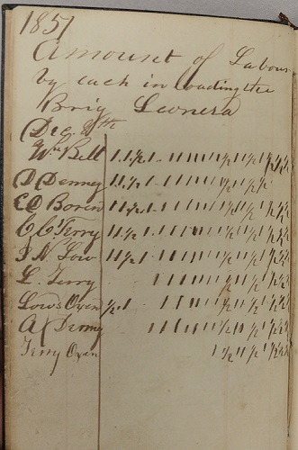
As the first four housing units were completed, the Alki community was visited by the Brig Leonesa captained by Daniel S. Howard. Captain Howard was a seaman as well as entrepreneur. He was in search of a cargo of piles (heaps of wood). Howard’s fortuitous visit, on December 8th, provided the immigrant group’s first income earning opportunity. As Arthur Denny later reported, “we readily made a contract to load his vessel …… Some of us went to work cutting the timber nearest to the water and rolled and hauled in by hand…..” This effort was also recorded by Charles Terry in his account book (Figure IV to the right).

This account book entry indicates that work began on or about December 8, 1851 and records the labor (the units of labor are unstated but are probably days) of each in loading the Brig Leonesa. Labor was provided by all adult male members of the Alki immigrant community and Low’s and Lee Terry’s oxen.
From: Charles C. Terry Account Book, November, 1851, Portland, Oregon, University of Washington Library, Special Collections, Seattle, WA accession 0247-001.

Ignored in the Arthur Denny telling of the immigrant party’s Alki landing and settlement is the entry of the amount of labor by “Low’s Oxen”. This is a significant omission for it masks the critical role of Captain Robert C. Fay, as described earlier, of assisting John Low in his return to Portland, the main party’s travels to Alki on the Schooner Exact, and bringing Low’s cattle from Ford’s Prairie to Alki by the end of November, 1851.

It should be noted that Lee Terry’s labor contribution to the Leonesa effort was somewhat less than that of others, except Arthur Denny’s. As reported in Denny’s Pioneer Days, Lee was dispatched to secure the services of a team of oxen to assist in the lumbering and longshore work required to fulfill the Leonesa contract. Lee is reported to have gone south to the Puyallup River and returned with the cattle driving the yoke of oxen along the Puget Sound shoreline. The arrival of these oxen explains the final entry in Charles Terry’s labor log.

Arthur Denny’s report;

“We had no team at the time, but some of us went to work cutting the timber nearest to the water, and rolled and hauled in by hand, while Lee Terry went up the Sound and obtained a yoke of oxen, which he drove on the beach from Puyallup with which to complete the cargo, but we had made very considerable progress by hand before his arrival with the cattle.” (emphasis added)

clearly conflicts with the Terry labor log record and entry for John Low’s oxen (see Figure IV above). Arthur Denny’s assertion that fulfillment of the Leonesa contract was initially undertaken without the aid of any beast of burden should be dismissed.

There could be several different reasons why Charles Terry recorded the labor given in loading Howard’s brig. The first is that Terry was providing a time keeping service to the community. The results of the recording would be used to divide the payment from Howard to group members. This would indicate that the Howard contract was a group agreement with the group having a subsequent understanding among its members similar to a cooperative marketing organization.

Alternatively, Terry actually made the contract with Howard and, in turn, Terry contracted with the group or its individual members for a wage labor payment, and captured for himself the residual between wages paid and Howard’s agreed upon payment. Timekeeping by Charles Terry was for purposes of determining the amount of wages to be paid, by him, to individual group members.

Under either interpretation of the Charles Terry timekeeping log, Arthur Denny contributed the least labor of all while all others contributed about equally given recognition of Lee Terry’s absence to secure additional oxen. Arthur Denny may have suffered an additional fit of the ague (malaria) or, hopefully not, thought the labor was beyond his capabilities or station.

Also maintained in Charles Terry’s account book is a record of the amount and dating of cargo loaded (see Figure V below).

Figure V - Cargo Loading Manifest, Brig Leonesa
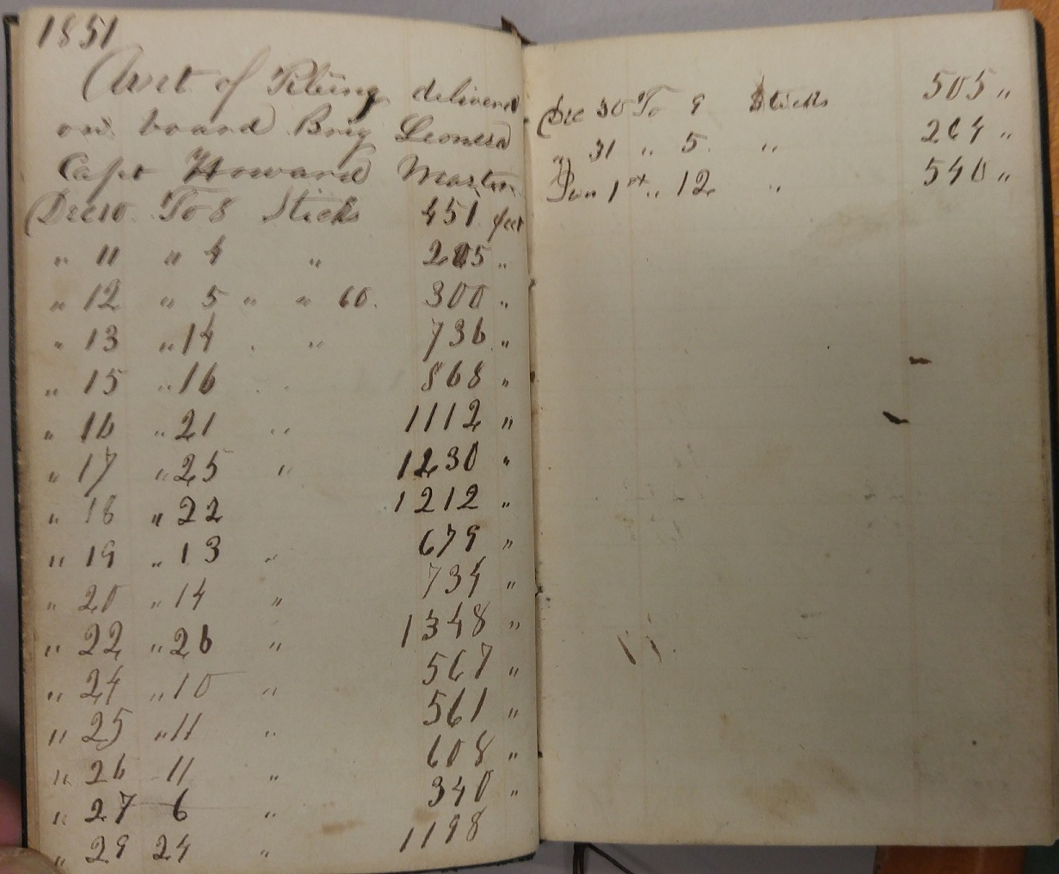
From: Charles C. Terry Account Book, November, 1851, Portland, Oregon, University of Washington Library, Special Collections, Seattle, WA accession 0247-001.
This record indicates that cargo loading began December 10th and continued until January 1, 1852. The Alki longshoremen worked six days a week taking two out of three Sundays, a Saturday and Christmas Eve off and worked Christmas and New Year’s Day. Workdays were probably on the order of 8 to 8.5 hours each given sunrise and sunset times for the Alki latitude and time of year. The purpose of Terry’s recording is clear. Why Terry made the recording is less clear but an explanation lies in reasons parallel to his timekeeping.
By the time of Charles Terry’s departure from the California gold mining fields he probably had learned that to the first go the best opportunities and that there was more money to be made from mercantile and real estate endeavors than panning for gold. Also, given that Charles Terry, in the ensuing weeks and months, developed an ongoing business relationship with Captain Howard it is highly probable that Terry maintained his records for purposes of wage payment, collection of monies due and personal enrichment. The wage rate was never stated.
If the endeavor had been a collective or group effort, by temperament, Arthur Denny would have been more inclined to assume record keeping duties. Denny was the settlement project leader and master. He made the decision to settle on Puget Sound. He would have seen Terry as a newcomer; someone who had been with the immigrant group less than a month. Denny, in his journal that survives, kept voluminous and detailed records. Denny’s journal begins with his surveyor field notes from his Knox County, Illinois work and continues with a diary of times and events crossing the western frontier and August 1851 Portland, Oregon arrival. At this point the journal concludes, in pencil, “distance from the Missouri River to the Dalles according to the foregoing journal is 1765 miles the time occupied is 80 1/2 days.” The journal begins anew with the entry, in ink; “Received of David $50.00 to apply, on hauling of pile” and then continues “Private act with C. Boren” and then sets forth a page length invoice of 25 items or so totaling “$58.06.” The journal records over the next two years, 1852-53, seventy-nine pages of commercial transactions largely composed of the selling and trade of timber and housewares, foodstuffs and other daily necessities of frontier living. It is not likely that Denny would have entrusted record keeping duties of his affairs to others.
Arthur Denny’s crediting the group (i.e. “we”) with making the Howard contract can be seen as an effort to disguise the Terry leadership role. Arthur Denny’s lifetime Seattle status, reputation and wealth was premised upon the aura of his Alki and Seattle settlement leadership. He had every reason to diminish the leadership role of others in comparison to his own.
If the contract was Terry’s venture, its fulfillment would have served to divide the immigrant group, for none of them had been motivated to cross the continent to take on wage service and a subservient and dependent role. But, at this point the allure of immediate income was too good to resist. Independence from Terry would soon be asserted.
Regardless, of the purpose of Charles Terry’s timekeeping and recording of cargo loadings, the group quickly learned that the timber resources of Puget Sound when turned into boards, piles, shingles and spars would become a quick and ready source of income, barter and cash. This lesson would not be lost on Puget Sound entrepreneurs and exploiters for the next 100 years.
Once all were minimally housed and some income secured, the immigrant group and its members could turn to questions of daily chores and longer term living arrangements. Charles Terry had already initiated a mercantile enterprise. In the spirit of lessons learned in the California gold rush fields of being first, Charles Terry brought with him on the Schooner Exact, a housewares inventory. He made his first sale on November 28, 1851. Charles Terry would thereafter and on into the Spring ramp up his mercantile endeavor in partnership with Low and Captain Howard of the Brig Leonesa. Howard would serve the role of importer of food, hardware, supplies, and the all-important whiskey from San Francisco and Terry and Low would advertise their availability and act as retail vendor. In turn, Captain Howard would purchase or take in trade piles, spars, boards, shingles and other wood products so urgently demanded in the San Francisco market. The Denny contingent, absent a goods inventory, could only sit idly by resigned to Charles Terry’s profit seeking sensibilities.
Fresh Water – Needed By All
Twenty years earlier William Tolmie identified a critical work task – secure a fresh water supply and make it readily available. No records exist indicating how the immigrant group secured fresh water in the winter and spring of 1851-1852. Coastal survey mapping (see Map 11 below) indicates that the immigrant group and those who joined shortly thereafter were located a few dozen yards from Alki Point and spread toward the east along the beach shore removed from the nearest free flowing fresh water site. As Tolmie indicated fresh water was available further east a half-mile distant but in reality, it was somewhat more than that from the Alki settlement (see Map 8 below). In 1862 the General Land Office surveyed the Alki area and the Duwamish Peninsula. In the course of that survey they noted free flowing fresh water sources. Those sources are noted on Map 8 below relative to the Alki Point settlement.
Map 8 - General Land Office Survey 1862
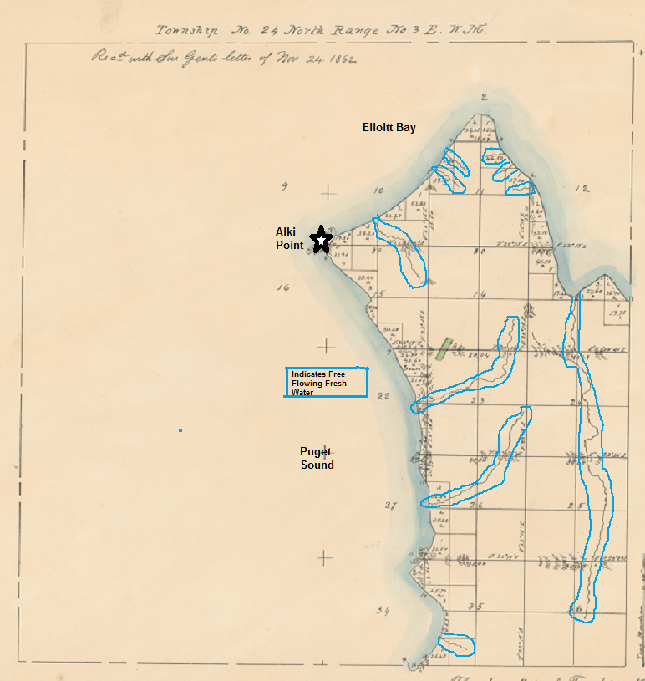
From: U. S. Department of Interior, Bureau of Land Management, General Land Office Records accessed https://glorecords.blm.gov/details/survey/default.aspx?dm_id=322319&sid=anersvfv.2kq#surveyDetailsTabIndex=1
on September 10, 2016 (Township 24 N, Range 3E, Williamette Meriden). Annotations by author.

The group would have to arrange for water transportation and storage on a regular basis, as well as making provision for cattle herd watering. The Arthur Denny early account does not address this issue nor alternatives undertaken (i.e., well drilling or rain collection) to the transportation of water to the settlement. Well drilling would have been a major undertaking and certainly would have been a noteworthy effort. The location of the well would have to avoid salt water intrusion. This indicates a location off the beach shoreline and toward slightly higher ground to the south and east. The absence of a report about such a major undertaking as well drilling indicates a high probability that no well drilling effort, in these early days, was undertaken.
Water provision was more than likely a collective and communal effort. Everyone had a water need. It was better to share the burden of water transportation rather than duplicate effort. In short order, the issue of an adequate fresh water supply would make or break Alki’s future.
Relationships with the Sovereign Native American Nation
The immigrant group did not perceive as if they had invaded the territory of a sovereign nation but they behaved as an occupying force. They expropriated the land and used its resources without asking. The Duwamish Native Americans, who had been living on and around Alki, Duwamish Peninsula, Duwamish River and Elliott Bay, had been doing so for 10,000 years.
It was the domain of the Duwamish, even by the standards of the European doctrine of discovery, holding aside the requirement that to achieve their domain, by discovery, they had to be subjects of a European Christian monarch. This requirement would be a hard bar to cross given that the Native Americans had first discovered the land in question 8,000 years before the founding of Christianity or any of the ruling European monarchs. The immigrant group was unconcerned with such matters.
Under color of the Oregon Donation Land Claim Act of 1850, the immigrant group asserted Alki land ownership and rights. This same Act enabled similar takings across the Oregon Territory and would become, in time, a source of frontier anxiety until good title was delivered by the United States Government. The ability of the government to deliver good land title was a legal fiction invented by United States Supreme Court Chief Justice John Marshall to enrich himself, his family and friends and hundreds of western land speculators, including the Alki immigrant group.
Though there was friction, the relationship between immigrant and Native American, in the Puget Sound region, previously, had been based upon mutually beneficial trade. This trade took place largely under the Hudson Bay Company’s banner. Once the issue of land ownership and rights to land use entered the picture, the nature of the relationship between immigrants and Native Americans changed. There would be a host of cultural, social, political and economic misunderstandings. Several years into the future the relationship would deteriorate to the point of armed conflict. In the moment, the Alki settlement process presented an early cultural misunderstanding.

Almost from the beginning the immigrant group came into close contact with Native Americans. Like hundreds of others, the immigrants were hesitant and fearful. In his Pioneer Days on Puget Sound, Arthur Denny wrote of the immigrants’ early encounter with Native Americans:
“Alki Point had not been a general camping place for the Indians, but soon after we landed and began clearing the ground for our buildings they commenced to congregate, and continued coming until we had over a thousand in our midst, and most of them remained all winter. Some of them built their houses very near to ours, even on the ground we had cleared, and although they seemed very friendly toward us we did not feel safe in objecting to their building thus near to us for fear of offending them, and it was very noticeable that they regarded their proximity to us as a protections against other Indians (emphasis added).”

The estimate of over a thousand Indians coming to Alki is a wild exaggeration, there being only 30 to 35 thousand Native Americans in the Puget Sound region at the time. Such an exaggeration was an expression of the immigrants’ apprehension and anxiety. How many Indians actually gathered on Alki is a debatable proposition. A few dozen would be a fair estimate given that, by this time of the year, the Duwamish people would have returned, for the winter, to their permanent villages and longhouses having completed the summer and fall food production and storage tasks.

Denny states that the Indians gathered ‘as a protection against other Indians’. The Native Americans of Puget Sound had long defended themselves, when warranted, from one another. It was simply another wild exaggeration to state that the Native Americans were in need of defense by a small group of European-Americans who had been on the ground just a few short weeks. A European-American guardianship was never requested much less expected.

Denny ignored any possibility that the Native Americans had gathered at Alki to assert their land and cultural interests or to object to the immigrants’ presence. “The curious mound” described earlier (see page 13) to the immediate east of Alki Point and only a few hundred yards south of the immigrant’s settlement is a key to understanding motivations for the Native Americans’ Alki gathering (see Maps 11 and 12 following). Denny suggests it was for protection from other Native Americans. In the alternative, the Native Americans may have been attempting to protect their sacred ground from potential immigrant despoliation or to register a protest against foreign occupancy of their long-held land.

It is an open question if the “Mound” was to Native Americans sacred ground. If it were the gathering can be seen as a non-violent human shield for the purpose of protecting the sacred ground or land long occupied for other uses. Oral history, recorded in 1999 dealing with events prior to 1930 states;

“The Indians never lived at Alki Point. It was a burial ground. And, and uh, my dad and his brothers, us, his two brothers were older, his, and I know that they, they would observe several times, uh, uh, the Indians stopping and camping on the beach and having a burial ceremony and then taking people up on the hill or wherever to actually bury them.”

In this statement, there is the absence of specific identity of the hill in question. On Alki “the hill” could have meant The Mound or the steep hillsides surrounding Alki Point and its beach plain. But clearly in this oral history an Alki burial ground is identified. Some years previous to the taking of the oral history cited above a journalist’s work entitled “West Side Story” appeared that stated;

“Before the 1850s, the point was used exclusively as a burial ground. Not until the Denny party arrived did the native begin to congregate there.
The burial ground was situated east of the point, behind the hill near what is now the Bar-S baseball field…….”

This statement clearly identifies the burial ground location as The Mound.

Major construction activity post 1940 has taken place on and around the Mound. Today the Mound is covered by a large apartment building, houses and a roadway. Significant grading has taken place. At the foot of the Mound lies a sewerage treatment and waste water collection facility. In the late 1980’s and early 1990’s these facilities, as part of a major expansion, were subject to a Traditional Cultural Property Study in conjunction with an environmental impact assessment. This assessment’s objective was to detect historical/archaeological resources. The “Draft Technical Memorandum” of this work is heavily redacted in an effort, under Washington State law, to protect archaeological sites from plunder and vandalism. In its redacted condition the report neither supports nor denies the historical use of the Mound as a burial ground. In the Archival Review for the Northern Transfer Project segment of the project, the Traditional Cultural Property investigator stated, “a potential burial ground was noted”.

Contemporary evidence supports, but not conclusively, that the Mound was a Native American cemetery. However, evidence from 1853, speaks with authority in support of the presence of a Native American cemetery. On April 4, 1853, the bark Sarah Parker called at Alki to deliver goods consigned to Charles Terry. On board, was the Captain’s wife, Charlotte Coffin Gardner and her son George. Gardner kept a journal of her experiences. On April 7^{th,} she and her son went ashore to visit with the Low family, and observed;

“George enfoyed (sic) himself well, racing about over the prairie under the trees and down to the shores with Alonzo (John Low’s son) and John Low. I walked a great distance with the two little girls, Mary and Minerva (Low’s daughters). I picked several wild flowers and saw some Indian graves not far from the shore, some with a board fence around them, others in this form with their basket and tin plate or cup laid upon the grave or hung over it. Over one’ (sic) child’s grave was hung the little tin cup he used to play with.”

The anchorage of the Bark Sarah Parker, according to Gardner was in 17 fathoms (102 feet), three ship lengths from the shore. Given the water depth provided by Gardner (see Map 11 following) and the location of the Alki prairie (see Map 7 above) the likely anchorage was west and north of Alki Point, and the coming ashore point would have been in close approximation to the Mound. Gardner unambiguously identifies a Native American cemetery land use in and close by the Alki settlement.

The Native American gathering may have been a nonviolent protest of the immigrants’ land occupation in an attempt to protect sacred ground or, just simply, a protest of land occupation by the immigrant arrivals. The immigrants misread the significance and meaning of the Native American gathering. If roles were reversed, the immigrants would have been as upset as the Native Americans and actions would have been taken to preserve and protect this cultural site. Serial cultural misunderstandings had just begun.

The William Bell Affair and the Dennys File A Change of Address Notice

As the winter began to wane, the Denny contingent of the immigrant group began to cast around for alternative settlement and land claim sites. With plenty of “free” land around, Arthur Denny and his contingent had no reason to remain land dependent upon Terry and Low. To be a success, the planned community promoters needed a residential critical mass. The two contingents had conflicting goals. Arthur and David Denny and Carson Boren had all but decided that they were leaving Alki. The only question was when. On February 15,1852, they located and marked land claims on Elliott Bay’s eastern shore (later to become Seattle’s commercial core). But William Bell, the last to join the immigrant group, had reservations.
Figure VI - Offer to William Bell By Lee Terry and John Low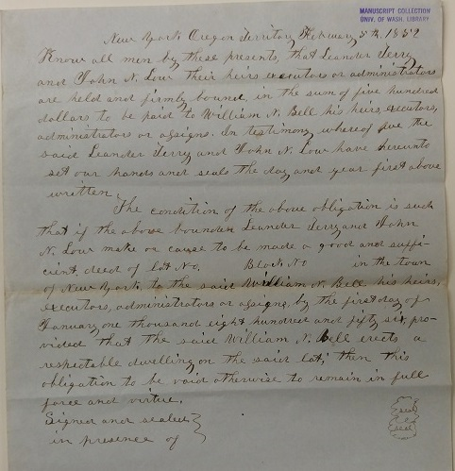
From: University of Washington Library, Special Collections, Seattle, WA, Denny-Frye Family Papers, accession no. 0096-001, Box 1, Folder 41, Bond Leander Terry and John N. Low to William H. Bell
Low and Terry wished Bell to remain at Alki and “erect a respectable dwelling” on one of the forthcoming building lots in the Town of New York. They offered Bell an inducement. If Bell built this respectable dwelling by January 1, 1856 Terry and Low would pay him $500. The lot purchase price was unstated. One could presume that it was to be free given the offered premium. The offer was dated February 8, 1852, as shown in Figure VI above. Lee Terry and Low were attempting to secure a continued presence at Alki of the family that had the least attachment to the Denny contingent. Bell considered, declined the offer and joined those relocating to Elliott Bay’s eastern shore making a land claim simultaneous with the others. Over the next two months the relocating families prepared for their departure. Seattle, in April 1852, welcomed its first non-Native American residents.

The New York promoters had lost all but one of the original settlement families and two single individuals. The Town of New York was not off to a rousing start. The offer to Bell was fatally flawed, and exposed the promoters’ fundamental ignorance of the urbanization process.

Urban places come into existence because they are efficient means to resolve the relationships of those having commodity surpluses with those having need for commodities. Initially, these surpluses and needs generally involve food and raw materials but soon expand to services and social interactions. Quickly, this process of exchange evolves to include interchange or trade with other and perhaps larger urban places, therefore creating a portal to more distant places. This portal permits places having surpluses and needs to be matched more efficiently than one person could do individually. How did Terry and Low expect Bell to sustain himself, much less to produce, for exchange, surplus commodities that would enable the Town of New York to grow? Terry and Low held monopoly power over the land, and the steep slopes, hillsides and bluffs made the immediate New York environs extremely difficult to access. These same topographical features also created a barrier to development of the narrow peninsula for which the proposed town could serve as a trade center or urban place.

Bell would have been foolish to have rented the flat plains surrounding Alki Point or the Alki environs when, in every direction, there was an abundance of “free” land. It would have been irrational for Bell to log, clear and bring into agricultural production land owned by Terry and Low. The same effort could have been expended on land he claimed for his benefit. Bell choose wisely. Terry and Low continued with their flawed notion and Terry’s brother, Charles, would persist with that notion as well.

The Denny contingent relocation to Seattle is frequently attributed to the superior harbor potential of Elliott Bay’s eastern shore citing water depth and storm shelter. The relocation was caused by the desire to lay claim to land because Low and Terry held the New York land monopoly. Previously, the Denny contingent had investigated places along the eastern Puget Sound shoreline as far south as Puyallup and found them lacking. The Seattle location was the best available from all the alternates. Seattle was founded because the Denny contingent of the immigrant group wished to become an occupying force beholden to no others. Harbor potential was a side benefit. Free land was the goal.

Leander Terry Reconsiders His Future

Upon failure of the attempt to induce Bell to remain and build his home at Alki, Leander Terry probably had second thoughts about Alki’s prospects. For the moment, he could put them to the side and devote his efforts to improvement of living conditions and income generation projects. The magnitude of tasks and the probability of success to recover from the loss of over three-fourths of Alki’s population and to move from hamlet to a thriving frontier town center began to dawn upon Lee Terry. Terry may well have concluded that it would be years before he could send for his wife and children to join him on the western frontier or he may have received a letter from his wife, Mariah, appealing for his return to their Madison County, New York farm.

On April 25, 1852 Lee Terry stepped aboard Captain Howard’s Brig Leonesa along with a fellow passenger, Mrs. O’Meara, and a cargo of 10,000 feet of piles and sailed to San Francisco. Arriving nine days later, Captain Howard disposed of his cargo, replenished his cargo hole with goods, supplies and inventory for Puget Sound barter and trade. Leander Terry continued his return journey home. Whatever Alki interests Terry had, he presumably granted them to his brother Charles or Charles just assumed them. Leander would rejoin his wife, two children and mother-in-law and father a third child. As so far is known he never returned west and died, at age 44, June 6, 1862. However, his younger brother Alfred Gore Terry would leave Madison County, New York, sometime in 1855-56, and resettle in Seattle alongside Charles Terry.

A Good Market Opens in the New Town of New York

When Charles Terry disembarked the Schooner Exact and stepped onto the Alki shore he was prepared to begin a new merchant career. As his account book shows he brought with him a small inventory of goods from Portland and the well timed arrival of the Leonesa would provide for replenishment and extension of the initial inventory held for sale on the Puget Sound frontier. Over the ensuing months the Brig Leonesa, and its captain Daniel S. Howard, would become an integral part of the Charles Terry retail supply chain.

Within days of his Alki landing, Charles Terry made his first recorded retail sale. He sold two axes to John Low, his brother Lee’s partner, on November 28, 1851, shortly after Low’s return with his cattle. The sale price was $6.00. Over the next month he sold most of his initial inventory (axes, tobacco, brandy, whiskey, tin ware, raisins) that he brought from Portland on the Schooner Exact. After his Alki arrival Terry secured (presumably from Captain Howard of the Brig Leonsea) an additional inventory of cooking and kitchenware which was sold to Luther Collins, according to a Terry account book entry. The Collins sale is undated but probably took place in December 1851 or January 1852. Acquisition of goods by Charles Terry sold to Collins took place, most likely, as a trade or barter as part of contract to provide the Brig Leonesa with a cargo of pilings which was completed on January 1, 1852.

The ownership status of the Charles Terry retail merchant endeavor in the early days of 1852 is unclear. At the time Lee Terry and John Low were the land claimants. Therefore, the retail endeavor would have been subservient to the Low and Lee Terry land claim interests – the endeavor was a tenant. Where Charles Terry stored his goods for sale is unknown and the equity of interest that Low and Lee Terry held in the merchandizing enterprise, if any, is also unknown. To have undertaken a retail endeavor would have required the understanding and cooperation Low and Lee Terry. Low and Lee Terry would willingly support the Terry retail enterprise to advance the growth of their Town of New York but their ownership and involvement, in the retail establishment is unknown.

The retail business grew and prospered. Charles Terry found it useful to engage assistance. William H. Brown became Alki’s second wage labor employee, holding aside the Leonesa longshore crew. Terry wrote in his account book; “1852 Wm H. Brown commenced work for Terry & Co. March 22nd at the rate of $50. P month & quit work by the month May 1st Commenced work by the day May 3rd at $2.00 per day.” Terry composed this entry in a manner that would indicate that it was Brown’s initiative to increase the employer’s discretion over the available work and compensation expense. Brown’s job responsibilities were unstated.

Charles Terry was profiting from the California lesson of ‘to the first go the best opportunities’. His potential Duwamish Bay competitors, that left Alki in early April 1852, at this time possessed only dreams. Terry’s penchant for advertising and promotion helped build upon the advantages of being first to market.

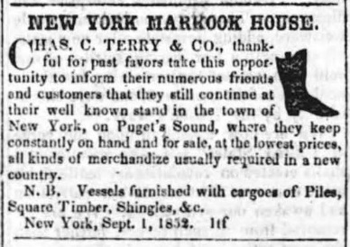
In the first edition of the first newspaper of general circulation in Puget Sound, the “Columbian”, Charles Terry placed the advertisement shown in Figure VII left. In the weeks following, this advertisement would grow in size and begin to list items held for sale and would also inform potential shippers that “cargoes of piles, square timbers, singles & c.” were available. Charles Terry had not forgotten the Leonesa lesson – Puget Sound’s timber was in great demand and was easily accessed, extracted and converted into cash. Terry would invoke this lesson so long as he was Alki’s lord.
Figure VII - New York Markook House Advertisement Columbian, September, 1852
Columbian, Olympia, Oregon Territory, September 11, 1852, Vol 1, No. 1, page 3. From: Washington Secretary of Stat Historic Newspapers accessed https://www.sos.wa.gov/library/newspapers/newspapers.aspx
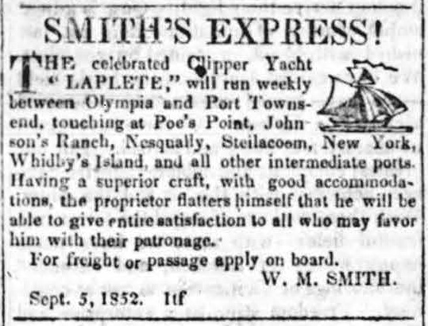
Two other items of note also appeared in the same edition of the “Columbian” that bared upon the potential success of the Terry’s New York Markook House. The first was a notice that C C Terry had been appointed the New York subscription agent for the weekly “Columbian”. Secondly, that W. M Smith had initiated Smith’s Express with weekly service to various points on the Sound including New York. The express business, of the time, forwarded mail, small packages, bills of exchange and goods to outlying communities and commonly delivered these items to general stores to be held for retrieval by the addressee. Both these item promised Charles Terry a steady and regular stream of visitors and potential customers.
Figure VIII - Smith's Express Announces Service to New York and other Sound Points
Columbian, Olympia, Oregon Territory, September 11, 1852, Vol 1, No. 1, page 3. From Washington Secretary of State Historic Newspapers accessed https://www.sos.wa.gov/library/newspapers/newspapers.aspx
So long as Terry operated his Alki store he remained a subscription agent and Smith’s Express would evolve into an Alki retail competitor called Lambert and Smith. Terry provided an Alki location to Lambert and Smith, in recognition, as any contemporary shopping center operator knows, that co-location of many retail firms generates more consumer traffic benefiting all, as opposed to many retail operations widely dispersed requiring greater customer travel to satisfy their many needs. Terry was attempting to build a central exchange location – a town. But first he would rebrand his store. In the second edition of the newspaper “Columbian”, Terry’s weekly store advertisement carried a new name - the New York Cash Store. There would be other name changes.

The scale and scope of inventory held for sale by Terry grew quickly. Clothing and dry goods, food, produce, spirits, tobacco, house, kitchen and serving ware, soap, rope, building supplies, office supplies, guns, and ammunition could be found at Terry’s establishment.

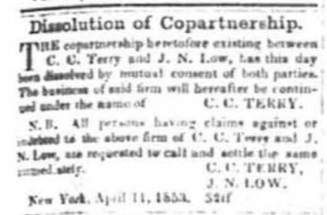
Nearly a year after Lee Terry departed and Charles Terry assumed or was granted his brother’s Alki interest, the partnership between Charles Terry and John Low ended. C. C. Terry and J. N. Low announced, as of April 11, 1853, ‘Dissolution of Copartnership’ in the April 16, 1853 edition of the “Columbian” (see Figure IX left). The notice of co-partnership dissolution makes no reference to the scope of partnership activities previously existing that were being dissolved but afterwards they would be conducted exclusively by Charles Terry. John Low and his family departed Alki and took up residence in Olympia, site of Low’s initial exploration of the Sound. In later years, he would remove himself and family to Snohomish County, Washington north of Seattle.
Columbian, Olympia, Washington Territory, April 16, 1852, Vol 1, No. __, page 3. From: Washington Secretary of State Historic Newspapers accessed https://www.sos.wa.gov/library/newspapers/newspapers.aspx
Figure IX Notice of Terry – Low Copartnership Dissolution

Quickly following the dissolution of the Low-Terry partnership, Lambert and Smith announced the opening, on April 19, 1853, of their New York Wholesale & Retail Store, and Ship Chandlery. Two months later, in “Columbian” advertising, they would begin referring to their store as the Alki Wholesale & Retail Store, and Ship Chandlery. At the same time Terry dropped references to New York from his advertising and adopted Alki as the name of his store location. The rebranding of New York to Alki was now complete. The Native American word Alki meaning “by and by” would now designate the immigrant group’s founding settlement site.

And Now for the Real Money – Real Estate Sales

As successor to his brother Lee and John N. Low, Charles Terry’s land claim interests had been in ambiguous circumstances. First, Low and Lee Terry together were entitled to a land claim grant of no less than 640 acres. As a single person and, if he entered Oregon Territory prior to December 1, 1850, Charles Terry was entitled, to a 320 acre land claim grant. As a successor to John Low and his brother Lee, Charles Terry would have to shed at least 320 acres of the Low-Lee Terry land claim. But Charles’ bigger problem was that the land claim was nowhere acknowledged in any official record. It was only what he said it was. There was no authoritative basis to defend his land claim. Anyone could have disputed his position. A sale of the land he claimed would be clouded by the uncertainty of his interest and interests of all others.

The Native Americans had been dispossessed of their land at the hands of the United States Supreme Court and Chief Justice Marshall. The United States Congress had seen to it that the Native Americans were not about to get any of their land back by restricting eligibility for Donation Land Claim Act grants to “white settlers” who were citizens or intended citizens. Terry was not concerned that Native Americans would assert any rights to his land. It was other “white settlers” that he feared. The government was the source of his land rights so he had to avail himself of governmental powers to protect his land rights. It was time for Charles Terry to put his land claim into writing and put all others on notice.

On May 27, 1853 Terry filed a land claim notice with the King County, Washington Territory Probate Court. He set forth his claim’s survey boundaries as;

“Commencing at New York Point, thence S 51 degrees E, 30 ch (chains or 66 feet per chain) with beach thence S 26 degrees E 10 ch thence S 10 ch thence S 35 ½ degrees E 5 ch to a post from which a maple 14 in bears N 12 W 31 lin (links or 1/100 of a chain) thence due east 31 ch 66 link to a stake, thence due north 41 ch to a stake on the beach from which a crab apple tree bears S 36 degrees W 17 links, thence in a westerly direction along the beach to the place of beginning containing 320 acres.” (Italicized added by author for clarity.)

There was one problem. His surveyor, Arthur Denny made a huge blunder. The survey boundary description failed to ‘close’ and did not encompass the stated 320 acres. This is shown in Map 9 below. The survey boundary from the “stake” to the “stake on the beach” should have been something on the order of 73 chains (about 4820 feet) long not 41 chains (about 2710 feet) as stated in the recorded survey. This error was corrected and the land claims boundaries would be adjusted some years later when David S. (Doc) Maynard purchased Charles Terry’s Alki interest. The corrected boundaries defined a land claim somewhat less wide east to west and longer north to south.
Map 9 - Charles Terry Land Claim Survey Boundaries, May 1853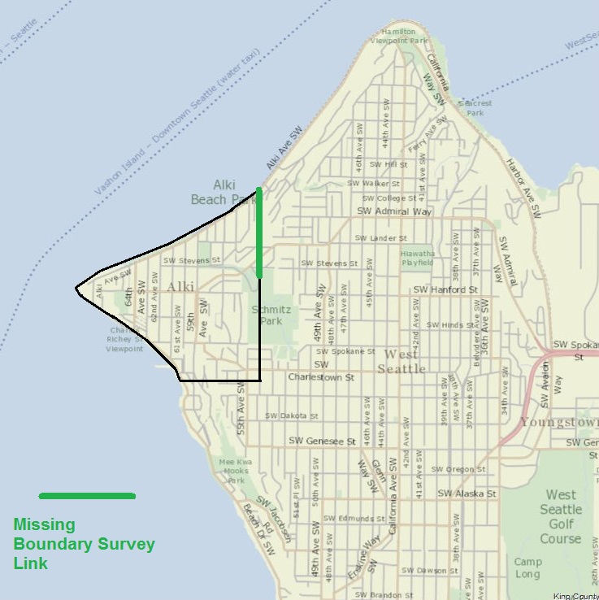
From King County iMap accessed at: http://www.kingcounty.gov/services/gis/Maps/imap.aspx June 23, 2017. Annotations by author. Boundaries are approximations.

As part of his King County land claim filing, Terry also laid out his Town of Alki. The Town, (Map 10 below), was to be composed of two streets, Front and 1st Streets, running nearly parallel to the shoreline and seven streets running perpendicular. Six blocks of eight lots each were therefore specified. Lots were to be 60 by 92 feet, streets were to be 66 feet wide with alleys 16 feet in width. Taken all together the Town was to be 1,902 feet long along the shoreline and 332 feet deep from the shore or about 14.5 acres in size (.023 square miles).

Map 10 – Plat of Town of Alki, May 27, 1853
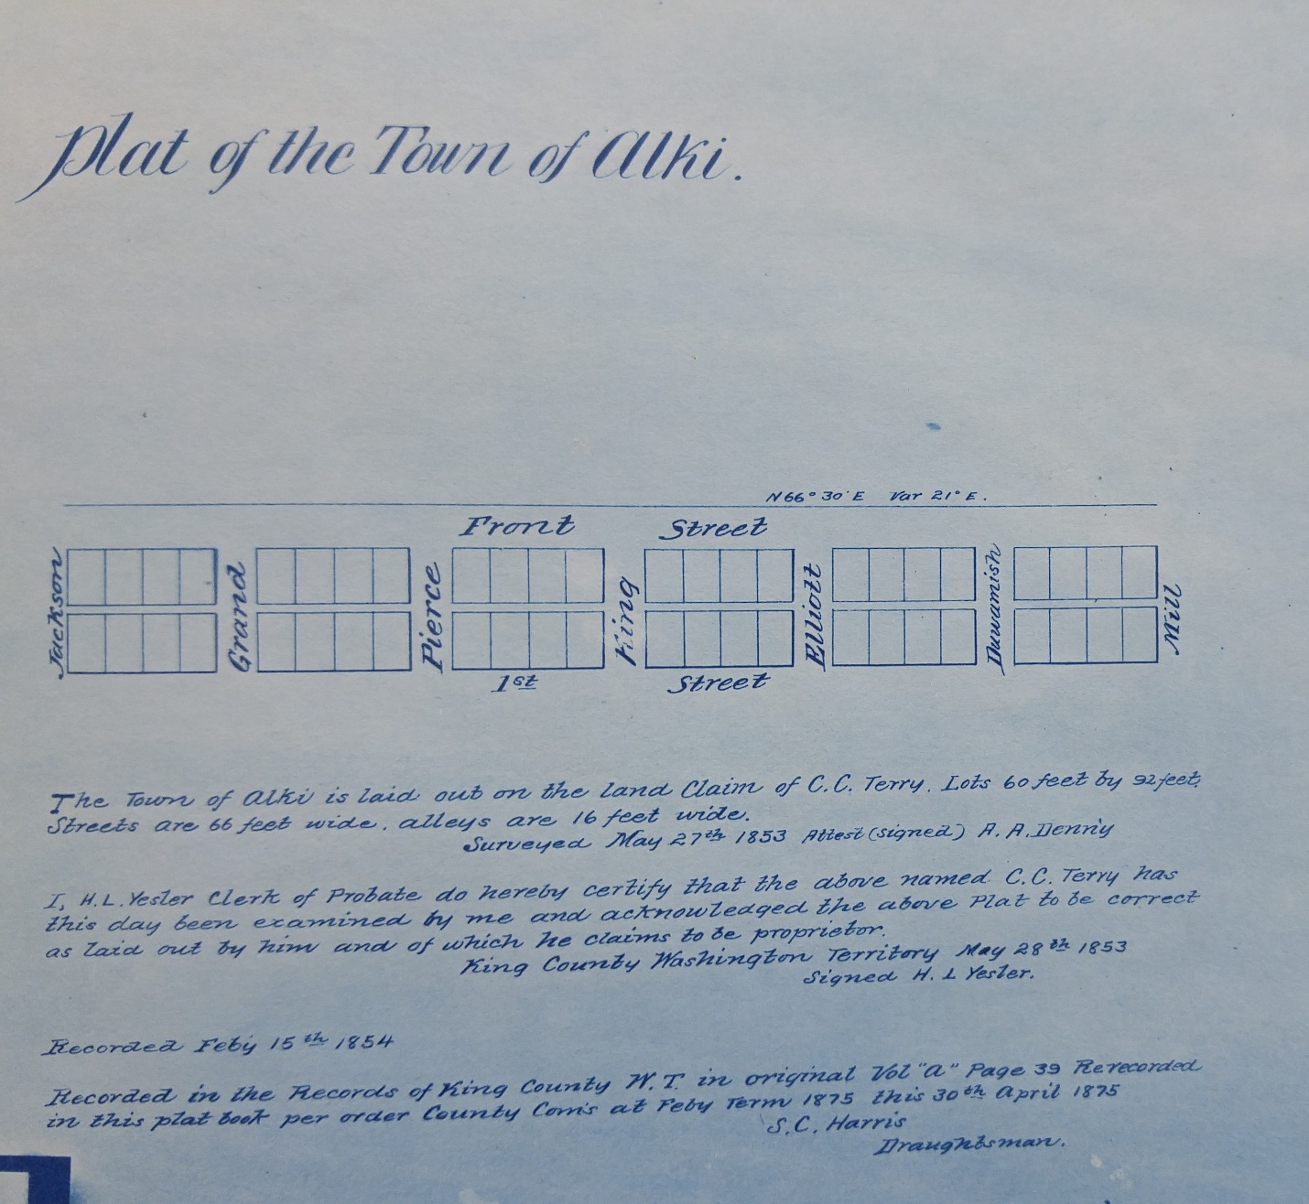
From: City of Seattle, Seattle Municipal Archives, Book of Plats, Seattle, WA. Also found at Washington Secretary of State, Olympia, WA, Digital Archives, accessed https://www.digitalarchives.wa.gov/Record/View/761FC746742DF6AEEF9BFF165A89AEAF on August 17, 2017.

A difficulty with Terry’s town specification is that the surveyor or recorder failed to indicate where the Town of Alki lay within the land claim. It was clear that the Town was laid off nearly parallel to the shoreline but the distance from the shoreline and the beginning point on the west, east, north or south side was not specified. A potential second flaw was that each lot within each block was not uniquely identified. It was the custom of the time to number blocks and lots so that each could be readily identified. In this case blocks and lots would have to be identified by street location and direction from a street intersection and an offset count of lots from that intersection. Such would have been unwieldly and prone to error. When Terry would begin to market his Town of Alki it would have been impossible for him to identify, by simple reference to an authoritative map and government recording what was being sold and what was being purchased. Buyer beware.

Once Terry had certainty as to his land claim he could begin to market his real estate. But economic forces were not with him. No doubt he encountered buyer resistance similar to that of William Bell the year prior. Topography was not Charles Terry’s friend either. The sale of lots did not go well. When Terry sold his land claim in 1857 to David S. (Doc) Maynard, the claim was sold “excepting and reserving three town lots in the formerly town of Alki ….. sold to Adam Boles”. Forty-five lots remained unsold. The sale of the three lots was never recorded in the records of King County, Washington. So far is known, Adam Boles never asserted any Alki property interest.

The fate of Adam Boles and his Alki land ownership interest has been lost to history. Despite the slow pace of Alki real estate sales the Town of Alki was undergoing development. The 1854 Coast Survey mapping captured that development (see Map 11 below).

Map 11 – Alki As Shown In the 1854 Coast Survey of Duwamish Bay
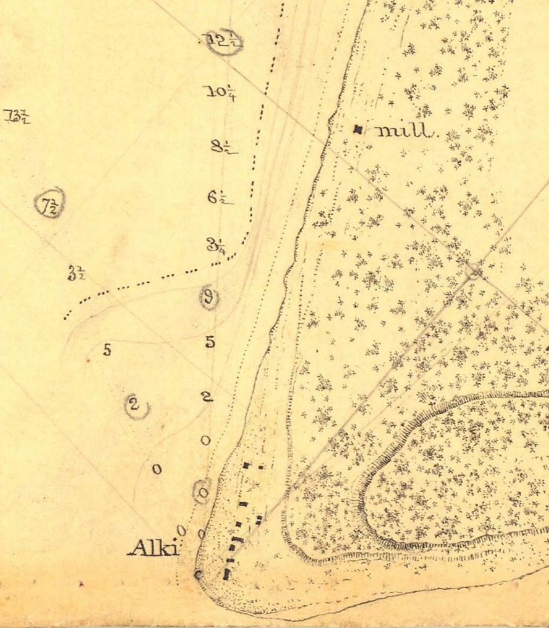
From: Historic Map & Chart Collection, NOAA, Office of the Coast Survey, Preliminary Survey of DUWAMIAH BAY, Washington accessed https://historicalcharts.noaa.gov/historicals/preview/image/H00432-00-1854

Along the shore, just off the Point, there are a series of buildings well-ordered and neatly arranged. Most of the buildings are along what would have been Front Street and a few behind on would could have been 1st Street. The future Renton sawmill is to the east on a brook mapped by the General Land Office in 1862 (see Map 8, earlier).

Celebration and Parade At Alki

Alki, like many communities before or since, could not let Independence Day come and go without a celebration and parade. Eighteen months after Alki’s colonization, an unnamed “Columbian” news reporter would write that Alki’s acknowledgement of America’s founding, as least in the eyes of the settlers, was;
“quite a neat affair …. The flag was hoisted at sun rise and the stipulated number (unstated) of guns fired …. At the appointed time a procession was formed of those assembled for the occasion and we then proceeded a short distance …. To a small grove near the beach where the Declaration of Independence was read …. We returned to partake a nice dinner …. served up in a spacious room, neatly decorated for the occasion. A few toasts were drunk. In the evening we had a dance.”

If the reported July, 1853 celebration was not an adequate promotion of the Alki community, the unnamed reporter was moved to add;

“By and by, about one being out of the way here, We are beginning to think quite the contrary, and that we are as likely to be right in the way as any point on the Sound. Something over a year ago there was not a settler on Duwamish Bay. Now most of the claims on the Bay are taken – The Duwamish River and Lake country, also are fast filing up with settlers. There is a better country, and more of it, in this vicinity than there is generally imagined.”

The hidden promotional hand of Terry was no doubt at work. The promise of food, spirits, dancing and a day’s break from labor could not have been more appealing. No doubt, Alki’s two grog shops did a brisk business that day. Alki was now being noted as a place for trade as well as recreation; a forward step for town growth and development.

Industrial Development Begins

When the Saturday morning newspaper “Columbian” of June 4, 1853 hit the door-steps it bore news of not only Alki’s renaming but also that Alki was soon to be home to a steam powered sawmill. Shortly thereafter, the Puget Sound community would learn that Captain William Renton, late of Nova Scotia Canada and San Francisco, was bringing a sawmill startup to the Alki shores. A sawmill promised prosperity so long as the capitalist investor saw fit to maintain and not withdraw his investment. The sawmill would provide employment and promote growth of a residential population. The sawmill’s operations would bring a steady stream of visiting lumber workers delivering logs for processing, and regular and frequent sailing ships, passengers, crew members and news and goods of the world beyond. Renton’s sawmill began operations sometime in late August, 1853.

The wood products of Puget Sound were in demand not only in San Francisco but the Hawaiian Islands (then called the Sandwich Islands), Australia, Europe and China. The trade in lumber was highly profitable. What was procured on Puget Sound for 8 cents a foot was sold for $1 a foot on the San Francisco docks. By 1854, the capacity of the sawmills of Puget Sound and Hood Canal (a waterway arm of the Sound) soared to 99,000 board feet per 12 hour shift, including the Alki mill at 6,000 board feet. At capacity, the Puget Sound lumbering trade had a gross operating margin of over $90,000 per day.

There are no known Alki mill employment reports but by early December 1853, Alki had grown to 30 persons or, at least, 30 persons who attended religious services. The preacher for these services, David Blaine, also reported that Alki had “8 or 9 houses and a sawmill”. This would be consistent with Coast Survey 1854 mapping (see Map 11 earlier). A reasonable estimate of the 30 or so persons living on Alki, at that time, that five to eight were employees of the Renton sawmill.

The circumstances and degree of Charles Terry’s financial involvement in the Renton sawmill is unclear. The sawmill was located on the Terry land claim; hence the mill existed at Terry’s sufferance. As later events would show there was significant financial involvement beyond that of landlord. In the meantime, Terry let it be known in the April 30, 1853 “Columbian” that he would receive timber and piles in exchange for his goods. In other words he was prepared to add to his mercantile profit margin by bartering for export goods and reselling them, rather than restricting his activities to cash sale of houseware, food, clothing, cookware and the like.

In the pursuit of mighty and quick profits, Renton failed to conduct an appropriate sawmill and harbor location feasibility study. Strong winds and the choppy waters and heavy waves created thereby are the enemy of sailing ships and log booms at anchor or attempting to maneuver in relatively shallow waters. In the case of log booms, they can be swamped by waves and their entire cargo lost to the sea. Alki was a less than perfect harbor. Its waters were shallow and the shore was exposed to winter storms.

The sawmill location was on or near to the large brook due east of the Alki settlement. (See Maps 8 and 11). As the General Land Office surveyors reported the fresh water brook was 2.6 feet wide. This fresh water would supply the sawmill’s steam engine. No doubt the sawmill dammed this brook to create a water reservoir and means to divert water to meet the mill’s steam engine demands. This damming would destroy the surrounding marshes and nature’s land to sea, drainage, flood control and aquatic and wildlife habitat landforms. Alki suffered its first industrial development environmental consequence.

The Renton sawmill failed due to the “lack of abundance of fresh water” and the winter’s “strong northerly winds”. In late Spring, 1854, Renton packed up his sawmill and moved to Port Orchard on Puget Sound’s western shores, across from Alki. It is unknown if the capitalist offered jobs at the relocated site to his Alki workforce or any sort of relocation or severance allowance. But Alki no longer had the sawmill’s economic sustenance. The degree and rate of recovery from the sawmill’s environmental damage is unknown.

Terry’s financial interest in the Renton sawmill now became more apparent. Terry took from Renton a promissory note and mortgage on June 17, 1854 in the amount of $2,400. A second note and mortgage from Renton and Daniel S. Howard, captain of the Brig Leonesa, was taken by Terry on July 12th in the amount of $3,600. The mortgages pledged “buildings, mill, machinery, steam engine, bushes, gearings, and fixtures of the sawmill …… being at Port Orchard…..Also all and singular tools, iron, steel, and other materials …… Also four yoke of oxen ….. all household furniture…… Also all saw logs and lumber” belonging to the mill to guarantee payment of the underlying promissory notes. Terry’s interest in the Alki sawmill came to an end, except for that of lender. Previously, he was landlord and either an equity holder or lender. If he was an equity holder the mortgages above represent a financial exit strategy in an enterprise that was no longer central to his Town of Alki. If his Alki sawmill interest was that of lender the mortgages represented a refinancing and continuation of that status until the promissory notes were repaid in March, 1855. More than likely the mortgages represented a financial exit strategy of an inducement to or partnership with Renton to have the mill located at Alki.

Howard’s sawmill investment clearly was an effort to secure at both Alki and Port Orchard a continuing source of lumber product without great debate over price. Terry desired the economic sustenance for his emergent Town of Alki that the sawmill would provide. Renton was a capitalist extracting profit from nature’s bounty. There was no one on hand to question the venture’s anti-competitive aspects, sustainability or environmental wisdom.

Another venture begun nearly simultaneous to that of the Alki sawmill was a cooperage (barrel making and repair facilty). The wooden barrel was the cardboard box of its era. On the Puget Sound frontier the barrel was used to pack salmon and oysters for export to San Francisco and other markets and to import and transport salted meats, foodstuffs and grains. Barrel production, repair and reconditioning was a valued and needed service. The coopers, Stillwell and McMillen, gave notice of their Alki enterprise in the July 9, 1853 “Columbian”. They may well have made use of by products from the Alki sawmill as well as found the mill to be a convenient raw materials source. But the cooperage did not succeed. After August,1853 the coopers at Alki discontinued their regular “Columbian” advertising and apparently ceased operations. Another source of Alki economic subsistence, employment and consumer and trade traffic was lost.

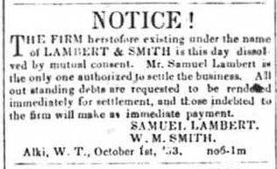
Shortly thereafter, Lambert and Smith would announce the dissolution of their Alki retail concern effective October 1, 1853 (see Figure X left).
Figure X - Lambert & Smith Closing Notice, October 1, 1853

Expectations Are Not Being Met

On June 24, 1854, it was announced that the United States Postmaster General had established a new post office at Alki and appointed Charles Terry postmaster. As early as December, 1851 barely a month after the immigrant group landed, efforts were made to secure an Alki post office. It is highly doubtful that Charles Terry ever served his first day as postmaster. His postmaster appointment came after he began to conclude his Alki ventures and search out more promising prospects. The promise of Alki had faded.
"Columbian", Olympia, Washington Territory, October 29, 1853, p 3, col 2. From: Washington Secretary of State Historical Newspapers accessed https://www.sos.wa.gov/library/newspapers/newspapers.aspx

The news of the forthcoming relocation of the Renton sawmill, coming on the heels of the Lambert and Smith and cooperage failures must have been, to Terry, a crushing blow. Exactly when he realized that Alki was not as promising as he had thought is unclear. In the February 4, 1854 edition of the “Pioneer and Democrat” he placed the following:
“Notice
Is hereby given to all person having demands against or
indebted to the firm of the Leonesa Co. or to C. C. Terry,
are requested to call and settle immediately, as the
undersigned is about to leave for the Atlantic states.
CHAS. C. TERRY,
Jan. 26, 1853. (sic)”

In the notice not only was Terry alerting all persons of interest to settle financial matters related to his proprietorship but also those involving the Leonesa Company and, presumably, Captain Daniel S. Howard. The long-standing supply chain relationship between Howard, the Brig Leonesa and Terry was also coming to a close.


At this point, one must question Charles Terry’s intent. The phrasing of his notice could support a conclusion that he was either permanently or temporarily departing. Seemingly, all business matters were being brought to a final conclusion. But a door to return from the Atlantic states was ajar.
Figure XI - Terry's Going Out of Business Advertisement, February 4, 1854

Simultaneous with this notice Terry’s weekly advertisement declared a ‘going out of business and clearance sale’ (see Figure XI left) and he ceased his service as a subscription agent for the “Columbian” newspaper and its successors. Terry was bringing Alki matters to a close. The establishment of an Alki post office was too little too late. At this point it had become apparent that the Renton sawmill was poorly located and preparations were probably well underway for its Spring, 1854 relocation.
Pioneer and Democrat, Olympia, Washington Territory, February 4, 1854, Vol II, No. 22, page 3, col. 4. From Washington SOS Historic Newspapers accessed https://www.sos.wa.gov/library/newspapers/newspapers.aspx

Alki, as the site of governmental services, such as a post office, would have significantly aided Terry’s town development objectives. At the time, the territorial jurisdiction of King County (the local governmental entity of the area) included the east and west Puget Sound shores. John Low had been appointed Justice of the Peace, a low level judicial officer, in December, 1852. This could have been the start of the Town of Alki as a governance center. But Low departed Alki shortly after his appointment. Local and federal courts, recording functions, county commissioner meetings and sheriff duties all became sited at the emergent Seattle community. Persons on the western shores of Puget Sound bypassed Alki to access local governmental services and proceedings. Alki was irrelevant for persons on the eastern shore seeking to access local governmental services. Alki failed to become a governing center.

Charles Terry continued efforts to divest himself of his Alki operations through at least late spring and early summer 1854. He completed resolution of his financial relationship with the Renton sawmill in June 1854. Sometime during early July, 1854 Terry sold his remaining retail inventory to George & Co. The public became aware of this transaction in the July 29, 1854 edition of the “Pioneer and Democrat” with the following notice;

“THE UNDERSIGNED having purchased the stock in hand of C. C. Terry, together with recent arrivals per Success and Merchantman, have on hand an assortment of general merchandise for the trade, which they offer wholesale and retail at a small advance on costs.
George & Co.
Alki, July 21, 1854”

The landlord-tenant arrangements between Terry and George & Co. are unknown, but Terry’s remaining Alki days were few. George & Co. liquidated the Terry inventory and advertised an ongoing Alki retail concern until February, 1855. At this point Alki business and trade activity of the European – American community ceased.

The Alki Exit

Terry’s planned 1854 trip to the Atlantic states did not take place. He was nominated by the Whig Party for membership in the upper chamber of the Washington Territorial Legislative Assembly and was elected at the September, 1854 election. He took his office in December, 1854 and served in the ensuing legislative session ending February 1855, representing Pierce and King Counties. He reportedly began, in June 1855, his belated trip to the Atlantic states. The date of Terry’s return to the Puget Sound frontier is unknown but was no later than May 5, 1856, the date of his Donation Land Claim grant application and filing. What circumstances prevailed upon Terry to return to Puget Sound rather than to remain in the “Atlantic states” are unknown. The public recognition earned from election as member of the Territorial Legislature and the opportunity, presented in April, 1855, prior to his east coast departure, to buy into the more successful Town of Seattle probably weighed upon his decision. Or, it may have been a budding romantic relationship.

Charles Terry was wed, in King County, to Mary J. Russell on July 13, 1856. He purchased, with Edward Lander, a large portion of Carson and Mary Boren’s downtown Seattle land claim on July 30, 1856. Terry retained his Alki land claim until its 1857 sale to David S. (“Doc”) Maynard.

Conclusions
Was Terry Entitled to His Alki Land Claim?
Terry’s fulfillment of the requirements of the Oregon Donation Land Claim Act is not above questioning. As noted earlier he had great incentive to ‘fudge’ his Oregon migration date. A similar, if not greater, incentive lay in his Alki land claim dates of residence and cultivation. He was required to have resided upon and cultivated his land claim for four consecutive years. His land patent application asserted a period beginning May 1, 1852 and ending May 1, 1856 as his required period of residency and cultivation. His beginning date is consistent with the documented date of his brother’s Alki departure. By affidavit of Andrew I. Simmons of Thurston County and David S. (Doc) Maynard of Seattle it was asserted that they were disinterested parties and that they, by personal knowledge, agreed with the claimed period of personal residence and cultivation.
What it took to comply with the cultivation requirement was unstated and unsubstantiated. Terry showed no interest in cultivating a tract as large as 320 acres. Perhaps as little as a tomato plant or a small potato patch was sufficient to comply? A certainty is that Terry’s Alki land use objective was not that of the United States Congress. It is doubtful that Terry ever substantively cultivated his Alki land claim and the Land Registrar, located in Olympia, Washington showed no interest in asking substantive questions.
Residency upon the land claim until May 1, 1856 is an open question. Sometime in mid-1855, Terry departed Puget Sound. Was his absence of sufficient length to interrupt his required consecutive Alki residency? A round trip to the “Atlantic states” would have taken six to nine months plus whatever time Terry devoted to the purposes of his travels. Did Terry relocate from and/or abandon Alki, in mid-1854, after he discontinued his Alki business ventures? When Terry returned from the “Atlantic states” in early to mid-1856 did he return to a deserted Alki or the Seattle settlement? How could Andrew Simmons of Thurston County have personal knowledge of Terry’s residence except for what Terry shared with him? Doc Maynard may or may not have been a disinterested party at the time of the land patent application but a little over a year later Maynard purchased the Terry land claim. Did Maynard and Terry have any informal understandings at the time of the land patent application filing? Did the two conduct their business so as to afford Maynard the cover of plausible deniability?
Arthur Denny, perhaps unintentionally, has shed some light on the Terry residency question when he wrote in 1888; “Terry’s brother (Leander) having previously returned East, he (Charles) thus became sole owner at the (Alki) Point. On the 18th of April, 1855, he (Charles) and Edward Lander bought the front half of the Boren claim, and he (Charles) soon after opened businesses in and became a resident of Seattle….” King County land tenure and ownership records, show that the actual transfer of title from the Borens (husband and wife) to Lander and Terry took place on July 30, 1856; a date in keeping with the Borens’ Donation Land Claim requirements. However, an agreement to purchase and occupy the Boren land claim by Terry and Lander was made at the time suggested by Denny with title later conveyed on July 30, 1856. This arrangement aided Boren in avoiding any questioning of his compliance with the Land Claim Act requirements. If Arthur Denny’s observation that Charles Terry became a Seattle resident soon after the April, 1855 date is correct, it would imply that Charles Terry failed to fulfill his Alki land claim residency requirement and his Donation Land Claim Application statements were false.

Status of the Historical Record

At the age of 37, in 1867, Charles Carroll Terry died. His papers that survive him are composed of two account books, cited herein, his last will and testament, and inventory of Seattle town lots for sale and letters received from New York relatives and one from Charles to his brother Francis. The letters shed no light on the Alki settlement events. So far is known Charles Terry never prepared a firsthand account and recollection of events surrounding Alki settlement. If such a record survived, we would have a greater understanding of his time in the California gold fields, his journey north to Oregon Territory, and the circumstances leading to his Schooner Exact journey. Arthur Denny’s account would have us believe that Charles Terry materialized out of thin air and contributed little to the Alki settlement before the Denny contingent departed. Denny’s silence adds weight to the view that Terry had no association with the immigrant group until after he boarded the Exact. The fact that Charles Terry’s intended destination was Olympia adds to the coincidental and serendipitous nature of Alki and Seattle’s origins.
Early Seattle historians did not have the benefit of a written Terry account or his oral history. They had Arthur Denny’s and their subsequent work, accordingly, is bottomed upon same. An exception is Eldridge Morse’s unpublished work which was prepared and provided to Hubert H. Bancroft. At the time Morse prepared his Alki settlement history his Snohomish county neighbor was John N. Low. The details of the Morse account indicate a Low collaboration. As a newspaper publisher it is ironic that his work remains unpublished.
When David Denny, as a member of the advance party, remained at Alki while Low returned to Portland for his family he had no reason to believe that anyone other than the Low family would return. What was David’s contingency plan? Certainly, he had in mind rejoining the immigrant group in the Willamette Valley or sending for, at some date, his future wife, Louisa Boren. Louisa was Carson Boren’s sister. At age 19, David may well have felt that he was on a grand adventure for the first time in his life outside the supervising eye of his father and older brother Arthur and he was going to make the most of it. David was attributed in later years with having expressed the view, upon the immigrant group’s landing, that he “wished that they hadn’t come”. Upon being rebuked by Arthur Denny, David explained that the Alki housing was unfinished and there was no place for the women and children. Lore has seen his comment as a comment expressing poor and harsh conditions on the Alki frontier. But, perhaps David had more grandiose plans in mind that did not include the entire Alki immigrant party and that this is the source of his socially awkward but truthful declaration if actually made. In the end, at age 21, David Denny made a Seattle land claim north of those of Bell, Boren and his brother Arthur.
Entries in Charles Terry’s account book had been previously published as early as 1908. When Arthur Denny prepared his version of events, in 1887, he had no expectation that documentary evidence would arise that might require greater explanation on his part. For the most part, Denny is correct when he wrote “it will be my earnest endeavor to state nothing but facts”. It is what he fails to disclose that is critical to a more complete understanding of navigating to the Town of Alki story.
Denny fails to disclose many details concerning John N. Low. Denny does not share with his readers critical information pertaining Low’s expectations for the Denny contingent returning to Alki, how John Low was expected to find his way back to Alki from Portland, and the means and method used by Low to bring his cattle to Alki. The record discloses activities of Boren, Bell and himself after the Leonesa pilings contract was completed but his writings are silent on the activities of the Terry brothers and Low. With detail Arthur Denny informs us of the manner in which housing was provided for all except the Terry brothers. Did the Terry brothers fend for themselves? Why were their housing arrangements unworthy of comment?
Arthur Denny declined participation in the Alki and Puget Sound advance party activities of his brother and John Low on account of illness. He later postponed his relocation to Elliot Bay’s eastern shore due to this same illness. Between the arrival at Alki in mid-November, 1851 to mid-April, 1852 what was Denny’s health status? Was he incapacitated to an extent that he was unable to assist in the labor associated with the loading of the Leonesa? If he was incapacitated was he unaware of events around him due to malaria (ague) fever and chills? In this time period, he asserts that he and his family did not suffer from fever or chills. Did Denny’s health and/or a mental acuity impairment give Charles Terry a leadership opening and profit opportunity that would not have otherwise been available? If Denny was in good health why did he fail to contribute his labor in the loading the Brig Leonesa cargo in an amount comparable to others?

Children and grandchildren of the Denny brothers, born years after Alki settlement events, would write accounts of the absence of Lee Terry from Alki at the time of the immigrant group’s landing. One account would suggest that Lee had gone to Nisqually, some 30 miles south of Alki, in search of tools. Another places Lee Terry at Olympia. Arthur Denny was silent on the matter, but would have no reason to note Lee Terry’s presence. The former accounts should be suspect. If Lee Terry was absence would Charles Terry have disembarked at Alki? Perhaps Charles made a snap decision adding to the serendipitous nature of founding events. The written record of Denny gives us no answer. In fact, Denny ignores Charles Terry’s motivations for boarding the Schooner Exact and a change in his planned destination from Olympia to Alki.

The effort herein is not to suggest an alternative Alki creation story. Coll-Peter Thrush has done an excellent service in bringing to light additional Alki and Seattle creation stories reflecting the viewpoints of others arriving before, during and after the Alki settlement. The effort herein accepts the “classic” Alki settlement story. The “classic” story, however, demands a broader and wider fact inclusion. The pivotal role of Captain Fay has been ignored, as probably Arthur Denny chose to ignore it. As related here, Fay’s role remains subject to questioning and examination.
A values conflict more than likely gave rise to John Low’s Alki departure. Arthur Denny believed that land was to be taken, bought, sold and financed. Charles C. Terry shared this view and where Denny embraced banking and finance, Terry embraced mercantilism. John Low saw things differently. Land was a source of subsistence. The care and attention he gave to the assembly of his cattle herd demonstrates that view. His entire life was spent drawing subsistence from the land. As a founding member of the Democratic Party of Washington Territory he embraced the time’s agrarian-populist ethos. Arthur Denny was a Whig and Republican who emphasized in his private and political career public improvements, trade and industry. In the early settlement days Terry was a Whig. As a Whig he was elected a member of the upper house of the territorial Legislative Assembly. With the decline of the Whig party, Charles Terry became a Unionist Democrat who was probably more interested in the local patronage aspects of party politics than political platform. The political differences and a different view of land probably lies at the heart of the departure of Low from Alki in April, 1853 and his decline of a simple move across Elliott Bay. At that time Charles Terry was on the verge of his sawmill deal with William Renton and also promoting his retail concern and welcoming other business ventures to Alki. Terry’s retail entrepreneurship and ambitions were well beyond a simple general store meeting the immediate needs of a surrounding agricultural community. Low was all in for a Town, but city building was not his style. Neither Terry nor Arthur Denny were advocates of Jeffersonian-Jacksonian ideals. The absence of diaries, letters and accounts directly illuminating the Denny-Terry-Low values conflict is, hopefully, something corrected.

Redress of Grievances

With resolution of the American-British disputed Canadian border, in 1846, came unfettered American jurisdiction and law. Suddenly, the indigenous people of Alki, the Duwamish, were dispossessed of the land they had lived upon for over 10,000 years. The Duwamish entered into a treaty with the United States Government that legitimatized, in the eyes of the immigrant group, this taking. In return, under the provisions of the 1855 Treaty of Point Elliott, the Duwamish were assured a reservation, or homeland. This reservation was never provided. In 1866, a reservation was proposed for the Duwamish which was opposed by members of the Alki immigrant group who were then Seattle residents.
To this day the consequences of the failure to provide for a Duwamish reservation reverberate. Without a communal home, it has been exceedingly difficult for the Duwamish people to maintain a continuous sense of tribal identity. The consequences of failure to provide a Duwamish reservation are now being used to deny the Duwamish people the benefits of the 1855 Point Elliott Treaty and American law. The immigrant group’s pursuit of “free” Alki land began this injustice. A focus upon this history might result in addressing the question how this injustice might be remedied. Alternatively, if the Duwamish pleas to honor the 1855 Treaty were held to the same standards of evidence and proof as Charles Terry’s Donation Land Claim application, a remedy might also be found. Maintenance of faith in the rule of law requires that the conclusion that the law always ‘takes’ but never ‘gives’ be avoided.
California Gold Rush – Critical to Alki’s Settlement

The role played by the California Gold Rush of 1849-55 in the early settlement and growth of Alki and the greater Puget Sound region is underappreciated. The Gold Rush brought four critical actors to Alki: The Terry brothers, Robert C. Fay and William Renton. Absence any one of these actors, the Alki story would have unfolded much differently or never at all. But more importantly, it was the Gold Rush that provided a nearly insatiable
demand for the only commodity that Puget Sound had that was easily accessed, extracted and converted into a cash hoard – timber. Without the demand for timber generated by the Gold Rush there would have been little means for Puget Sound immigrants to sustain themselves. Without the timber industry’s economic support there would have been little incentive to venture forth into a far corner of the American landscape by both timber buyers and sellers. The Gold Rush spawned a major industry that contributed to the growth of Puget Sound for over a century. Early San Francisco was built, in part, of Alki lumber and early Alki and Puget Sound was sustained by San Francisco. Neither community would be what they are today without the other.

Alki Was Destined For Failure

The loss of the Renton sawmill was a devastating blow to the Town of Alki. As events demonstrated, Alki was unfit to support the enterprise. Renton’s sawmill failure meant that the consumer demand of the mill’s labor force supporting the emergent Alki mercantile enterprises was lost. The number of visiting raw material providers and shippers was drastically reduced. Their support of the emergent mercantile enterprises evaporated. There was nothing to replace it.

Topographically, Alki was challenged. Being surrounded on two sides by water did facilitate waterborne commerce and activity. But waterborne commerce and activity was only one half of the equation. The equation’s second half of reaching out into the hinterlands for raw materials, natural resources, food supplies and satisfaction of the demand for finished goods and services was a logistical challenge. Alki had no natural trade area. Topography prevented access. To the northeast and east Alki was hemmed in by steep bluffs and hillsides and had no land based entry to the Duwamish River Valley and interior of the long narrow Duwamish Peninsula. The same was true to the south except for a narrow tide flat. Inland trails and paths to be built upon, leading to Alki, simply did not exist. Topography prevented the emergence of an urban place serving the function of a central point for exchange of ideas, commerce and social processes. The Alki access problem would not begin to be addressed until 1905.
There was a reason why Native Americans, before the arrival of the European-Americans, did not maintain an Alki communal village. It has been frequently written that the Denny contingent relocated to what would become Seattle’s commercial core because of its superior deep harbor potential. That maybe so, but the Native Americans had long ago discovered what the Denny contingent would soon learn, that the place to be named Seattle, was a superior “crossing over place” for land and waterborne exchange, trade, commerce and social activities. Early European-American evidence of the superiority of the “crossing over place” is the purchase of town lots by early land claimants south of Seattle along the Duwamish River creating a village like system of town homes and a surrounding agricultural zone maintained by town residents. Even Charles Terry, in later years as a Seattle resident, sought to maintain both a town and farm home. The failure of the Town of Alki, was not due to the Town of Seattle success, as many suggest, but was due to Alki’s inherent limitations. Unlike early Seattle residents, the Alki town promoters made almost no effort to build roads into the hinterland and expand land based trade potential. Alki was typographically and geographically unfit for such an effort. Seattle built upon the trade and social network blazed by the Duwamish people serving the “crossing over” place. Alki had no such network.
Even if the Renton sawmill had survived, once the timber near the shoreline had been harvested and processed, Alki would have suffered entropy in the absence of a low cost ability to access the hinterland for exchange between land and water based activity. Topography extracted a continuing price of inaccessibility. The Alki dream of being a New York without a version of an Erie Canal internal improvement was smoke and mirrors. Unlike the Erie Canal such a project would be for the purpose of remedying disadvantages not building upon natural advantages. John Low and Lee Terry, and later Charles Terry, choose poorly. They would have realized their mistake sooner if they had made better observation of the practices of and talked with the Duwamish people living on the land occupied by the immigrant group. In the end, Charles Terry’s only profitable long run choice was selling his mistake, in 1857, to Doc Maynard and buying into the new Seattle.
Pioneers Were Not Perfect People

Pioneer history frequently elevates its actors to undeserved heroic heights. They were ordinary people who pursued their own ends. Among such ends were self-enrichment and reputation enhancement. Their efforts were not altruistic. Though often literate, learned and highly capable they often erred as the Alki story demonstrates. The pioneers aided the nation in avoidance of a Malthusian resource scarcity but their contribution to building a national resource base did so at great expense to indigenous peoples and the environment.

At best, the Alki immigrants were ethnocentric and, at worst, racist. This would become increasingly clear in the years following the Alki failure. The taking of land, at least in a European-American culture, required a view that those previously residing upon it were less than worthy. Violence is an expected outcome when the humanity of a people is depreciated. The Alki settlement story and actions of the immigrant group is an early chapter leading to the Indian Wars of 1855-56 and Native American subjugation. As their West Point trained wartime leader, territorial Governor Isaac Stevens, declared; “This war shall be prosecuted until the last hostile Indian is exterminated”. In the case of Native Americans, Stevens failed to appreciate the difference between vanquishing or defeating the enemy and exterminating the enemy. His declaration of 1856 was answered with cheers.

Pioneer character and integrity is not above reproach. Potential character flaws and judgments of the Town of Alki’s promoters needs additional examination. Keeping their accomplishments in context of the costs to others and their errors aids, in a contemporary time, avoidance of overreach and hubris. A better understanding of our heritage enables a better assessment of our future.

An Alki Future
The Coast Survey would publish a map of the Seattle Harbor and Duwamish Bay in 1856 (see Map 12 below) noting the Town of Alki and declaring it deserted. Based upon those observations, the Coast Survey wrote in its 1862 annual report; “On this side of Battery Point is the deserted town of Alki, (the Indian phrase for “by and by”). The town has had several names, but there is nothing about it to command trade.” Contrary to views of the Coast Survey scribe, Alki had a great deal to command trade - recreation, leisure time activities and suburban living. It would take time, public infrastructure investment and the development of a larger metropolitan community, composed of more than a “few houses and stores, a church and a sawmill” as Seattle was then dismissed by the same Survey scribe, for Alki’s potential to be realized.
Map 12 - Alki As Shown In 1856 Coast Survey Mapping
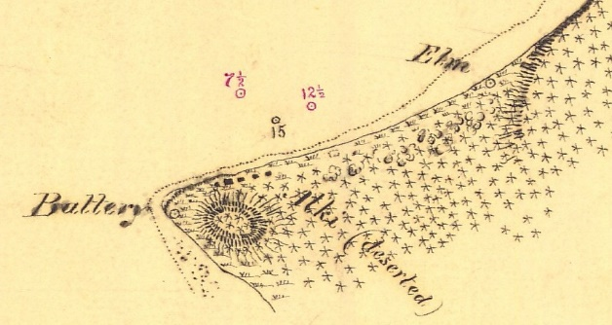
From: Historic Maps and Charts, NOAA 1856 Coast Survey accessed https://historicalcharts.noaa.gov/historicals/preview/image/T00590-00-1856

Epilogue

Resting on the Alki shoreline at the foot of 63rd Avenue SW, Seattle, is a monument to the 1851 immigrants’ landing. Frequently, while taking one of his walks around Alki, the author is asked the question, by visitors and neighborhood residents alike, “Is this really where they landed?” More often than not the answer given, depending upon the current mood, lies in the range of “maybe” to “only when elephants roost in trees”. My neighbors and visitors deserve a more thoughtful answer.
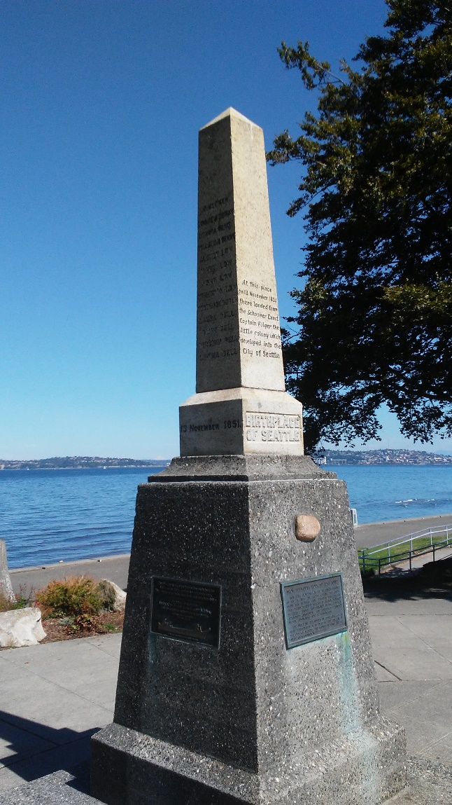
Original Monument Location – Hotel Stockade Grounds (about today’s southwest intersection of Alki Avenue and 63rd Avenue SW
Current Monument Location - Alki Waterfront at the Foot of 63rd Avenue SW
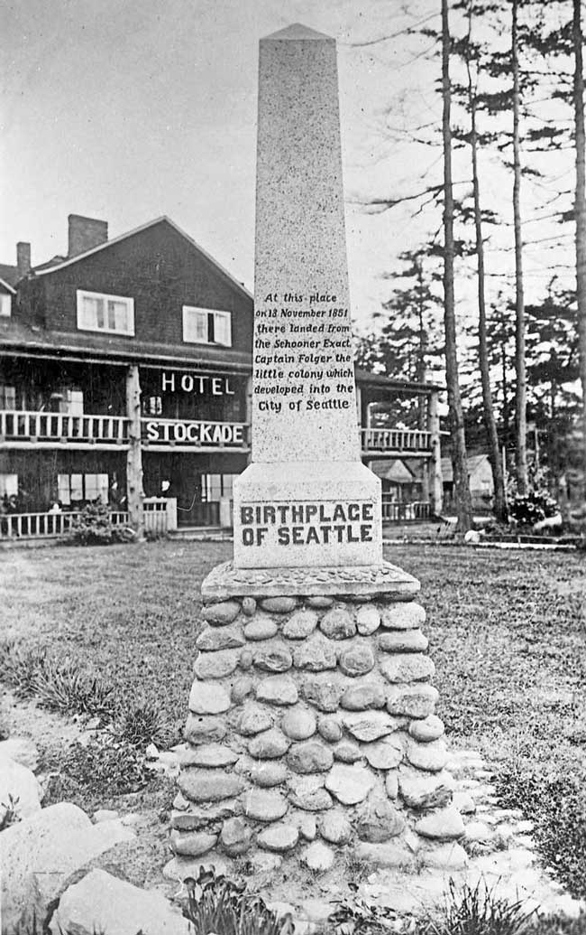
The monument was erected in 1905 by the Washington State Historical Society as a gift
by Lenora Denny. Lenora was the daughter of Mary Ann and Arthur Denny, and was a three years old member of the immigrant landing party.

The monument’s original location was diagonally across the street from its current location, on the grounds of the Hotel Stockade. The Stockade marketed itself as a premier resort and sponsored dances, concerts, cruises from Seattle across Elliott Bay and festive dining. When the monument was placed on the Hotel’s grounds there was no public property along the Alki shore. Placement of the monument, on its original site, would have added to the Hotel’s marketing image. After the City of Seattle acquired the Alki beachfront in 1910-11, voices grew to relocate the monument to public property. It was moved in 1926 to its current location.

The monument reads in part; “At this place on 13 November 1851 there landed …. the little colony which developed into the City of Seattle”. An answer to the question if the monument marks the immigrant landing site rests on the meaning of “place”. If one means pinpoint precision then the monument by its own migration and original placement, by convenience, fails to mark the landing site. If one means a generalized “place”, the monument might succeed in marking the landing site. But even by this standard the monument, more likely than not, is an inaccurate memorialization.

The current monument location is nearly 2,000 feet distant from Alki Point, or about 1,500 feet from the suspected center of the Town of Alki, as shown on the 1854 Coastal Survey map (Map 11 earlier). Given the advantages of seeing up and down the Sound and being seen as one navigates up and down the Sound, the more probable location of the immigrant group landing site is a “place” much closer to the Point and the 1853 Town of Alki location.

Knowing, with precision, the immigrant group’s landing site is more a curiosity than a matter of importance. The importance of the monument is not the noting of a place but the story it tells, unintentionally, of changing American culture.

At the time the monument was erected, it listed members of the immigrant party. Married women were not identified by name. They appeared as “and wife”. Married women were subsumed into the existence of their husbands. When the monument was moved, in 1926, this was unchanged, but the rising culture of the automobile and motoring was celebrated. A rock from Plymouth, Massachusetts from the beach near the Pilgrims landing place was transported by the First Transcontinental Motorized Caravan to Alki and was mounted in the monument’s foundation. The new Plymouth rock’s transportation and mounting was sponsored by the Michigan Automobile Club. The car was declared transcontinental travel king.

A hundred years after the original immigrants’ landing a time capsule, to be opened in 2051, was placed near the monument. A new plaque, noting the capsule, was mounted to the monument reading, in part; “honors the founders of Seattle and the men and women whose vision and efforts made this city….”. Lastly, in 2001, two additional plaques were incorporated into the monument. The first recognizes the Duwamish people and their contributions in the founding of Seattle. The second honors, the adult and married women members of the Alki landing party by name. The monument, overtime, has begun to reflect an improved sense of recognition.

This author, in the spirit that history is a continuous process, has requested that his son be present for the time capsule opening in 2051 and to revise this paper as indicated.

Acknowledgements
This work has been immeasurable improved by the critical and thoughtful suggestions and commentary of Greg Lang, King County archivist, and Lissa Kramer, Southwest Seattle Historical Society Museum curator. Both aided and offered encouragement to widen the search for materials shedding light upon “Navigate to the Town of Alki” events. Their support in questioning conventions in the classic Alki’s settlement story was essential to this paper’s completion. Completion of this paper was aided by Patricia Ahonen’s editorial assistance for which I am deeply grateful.

Appendix A
Alki Location Within The City of Seattle, Elliott Bay on the North, Puget Sound on the West and South
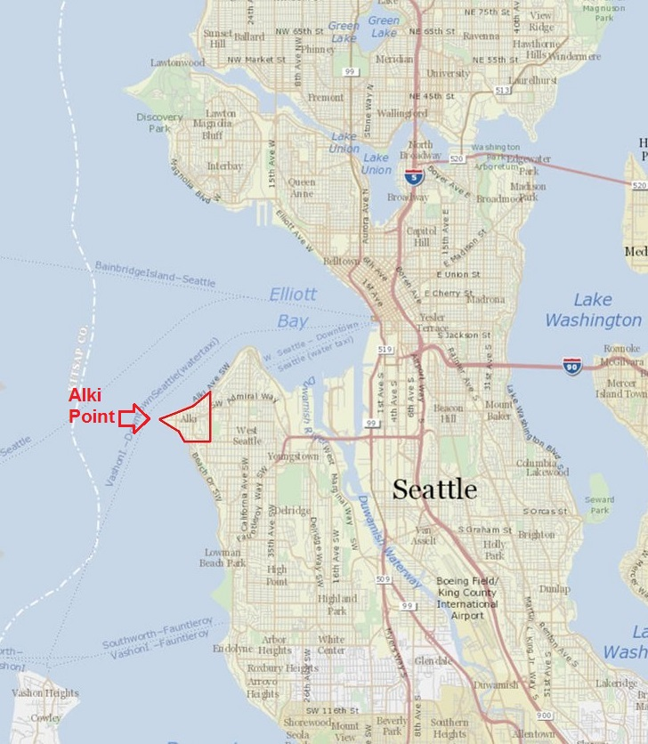
From: King County, WA iMap, Seattle , WA accessed: http://www.kingcounty.gov/services/gis/Maps/imap.aspx
on June 22,2017. Annotation by author.
APPENDIX B
Text of Letter Published in the “Oregon Spectator”, Oregon City, Oregon Territory, October 17,1850, from I. N. Ebey to M. T. Simmons
Olympia, Oregon, Sept. 1, 1850
M. T. Simmons, Esq.:
Dear Sir—In reply of your letter of inquiry, concerning the character of the land on the east side of Admiralty in-let, in regard to its adaptedness to agriculture, grazing, &e., I would say that the time I have devoted in exploring that section, is not sufficient to warrant me in giving a minute description. What I have seen is no more than a mere outline of a great country. The filing up must be done at a future day, and by persons who have more time and leisure to devote to it than has fallen to my lot the past season.
The Powalp (Puyallup) is the first stream of any size falling into the bay north of Nesqually (Nisqually) river. The stream falls into the Powalp by a little south and east of Vashon’s Island. This bay is beautifully situated, with abundance of good anchorage. It is surrounded, and to a considerable distance in the interior, by a body of low timbered land, covered with a growth of cedar, fir and maple timber. This character of land continues to a considerable distance up this river. The soil will be found of first quality, with easy access to navigation. The river is rapid and of no great depth. Fine mill privileges exist here, with an abundance of good timber. Many good situations for farms are to be met with, where the removal of the timber is by no means an undertaking of serious moment. I know of no plains on the river near the bay. Where the wagon road to Walla Walla via Mt. Rainer crosses the river, about thirty miles from the bay, fine richg plains are found, with a soil that will not suffer by a comparison with the best land in Oregon. Of their extent I am unacquainted.
The next river north, is the Dewamps (Dumwamish). This River falls into a bay of the same name (now called Elliott), below Vashon’s Island, and immediately opposite Port Orchard. This bay forms a beautiful little harbor of about four miles in width, and some six miles in length. This bay, like the Powaip (Puyallup), is surrounded by wood land. The river, for the distance of about twenty miles, has an average width of about forth yards, with a deep channel and placid current.
The river meanders along through rich bottom land, not heavily timbered, with here and there a beautiful plain of unrivaled fertility, peeping out through (ineligible) fringe of vine-maple, alder or ash, or boldly presenting a full view of their native richness and undying verdure. Other plains of more extensive character are represented as being near at hand, and of sufficient fertility to satisfy the most fastidious taste.
At a distance of about twenty miles from the bay, the river forks – the right fork bears the name of the Dewamps – It has its source about ten miles to the north in a large clear lake. This stream has an average width of about twenty yards. The country along its banks (ineligible) of the same character. (ineligible) Sandstone, of a good quality for building materials, make their appearance along this stream.
The lake from whence this stream has its source, is of considerable extent, surrounded principally with wood land, consisting of cedar, fir, maple, ask, oak, &c. It varies in width from one to six miles.—I traveled on it to the north, a distance of more than twenty miles, without finding its terminus. The water is clear and very deep; from the beauty of the lake and scenery surrounding it, we christened it by the name of Geneva (called Lake Washington today), and connected with it by a small stream.
Of the left bank of the Dewams very little is known, until you get in the region of country where the wagons can crosses the same. The Indians represent the character of the country above (ineligible) the same as that already described.
Where the wagon road crosses the river, plains of unrivaled fertility are found, covered with the most luxuriant growth of grass I have ever met with, a great deal of it being from three to four feet high, in which the red and white clover are found sprinkled with a liberal hand.
The tide flows up this river a distance of more than twenty miles.
Between Geneva lake and Admiralty Inlet, there appears an extensive county of low land, that has never been examined by white men, and when examined I have no doubt will be found very valuable.—The distance from the Inlet to Geneva lake in many places cannot exceed a few miles, as the Indians make portages across with their canoes.
About ten miles up the lake a foot trail takes across to the celebrated falls on the Snoqualamy (Snoqualmie) river. These falls are situated about twenty-five miles north east of Geneva lake. The trail is represented to pass over a good quality of farming land. I will here take the liberty to transcribe from Capt. Fay’s Journal a description of these falls. I have not visited them myself, but place the utmost confidence in the truth of the extract.
“Sept. 21. At 9 A. M., left camp in two canoes for the falls, five or six miles above. The river here is very rapid, with a number of regular rapids with falls from five to ten feet, some much more; the river is quite uniform in width being from seventy to eighty yards wide with no drift. Left our canoes a little below the falls and reached the summit on foot, where we had a good view of these stupendous works of nature. No one of our party judged the falls at less than one hundred and and fifty fee perpendicular, with a broken fall at the top of from twelve to fifteen feet.”
I have extended this communication to a much greater length than I designed, but have not given as much description as I could wish, for my thme (time) is limited.
Yours truly,
J. (I.) N. Ebey

From: Historic Oregon Newspapers, University of Oregon, accessed: http://oregonnews.uoregon.edu May 9, 2017. Text transcribed by author and additions in parenthesis are to improve clarity.

Arthur A. Denny, Pioneer Days on Puget Sound (Seattle, WA: C. B. Bagley, Printer, 1888). A revised version of this work appeared in 1908 under the editorial pen of Alice Harriman. See: Charles W. Smith, “Book Reviews Pioneer Days on Puget Sound,“ Washington Historical Quarterly, Vol. 2, No. 3 (April, 1908), p 265-268.
The Oregon Territory then encompassed what we now know as the States of Washington, Oregon, Idaho and western Montana and western Wyoming. The Washington Territory was formed in 1853 from that part of the Oregon Territory north of the Columbia River and the 46th parallel.
The Duwamish tribe of Native Americans had long maintained a settlement in and around what would become Seattle’s commercial core and waterfront.
Captain George Vancouver, A Voyage of Discovery to the North Pacific Ocean and Round the World, Vol. 1. (London: G.G. and J. Robinson, 1798), p. XVII.
Vancouver named two geographic features, Admiralty Inlet and Puget Sound. Today, these features are generally referred to as Puget Sound. Admiralty Inlet is the northerly half of the Sound whose southern boundary, in Vancouver’s time, would have been about a line drawn east to west from today’s West Point to Bainbridge Island. Admiralty Inlet, in contemporary times, means one of the five Puget Sound basins somewhat smaller in area than that named by Vancouver.
Derek Hayes, Historical Atlas of the Pacific Northwest (Seattle, WA: Sasquatch Books, 1999) p. 77-79. Simultaneous with Vancouver’s Puget Sound mapping, Spanish Crown representatives Alcala Galiano and Cauetano Valdes were surveying the Straits of Georgia and nearby waterways. Galiano and Vancouver met and exchanged maps in June 1792 and the two collaborated on further exploration. Spanish state secrecy prevented Spanish publication of Puget Sound maps until 1802, four years after Vancouver’s maps and surveys appeared in publication. If it were not for Spanish secrecy, Alki’s second language may well have been Spanish not English. The first language of Alki is Lushootseed. Lushootseed is the language of the Duwamish people.
Vancouver, A Voyage of Discovery, p. 279.
Ibid, p 259.
This article is about European-American Alki occupation. Native Americans had long held domain over Alki. A future article will cover the topic of the Native American domain and their relationship with the European-Americans through the lens of sociology’s neighborhood change invasion-succession theory with an important exception to follow herein.
William Fraser Tolmie, The Journals of William Fraser Tolmie (Vancouver, BC: Mitchell, 1963), p. 216-217.
These competing claims were resolved with the establishment of the 49th parallel as the United States and Canadian border excepting Vancouver and the Gulf Islands.
See: Journals of the Lewis and Clark Expedition, accessed May 15, 2017, https://lewisandclarkjournals.unl.edu/item/lc.jrn.introduction.general .
Charles Wilkes, U.S.N. Narrative of the United States Exploring Expedition During the Years 1838, 1839, 1840, 1841, 1842, Vol. 1, (Philadelphia, PA: Lea and Blanchard, 1845), p. XXXVII.
Not to be confused with Point Roberts near the mouth of the Fraser River and Boundary Bay.
Wilkes, Narrative of the United States Exploring Expedition, Vol 4., p. 304.
Not to be confused with another Charles Terry who also lived in Madison County, New York and was enumerated in the 1850 and 1860 census. This Charles Terry was eight (8) years older than Alki’s Charles Terry and married.
Most often the landing party is referred to as the Denny Party, taking its name from Arthur Denny, the presumed immigrant group leader. As will be shown later the more accurate name should be the “Low Party”.
See footnote 28 following. At the beginning of the Alki settlement story, Alki was located in the Oregon Territory. The Oregon Territory was composed of today’s states of Oregon, Washington, Idaho and western Montana and Wyoming. Oregon Territory was subdivided in 1853. The northern half of the Territory was organized as the Washington Territory.
It is known that John N. Low entered Oregon Territory after December 1, 1850, therefore, as a married man, he was eligible for a 320 acre land claim.
Surveyor’s Field Notes, General Land Office, Township 24 North, Range 3 East, pages 357-379, dated October 3, 1862 accessed https://www.blm.gov/or/landrecords/survey/ySrvy2_popup.php?tr=02400N00300E&srt=A&ti=48&ri=4&ln=10000000 on June 4, 2017.
Report of The Superintendent of the Coast Survey Showing The Progress of the Survey During the Year 1858, p. 446 accessed https://www.lib.noaa.gov/collections/imgdocmaps/cgs_annual_reports.html NOAA Central Library, U.S. Coast and Geodetic Survey Annual Reports. The description is based upon observations made in 1852.
Report of The Superintendent of the Coast Survey Showing The Progress of the Survey During the Year 1862, p. 409 accessed https://www.lib.noaa.gov/collections/imgdocmaps/cgs_annual_reports.html NOAA Central Library, U.S. Coast and Geodetic Survey Annual Reports. The curiosity of the Coast Survey, as to the natural cause of the formation of the mound, would be answered in 1992. See: Robert C. Buckman, Eileen Hemphill-Haly and Estella Leopold, “Abrupt Uplift Within the Past 1700 Years at Southern Puget Sound, Washington” Science, Vol. 258. No. 5088 (December 4, 1992) p. 1612.
Historical Charts and Maps Collection, NOAA, Seattle Harbor and Puget Sound, 1879 accessed https://historicalcharts.noaa.gov/historicals/preview/image/651-5-1879 on June 1, 2017.
Waterline Project Map, Burke Museum of the University of Washington, Seattle, Washington accessed: http://www.burkemuseum.org/static/waterlines/images/maps-and-images/waterlines_map_medium.pdf on July 10, 2017, and Coll Thrush, Nile Thompson and Amir Sheikh, “An Atlas of Indigenous Seattle” in Native Seattle Histories from the Crossing Over Place, Coll Thrush (Seattle, WA: University of Washington Press, 2017), p.209.
Denny, Pioneer Days (Bagley edition), page 11.
The stop in Olympia is generally overlooked but is a key Alki story element.
Denny, Pioneer Days (Bagley edition), p. 11.
The Oregon Donation Land Claim Act (31st Congress, Session I, Chapter 76, Section 5, page 496) provided for a minimum age of 21 to be granted a land donation to those immigrating to the Territory after December 1, 1850 and before December 1, 1853. David Denny was 19 at the time of his Oregon arrival and Alki settlement and therefore ineligible to assert a donation land claim interest. The Act also provided for a land grant only to American citizens or intended American citizens if they were a white settler or a married woman. This restriction effectively dispossessed Native Americans of lands that they had populated for previous centuries and denied African Americans, freed from bondage, other non-white races and unmarried women economic opportunity from the first days of America’s northwest frontier.
Eldridge Morse, “Notes of the History and Resources of Washington Territory, Book 1, University of Washington Library, Microforms and Newspapers (Call Number: Microfilm A4280), Seattle, WA undated, p. 118. Also, University of California, Berkeley, CA Bancroft Library.
Letter of David T. Denny to Clarence Bagley dated February 5, 1901, University of Washington Library Special Collections, Clarence Bagley Papers, Accession 0036-001, Miscellaneous D, Box 4, Folder 20.
Located on the Chehalis River northwest of today’s Centralia, Washington about 80 miles north of Portland and 30 miles south of Olympia, Washington.
The size of the cattle herd at this point is unknown. It originally numbered 45.
Then located in Oregon Territory later to become Washington Territory and then Washington State.
Letter of David T. Denny to Clarence Bagley dated February 5, 1901, University of Washington Library Special Collections, Clarence Bagley Papers, Accession 0036-001, Miscellaneous D, Box 3, Folder 20. The pertinent part of the letter reads, “P.S. you have it wrong as to the Terrys – they did not come with Low as I helped Low as I helped Low (sic) bring his stock over starting from Portland Sept 10 -1851- the Terrys had been in the Shasta mines and Low and I found Lee Terry at Olympia – CC Terry came around in the Schooner Exact when Low ... came to the Sound in November.”
"United States Census, 1850," database with images, FamilySearch (https://familysearch.org/ark:/61903/1:1:MCBM-53V : 12 April 2016), Leander L Fensey, Madison, Madison, New York, United States; citing family 1147, NARA microfilm publication M432 (Washington, D.C.: National Archives and Records Administration, n.d). Note the misspelling of Terry in the FamilySearch database. See original enumeration sheet provided in FamilySearch database.
Clarence B. Bagley, History of Seattle From The Earliest Settlement to the Present Time, Vol 2, (Chicago, IL: The S. J. Clarke Publishing Company, 1916), p 799.
This is the method that would bring the Brig Orbit to San Francisco and Puget Sound. The Brig Orbit was to be commanded, at a later date, by Captain Robert C. Fay. Fay would play a pivotal Alki settlement role. See: Orbit (brig-No. 1), John B. Goodman Collection, 1919-1991, Huntington Library, San Marino, CA, Box 8, Folder 63.
The Weekly Herald, Sewickley, PA, October 7, 1905, “From the Diary of a “Forty-Niner” by Joshua S. Peers, page 3, column 1. Accessed http://sewickleylibrary.org/research/heraldarchive/ August 12, 2017. The Bagley report (see: footnote 36 above) and the Peers report are at odds with one another. Bagley provides no substantiation for his claim that Charles Terry came to the California gold fields via Cape Horn. It is doubtful that Bagley received information on Terry’s journey directly from Terry himself given that Bagley was a young man of 15 at the time of Terry’s death. However, Bagley had the opportunity to learn of Terry’s life from Terry’s surviving wife, children and associates. Peers’ account is a first-hand recollection drawn from a diary purportedly kept at the time of the event. If Peers’ C. C. Terry is the same as Bagley’s, both accounts cannot be true. The reader needs to determine which account should be given the greater weight.
Letter from David Denny to Clarence Bagley, February 5, 1901, Clarence Bagley Papers, 1864-1931, University of Washington Library, Special Collections, Seattle, WA, Accession 0036-001, Box 3, Folder 20. (Also, see footnote 34 above.)
Richard Dillion, Siskiyou Trail, (New York, NY: McGraw-Hill, 1975) p 358 – 362.
Washington Donation Land Claims, National Archives and Records Service, Washington, DC, Microfilm Roll 98, page 402, Donation Certificate #423 of Charles C. Terry, Donation Notification # 260.
Morse, “Notes of the History”, Book 1, p. 120.
An arrival prior to December 1, 1850 would have entitled a single man to a claim of 320 acres. An arrival afterwards would have entitled a man of the same standing to a claim of 160 acres.
Arthur Denny’s first person account is silent on the manner and timing of Charles Terry’s Alki arrival from Portland, only stating “….. on Thursday, the 13th, our party, consisting of …… Charles C. Terry landed at Alki Point……” Denny, fails to disclose a critical detail in the formation of the immigrant group.
This land claim would be pursuant to the Donation Land Claim Act providing a grant, to all those arriving in the Oregon Territory after December 1, 1850, of 160 acres to a single male and 320 acres to a married man and woman. The claimant had to be at least 21 years old, white and an American citizen or intending to become an American citizen. David Denny, by age, was an ineligible to receive a grant at the time of the events described herein.
John B. Goodman Collection 1919-1991, Huntington Library, San Marino, CA, Box 8, Folders 63-64, Orbit (brig-No.1), p. 5 and “Shipping Intelligence”, Daily Alta California (San Francisco, CA), July 4, 1850, p. 2. Col 4.
"United States Census, 1850," database with images, FamilySearch (https://familysearch.org/ark:/61903/1:1:MHHW-4RB : 12 April 2016), R C Fay, Clark county, part of, Clark, Oregon Territory, United States; citing family , NARA microfilm publication M432 (Washington, D.C.: National Archives and Records Administration, n.d.). Fay was recorded as being at Fort Nisqually, in command of the Brig Orbit, on October 15, 1850. See: George Dickey, transcriber, Journal of Occurrences at Fort Nisqually Commencing May 30, 1833; Ending September 27, 1859 (Tacoma, WA: Fort Nisqually Association (1993), compilation of mentions of Fay, Orbit, and Albion by Greg Lange.
Alice Kellogg Cahail, “Sea Captains of Whidby Island”, Whidby Island Farm News Bureau News (Whidby Island, WA), March 9, 1939 – April 27, 1939 accessed http://www.gsswi.org/documents/SeaCaptainsofWhidbyIsland.pdf on May 20, 2017, p.5, and “Shipping Intelligence”, Daily Alta California (San Francisco, CA), May 30, 1850.
Oregon Spectator, Oregon City, Oregon Territory, October 17, 1850, Letter from J. N. Ebey to M. T. Simmons, Olympia, Oregon Territory dated September 1, 1850, p. 1 (See Appendix B for full text) and Oregon Statesman, September 18, 1851 Letter from M. T. Simmons to A. Bush, Oregon City, Oregon Territory republished “More Gold Discoveries”, Portage Sentinel, Ravenna, Ohio, December 15, 1851 p.3.
First person recollections do not mention that Fay transported Low to Olympia but as will be shown later it is highly probable that Fay did.
In Search of the Schooner Exact, Craig Magnudson, revised as of July 25, 2016, accessed http://www.craigmagnuson.com/exact.htm May 15, 2017. The Exact had previously sailed in August 1851 from Portland along the northwest coast to Sitka and returned to Portland in the fall of 1851. Reports of the Exact being lost at sea at this time are false.
Ibid.
See Appendix B. Arthur Denny may or may not have become familiar with I. N. Ebey’s letter to M. T. Simmons, as published in the Oregon Spectator. The Spectator was the leading newspaper of the upper Willamette Valley. If not the actual article, the sentiments expressed therein would have in all probability would have come to Arthur Denny’s attention.
Low tide on the 13th was at 1:04am and 2:05pm. High tide was at 8:25am and 6:36pm. See https://tidesandcurrents.noaa.gov/ at station 9447130 Seattle, WA accessed May 28, 2017. The times shown are based upon contemporary local standard time conventions.
“Schooner EXACT log entry, listing Denny Family” accessed: http://digitalcollections.lib.washington.edu/cdm/singleitem/collection/kccollects/id/509 on May 18, 2017, held by University of Washington Library Special Collections, King County Collects Heritage Collection, Seattle, WA. Note an error exists in the titling of this item. No Denny family members are listed in the document. The document is a registration, November 15, 1851, of the Schooner Exact at the Olympia Customs Office. The Exact had disembarked its Denny family passengers prior to its Olympia arrival.
Report The Superintendent of the Coast Survey Showing The Progress of the Survey During the Year 1858, p. 439 accessed https://www.lib.noaa.gov/collections/imgdocmaps/cgs_annual_reports.html NOAA Central Library, U.S. Coast and Geodetic Survey Annual Reports.
Helen M. Buss and Judith Hudson Beattie, Undelivered Letters to Hudson's Bay Company Men on the Northwest Coast of America, 1830-57. (Vancouver,BC: University of British Columbia Press, 2003),p. 368. The February 27th report that the Brig Orbit “was driven high and dry off Whitby Island” is false. See Goodman Collection, page 5.
“Early Shipping in the Puget Sound Area”, National Archives and Records Center at Seattle, Washington accessed: http://genealogy/trails.com/wash/king/ship.htm on May 31, 2017.
Charles Terry, Account Book, November 2, 1851 Portland, Charles C. Terry Papers, 1851-1866, University of Washington Library, Special Collections, Seattle, WA, accession 0247-001. Terry’s account book notes a sale of axes to J. N. Low on November 28, 1851. A fuller discussion and citation of Terry’s account books follow.
Denny, Pioneer Days, Hubert H. Bancroft, History of the Pacific States of North America, Vol XXVI (San Francisco, CA: The History Company, 1890), Welford Beaton, The City That Made Itself (Seattle, WA: Terminal Publishing Company, 1914), Thomas W. Prosch, A Chronological History of Seattle From 1850 to 1897, Part I (Seattle, WA: Unpublished Typescript, University of Washington Library Special Collections, 1900-1901), Frederic James Grant, History of Seattle, Washington (New York, NY: American Publishing and Engraving Co., 1891) and Clarence B. Bagley, History of Seattle from the Earliest Settlement to the Present Time (Chicago, IL: The S. J. Clarke Publishing Company, 1916).
The four units of housing built were nothing more than log and cedar board one room cabins. Arthur Denny in Pioneer Days (Bagley edition) refers to these housing units as houses. That convention is carried forward here.
Terry, Account Book, and Denny, Pioneer Days, p 31, taken together dates the completion of housing by the end of the first week of December, when the immigrant group began the task of harvesting timber for sale to the Brig Leonesa.
Point at which Denny contingent met John N Low family and began joint travel.
Two mast sailing vessel.
Given that the Howard contract was made as the initial Alki housing units were completed this account entry date also represents the approximate date of that the housing was completed.
If Terry’s account book is to be accepted, the labor of the female members, and probably that of the older children, in service to the community’s welfare was unworthy of being recorded and/or their labor in cargo loading was ignored. Either way, Alki kept with the era’s unfair view of woman’s work.
Denny, Pioneer Days (Bagley edition), p. 13.
Denny, Pioneer Days (Bagley edition), p 10. Denny writes that during the winter “we did not shake with ague”. Denny, Pioneer Days (Bagley edition), p. 18.
Malcolm J. Rohrbough, Days of Gold: The California Gold Rush and the American Nation, (Berkeley, CA: University of California Press, 1998) p. 125-27, and Karen Clay and Randall Jones, “Migrating to Riches? Evidence from the California Gold Rush”, Journal of Economic History, vol. 68, No. 4 (December 2008): p 1021-1023.
Arthur Armstrong Denny Papers, Journal, p. 28-29, University of Washington Library, Special Collections, Seattle, WA, accession 2343-003, Box 1, Folder 4.
Terry, Account Book.
Denny reported a well digging attempt upon his April, 1852 relocation to the Elliot Bay eastern shore. See: Denny, Pioneer Days, p 19.
Stuart Banner, How the Indians Lost Their Land: Law and Power on the Frontier, (Cambridge, MA: Belknap Press of Harvard University Press, 2005), p. 168-188, Roxanne Dunbar-Ortiz, An Indigenous Peoples' History of the United States, (Boston, MA: Beacon Press, 2014), pp. 197–201.
Kent D. Richards, Isaac I Stevens Young Man In A Hurry, (Provo, UT: Brigham Young University Press, 1979) p. 192-195.
Banner, How the Indians Lost Their Land, p.178-190
Richards, Stevens Young Man In a Hurry, p. 192-195.
Denny, Pioneer Days (Bagley edition), pages 13-14.
Robert Boyd, The Coming of the Spirit of Pestilence, (Vancouver, BC and Seattle, WA: University of British Columbia Press and University of Washington Press, 1999), p. 262-267
Oral History Transcript of Martin Smith, Southwest Seattle Historical Society, Seattle, WA, Object Id: 1999.046.0010, Home Location: SSCC Oral History Cabinet.
Clay Eals, ed. and Dan Portman (primary writer for 1851-1888), West Side Story, (Seattle, WA: Robinson Newspapers, 1987) page 17. (Note: Publication available at Seattle Public Library and the Southwest Seattle Historical Society, Seattle, WA)
“Seattle Predesign Services for the Alki Transfer/CSO Facility Project Historical/Archaeological Resources Draft Technical Memorandum” Lynn L. Larson, submitted to: Molly Adolfson Consulting Environmental Analysis, Seattle, WA for Municipality of Metropolitan Seattle, Seattle, WA August 15, 1989.
“Alki Transfer/CSO Facilities Project Traditional Cultural Property Study Final Summary of Findings” Lynn L. Larson of Larson Anthropological/.Archaeological Service, submitted to HDR Engineering, Incorporated Bellevue, WA, prepared for King County Department of Natural Resources, Water Pollution Control, Seattle, WA February 16,1996 p. 3
Charlotte Coffin Gardner, Journal Kept by Charlotte Coffin Gardner While Onboard Ship Sarah Parker, 1852-1855, San Francisco Maritime National Historic Park, Maritime Research Center, San Francisco, CA. Typescript of Journal, April 7, 1853 p.10.
Ibid, April 4, 1853, p.10.
Alki history will remain incomplete until scholars reach a definitive conclusion of the Mound’s Native American’s land use. When and if a conclusion is reached an appropriate recognition of the Mound’s history is in order.
Denny, Pioneer Days (Bagley edition), p 16-17.
Ibid, p. 16.
Ibid, p. 16.
Louis J. Rasmussen, San Francisco Ship Passenger Lists, Volume III, (Colma, CA: San Francisco Historic Records, 1967), p 182.
"United States Census, 1860", database with images, FamilySearch (https://familysearch.org/ark:/61903/1:1:MC4Y-WYB : 30 December 2015), Leander Terry, 1860.
http://www.werelate.org/wiki/Person:Leander_Terry_%281%29 accessed 5/1/2017.
Letters to Charles and Alfred Terry from Francis Terry, University of Washington Library, Special Collections, Seattle, WA, Terry Family Papers, 1852-1923, Accession 0207-001, Box 1, Folder 1-2 and Certificate of Marriage of Charles C. Terry and Mary Jane Russell, Alfred Gore Terry witness, King County Marriage Records, 1855-Present, Washington State Archives, Digital Archives, http://digitalarchives.wa.gov , August 11, 2017. See: https://www.digitalarchives.wa.gov/Record/View/475E67AB9C7C47E648A6E3E56A450746 or https://www.digitalarchives.wa.gov/Record/View/FC1C92DA514B69C61175F4627391A992
Terry, Account Book.
The Lambert and Smith retail enterprise also had its roots in a store originally founded by W. M. Smith at New York (soon to be called New York-Alki and then Alki) in February 1853. See “Columbian”, February 2, 1853, page 2. Col 6.
Charles Terry Opens First Store In Future King County No Later Than November 28, 1851, Greg Lange HistoryLink.org (March 8, 2003), accessed http://www.historylink.org/File/5395 on June 24, 2017.
Charles Terry had a great incentive to mislead about the date he entered Oregon Territory. If he entered after December 1, 1850 his land claim eligibility would have been 160 acres. He did assert his Oregon entrance date as November 10, 1850. See: Washington Donation Land Claims, National Archives and Records Service, Washington, DC, Microfilm Roll 98, page 402, Donation Certificate #423 of Charles C. Terry, Donation Notification # 260.
Fletcher v. Peck, 10 U.S. 87 (1810) and Johnson v. M’Intosh, 21 U.S. 543 (1823). See footnote 28 above.
The Oregon Territory was divided on February 8, 1853 into the Oregon Territory (generally south of the Columbia River) and Washington Territory (north of the Columbia River).
King County, Washington, King County Archives, Seattle, WA, C. C. Terry Land Claim, Book of Deeds, Vol. AC, p 23.
To ‘close’ means that stated boundaries are a continuous line and the beginning and ending points are one and the same.
This survey error was repeated in Denny’s survey contained in “Notification to the Surveyor General of Oregon of Settlement on Public Land Not Yet Surveyed” dated September 30, 1853 as part of Terry’s application for land claim Donation Certificate repeated this error. See: Washington Donation Land Claims, Notice No. 260 and Donation Certificate No. 423, National Archives and Records Service, Washington, D.C. Microfilm Roll 98, page 402.
The directional indicator on the plat is N 66 degree, 30 minutes East, nearly identical that shown in the 1854 Coast Survey at: Historic Map & Chart Collection, NOAA, Office of the Coast Survey, Preliminary Survey of DUWAMIAH BAY, Washington accessed: https://historicalcharts.noaa.gov/historicals/preview/image/H00432-00-1854 and a 1905 King County road survey at: King County Road Services Map Vault, King County, WA, Survey Field Book No. 105,p. 3 accessed: http://info.kingcounty.gov/transportation/kcdot/roads/mapandrecordscenter/mapvault/Default.aspx?DocId=TpGaQ3pwsUI1
For example, see the Plat of the Town of Seattle filed two days prior, Washington Secretary of State, Olympia, WA, Digital Archives, accessed https://www.digitalarchives.wa.gov/DigitalObject/Download/5c729165-cae6-437e-9aba-238de4a7f42a on June 17, 2017.
King County, WA, King County Archives, Seattle, WA Terry to Maynard Deed, Book of Deeds, Vol 1-2, Page 148, rerecorded at page 197.
When Maynard in future years sold his Alki holding, first to Noah Kellogg and Kund Olson, reference to the three lots purchased by Adam Boles was simply forgotten.
This brook, today, has been turned into an underground drainage system emptying into Elliott Bay at the Beach. Previously it was known as Schmitz Creek.
Unnamed, “Celebration At Alki”, Columbian (Olympia, W. T.), July 23, 1853, p 2, col 3.
Ibid.
Gardner, Journal Kept by Charlotte Coffin Gardner, Typescript, April 7, 1853, p. 10. Gardner wrote; “There are several wigwams and two grog shops here (Alki) kept by white men”.
Unnamed, “The Cascade Road Again”, Columbian (Olympia, W. T.), August 20, 1853, p 2, col 1.
Bancroft, History of Washington, p.337
Report of The Superintendent of the Coast Survey Showing The Progress of the Survey During the Year 1855, p. 192 accessed https://www.lib.noaa.gov/collections/imgdocmaps/cgs_annual_reports.html NOAA Central Library, U.S. Coast and Geodetic Survey Annual Reports. The Alki mill at the time of the Coast Survey Report had been relocated to Port Orchard.
Letter of David Edwards Blaine to his Parents, December 6, 1853, University of Washington Library, Special Collections, Seattle, WA, Blaine Family Papers, Accession No. 4611-001, Box 14.
Ibid.
Bagley, History of Seattle, p. 31.
The Renton sawmill site is the suspected location of a brickyard and plant that was in operation about 1900. The brickyard and plant was owned by A. A. Smith a significant Alki property owner and hotel / resort operator. The brickyard and plant would have recreated environmental consequences similar to that of Renton’s 1853 sawmill.
King County Archives, Seattle, WA, Mortgage of William Renton of Port Orchard to C. C. Terry, June 17, 1854, Vol AC Book of Deeds, page 30 and Mortgage of William Renton, et. al to C. C. Terry, July 12, 1854, Vol AC Book of Deeds, page 32 and page 41-42.
Eldridge Morse some years later would write; “Renton bought out Terry at Alki Point, transferred it (the sawmill) to Port Orchard….”. This suggests that Terry’s interest was that of an equity holder not lender. See: Morse, Notes on the History and Resources, Book 2, p. 3.
“Coopers At Alki”, Columbian July 9, 1853, p 3. Col 1. Washington Historical Newspapers, Washington Secretary of State accessed https://www.sos.wa.gov/library/newspapers/newspapers.aspx .
“New Post Offices”, Pioneer and Democrat, (Olympia, W. T.) June 24, 1854, p. 2, col 2 Washington Historical Newspapers, Washington Secretary of State accessed https://www.sos.wa.gov/library/newspapers/newspapers.aspx .
George H. Himes, “Seattle’s First Need of a Post Office”, Washington Historical Quarterly, 15, No. 2 (April, 1924), p.117-118.
Terry’s phrase “Atlantic States”, is no doubt a euphemistic term for his original home of Sangerfield (Madison-Oneida Counties) New York. Terry’s parents and many siblings resided at Sangerfield at the time of his ‘Atlantic States’ trip. Also, an older brother Alfred Gore Terry, who took up Seattle residence in 1855-56, with little doubt returned with Charles from Sangerfield and Madison-Oneida Counties. See footnote 92 above.
“Agents”, Pioneer and Democrat, (Olympia, WA Territory), February 4, 1854 and thereafter, p 1, col. 1.
Thurston County First Recording Book, page 27. King County was established and separated from Thurston County in 1853
Pioneer and Democrat, (Olympia, W. T.), July 29, 1854, p 3, col 3.
“Members Elect to the Legislative Assembly”, Pioneer and Democrat, (Olympia, W.T.),November 4, 1854, p. 2, col. 2.
Territorial Assembly, 1854-1887, Ellen Levesque, et. seq. Washington State Library, Olympia, WA, 1989 accessed at: https://www.digitalarchives.wa.gov/do/6ADBC9167D4DE75630D465F58DBEBD38.pdf on 7/1/2017.
“Browns”, Pioneer and Democrat (Olympia, WA Territory), June 29, 1855, p. 2, col 6. Terry is known to have been in Seattle, WA as late as April 26, 1855 when he signed court documents attempting to recover property and court costs. C. C. Terry v William McLane, King County, W. T., Original Case No. 62, Thurston County, W. T. Case No. THR-63, 1855, Washington Secretary of State Digital Archives accessed https://www.digitalarchives.wa.gov/Record/View/F7B9A4A991F9C5D4322DF2CD61CCDDE3 August 30, 2017.
Certificate of Marriage of Charles C Terry and Mary J Russell, King County Marriage Records, 1855-Present, Washington State Archives, Digital Archives, http://digitalarchives.wa.gov, August 11, 2017. See: https://www.digitalarchives.wa.gov/Record/View/475E67AB9C7C47E648A6E3E56A450746 or https://www.digitalarchives.wa.gov/Record/View/FC1C92DA514B69C61175F4627391A992
King County, WA King County Archives, Seattle, WA, Deed from Boren to Terry and Lander, Book of Deeds, Vol. ABC, page 111, July 30, 1856.
The grant of a land patent was a precondition to passing of “good” title from the United States government to the land patent holder.
Andrew Simmons was David S. (Doc) Maynard’s brother-in-law and Michael T. Simmons brother.
See footnote 128 above.
Denny, Pioneer Days (Bagley edition), page 21.
King County, WA, King County Archives, Seattle, WA, Deed Boren to Lander and Terry, Book of Deeds, Vol ABC, p. 111.
A common practice of the time in dealing with Donation Land Claims was, prior to the issuance of a land patent and “good” title, to sell the right of possession of land with an agreement to convey title, at a future date certain. The future date certain would be subsequent to the end of the required period of Donation Land Claim residence and cultivation. The sale of possession and agreement to convey title was under “bond” meaning that the purchaser was entitled to a penalty if the seller failed to convey title. In this case the April 18, 1855 date was the date of the agreement between the Borens and Lander and Terry to grant possession and agree to convey title at a future date certain. See: King County, WA, King County Archives, Seattle, WA, Bond, Borens to Terry and Lander, Book of Deeds, Vol ABCD, p. 59. How one could comply with the residency and cultivation requirement, under the Land Claim Act, while granting land possession to another is an investigation left to others. In this case, Terry was in possession of the Boren land which adds weight to the case that he was no longer residing at his Alki estate.
Bancroft, History of the Pacific States, Beaton, The City That Made Itself, Prosch, A Chronological History of Seattle From 1850 to 1897, Part, Grant, History of Seattle, and Bagley, History of Seattle.
Letter from Arthur Denny to F. F. Bancroft (sic) dated October 28, 1886, University of Washington Library, Special Collections, Seattle, WA, Accession 2343-004 Typescript and Letterpress Book of AA Denny Letters, 1880-87. Denny writes Bancroft “… sending you the enclosed clip and if you should already have it no harm is done. It was prepared by me and published in the “Seattle Post” Jan 1st 1880. The manuscript is still in my possession signed by and approved as correct by (six pioneer settlers including himself) …” Here Denny is seeking to influence Bancroft’s perception of settlement events. The manuscript offered is the “Chronology of Events” published in Pioneer Days (Harriman ed.) at page 101. Denny’s Pioneer Days would come eight years later. His Chronology (1880) and Pioneer Days (1888) would be an influential first “authoritative” and written account verified by others. A question worth exploring is if any of the others would be willing to dispute a matter the town banker felt strongly about.
“Notes of the History and Resources of Washington Territory, Eldridge Morse, Book 1 and 2, University of Washington Library, Microforms and Newspapers (Call Number: Microfilm A4280), Seattle, WA undated. Also University of California, Berkeley, CA Bancroft Library.
In 1909, David Denny’s daughter, Emily Inez, would suggest that Low carried a letter from him to his brother Arthur Denny. In her book, “Blazing the Way”, she quotes two different versions of this letter. In time, a third and fourth version would be appear. In the histories of the period written prior to 1909 there is no suggestion of a written communication between the two Denny brothers. After 1909 the notion of a letter begins to creep into the telling of Seattle history. The existence of a letter between the two brothers is suspect and a worthy topic of greater exploration.
Roberta Frye Watt, Four Wagons West, (Portland, OR: Binfords & Mort, Publishers, 1931), p. 43, and E. Inez Denny, Blazing the Way, (Seattle, WA: Rainer Printing Company, 1909), p. 51.
Denny, Pioneer Days (Harriman edition).
Denny, Pioneer Days (Bagley edition) p. 3-4.
Ibid, p 18.
Coll Thrush, Native Seattle Histories from the Crossing-Over Place, 2nd ed. (Seattle, WA: University of Washington Press, 2007 and 2017), and Coll-Peter Thrush, “Creation Stories: Rethinking the Founding of Seattle” in More Voices, New Stories King County Washington’s First 150 Years, ed. Mary C. Wright (Seattle, WA: The Pacific Northwest Historians Guild, 2002), p.34-49.
“Proposed Mass Meeting”, Columbian, (Olympia, W. T.) June 11, 1853
“Whig Convention in Washington Territory”, Pioneer and Democrat, (Olympia, W. T.) July 8, 1854, p.3 col 2., “Members Elect to the Legislative Assembly, Pioneer and Democrat, (Olympia, W. T.), November 4, 1854, p. 2. Col 2, and “Union Meeting”, Pioneer and Democrat, (Olympia, W. T.), March 15, 1861, p. 2, col 5.
David Wilma, Seattle Pioneers Petition Against A Reservation On the Black River for the Duwamish Tribe in 1866, HistoryLink.org accessed http://historylink.org/File/2955 September 2, 2017.
Thrush, Native Seattle Histories, p. 36-37.
King County, WA, King County Archives, Seattle, WA, Deed Maynard to S. Maples, Book of Deeds, July 3, 1856, Vol AC-D, p. 104, Deed Maynard to H. Van Asselt, Book of Deeds, April 13, 1857 and July 3, 1856, Vol. AC-D, p. 174 and p. 104, Deed Boren to E. Maple, Book of Deeds, January 2, 1857, Vol. AC-D, p. 148, Deed Bell to J. Buckley, Book of Deeds, April 4, 1856, Vol AC-D, p. 73, Deed Boren to J. Buckley, Book of Deeds, November 28, 1856, Vol AC-D, p. 134, and Deed Boren to VanAsselt, Book of Deeds, December 10, 1856, Vol AC-D, p. 145.
Letter from Charles C. Terry to Francis Terry, December 20, 1860, University of Washington Library, Special Collections, Seattle, WA. Terry Family Papers, Accession 0207-001, Box 1, Folder 1-9. The location of Terry’s farm referred to in his letter is probably that on land he owned along the Duwamish River south and west of today’s Boeing Field (King County Airport). See: U.S. Bureau of Land Management, Washington, D.C. Land Patent Details, Accession Nrs. WAOAA 072315 and 072303 accessed: https://glorecords.blm.gov/details/patent/default_pf.aspx?accession=WAOAA%20%20072303&docClass=SER and https://glorecords.blm.gov/details/patent/default_pf.aspx?accession=WAOAA%20%20072315&docClass=SER
Denny, Pioneer Days, p 44-48 and Thrush, Native Seattle Histories, p. 22-24.
The sale to Doc Maynard was an exchange of land claims and cash. Doc Maynard took Terry’s Alki land claim in exchange for Maynard’s Seattle land claim. Maynard’s claim was to become known as Seattle’s Pioneer Square.
Richards, Isaac Stevens, p. 258.
Report of The Superintendent of the Coast Survey Showing The Progress of the Survey During the Year 1862, p. 409 accessed https://www.lib.noaa.gov/collections/imgdocmaps/cgs_annual_reports.html NOAA Central Library, U.S. Coast and Geodetic Survey Annual Reports. The description is based upon observations made in 1854.
John Slattery, “City’s Birthday Impressively Observed”, Seattle Daily Times (Seattle, WA) November 13, 1905.
Unnamed author, “Rededication of Alki Point Monument”, The Washington Historical Quarterly, Vol 17, No. 4 (October, 1926), p. 312-313.

