Alki’s First Housing Finance Crisis
Phillip H. Hoffman

Abstract

Demonstrating that not all pioneers were virtuous and noble, N. S. Kellogg spawned, along with many other misdeeds, Alki’s first housing finance crisis. Kellogg purchased the Charles Terry land claim and site of Seattle’s founding, in 1862, from David (“Doc”) Maynard and then sold the claim, nearly a year later, back to Doc Maynard ‘in lieu of foreclosure’. Kellogg purchased the Charles Terry land claim, and site of Seattle’s founding, in 1862 from David (“Doc”) Maynard and then sold the claim, nearly a year later, back to Doc Maynard ‘in lieu of foreclosure’. In the ensuing years Kellogg engaged in logging, carpentry and liquor sale pursuits, developed a recurring pattern of failure to pay debts, and was an early employee of the Washington Territorial Asylum for the Insane. In 1874, he married a recent divorcee. After his wife took ill he left her in the care of her eldest living daughter, never to see his wife again before her 1886 death. Kellogg meandered about the Pacific Northwest and Southern California arriving in Murray, Idaho in 1884. In the summer of 1885, Kellogg accidently discovered a prolific lead and silver mining lode. This discovery sparked litigation testing the efficacy of community property laws, in the case of marital abandonment, endangering the investment of Kellogg and Simeon Reed, noted Portland, Oregon capitalist, in the Bunker Hill and Sullivan Mining and Concentrating Company. Kellogg died in 1903 with his second wife declaring “Ive never had an hours happiness with Mr Kellogg” and his third wife’s disposition being unknown.
Introduction

Alki is a beachfront residential and recreational neighborhood of Seattle, Washington bounded on the north by Elliott Bay and on the west by Puget Sound. It is about 280 acres in size and home to 4,000.

Map 1 - Alki Neighborhood Location
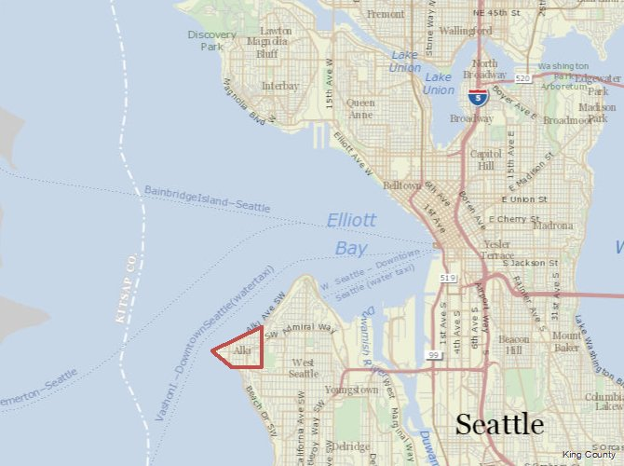

At the mid-point of the 2007-09 Great Recession the Alki area housing foreclosure rate was estimated to be .3%. In other words, of all residential mortgages taken out for the years 2004-2006, one third of one percent of those mortgages had defaulted in the eighteen months ending June 2008. In the same timeframe, 1.9% of metropolitan area mortgages had defaulted. Nearly 150 years earlier the Alki mortgage default rate was 100%.

Alki is the original point of Seattle settlement by European-Americans. In the fall of 1851, exploratory members of the Denny Party arrived on the Alki shores and established a beachhead anticipating the full party’s later arrival. Intending to found a great city, the remainder of the party arrived November 13, 1851. It is from this point that pioneers date Seattle’s founding. Several others sharing the desire to found a great city, most notable being David S. (“Doc”) Maynard, joined the Party at Alki.

With the exception of Charles C. Terry, Alki failed to fulfill Denny Party expectations. The Party, numbering 24 (half were children), and Doc Maynard abandoned Alki the following spring in favor of the deeper waters and potential harbor of Elliott Bay’s eastern shore. This new site would become Seattle’s central business district. Terry remained on Alki and operated his general store and attempted to market 60 by 92 foot lots in his Town of Alki (see Map 2 below). He sold three (3) of his 48 town lots.,

Map 2 - Charles C. Terry's Plat of the Town of Alki, 1863
(From Book of Plats, Seattle Municipal Archives, Office of the City Clerk, City of Seattle, Seattle, WA)
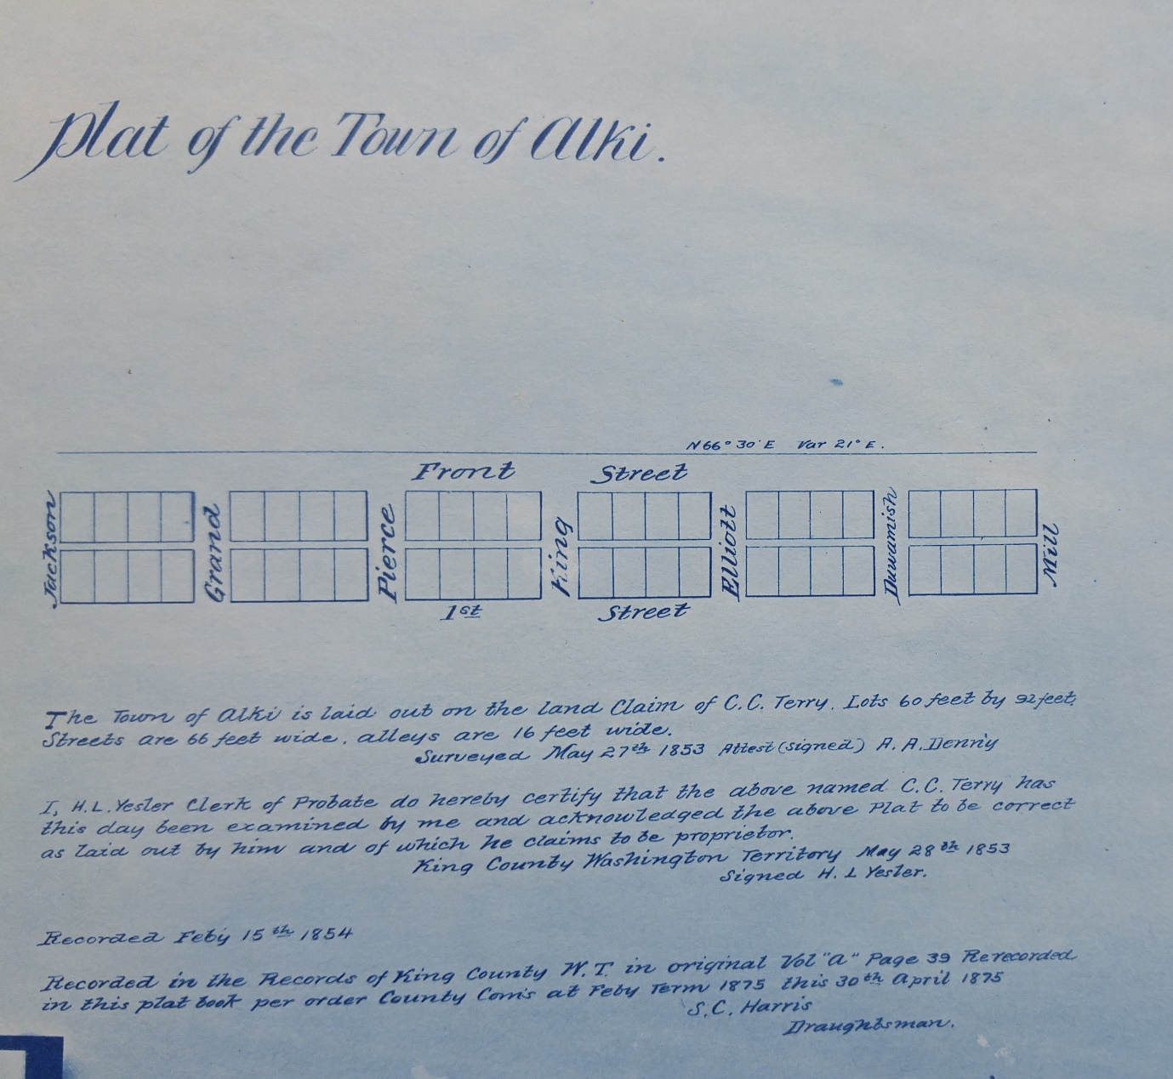

Charles Terry formalized his stay on Alki with a land claim of 320 acres. The markings for this land claim do not exist today. The land claim was later restated to conform to the survey lines of the Public Land Survey System and General Land Office Survey of 1862. (See Map 3 below.) Today, Terry’s original land claim would lie approximately within that part of Seattle west of 55th Avenue SW, north of SW Genesee Street, south of Elliott Bay and east of Puget Sound.

Map 3 - Charles C. Terry Land Claim
(red line notes original claim, black line notes claim as conformed to General Land Office 1862 Survey)

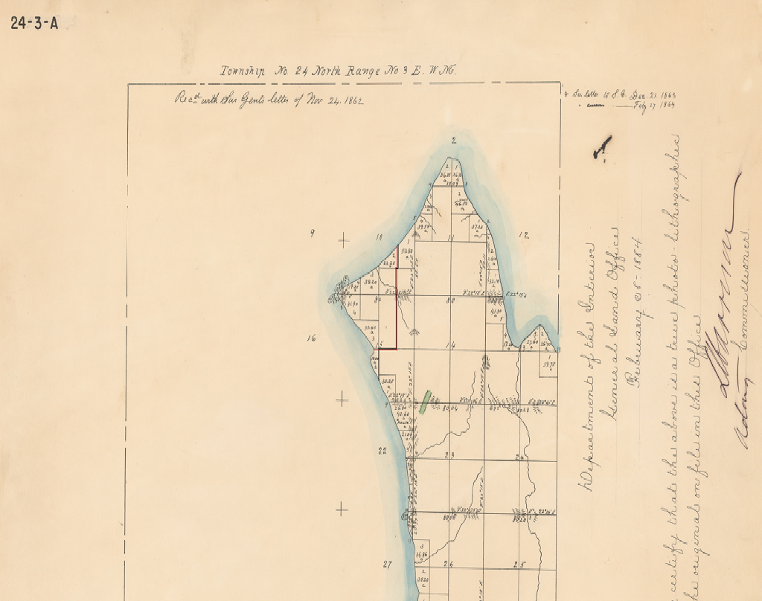

Terry quickly realized his error and soon began making plans to rejoin the Denny Party on Elliott Bay’s eastern shore. But by this time the Bay’s eastern shoreline and environs had been divided among Party members, Doc Maynard and other early arrivals. The land was taken. To get into the Seattle building game Terry would have to buy his way in. He found his mark in Doc Maynard.

Doc Maynard laid claim to 320 acres on Elliott Bay’s eastern shore and promptly began playing his role to build a great city. He modeled his vision upon his experience and observations in the founding and growth of Cleveland, Ohio. Upon the failure of his Cleveland medical school venture he traveled west and joined forces with the Denny Party. He eventually found himself at odds with the members of the Denny Party over matters of public morals, public regulation of private conduct, political preferences and, importantly, Indian relationships. He tired of the conflict.

Who first approached the other is unknown but Maynard and Terry exchanged cash and land claims. Terry found himself in possession of 260 acres in downtown Seattle, now known as Pioneer Square, and Maynard became Lord of Alki on July 11, 1857 presiding over the original Terry land claim sans the three Alki town lots previously sold. Maynard retired to his agricultural haven, built a new home on Alki (only to be destroyed by fire and then rebuilt), probably pursued his legal and medical practices, hosted passing boatmen and visitors, and testified in a murder trial as to defendant’s motives.

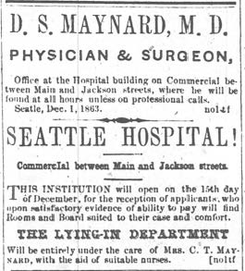
Maynard was a city person. Alki was remote and distant. He soon longed for a return to the growing settlement to the east. He let it be known that the original Terry land claim was for sale and he returned to Seattle to open a hospital on December 15, 1863 located in the midst of his original land claim. Maynard’s Alki land holding was sold, in 1868, to Norwegian immigrant Knud Olson. Olson made his way to Puget Sound via Wisconsin, Lake County, California and Alpha Prairie, Washington.
Seattle Gazette
Seattle, Washington Territory
December 26, 1863
(from Historic Newspapers Collection of the Washington State Secretary of State)

Olson’s children and his business partner Hans Martin Hanson and his family would shortly join Olson. These late comers remained in Alpha Prairie (outside today’s Longview, Washington) while Olson scouted Puget Sound prospects and closed the Alki purchase transaction. Olson and Hanson held the original Terry land claim undivided until 1891. Thereafter they initiated an orderly process of division of interest in the Alki estate between Hanson’s children and Olson. Knud Olson would reside on and manage his Alki holdings until his death in 1919. Afterward Olson’s children managed the Alki holdings and resided on Alki until their 1944 deaths. Hans and Anna Hanson remained Alki residents until their deaths in 1900 and 1902. Thereafter the Hanson children and their spouses sold and developed their Alki holdings. Most of the Hanson children remained lifelong Alki residents.

Or so goes the Seattle creation story.

The Forgotten Transaction and Finance Crisis
Many wonder at the nearly five year period between Doc Maynard’s entrepreneurial hospital start-up (1863) and the Olson purchase of Terry’s Alki land claim (1868). Maynard paid Terry $1,000 in cash in addition to the land claim exchanged while he received only $450 from Olson and no other known consideration. The reduced cash price received between the two transactions would seem to indicate prevailing harsh real estate market conditions and difficulty of finding a buyer.

Seldom recognized and often overlooked is an earlier Doc Maynard sale of Terry’s Alki land claim. October, 1862 brought good fortune to Doc Maynard. He found a buyer for the Alki estate. The buyer agreed to pay $3,000 in the form of $1,000 in cash and a series of mortgage notes representing the $2,000 purchase price balance at 10 percent interest payable, annually, over the next six years. In addition to whatever other current assets Maynard had, he now had capital to finance his hospital start-up.

The buyer, N. S. Kellogg, executed the transaction on October 2, 1862. Maynard granted to Kellogg the entire Terry land claim using the original Terry land claim boundaries. Terry’s earlier sale of three (3) town lots was forgotten.

Kellogg was on a real estate roll. Just days earlier, September 9, Kellogg agreeing to pay $150, had purchased a lot in the Town of Seattle plat (lot 4, block 10). The purchased lot was originally part of Doc Maynard’s Seattle land claim but at the time of Kellogg’s purchase was owned by Maynard’s friend Charles Plummer. To finance the purchase Kellogg gave back a mortgage to Plummer. Kellogg’s plans for his realty holdings are unknown but a reasonable inference was that Kellogg had visions of a country estate financed by Alki agricultural and lumbering pursuits and a city home when social and economic circumstances indicated. Which home was the vacation home, in his mind, is unknown but his grand scheme would soon collapse.

Was N. S. Kellogg A Worthy Credit Risk?

In the short run – no. He never made the first payment on any of his real estate acquisition debts. Maynard took back the keys to the original Terry land claim September 21, 1863 shortly before the first $200 interest payment was due and cancelled the outstanding mortgage. In contemporary parlance Kellogg deeded the property back to the lender “in lieu of foreclosure”. The Alki housing finance crisis came to an end with Kellogg out his original $1,000 down payment. But, in Seattle, unhappy news awaited Kellogg.

Charles Plummer was looking for his money and was none too happy about it. Plummer obtained a King County probate court judgment for monies due ($171.44) including interest plus additional costs. Plummer then proceeded to have the court authorize a Sheriff’s Sale of the mortgaged Seattle property to satisfy the debt. The sale was scheduled for December 12, 1863. The sale never took place. Kellogg sold the property
Map 4 North Puget Sound, 1867
(annotations by author)

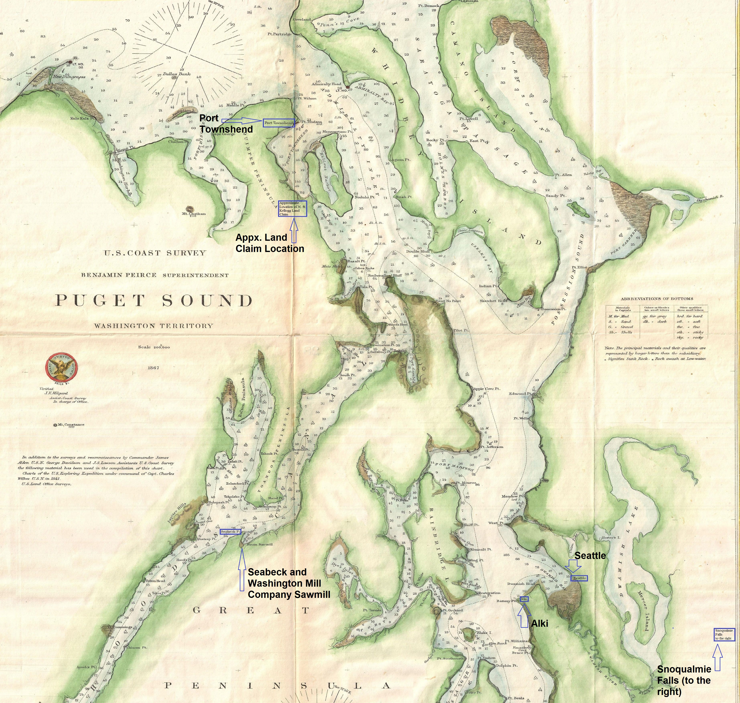

Source: https://commons.wikimedia.org/wiki/File:1867_U.S._Coast_Survey_Chart_or_Map_of_Puget_Sound,_Washington_-_Geographicus_-_PugetSound-uscs-1867.jpg

Map 5 South Puget Sound, 1867
(annotations by author)

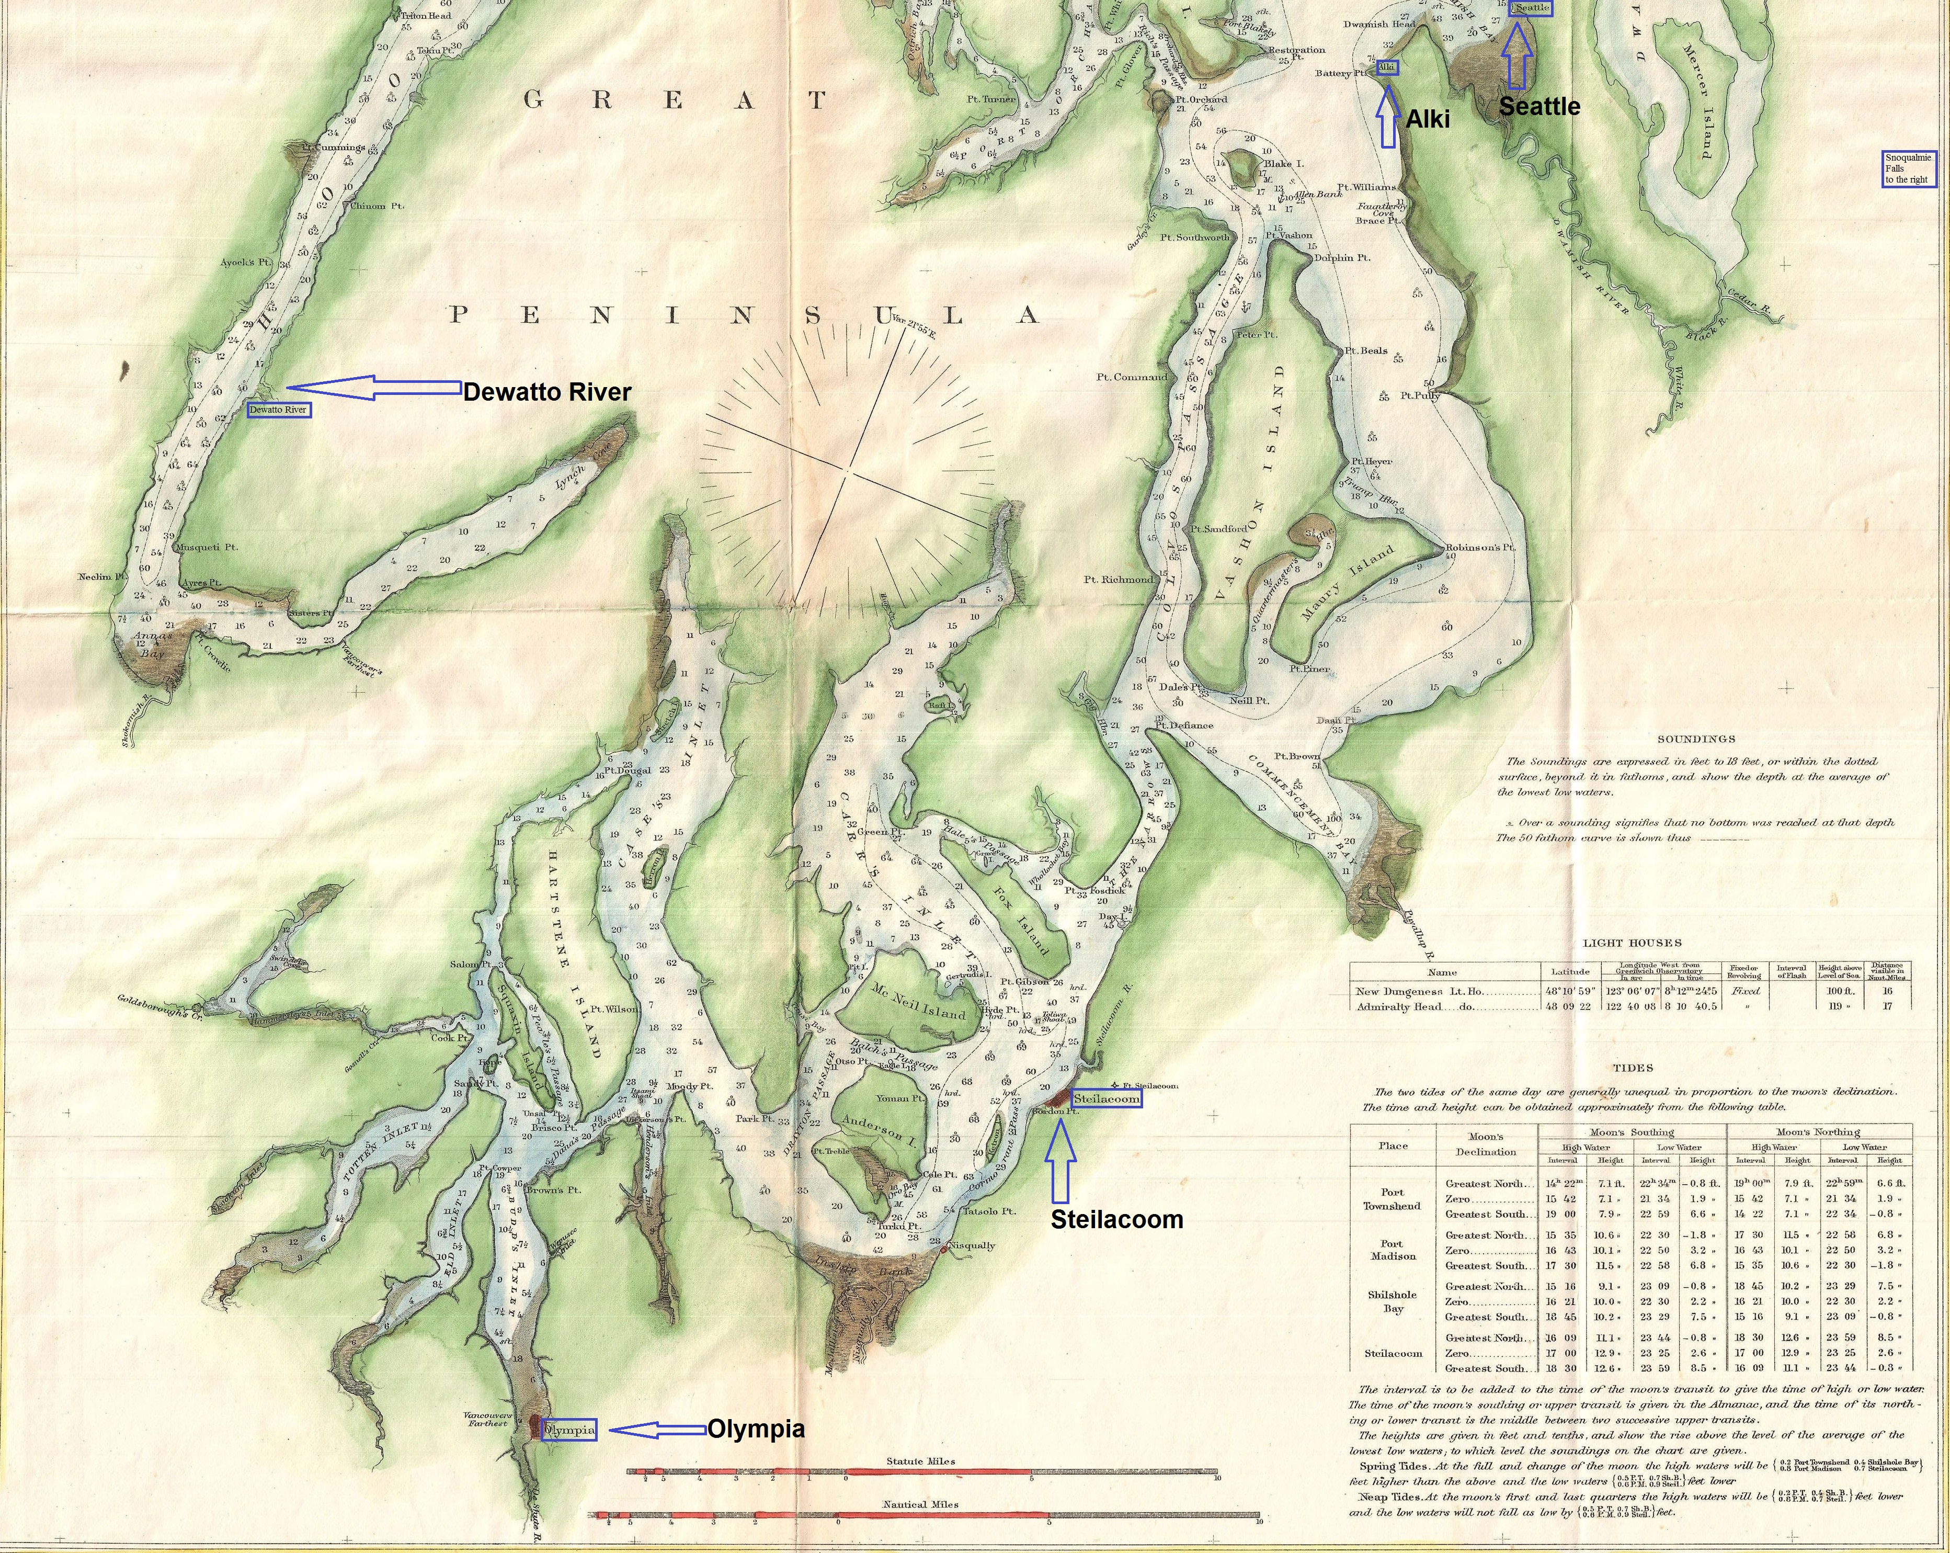
Source: https://commons.wikimedia.org/wiki/File:1867_U.S._Coast_Survey_Chart_or_Map_of_Puget_Sound,_Washington_-_Geographicus_-_PugetSound-uscs-1867.jp
back to Plummer on December 11th, giving rise to another “in lieu of foreclosure” transaction.

There being no credit reporting companies and credit scores in the time, it is hard to say how Maynard and Plummer evaluated the credit risk before them. Only through prior business relationships, firsthand knowledge of their borrower and borrower’s reputation would they have understood the risk. They were clearly wrong. And as events would unfold their error was confirmed multiple times.

N. S. Kellogg – What A Credit Check Might Have Shown

Prior to the Alki and Seattle “in lieu of foreclosure” sales there is only fragmentary information about Kellogg. Kellogg arrived on Puget Sound sometime after mid-1850 and before fall 1854. On October 4, 1854 N. S. Kellogg filed a 160 acre land claim under the Washington Territory Donation Land Claim Act of 1853-1855. This claim was in Jefferson County, Washington south of Port Townsend, probably on Chimacum Creek east of today’s Anderson Lake State Park (See Map 4).

Two months later O. S. Kellogg filed a 160 acre land claim. In 1857 O. S. Kellogg was enumerated in the Kitsap County census. This indicates that the land claim may have been located in Kitsap County but land claim records are insufficient to precisely locate the claim. A location in Kitsap County would not be far removed from the N. S. Kellogg’s claim location.

The size of the two land claims would indicate that both persons were single individuals. Neither Kellogg was ever issued, by the General Land Office, a land patent for their land claims. A land patent would have entitled them to purchase their claim from the United States Government for $1.25 per acre.

N. S. Kellogg and O. S. Kellogg were brothers. N. S. was the elder by two years. He was 24 at the time of his 1854 land claim filing. Both Kelloggs were born and raised in LaGrange Township, Lorain County, Ohio and resided at their birthplace at the time of the 1850 federal census. They had ten brothers and sisters with N. S. and O. S. being the second and third youngest. Their father farmed and was named Noah. At the elder Kellogg’s death in 1866 he owned a house and 143 acres. The house and 13 acres were left to his wife and children’s mother, Jerusha (Stoddard), with the balance of the acreage to be sold. Sale proceeds were to be used for Jerusha’s lifetime maintenance and support. Upon Jerusha’s death the estate was to be divided among his legal heirs. Jerusha’s died in 1870. It is unknown if N. S. or O. S received any estate proceeds.

O. S. Kellogg’s full name was Orange Stoddard Kellogg. N. S. Kellogg’s full name was Spencer Noah Kellogg. Sometime after 1850 but before his land claim filing Noah reversed first and middle name and became known as Noah S. Kellogg or N. S. Kellogg. The motivation for this change is unknown. It could have been that the use of Noah, would not have confused him with his father far removed from Ohio, and he preferred that name, he wanted to make it difficult to be found or the 1850 Census was in error.

The reasons why the Kellogg brothers failed to follow through on their land claim commitments are also unknown. They may have found conditions too harsh, became injured or disabled in the course of working the land, found brighter prospects elsewhere, the venture was not rewarding enough relative to the labor, they were dislocated by the Indian Wars raging around them, they harvested the land’s timber resources and had no further use of the land, or they failed to produce sufficient income to pay the required purchase price. The failure to fulfill their land claim commitment should have been a sign of possible credit trouble ahead.

Little is known about Noah Kellogg for the four year period after he failed to secure his land claim patent (1858) and his purchase of the Maynard Alki estate (1862). Arthur Denny in his autobiographical statement Pioneer Days on Puget Sound gives a clue when he relates; “The first settlement was made on the Snoqualmie river, on the prairie above the fall, (by) the Kellogg Brothers, in the spring of 1858, followed in the summer by J. W. Borst”. Denny makes no further reference to the Kellogg Brothers. It is probable but not certain that Noah and Orange were the Kellogg Brothers referred to by Denny. Their activities, in King County, just east of Seattle, and means of subsistence is a mystery.

Some support of the Denny clue lies in the 1860 Federal decennial census. Among the 302 persons enumerated in King County, there is a Spencer Kellogg, age 35, who gives his occupation as farmer. The 1860 census does not provide address information that would permit identification of a specific location within King County. But the person enumerated immediately before Spencer Kellogg was Jeremia Borst, indicating that this Kellogg is the same Kellogg noted by Denny and that he probably remained at the Snoqualmie river site. No Orange or O. S. Kellogg is enumerated. Spencer Kellogg in this instance is shown as being four years older than the Spencer Noah Kellogg identified previously and states that he was born in New York not Ohio. The Spencer Kellogg identified in the 1860 census and the Noah Spencer Kellogg are probably one of the same but it is not certain.

The potential sale of Noah’s Jefferson County land claim, the claim’s timber resources, or the sale of resources extracted from the Snoqualmie River settlement or a lucky game of cards may have provided the source of cash to fund Kellogg’s 1862 real estate purchases. Whatever the source or sources, he was without means after the Alki housing finance crisis.

The Entrepreneurial Spirit Burns Bright

By 1867 Noah Kellogg had developed a business persona. He began to refer to his ventures as Kellogg and Company and focused on the logging and lumber business. Kellogg and Company entered into a partnership in the spring of 1867 with the Washington Mill Company. Kellogg’s company was to supply the mill with logs, spars and pilings and, if general industry practice prevailed, the mill would make advances to cover material, supply and equipment costs. This supplier and mill relationship lacked mutuality. As others have written the relationship “resembled the relationship of a debtor employee to a company store. The logger’s lack of capital caused most to begin operations in debt and in a binding partnership with the mill company.”

The Washington Mill Company was an early Puget Sound enterprise beginning operations in 1857, located in Seabeck, Washington (See Map 4). The company primarily sold lumber into the San Francisco market necessary to support the city’s burgeoning growth as the west coast’s leading commercial center. The company was a partnership of Marshall and Samuel Blinn and William J. Adams, San Francisco capitalists, and others including Hill Harmon. Harmon owned a one-eight share at the time of the company’s founding but would later sell his share (before Kellogg entered into his Mill Company partnership). Harmon was possibly the conduit introducing Kellogg to the Washington Mill Company and the independent logging business.

Kellogg commenced fulfillment of his obligations. In late winter 1869, an unnamed employee stationed at the mill’s Seabeck wharf entered into their diary “Scaled” (meaning measured) “Kellogg’s boom today.” Where Kellogg secured his log cargo is unknown but the practice of the day was to rely upon the “public domain, mill company lands, and other privately owned lands.” The relationship between mill and Kellogg continued until December 2, 1869 when, contends the Mill Company, the Mill notified Kellogg that the partnership was dissolved because they “were dissatisfied with his manner of doing business” and demanded settlement of transactions. The Mill contended that he refused to comply. In later court pleadings, the Washington Mill Company alleged that $16,000 was due and the Company sought an order prohibiting Kellogg from selling or disposing of any of the property belonging to the partnership.

Dissatisfaction with the way in which Kellogg conducted his business may have been a pretext. A forecast of increasing poor business prospects may have been the real reason for the attempted partnership dissolution. In 1870, the “shipping volume (lumber) to San Francisco steadily decreased” and “fell to its lowest point in 1873”. The Washington Mill Company may have been attempting to cut its incoming log inventory at the expense of its biggest debtor. Kellogg and Company’s debt was seven times greater than that of other Washington Mill Company logging partnerships.

At the direction of Marshall Blinn, on May 2, 1870 the Washington Mill Company’s lawyer visited the Seabeck offices in preparation to bringing a court action to collect the Kellogg debt. A King County court complaint was filed on May 9th and Kellogg was served court papers at Steilacoom, Washington on May 20th. Court records do not reflect any answer by Kellogg or proceeding outcome. The Company lawyer, B. F. Dennison, by letter of June 17, informed the Mill manager, Richard Holyoke, that “Noah Kellogg had sold all the logs …. camp implements and delivered possession to Isaac Carson before the suit was commenced.” Dennison then advised Holyoke to make an inspection of the camp, locate as much of the partnership property as possible and instruct all concerned not “to remove the property”. In turn, Holyoke informed Dennison on July 13, that the camp had been vacated except for two men, that operation on the logs had been suspended and that “there is about eight hundred dollars worth of logs out that can be got” and asked if the “logs should be taken”.

The Washington Mill Company was not about to drop the matter; they went looking for Isaac Carson. They found him in Thurston County, Washington. The Company lawyer, Dennison, brought an action in the 3rd District Territorial Court holding term in Olympia, Washington in the name of the Company and Kellogg and Company to recover the logs and camp implements sold to Carson. The complaint dated June 24, 1870 or seven days after the Company had learned of the Carson sale, sought recovery of 3.5 million feet of saw logs, equipment and “chattels” having a value of $18,000 plus $1,000 damages. The Company complaint brought to light that Kellogg and Company had been engaged to establish a logging camp at the mouth of the DeWatto River in Mason County (formerly part of Kitsap County) about 20 miles south of the Washington Mill Company’s Seabeck saw mill (See Map 5). Carson answered the complaint on September 27, 1870 contending that the logs and chattels had been sold to him by Kellogg on April 4th.

Two other court cases were then spawned. Taken on their whole, the three contests in the Olympia court reveal that Noah Kellogg had sold the logs and associated equipment, materials and supplies to Isaac Carson on April 4th for $7,000 and, in turn, Carson sold the logs and associated goods to John Swan. This later sale, in the amount of $5,500 took place January 21, 1871. A sale by Kellogg would have been contrary to the “co-partnership” agreement between Kellogg and the mill company that provided that Kellogg would “exclusively” supply logs to the mill in return for the mill’s financial support in establishing the logging camp and payment to Kellogg of $75 per month for his personal services. The financial support and payments to Kellogg were to be offset from Kellogg’s share of the equal division of profits generated by the logging camp.

Kellogg, Carson and Swan contended that the sales were legitimate transactions evidenced by Bills of Sale. The Mill Company demanded production of the Bills of Sale.

The Bills of Sale dated April 4, 1870 and January 21, 1871 were produced. Each Bill recited the list of items sold substantially in the same order and description of items as they appeared in the Washington Mill Company complaint of June 24, 1870. It would be hard to believe that the April 4th Bill of Sale and the later complaint of June 24th drawn prior to the knowledge of the existence of any Bill(s) of Sale would share such a high degree of wording and form. A fair understanding would be that the Bills were back dated documentation to defend against the Mill Company complaints. As a later observer of Kellogg’s actions said, when the stakes were much higher, the stories told “are fishy”.

The Court, it appears, tired of the finger pointing of the parties and appointed a Master to investigate the affair, the manner in which the Washington Mill Company conducted its business and to take testimony. J. N Houghton was appointed Master on March 22, 1873 and was to report back to the Court by October 1st. Case files do not indicate that a report by the Master was ever made.

While the Washington Mill Company matter was pending, Kellogg and Swan had a construction compensation dispute. In a “turnabout is fair play” saga Noah Kellogg sought recovery of $550 for labor and services associated with the building of a barn and bridge, making roads and yokes plus interest. Kellogg contended that John Swan and J. E. Smith failed to pay for his work beginning in late 1871 and continuing into 1872 concurrent with the Washington Mill Company collection attempt. The parties settled and sought dismissal of the court case on July 5, 1872. Such a settlement would have permitted the two parties to focus upon defense against the Washington Mill Company’s effort to recover a much larger sum.

Just days before the Swan and Smith settlement, Isaac Pincus and Adolphus Packsher brought an action, in the District Court for Pierce County, to compel payment of a promissory note in the amount of $90.88 that Kellogg executed on January 17, 1870. The purpose of the loan is unstated. The note carried an interest rate of 2% per month and was due January 17th of the following year. Noah failed to pay, once again, and also failed to answer the lawsuit. The Court, for failure to answer, on July 30, 1872 entered a default judgment against Kellogg.

The record does not reflect a resolution of the Washington Mill Company matter. An index to the Washington Mill Company accounting ledger shows a transaction with N. S. Kellogg taking place in the period January 1, 1871 to December 21, 1874. The ledger is now missing from or misplaced within the Archive records. However, as noted above, the Washington Mill Company was carrying a Kellogg debt on its books in the amount of $16,261.05. At this point it is not possible to know if Kellogg paid, in whole or in part, the debt owed, what, if anything, was paid by Carson or Swan, if any logs were delivered to the saw mill, or if the Mill Company wrote the debt off. What is certain is that Kellogg failed to fulfill his contractual commitments, never really asserted a defense to the debt owed and sold the logs and camp equipment without ever making or offering to make a timely payment to the Mill Company. In all likelihood Kellogg was trying to make a better deal elsewhere and cast aside his obligations previously incurred. The Company resorted, as others had also found necessary, to a judicial action to collect a Kellogg debt owed. Admittedly, Noah Kellogg was captured in a one sided partnership. Nevertheless, it is Kellogg who failed to pay and make deliveries of logs as expected. In a contemporary world his credit score would have taken a hit.

Residing At Olympia’s Hotel Harmon

Federal decennial census day, 1870 (June 1st) found Noah Kellogg living in Olympia, Washington in the shelter of Hill Harmon, hotelkeeper and former Washington Mill Company partner. Noah told the census taker his occupation was lumberman. But he was not to be a lumberman much longer or at least he would take up, on the side, another line of business.

The local U. S. government tax assessor, Ross G. O’Brien, assessed in October, 1870 a tax upon Kellogg in the amount of $16.90 as a retail tobacco and liquor dealer doing business at Steilacoom, Washington. Noah had become a merchant and was about to go into the sale of liquor in a big way. On December 8th, John Morrison sold Kellogg a lot of various brand name liquors and miscellaneous goods amounting to $928.50. The inventory of liquor and goods was sold on credit and was to be paid for when sold. Their arrangement was a form of consignment sale. Noah admitted that on January 1, 1871 he “sold and disposed” of the goods.

In another Thurston County court case it came to light that Noah sold and delivered to Frank Clark the liquor and goods in question. He sold the liquor and goods to Clark for $928.50, the original Morrison purchase price. Why Kellogg would sell the liquor and goods without further mark-up is inexplicable. Clark was to pay Kellogg as soon as Clark could sell the liquors. Clark failed to pay Kellogg and Kellogg appealed to the Court on September 11, 1873 for resolution of the liquor sale matter as well as other disputes pertaining to payment of monies ($3,500) Kellogg alleged were due from Clark. In the end, on March 18, 1874 Kellogg was ordered to pay Clark $64.55; an outcome Kellogg surly did not expect.

Morrison sought the aid of the court in April, 1871 to secure payment of Kellogg’s debt incurred in the original liquor purchase. The Washington Territorial 3rd District Court issued several writs of attachment authorizing and directing the Thurston County sheriff to seize assets owned or due Noah Kellogg to satisfy the Morrison debt. It is unknown if Morrison ever recovered his credit advance.

Evasion of responsibility, in Kellogg’s business pursuits seems to be a recurring pattern. Even in the absence of credit reporting agencies and credit scores, it would be incredulous to think, that in the small community of central and south Puget Sound, that Noah Kellogg was not developing a poor credit risk reputation. This reputation should have become easily wide spread. After all Steilacoom had fewer than 400 persons, Olympia 1,200 and Seattle’s population was 1,100. Any lender should have been leery of Noah S. Kellogg.

Kellogg’s New Career Path

Kellogg left a string of debts the length of central and south Puget Sound. Nearing 45, his labors probably resulted in a fatigued and exhausted state. It would be surprising if he had not suffered significant injury in his 20 year logging and lumbering career. It was time for a change in life style and means of subsistence. Hill Harmon, his hotelkeeper, was contemplating a new health care business venture. For Noah Kellogg this represented a timely new opportunity.

Representing Island County in 1866, Hill Harmon had served one term as Territorial Legislative Representative. He began on October 1, 1869, a two year term as appointed Territorial Treasurer (responsible for Territorial revenue receipts and disbursements). Harmon’s political experience, not to speak of relationships formed as a hotelkeeper in the Territorial capitol city, placed him in an excellent position to fashion a public – private partnership for public service delivery.

The care of the mentally ill was an early Territorial issue. The issue was defined more as a financial issue than a medical or care issue. The mentally ill were just too expensive. The solution was to outsource their care. After experimenting with various organizational arrangements (care and treatment vested in the same contractor with and without a board of inspectors) the Territorial Legislature acquired from the United States Government the former military base located at Steilacoom to house an asylum and divided care from treatment responsibility.

The Territorial government proceeded to solicit care bids. Hill Harmon was the winning bidder and was named, effective August 15, 1871, Superintendent of the Territorial Asylum for the Insane. The care contract was for a five year term. The first months of the contract term overlapped Harmon’s service as Territorial Treasurer. Medical treatment, or what passed for treatment in the day, was entrusted to Olympia’s Dr. Stacy Hemenway. Washington had its first instance of health care Medical Director – Administrative Director institutional management, an organizational model that persists.

Harmon proceeded to staff, under his direction, the Asylum with a first and second keeper, a matron, and cook. The method used to appoint staff members is unknown but Noah Kellogg was one of the method’s beneficiaries. He took a position as ‘keeper’. Mary A. Byrd was hired December 11, 1873, as ‘matron’. Kellogg’s start date is unknown. On average, staff members were paid $40 per month plus board. With a steady monthly income and shelter, Kellogg’s life must have been a respite from that that had come before. He and Ms. Byrd developed a relationship.

Mary A. Byrd was a recent divorcee. She had been living in Washington since, at least, the late 1840’s. She married Mark Byrd in 1847 in Wisconsin. She had three daughters; all born in Washington Territory. The eldest was M. E. who died sometime before the divorce. The youngest was Josephine. Clarissa was the middle child. Mary originally hailed from Maine. Mark was an Ohio native and lawyer. Mary and Mark parted ways in 1873. Their eldest would have been 24. Clarissa was 20 and Josephine was 18. At the time of the divorce, Mary was 43.

On the day following Valentine’s Day 1874, Noah, age 44, married Mary A. Byrd at the residence of her uncle.

Coniferous Forests, Railroad Work and Golden Nuggets

Shortly after their wedding, the Kelloggs resigned their positions in health care and made preparations to improve their circumstances elsewhere. Improvement in Noah’s fortune would take over ten years. Mary was to die before then. According to Noah’s biographer John R. McBride, he and Mary lived an itinerate lifestyle not unlike the lifestyle Noah lived prior to taking his Hotel Harmon residence.

Noah and Mary moved a short distance to Tacoma where Kellogg resumed his lumber mill supply career. Over the next two years, as McBride reports, they lived and worked in Nanaimo, Victoria and Burnard’s Inlet, British Columbia. They returned in the summer of 1877 to Nisqually Plains near Steilacoom (See Map 5). At this point Mary took sick and while Noah continued his logging work at the mouth of the Columbia River, Mary and one of her daughters took a Portland, Oregon apartment. Noah shortly thereafter took ill with disabling rheumatism. Believing that the climate was better and would help them recover from their infirmities, they left the Puget Sound region and moved east to Dayton, Washington. Noah resumed, once again, his logging career and incurred significant debt to finance the enterprise.

Noah, to aid his wife, was recalled in November, 1878 from the timberlands. Mary had suffered a paralysis stroke. In the wake of Mary’s health crisis the Kelloggs were joined in Dayton, Washington by her daughters Clarissa Jacobson and Josephine Ward.

At this point the nobility of Noah to support and aid the recovery of his wife would come into question. The good fortune of a member of corporate America would rest on Noah’s intentions. Kellogg’s biographer and, as will be seen, defender of the corporate interest at hand, John McBride, would put Noah Kellogg’s behavior in the best possible light. An alliance of corporate interests and male privilege would work to defeat Mary’s community property interest requiring equal division of property between wife and husband. Unknowingly Mary’s second daughter, Clarissa Jacobson, would find herself an early women’s rights defender. Her sister Josephine may have been subsidized by corporate interests or Noah Kellogg and would neither support nor oppose her elder sister.

Ensuing years, according to McBride, would have Noah meandering across the western United States in pursuit of work and subsistence. He departed Dayton in early 1879, never to see his wife again. Mary Byrd died July 8, 1886. McBride asserts that Noah would search out work, diligently perform his job duties until he was no longer physically able to do so and then suffer periods of disability induced unemployment. The pattern repeated itself in Walla Walla, Washington while doing railroad construction work, in Rainier, Oregon when serving as a sawmill night watchman and in the Skagit River valley while gold mining. Purportedly, Noah spent two months in a Seattle hospital recovering from illness. The hospital bill was paid, by Noah, from $200 netted from sale of a Skagit River mine claim.

After a stint performing railroad grading work, at age 50, Noah Kellogg arrived in Medical Lake, Washington some 135 miles northeast of Dayton where his wife lay ill. Noah took work in April, 1880 at a Medical Lake sawmill. Two months later Noah purchased a lot and leased another for 99 years. A third lot was purchased several months later. Deeds to the lots were, according to later court testimony, taken out in Clarissa Jacobson’s name. This maneuver was intended, so says McBride, to protect these assets from a creditor’s taking to satisfy Noah’s debts. While her mother was still alive, Clarissa sold these lots for $300.

Noah’s meanderings across the western United States resumed. He left Medical Lake for San Francisco, bypassing Dayton on his southwesterly trek. He performed lumbering labor in Mendicino County, California, prospected in southern California’s Calico mining district (San Bernardino County), used his earnings to “grubstake” others, worked as a carpenter on the Oregon branch of the Southern Pacific Railroad, Redding, California, and, finally, arrived in July, 1883 in Arcada, California on the shores of Humbolt Bay. Illness once again overtook him. A recovery permitted him to resume his carpentry work.

Map 6 - Noah Kellogg's Travels
May, 1879 – July, 1884
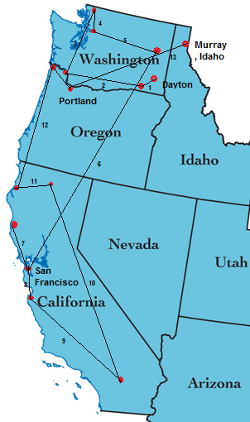
Base map from: https://pubs.usgs.gov/of/2005/1305/ Annotations by author.

Travel Segment | Date | Origin | Destination
1 | May, 1879 | Dayton, WA | Walla Walla, WA
2 | August, 1879 | Walla Walla, WA | Rainer, OR
3 | October, 1879 | Rainer, OR | Skagit Valley, WA
4 | Late 1879 - Early 1880 | Skagit Valley, WA | Seattle, WA
5 | April, 1880 | Seattle, WA | Medical Lake, WA
6 | Summer, 1881 | Medical Lake, WA | San Francisco, CA
7 | September, 1881 | San Francisco, CA | Mendicino County, CA
8 | December, 1881 | Mendicino County, CA | Monterey, CA
9 | April, 1882 | Monterey, CA | Southern CA and Calio mining district
10 | June, 1883 | Southern CA | Redding, CA
11 | July, 1883 | Redding, CA | Arcadia, CA
12 | May, 1884 | Arcadia, CA | Astoria and Portland, OR
13 | May, 1884 | Portland, OR | Murray, Idaho

Reports of rich mining placers in the Coeur d’Alene region of the Idaho panhandle came to Noah’s attention in May, 1884. Gold nuggets beckoned. Noah gathered the resources he could, found work, and borrowed funds to relocate to the Idaho panhandle. He arrived, according to McBride, in Murray, Idaho in the 1884 summer season. Kellogg, traveling on the Steamship State of California, made his way via Astoria and Portland, Oregon. His route to the Coeur d’Alene region would have passed directly through the eastern Washington district of which Dayton was a part (See Map 6). In fact daily rail service was offered from Portland to Dayton. He failed to visit with his wife. She would die the next year and Noah, according to McBride, would not learn of her passing until the year after. In the meantime good fortune would come Noah’s way.

Don’t Let The Facts Stand In The Way Of A Good Story
…. Or Money For That Matter

Lead and silver has great value. Maybe not as much as gold but when found in abundant enough quantities and in adequately concentrated ores, the mining of silver and lead can be immensely profitable. Noah would find, in September 1885, such a mining lode located on the banks of Shoshone County Idaho’s Milo Gulch, a tributary of the south fork of the Coeur d’Alene River (See Map 7). The lode would be named the Bunker Hill and Sullivan.

Map 7 - Bunker Hill and Sullivan Mining Lode Location

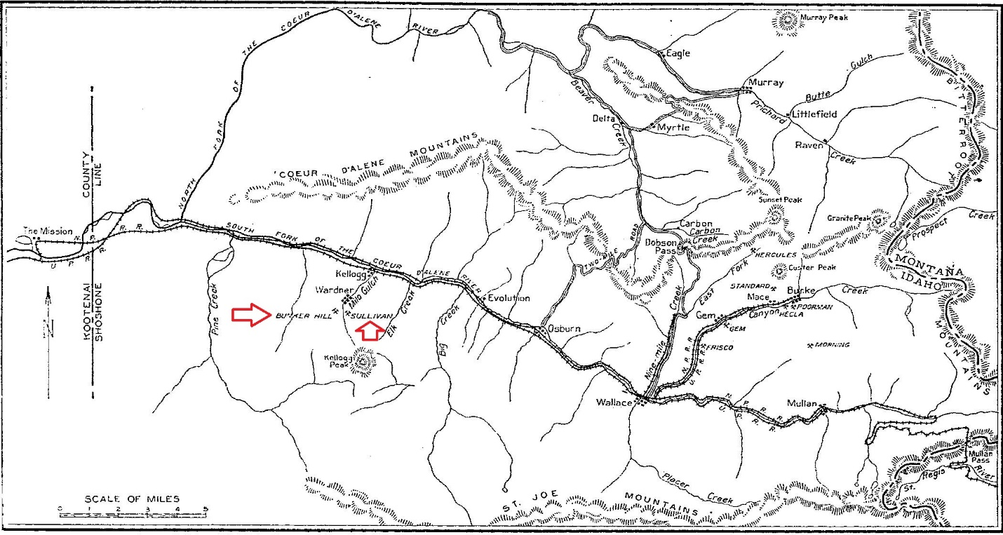
From: The Bunker Hill Enterprise by T. A. Rickard, Mining and Scientific Press (San Francisco, CA 1921), 16. Annotations by author.

This is what attracted Clarissa Jacobson’s attention and community property lawsuit seeking to recover her mother’s half interest in Noah Kellogg’s mine claim. Kellogg’s mining interest also attracted the attention of Portland, Oregon’s Simeon Reed. But first it would be necessary to firmly establish exactly what Kellogg owned. The lawyers were summoned to Murray, Idaho, the Shoshone County seat.

The discovery of Kellogg’s Bunker Hill and Sullivan lode has been the subject of romantic fantasy and tall tales starting with its accidental discovery by his burro. Re-telling of the various claim discovery and location stories is not necessary or desirable here. All of the versions have elements of falsehood, truthfulness and self-serving aspects. One observer labeled them “pure moonshine” while the Idaho Supreme Court was moved to suggest they were “laden with badges of fraud”. The result, at the end of the day, is what matters here. Kellogg had a half interest, so said the Idaho courts, with the balance divided among a cast of savory and unsavory characters.

Nothing in Kellogg’s background indicated that he had the technical and managerial talents or access to capital resources necessary to develop the lode into a productive mining enterprise. The same could be said for his partners having the balance of ownership. To remedy the lack of skills problem they took James F. Wardner into their partnership. Wardner proceeded, as best he could, to secure capital investment, build a transportation infrastructure and secure sales contracts so that the lode could be developed into a mine and profits generated. He meet with success but to fully realize the enterprise’s potential even more needed to be done.

Simeon Reed made his fortune as a railroad, real estate, banking, mining, and steamship investor and speculator. He was about to add, for $650,000, the Bunker Hill and Sullivan Mine to his investment portfolio. Bunker Hill and Sullivan was his April, 1887, twenty months after Kellogg’s discovery and eleven months after Mary Byrd’s death. Reed made additional investment in plant and materials. Bunker Hill and Sullivan became a prolific ore and refined lead and silver producer. The cash was flowing.

Clarissa Jacobson believed she was entitled to a share of the new found wealth and demanded it as a lawful heir to her mother’s community property. The lawyers were summoned once again. She lost in the local courts. The Idaho Supreme Court after examining her claims upheld the lower court. The matter largely turned on the question if Noah Kellogg had intended to abandon his wife in Dayton, Washington and lived separate and apart from her. If the intent to abandon had been found, Mary Byrd’s children could have inherited her share of the community property to the exclusion of Noah. Simeon Reed would have found himself with a new partner sharing in half the wealth and entitled to significant payment for the wealth previously extracted.

The court found no abandonment intent. Because of procedural issues and probable poor preparation by Clarissa Jacobson’s legal team, evidence of Noah’s post 1879 meanderings, including those bringing him within a short relative distance to Dayton on several occasions, and his past financial irresponsibility were never brought to the court’s attention. Noah walked away, as he had from other things before. Noah chose not to return even when he no longer had any economic impediment to returning before Mary’s passing. Whatever incidental financial support he provided, was motivated by a desire to avoid recovery by his creditors not to support his ailing wife. His behavior in leaving Dayton, Washington was fully consistent with all that came before; evasion of responsibility. He had demonstrated himself many times over to be a rogue.

Interestingly the statute upon which the question at hand rested, assumed that only a husband could abandon a wife. The property protections afforded the abandoned spouse were flimsy, at best, resting upon after the fact assertions not actual conduct. Maybe the exclusively male judges and lawyers would have conducted themselves differently if the statute had provided otherwise or had been gender neutral. Either condition, perhaps, would have persuaded them to look to actual behavior not inferred intent. At the time of the legislative enactment in question, in Idaho, there were three men over the age of 17 for every similarly aged woman. For every male voter there were zero female voters. Idaho was a male preserve and the legislature legislated accordingly.

A full exploration of Clarissa’s effort to recover her mother’s community property and enhance her financial position is beyond the scope of this article and requires a fuller analysis. There is evidence that she never had a chance and that Simeon Reed and the Bunker Hill enterprise were fully aware of Kellogg’s past and did not want it to become known to the court. McBride’s biography was probably more of a product of pretrial preparations as a trial advocate for Reed’s Bunker Hill and Sullivan Mining and Concentrating Company, than his purported post-trial interviews and ignores Noah’s life before his marriage. Reed’s San Francisco lawyer, William F. Herrin, advised local Idaho counsel after a review of case documents, “to make (a)……thorough and diligent search for all obtainable facts which will show or tend to show that Kellogg did not abandon his wife”. Even though Kellogg’s economic interest was the same as Reed’s, the Bunker Hill defenders, including McBride, may have felt that having Kellogg as a witness was too big of a risk. Kellogg owned 33,873 shares of the then outstanding 250,000 shares of the Bunker Hill and Sullivan Mining and Concentrating Company, the corporate successor to Reed’s original proprietorship. The book value of Kellogg’s holdings was $83,000. Kellogg had every economic incentive to lie about his intent if ever questioned. The court either did not know of Kellogg’s incentive or chose to ignore it. He lied and deceived others in the location of the original mine claim contest. There is no reason to believe that his moral character had recently improved.

The Bunker Hill enterprise was not a supporter of judicial integrity. In an earlier, unrelated case, they organized political pressure upon the courts, manipulated jury selection, and bought witness testimony. Was Clarissa Jacobson a victim of Bunker Hill’s version of judicial integrity? Past behavior would seem to indicate that she may well have been. This aspect of the matter also deserves greater exploration.

Conclusion

Noah Kellogg’s capital was his labor. His returns to capital were marginal, often negative and failed to propel him to property owning independence as promised by the time’s free labor ideology. Until his employment by Hill Harmon, Kellogg took an entrepreneurial approach toward his western labor. Afterwards, he was largely a migratory wage laborer. What Kellogg lacked most was land; the necessary third leg of the capitalist’s holy trinity of land, labor and capital. He was unable to secure and retain a land interest and this cost him dearly. Mobility has been seen as an American and western frontier birthright. This birthright when exercised comes at the cost of the ability to accumulate resources. Each move consumes accumulated resources and prevents resource accumulation while moving. To compensate, a compounding of future capital return rates relative to current returns is required if the move is to result in greater accumulation. Returns can climb only so high. His frequent borrowings indicate returns continually fell short. Noah, particularly after his marriage, was one of many thousands of western migratory workers sharing a landless state. Their labor may have been free but it never had any real promise of economic independence. In Noah’s landless state, capital accumulation, except by accident, was nearly impossible. Thousands shared his choice of economic sustenance but only a very few shared his good luck.

Kellogg also left or attempted to passed on his financial crises at every turn. Financial irresponsibility was a constant and his ethical conduct questionable. It was only happenstance that resulted in his great find; a find that would inevitably have been found by others. His labors’ value added was not any greater than that of his peers. His rogue behavior stained his labors’ value making a mockery of free labor’s believed nobility. He was no less caviler to the consequences of his actions than the period’s robber barons and well-tempered capitalists.

Post Script

Simeon Reed participated in the management and operation of the Bunker Hill and Sullivan mines until 1891. Afterwards the mine passed through various corporate hands. The wealth generated from the mines for Simeon Reed found its way into financial support, in the first decade of the twentieth century, for the establishment of Portland Oregon’s Reed College.

Labor unrest was a constant feature of the Bunker Hill mining landscape. Employees demanded fair and stable wages and improved working conditions. Profits of the Bunker Hill and Sullivan Mines were dependent upon lead and silver commodity prices and production costs but were handsome. The environmental consequences and costs of lead and silver mining were largely unconstrained until the 1970s. In 1968, the mines and associated facilities were sold to the Gulf Resources and Chemical Company. Mine production was halted and terminated by Gulf Resources in 1982. At their closing the Mines’ production was one-seventh of the nation’s lead and silver production.

With the exception of a report of logging in 1869-1870 in Snohomish County north of Seattle Orange Kellogg dropped from sight. So far is known he had no further interactions with his brother Noah. Orange resurfaced in 1900 living with his 58 year old wife, Malissia, in Yamhill County, Oregon. At age 87 Orange died.

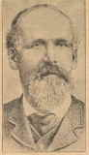
N. S. Kellogg died, at age 71, in Kellogg, Idaho March 17, 1903. He gave his name to the town that grew up around the Bunker Hill and Sullivan mines. In later life his money was managed by Martin Winch, Simeon Reed’s nephew and personal secretary, “so he cant squander it”. In 1900 Noah would refer to himself as a Landlord. Under Winch’s supervision, in a contemporary time, improvement in Kellogg’s credit scores would have been expected.
Noah S. Kellogg
about 1895 from Wallace Miner, December 26, 1935
Washington State University
Libraries Digital Collection

Kellogg remarried, apparently, twice. Marine M. (Mary) Reed (as far is known no relation to Simeon Reed) of Billings, Montana and Kellogg were joined October 24, 1888 at Spokane Falls, Washington. Mary Reed was not a happy wife. She wrote to Simeon Reed in the summer of 1891, “Ive never had an hours happiness with Mr Kellogg since I married him and in the last year and a half he has positively almost driven me mad by his foolish expenditure of money and his neglect of me and his managment in general.” Perhaps, it was Mary Reed’s letter that resulted in Winch’s call to arms. Narcissa J. Ashton, at age 51, would become Kellogg’s third wife on December 23, 1895. They married at Santa Clara, California. Her disposition in the following years is unknown.

William J. Adams of the Washington Mill Company was made wealthy by his city building ventures. His ventures resulted in massive wilderness destruction and deforestation. His grandson Ansel Adams, noted environmentalist and photographer, spent his life attempting to reverse wilderness destruction and deforestation and preserve that which had not yet been destroyed.

The Asylum at Steilacoom was the antecedent of today’s Western State Hospital. The Hospital remains charged with the care and treatment of the mentally ill. Methods of treatment may have advanced but the adequacy and accessibility of treatment and costs remains an acute issue as it was in 1871.

The author of this paper resides in Charles Terry’s Town of Alki at the corner of Grand and 1st Street or at least estimates his Town of Alki location as being Grand at 1st Street (See Map 2).

As noted earlier Noah Kellogg’s Alki land holdings were sold again by Doc Maynard to Knud Olson and Hans Martin and Anna Hanson. After the death of the Hansons various schemes of real estate development ensued and the Hanson and Olson children, grandchildren and great grandchildren pursued a variety of ventures and careers. One of the great grandchildren of Anna and Hans Martin Hanson, who wishes to remain anonymous, attended college on the east coast and, afterwards, pursued his business career in Houston, Texas working for Gulf Resources and Chemical Company. It was not until the late stages of research for this article that he learned of the relationship of Noah S. Kellogg, Alki, Bunker Hill and Gulf Resources. It all came full circle.

Endnotes United States Department of Housing and Urban Development, “HUD Provided Local Level Data – Neighborhood Stabilization Data”, accessed October 29, 2016, https://www.huduser.gov/portal/datasets/nsp_foreclosure_data.html. Seattle Metropolitan Area is defined as King, Snohomish and Pierce counties.
Such dating ignores settlement and habitation of Seattle and environs by the Duwamish Native Americans for the prior 10,000 years.
In time, the sale of these lots would be forgotten and overlooked. See: Deed Charles C. Terry to David S. Maynard, King County Archives, Deed Book, Volume 1-2, page 148, re-recorded at page 197, July 11, 1857, Seattle, WA. The grant or sale by Terry to Maynard was “excepting and reserving three town lots in the formerly town of Alki which said lots have been heretofore sold to Adams Boles”. Based upon the author’s search of King County grantor and grantee indices, sale of the town lots were, apparently, unrecorded.
Town of Alki plat suffers from a defect in that no initial survey point was stated. Without such a point the location of the plat or any lot within cannot be determined with any certainty.
Deed Terry to Maynard, King County Archives, July 11, 1857, Seattle, WA. Author’s calculations to estimate land claim boundaries from distances (measured in chains) and areas provided in Terry to Maynard Deed.
Land claims at this time were of dubious value. The Oregon Land Donation Act provided for claims of 160 or 320 acres, depending upon marital status of the claimant, if a treaty had been entered into with the Indians ceding the land to the United States Government and the land had been surveyed. Neither condition had been met in 1852.
Maynard had earlier sold or given away 60 acres of his land claim.
Thomas Wickham Prosch, David S. Maynard and Catherine T. Maynard : Biographies of Two of the Oregon Immigrants of 1850 (Seattle: Lowman & Hanford Stationery & Print., 1906), 47-50 and Territory of Washington v William Powell, King County Court, King County, Washington, Case # 997, 1866. Washington Secretary of State, Puget Sound Regional Archives, Bellevue, WA.
Deed D. S. Maynard to Knud Olsen, King County Archives, Deed Book, Volume 1-2, page 49, September 28, 1868, Seattle, WA. (Note: the incorrect spelling of Olsen, in the deed, has been corrected above and below)
Olson was widowed at the time of the transaction. He had two children Linda and Clara Isabel. Olson formerly purchased the Alki estate from Maynard while Hanson remained in Alpha Prairie. Some years later they formerly recognized their partnership by executing deeds in favor of the other. See: Robert E. Bowman, “Hansen / Gundvaldsen Genealogy”, Bulletin Seattle Genealogical Society Vol. 59, No. 1 (2009-10): 15-16.
Hanson and Olson sold, in 1888, 40 acres in the south part of the original Terry land claim to Nelson Chilberg for $8,000 in U.S. gold coin. Deed Knud Olson and H. M. Hanson & wf. to N. Chilberg, King County Archives, Deed Book, Volume 61, page 521, December 27, 1888, Seattle, WA
The author adopts Coll Thrush’s nomenclature for Seattle’s ‘In the Beginning’. Coll Thrush, Native Seattle Histories from the Crossing-Over Place, (Seattle: University of Washington Press, 2007).
Brooke V. Best, Celebrating 150 Years Architectural History of West Seattle’s North End (Vashon, WA: Brooke V. Best, 2003), 14.
Bill Speidel, Doc Maynard, The Man Who Invented Seattle (Seattle: Nettle Creek Publishing Co., 1978), Prosch, David S. Maynard and Catherine T. Maynard : Biographies, 49 and, Murray Morgan, Skid Road : An Informal Portrait of Seattle(New York: Viking Press, 1951)
Deed D. S. Maynard and C. T. Maynard to N. S. Kellogg, King County Archives, Deed Book, Volume A2, page 581 and 583, October 2, 1862 Seattle, WA.
Deed Charles Plummer to N. S. Kellogg, King County Archives, Deed Book, Volume AC, page 585, September 9, 1862 Seattle, WA.
Anonymous, “Sheriff’s Sale” Washington Standard (Olympia, WA), November 21, 1863.
Deed N. S. Kellogg to Charles Plummer, King County Archives, Deed Book, Volume 1, page 166, December 11, 1863 Seattle, WA.
Sections 14 and 15, Township 29 N, Range 1 W of the Public Land Survey System. http://www.digitalarchives.wa.gov/Record/View/D8F180BBAC3A11B586CFE506ACD87688 and http://www.digitalarchives.wa.gov/Record/View/C57F3A172B79F7E7C468A507F345BC49 Donation Land Claims in Washington Territory, 1852-1855, Office of the Secretary of State, Washington State Archives, Digital Archives, http://digitalarchives.wa.gov, accessed 10/15/2016 and List of Donation Land Claims in Washington Territory, July 1887, transcribed by James Wickersham at Washington State Library http://www.sos.wa.gov/history/publications_detail.aspx?p=43 , accessed 10/15/2016.
https://www.digitalarchives.wa.gov/Record/View/54C83F76C8CA7FD143FBADF364F5E72D Donation Land Claims in Washington Territory, 1852-1855, Office of the Secretary of State, Washington State Archives, Digital Archives, http://digitalarchives.wa.gov, accessed 10/15/2016 and List of Donation Land Claims in Washington Territory, July 1887, transcribed by James Wickersham at Washington State Library http://www.sos.wa.gov/history/publications_detail.aspx?p=43 , accessed 10/15/2016. Information necessary to locate this land claim is missing. Land claim records, like his brother’s, indicates that Port Townsend was the nearest post office. This does narrow the location possibilities to the north half of the Olympic Peninsula (Jefferson County, Washington) or Kitsap County, Washington (formerly known as Slaughter County). The 1857 Kitsap County census enumerates Orange S. Kellogg. In all likelihood Kitsap County was the land claim location.
Washington Secretary of State, Washington State Archives, 1857 Kitsap County Census (formerly known as Slaughter County) https://www.digitalarchives.wa.gov/Record/View/A103F0F4D4E790E66B9AE9909D526950 accessed 11/1/2016.
The Donation Land Claim Act granted 160 acres to a single individual. To be eligible for the grant one had to reside on the granted land for four years.
General Land Office, Bureau of Land Management digital search for a Land Patent at: http://www.glorecords.blm.gov/results/default.aspx?searchCriteria=type=patent|st=WA|cty=035|ln=kellogg|sp=true|sw=true|sadv=false and http://www.glorecords.blm.gov/results/default.aspx?searchCriteria=type=patent|st=WA|cty=031|ln=kellogg|sp=true|sw=true|sadv=false accessed October 1, 2016. O. S. Kellogg filed a year earlier (October 24, 1853) a Thurston County land claim (Section 18, Township 19N, Range 2W) that was abandoned April 12, 1854. See: Washington Secretary of State, Washington State Archives at: https://www.digitalarchives.wa.gov/Record/View/54C83F76C8CA7FD143FBADF364F5E72D , accessed October 3, 2016.
Ancestry.com and “United States Census, 1850,” database with images, Family Search (https://familysearch.org/ark:/61903/1:1:MXQK-YHJ : 9 November 2014) , Noah Kellogg, La Grange, Lorain, Ohio, United States; citing family 1385, NARA microfilm publication M432 (Washington, D.C.: National Archives and Records Administration, n.d.) and Spencer N Kellogg in household of Alice Kellogg, La Grange, Lorain, Ohio, United States; citing family 1585 (incorrect transcription should be 1385), NARA microfilm publication M432 (Washington, D.C.: National Archives and Records Administration, n.d.).
Ancestry.com. Ohio, Wills and Probate Records, 1786-1998 [database online]. Provo, UT, USA: Ancestry.com Operations, Inc. 2015. Name: Noah Kellogg, July 1, 1867, Lorain, Ohio.
"United States Census, 1850," database with images, FamilySearch (https://familysearch.org/ark:/61903/1:1:MXQK-YH2 : 9 November 2014:, Spencer N Kellogg in household of Alice Kellogg, La Grange, Lorain, Ohio, United States; citing family 1585, NARA microfilm publication M432 (Washington, D.C.: National Archives and Records Administration, n.d.)
There is modest evidence that Noah Kellogg may have begun prospecting in southern Idaho, northern Montana and the Kootenay district of British Columbia during this period. See: R. L. Brainard, ed, “Pioneer Days in Coeur D’Alenes”, Wallace Miner (Wallace, Idaho), May 4, 1939.
Arthur Denny, Pioneer Days on Puget Sound, ed. Alice Harriman (The Alice Harriman Co., (1908), 61.
"United States Census, 1860", database with images, Family Search (https://familysearch.org/ark:/61903/1:1:MC6W-X7J : 30 December 2015) , Spencer Kellogg, 1860, and “Population of the United States in 1860”, Bureau of the Census Library, Washington, GPO, 1864, 580-585.
S. P. Blinn, W. J. Adams and Washington Mill Company v. N. S. Kellogg, King County Superior Court, King County, Washington. King County Superior Court Clerk Seattle, WA, Original Case # 1218, renumbered Case KNG-1220, May 9, 1870.
Thomas Frederick Gedosch, “Seabeck, 1857-1886 The History of A Company Town” (MA Thesis, University of Washington, Seattle, 1967), 149-150. Chapter V of this work is an excellent description of the ‘independent’ logging company operations and economics. The Mill Company conducted its affairs in a manner to create dependencies.
Washington Mill Company records, Accession No: 3257-001, University of Washington Library Special Collections, Seattle, WA.
Goedosch, “Seabeck”, 140.
Blinn v Kellogg, King County Court, 1870.
Goedosch, “Seabeck”, 19.
Goedosch, “Seabeck”, 145 and Table XIV.
Letter from B. F. Dennison to Richard Holyoke, June 17, 1870. Washington Mill Company records, Accession No. 1005-001, Box 14 University of Washington Library Special Collections, Seattle, WA.
Letter from Richard Holyoke to B. F. Dennison, July 13, 1870. Washington Mill Company records Accession No. 1005-001, Box 14, University of Washington Library Special Collections, Seattle, WA.
Washington Mill Company and Kellogg and Company v Isaac Carson, Thurston County Court, June 24, 1870, Case # 769, THR-747, Office of Secretary of State, Washington State Archives, Olympia, WA.
Washington Mill Company and Kellogg and Company v John Swan and Isaac Carson, Thurston County Court, May 15, 1871, Case #998, THR- 944, Office of Secretary of State, Washington State Archives, Olympia, WA and Adams, Blinn, Blinn and Taylor v N. S. Kellogg and Isaac Carson, Thurston County Court, December 20, 1873 Case # 1313, THR-1246, Office of Secretary of State, Washington State Archives, Olympia, WA.
T. A. Rickard, The Bunker Hill Enterprise, (Mining and Scientific Press, San Francisco, CA 1921), 21.
Isaac Pincus and Adlophus Packsher v Noah Kellogg, Pierce County Court, June 25, 1872, Case #261, PRC-270, Office of the Secretary of State, Washington State Archives, Puget Sound Regional Archives, Bellevue, WA.
Washington Mill Company records, Accession No. 1005-001, Box 12 Oversize, University of Washington Library Special Collections, Seattle, WA.
Ancestry.com, “U.S. IRS Tax Assessment Lists, 1862-1918 for N S Kellogg”, List of Persons in Division No. One, of Collection, October, 1870, line 8, page 23.
N. S. Kellogg v Frank Clark, Thurston County Court, September, 11, 1873, Case # 1222, THR-1160, Office of the Secretary of State, Washington State Archives, Olympia, WA.
United States Census of Population, 1870 Census: A Compendium of the Ninth Census (June 1, 1870), Table IX: Population of Minor Civil Divisions, with General Nativity and Race, 1870 at http://www2.census.gov/library/publications/decennial/1870/compendium/1870e-17.pdf , 359. Accessed October 10, 2016.
Thomas W. Prosch, “The Insane In Washington Territory”, Northwest Medicine, April, 1914, 6-8, University of Washington Library Special Collections, Seattle, WA. See also: Russell Hollander “Mental Health Policy in Washington Territory, 1853-1875” Pacific Northwest Quarterly, 71, No. 4 (October, 1980): 152-161.
Journal of the Proceedings of the Council of the Territory of Washington, of the Session of the Legislative Assembly Begun and Held at Olympia, the Seat of Government, Upon the First Monday of October, 1871, Washington Territorial Legislative Assembly, “Report of Contractor for Care of The Insane”, September 30, 1871, 114-116, Olympia, WA.
Mary A. Byrd v Mark A. Byrd, Pierce County Court, December 15, 1873, Original Case # 473, Case # PRC-487, Office of Secretary of State, Washington State Archives, Puget Sound Regional Archives, Bellevue, WA.
Journal of the Proceedings 1871, Washington Assembly, 116.
“United States Census 1860”, database with images, Family Search (https://familysearch.org/ark:/61903/1:1:MC6WR : 30 December 2015), Mark A. Byrd, 1860, and Mary A. Byrd v Mark A. Byrd, Pierce County Court, December 15, 1873, Original Case # 473, Case # PRC-487, Office of Secretary of State, Washington State Archives, Puget Sound Regional Archives, Bellevue, WA.
Anonymous, “Local News”, Daily Pacific Tribune (Olympia, WA), February 19, 1874.
John R. McBride, R. L. Brainard, editor, “Pioneer Days in Coeur D’Alenes”, Wallace Miner (Wallace, Idaho), serialized March 30, 1939 – July 6, 1939. Found in Dubudar Scrapbook, University of Washington Library, Microfilm Collection, Book DS 15, p12-26, Roll A2946, Seattle, WA. McBride’s biography of Kellogg is unpublished except for its Wallace Miner serialization and begins with Noah’s marriage. As will be shown later McBride’s work should be taken with healthy skepticism. John McBride was counsel for the Bunker Hill and Sullivan Mining and Concentrating Company and served as Chief Justice of the Idaho Territorial Supreme Court until 1869.
Letter to Simeon G. Reed from Martin Winch, May 20, 1893, The Letters and Private Papers of Simeon Gannett Reed, Vol 31, 18, Reed College Archives, Portland, OR.
Jacobson v Bunker Hill and Sullivan Mining and Concentrating Company, December 2, 1891, Idaho Supreme Court Reports, Vol 3, 137.
Anonymous, “Passengers for Oregon”, The Daily Morning Astorian (Astoria, Oregon), 3, May 24, 1884 and Official Railway Guide, The National Railway Publication Company, New York, New York. September 1883, Pacific Steamship Company Timetable, 267.
Official Railway Guide, September 1883, Oregon Railroad and Navigation Company Timetables, 263.
Rickard, Bunker Hill Enterprise, 19 and Vol. 2 Idaho Supreme Court Reports, page. 332. Cooper, et. al. v Kellogg, et. al.
Technically, two mine claims were at issue; Bunker Hill and Sullivan. Bunker Hill was the larger of the two. Kellogg owned half of the Bunker Hill lode claim and one-eighth of the Sullivan claim. See: Letter to Simeon G. Reed from William H. Clagett, April 21st, 1889, The Letters and Private Papers of SGR, Vol. Miscellaneous, 209-213, Reed College Archives, Portland, Oregon. Also; Idaho Supreme Court Reports, Vol 2., 330 (1903).
Rickard, Bunker Hill Enterprise, 22.
Jacobson v Bunker Hill, Idaho Supreme Court Reports, Vol 3, 129-130.
Jacobson v Bunker Hill, Idaho Supreme Court Reports, Vol 3, 126.
United States Census of Population, 1880 Census: A Compendium of the Tenth Census (June 1, 1880), Table XLI: School, Military, and Citizenship ages – IDAHO Territory, 570 at: http://www2.census.gov/prod2/decennial/documents/1880b_p1-05.pdf (accessed November 6, 2016).
The right to vote was granted in 1896. See: https://en.wikipedia.org/wiki/Women%27s_suffrage_in_states_of_the_United_States
McBride explains the origins of the Kellogg biography as; “Although the writer was consulting counsel for the defendant, he had not heard Kellogg’s story and explanations, save through others, and when the case was closed without unsealing his (Kellogg) lips, I had an intense curiosity to hear his narrative.” John R. McBride, R. L. Brainard, editor, “Pioneer Days in Coeur D’Alenes”, Wallace Miner (Wallace, Idaho), April 13, 1939 (emphasis added).
Letter to John Jay Hammond from William F. Herrin, April 4, 1891, The Letters and Private Papers of SGR, Vol. Miscellaneous, 215-220, Reed College Archives, Portland, Oregon.
Letter to Philip O’Rourke from S. G. Reed, October 19, 1887, The Letters and Private Papers of SGR, Vol. 23, Part 1, 132-134, Reed College Archives, Portland, Oregon.
Letters to S. G. Reed from V. M. Clement, December 23 and December 27, 1889, The Letters and Private Papers of SGR, Vol. 24, 113-116, Reed College Archives, Portland, Oregon.
Carlos A. Schwantes, “The Concept of the Wageworkers’ Frontier: A Framework for Future Research”, Western Historical Quarterly, Vol. 18, No. 1 (January 1987), 50-55, Eric Foner, Free Soil, Free Labor, Free Men: The Ideology of the Republican Party Before the Civil War, (New York, NY: Oxford University Press, 1995), and Robert J. Steinfeld, Coercion, Contract and Free Labor in the Nineteenth Century, (Cambridge, UK: Cambridge University Press, 2001).
Katherine G. Aiken, Idaho’s Bunker Hill, The Rise and Fall of a Great Mining Company 1885-1981, (Norman, OK: University of Oklahoma Press, 2005), 205.
J. R. Williamson and James N. Draper v John C. LeBallister and O.S. Kellogg, Third District Court of Washington Territory for King, Kitsap and Snohomish Counties, March 3, 1870, Case # 1218, Renumbered, KNG-1219, Washington Secretary of State, Washington State Archives, Puget Sound Regional Archives, Bellevue, WA. Williamson and Draper sought recovery of $478.09 on their book of account with LeBallister and O. S. Kellogg. Williamson and Draper kept their ‘lumbering and merchandising business’ at Freeport at the mouth of the Duwamish River near Alki. Defendants alleged insufficient facts, that the account was incorrect, and included duplicate and erroneous charges. Williamson and Draper corrected the items of debt to a balance of $322.13 while defendants alleged a balance due them of $78.85. Parties entered into a settlement agreement. Under the agreement property was returned to Defendants valued at $80 and towage receipts of $261.50 were paid by Defendants.
Letter to S. G. Reed from Martin Winch, April 2, 1892, The Letters and Private Papers of SGR, Vol. 31, 106, Reed College Archives, Portland, Oregon.
"United States Census, 1900," database with images, Family Search (https://familysearch.org/ark:/61903/1:1:MM5Y-9WT : accessed 12 December 2016) , Noah Kellogg, Kingston, Kellogg Precincts, Shoshone, Idaho, United States; citing enumeration district (ED) 101, sheet 9B, family 181, NARA microfilm publication T623 (Washington, D.C.: National Archives and Records Administration, 1972.); FHL microfilm 1,240,234.
Spokane County, Washington marriage records, Volume B, Page 26 as reported in the Western States Marriage Record Index, Brigham Young University of Idaho Library Special Collections, Rexburg, ID.
Letter to S. G. Reed from Mary M. Kellogg, August 14, 1891, The Letters and Private Papers of SGR, Vol. 33, 141-144, Reed College Archives, Portland, Oregon.
“California, County Marriages, 1850-1952,” database with images, Family Search, Noah S. Kellogg and Narcissa J. Ashton, 23 Dec 1895; citing Santa Clara, California, United States, county courthouses, California; FHL microfilm 1,302,027 and U. S. Census of Population 1900, see endnote 70 above.
The author expresses his appreciation to Thomas F. Gedosch for noting this relationship. Keywords Adolphus Packsher, Alki, Alki Point, Anna Hansen, Anna Hanson, Arthur Denny, B F Dennison, Bunker Hill and Sullivan, Bunker Hill and Sullivan Mining and Concentrating Company, C C Terry, Charles C. Terry, Charles Plummer, Charles Terry, Clarissa Byrd, Clarissa E. Jacobson, Clarissa Jacobson, Coeur d'Alene, Coeur d'Alene River, community property, David Maynard, David S. Maynard, Dayton Washington, Denny Party, DeWatto River, Doc Maynard, Elliott Bay, Frank Clark, Gulf Resoures and Chemical Company, H. Martin Hanson, Hans Hanson, Hans M Hanson, Hans Martin Hansen, Hans Martin Hanson, Hill Harmon, Idaho, Idaho Supreme Court, Isaac Carlson, Isaac Pincus, J E Smith, James F. Wardner, James Wardner, Jefferson County, Jefferson County Washington, Jim Wardner, John McBride,J ohn Morrison, John R McBride, John Swan, Josephine Byrd, Josephine Ward, Josiphine Ward, Kellogg Idaho, King County, King County Washington, Kitsap County, Kitsap County Washington, Knud Olsen, Knud Olson, marital abandonment, Marshall Blinn, Martin Winch, Marty Winch, Mary A. Bird, Mary A. Byrd, Mary Bird, Mary Byrd, Mason County, Mason County Washington, Medical Lake, Milo Gulch, Murray Idaho, N. S. Kellogg, Noah Kellogg, Noah S. Kellogg, Noah Spencer Kellogg, O. S. Kellogg, Olympia, Orange Kellogg, Orange S. Kellogg, Orange Stoddard Kellogg, Pioneer Days on Puget Sound, Portland Oregon, Puget Sound, Richard Holyoke, Ross G. O'Brien, S. G. Reed, Samuel Blinn, Seabeck, Seattle, Shoshone County, Shoshone,County Idaho, Simeon G. Reed, Simeon Reed, Spencer Kellogg, Stacy Hemenway, Steilacoom, Territorial Asylum for the Insane, Terry land claim, Thurston County, Thurston County Washington, Town of Alki, Washington, Washington Mill Company, Washington Territory, William J. Adams

